CREATED A NEW UNIQUE BUCKET

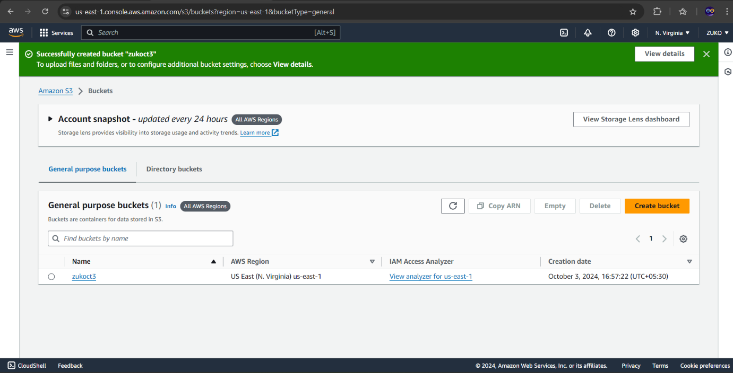

UPLOADED AN IMAGE

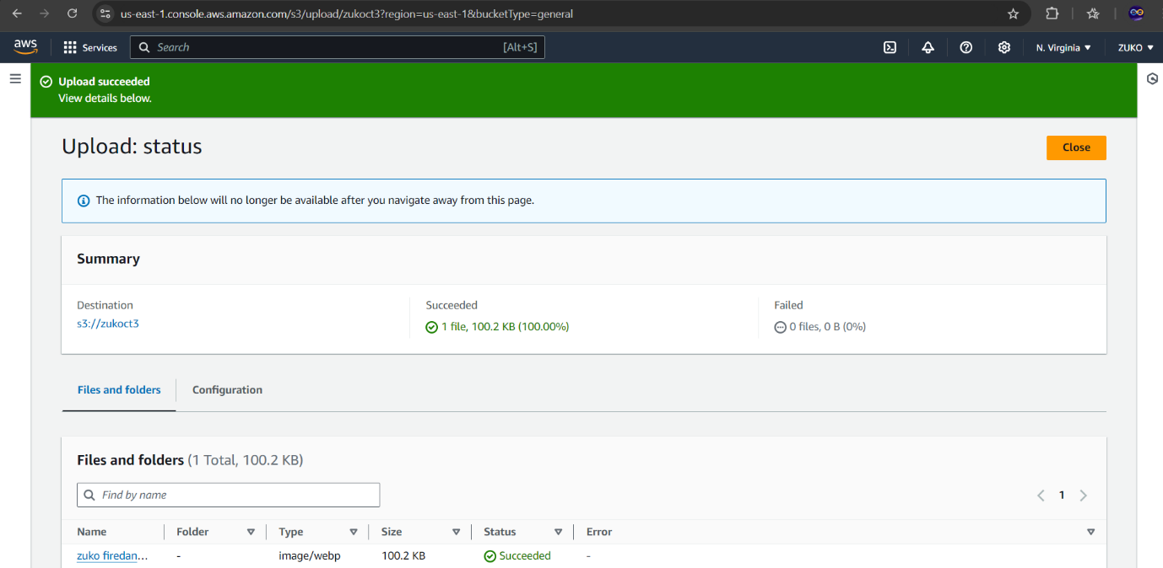

UPLOADED A HTML FILE

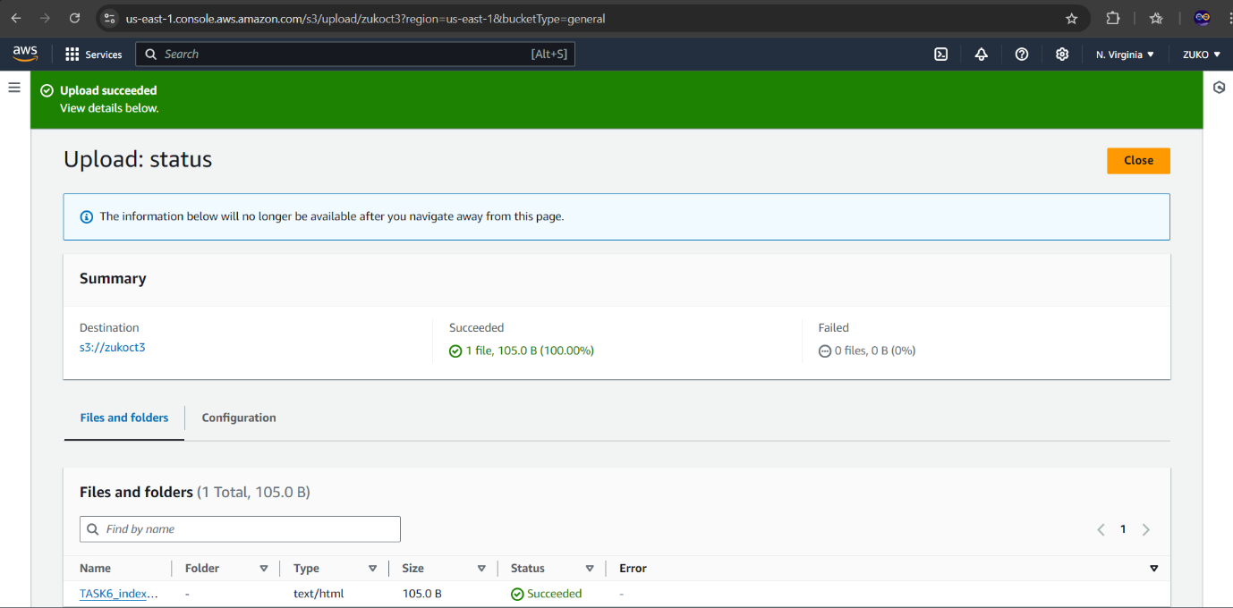

BEFORE UNBLOCKING PUBLIC ACCESS

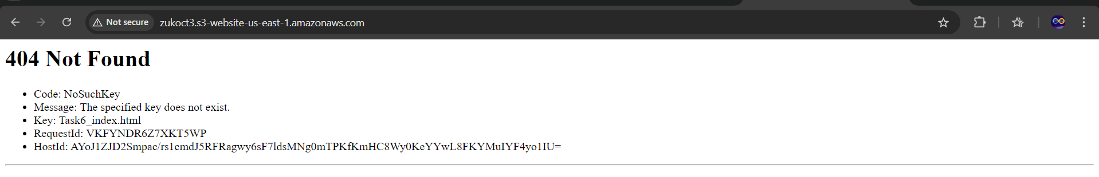

AFTER UNBLOCKING PUBLIC ACCESS, THE BUCKET POLICY WAS WRITTEN IN JSON, STATIC WEBSITE HOSTING WAS ENABLED.

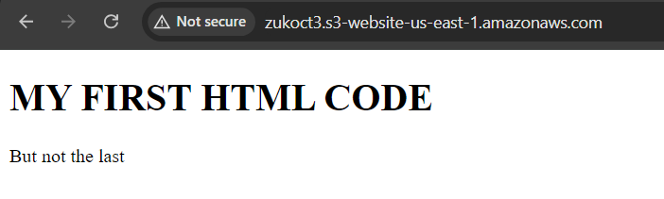

BUCKET VERSIONING ENABLED, EDITED THE HTML CONTENT AND SAVED

