VPC created.

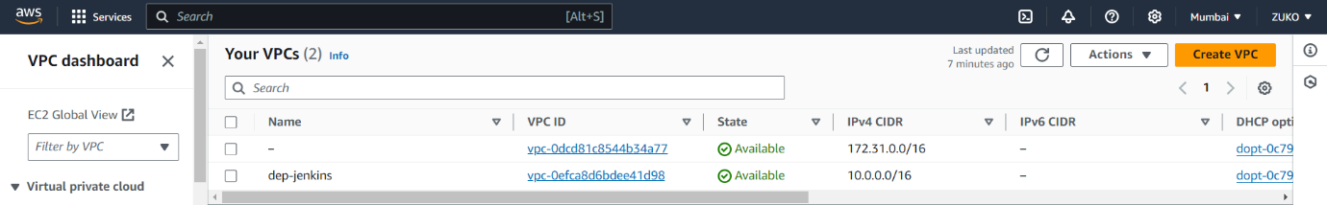

Two subnets were created, PUB_SN/PVT-SN.

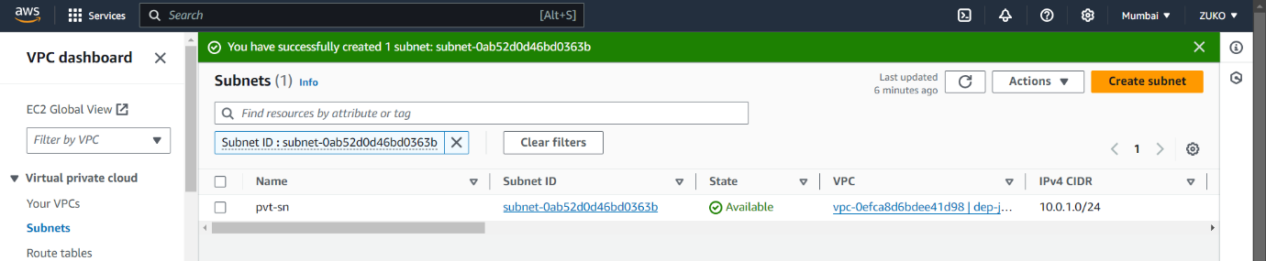

Internet gateway created and attached to created VPC.

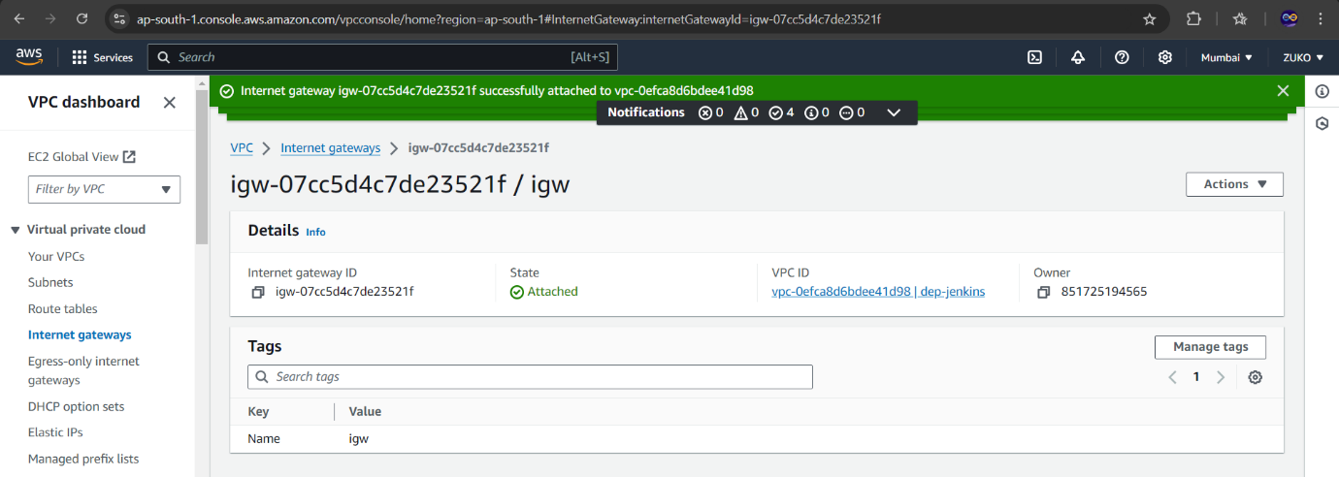

PUB-RT was created and using the edit route option connected to IGW associated with PUB-SN.

EC2 instance named JENKINS was launched using UBUNTU AMI within the created VPC/PUB-SN.

Port 8080 was opened along with HTTP and HTTPS.

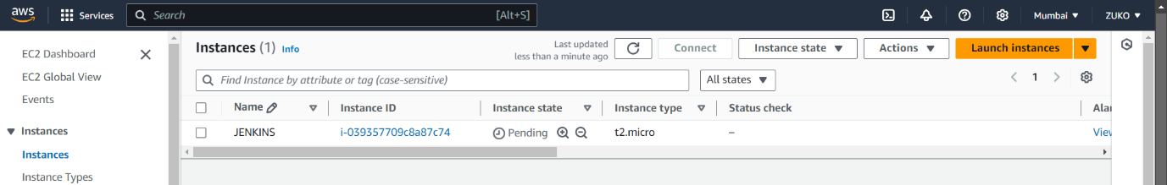

EC2 instance was connected using terminal and the following commands were used

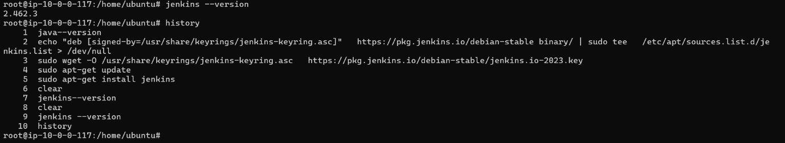

Deployed JENKINS by hitting PUB-IP:8080.

