Creating an IAM User, Assigning Permissions, and Enabling MFA

1.Creating an IAM User

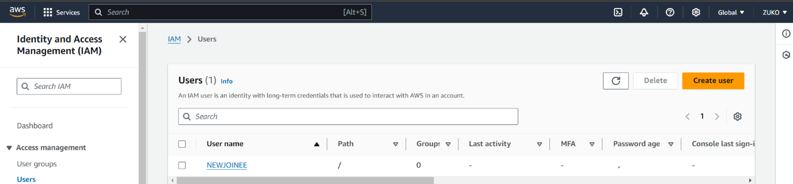

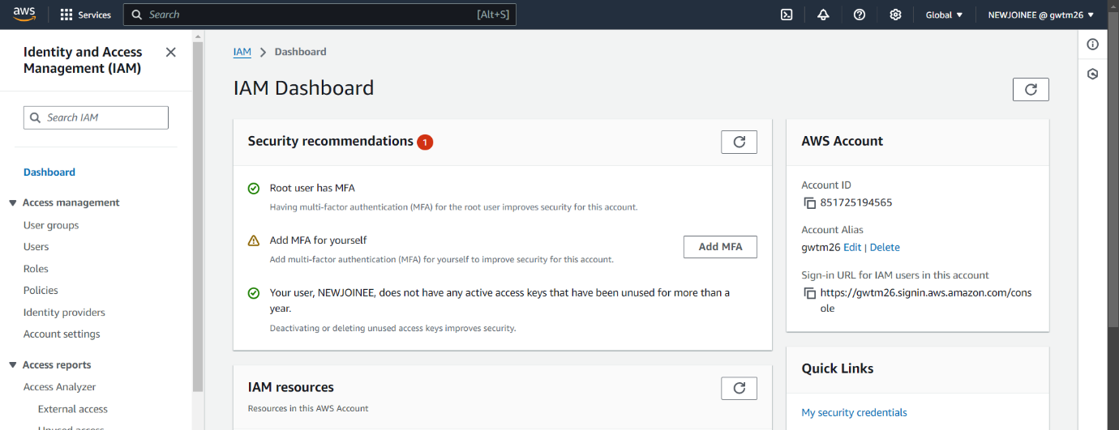

2.Assigning Policy Permissions

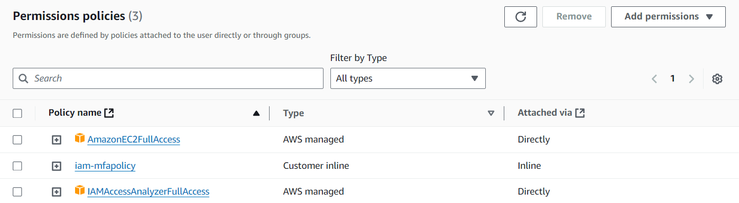

3.Enabling Multi-Factor Authentication (MFA)

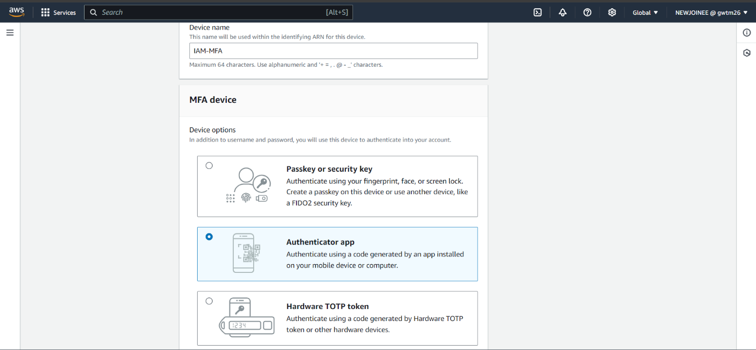

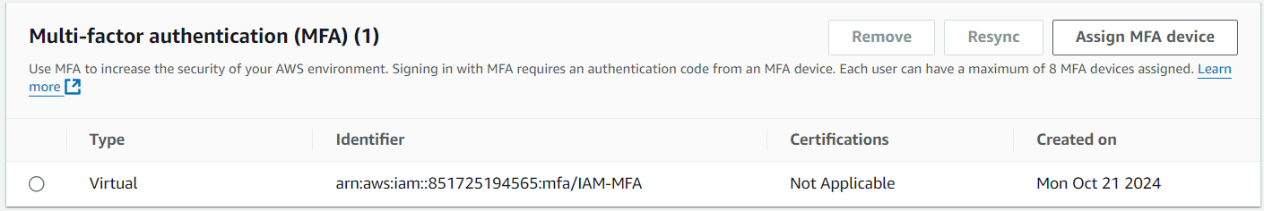

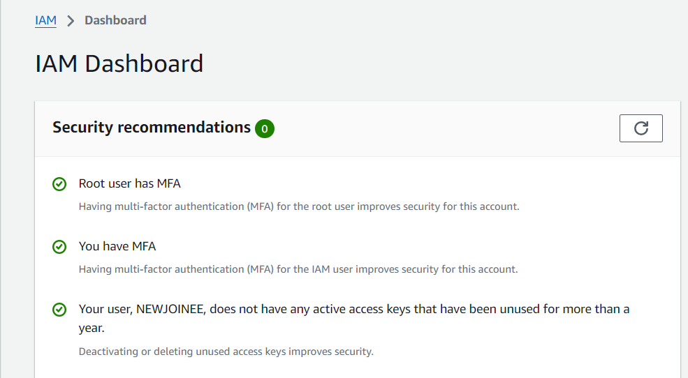

4.Testing Permissions

