TASK 14- ELASTIC IP

Public IP- 43.204.216.156 (when launched)

Pub IP- 3.108.59.208 (when restarted)

This shows us that the public IP is DYNAMIC.

1.CREATED AN EC2 INSTANCE

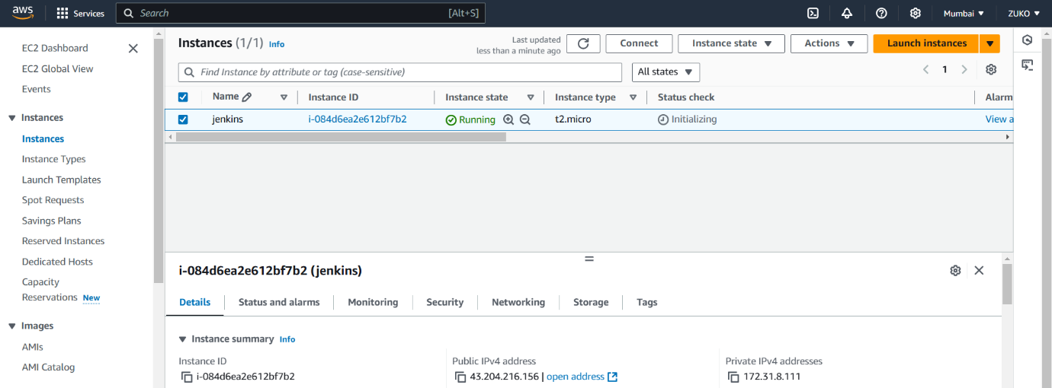

2. INSTANCE STOPPED

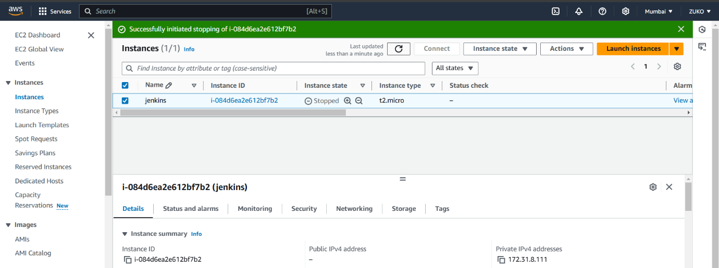

3. INSTANCE RESTARTED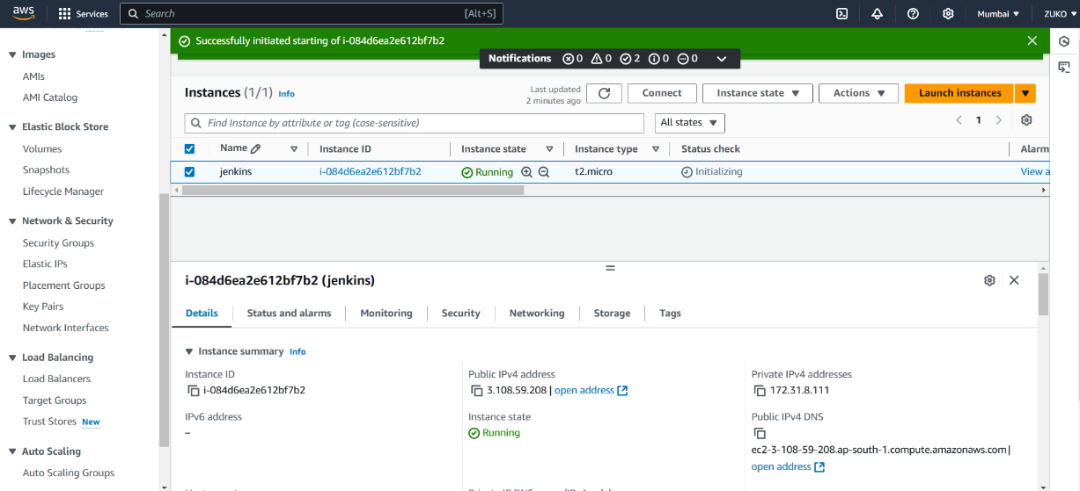

4. EIP ALLOCATION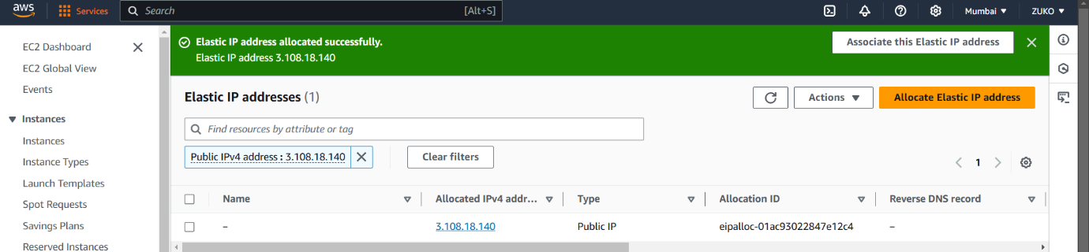

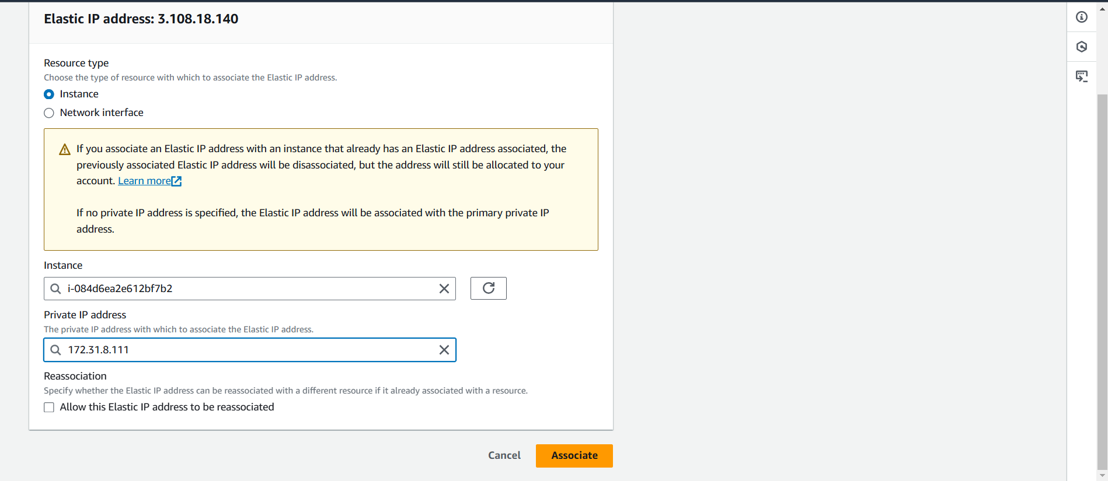

5. EIP ATTACHED TO AN RUNNING INSTANCE.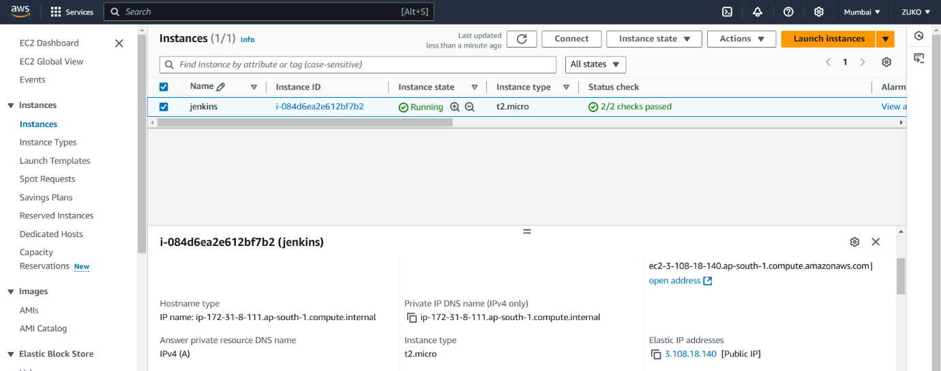

6. USING EIP AS PUBLIC IP OVER INTERNET

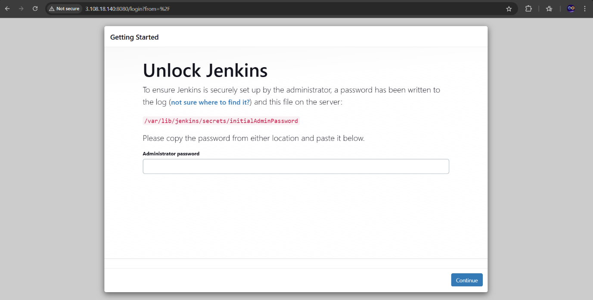

7. DISASSOCIATING & RELEASING EIP.

