TASK 15- RELATIONAL DATABASE SERVICE

STEP1: LAUNCH AN INSTANCE

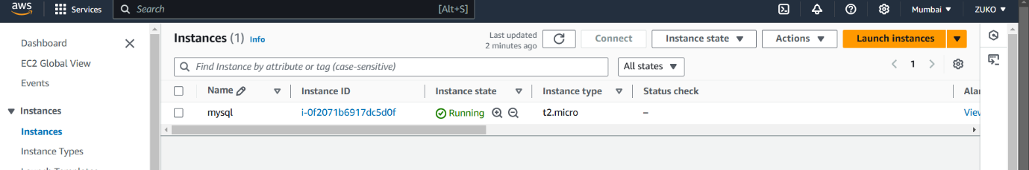

STEP2: CREATE DB SUBNET GROUP

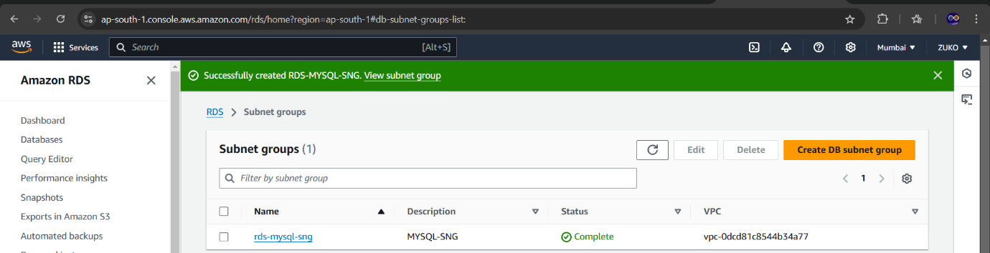

STEP 3: CREATED A DATABASE

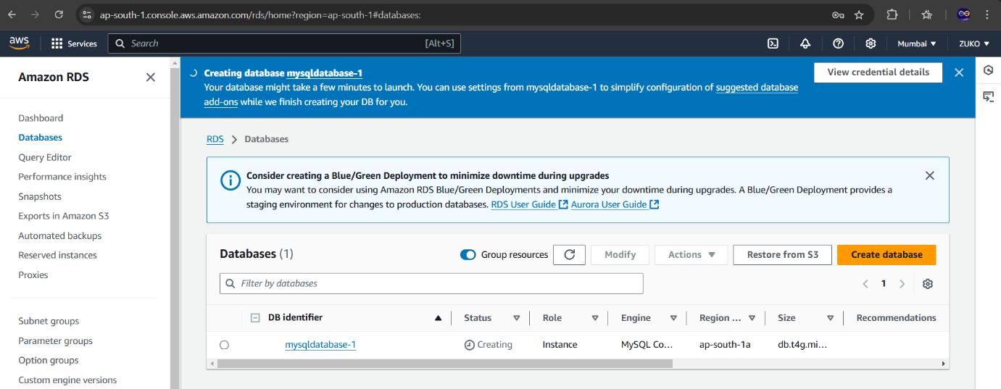

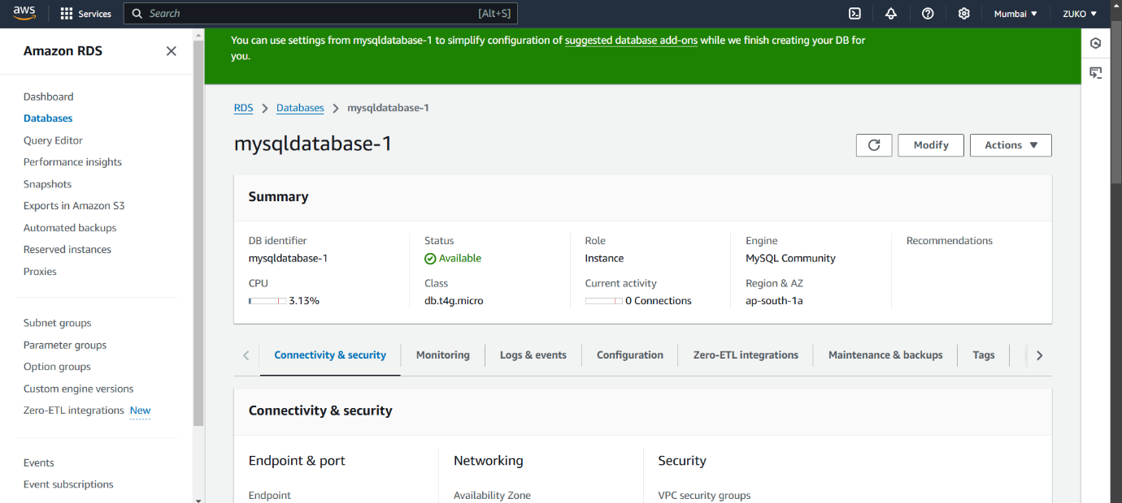

STEP 4: CONNECTED MY EC2 VIA PUTTY AND INSTALLED MYSQL.

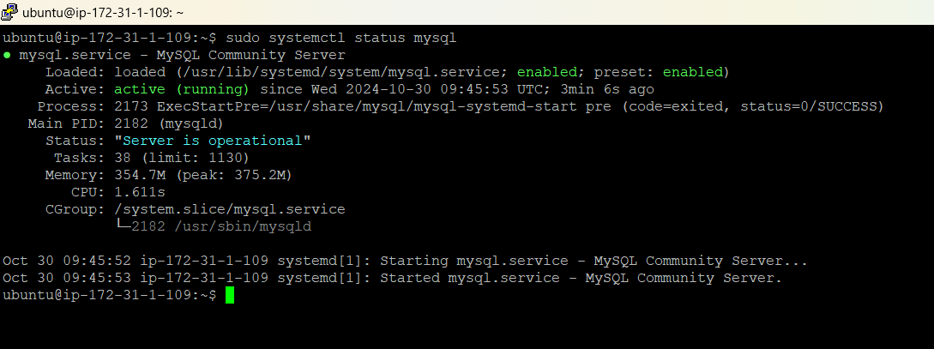

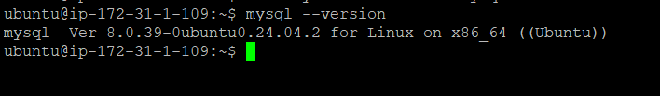

STEP 5: INTEGRATING EC2 WITH RDS

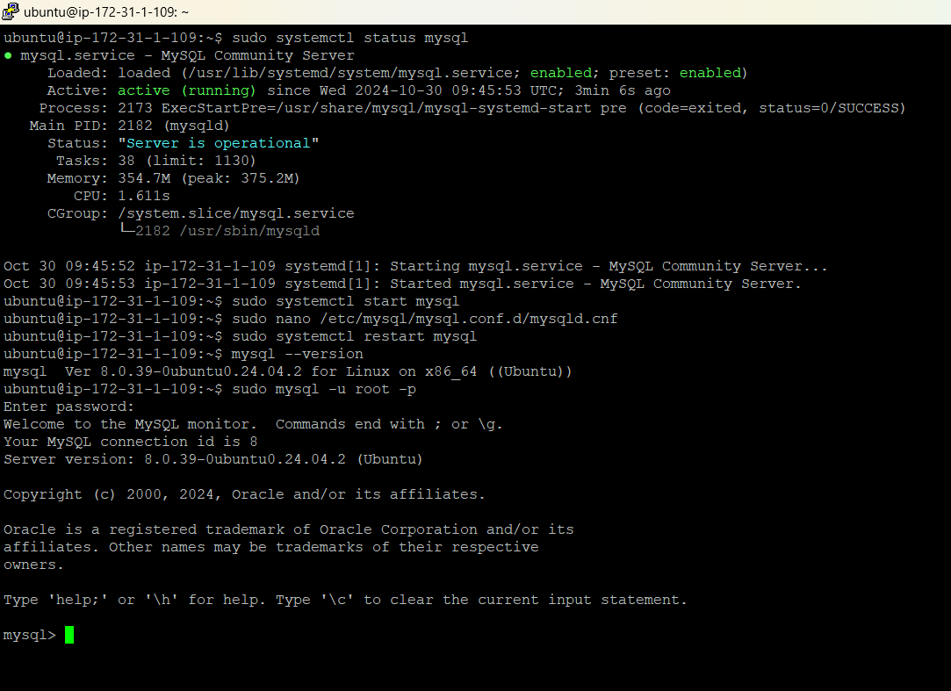

EVENTS

