**TASK 20 - EBS Snapshot Restoration and Mounting on EC2 Instance**

**EBS (Elastic Block Store) is a scalable, high-performance block storage service provided by AWS (Amazon Web Services) that can be attached to EC2 instances. It provides persistent storage, meaning data remains intact even if the associated EC2 instance is stopped or terminated.**

**Step 1: LAUNCH AN EC2 Instance**

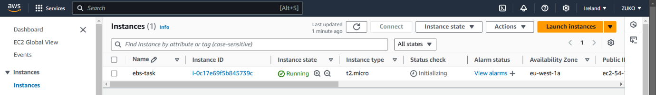

**STEP 2: CREATE AN EBS VOLUME & ATTACH TO EC2.**

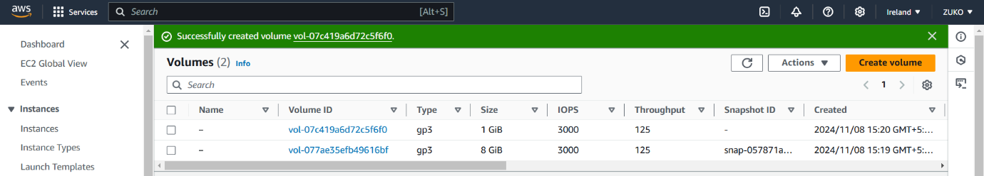

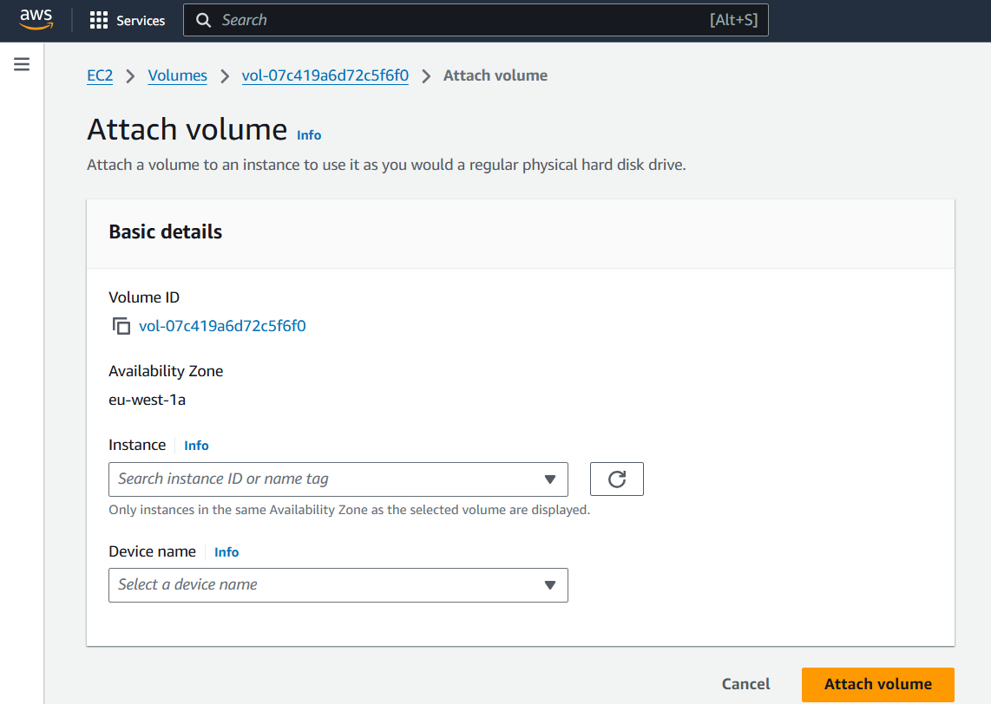

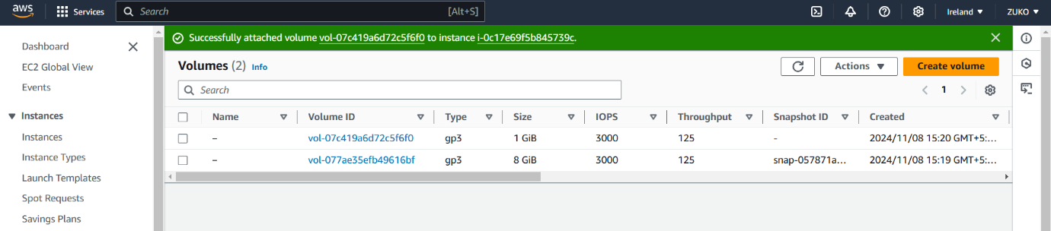

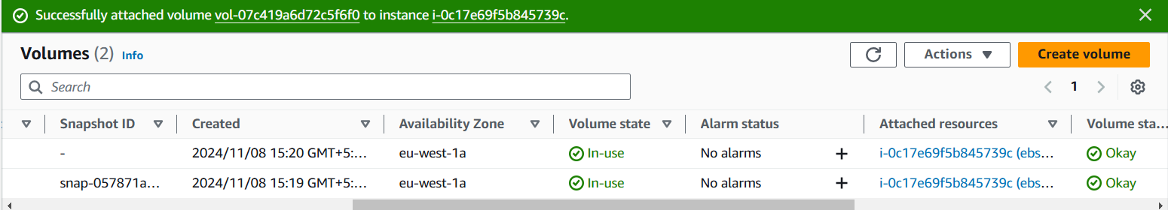

**STEP 3: CONNECT USING SSH**

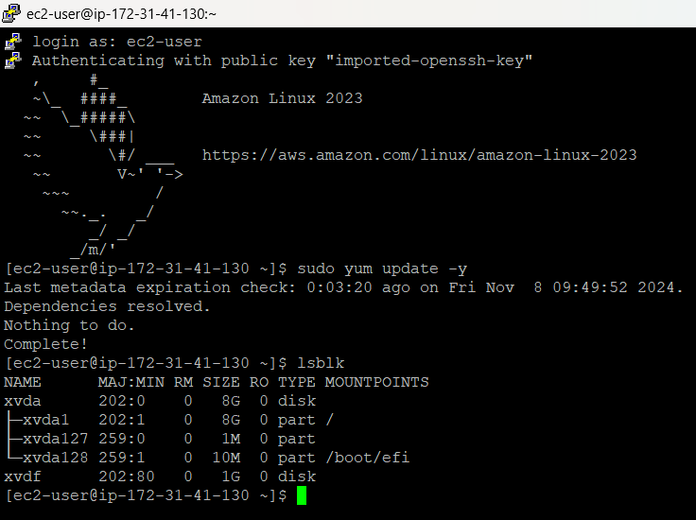

FOLLOW THE STEPS INSTRUCTED IN AWS DOCUMENTATION.

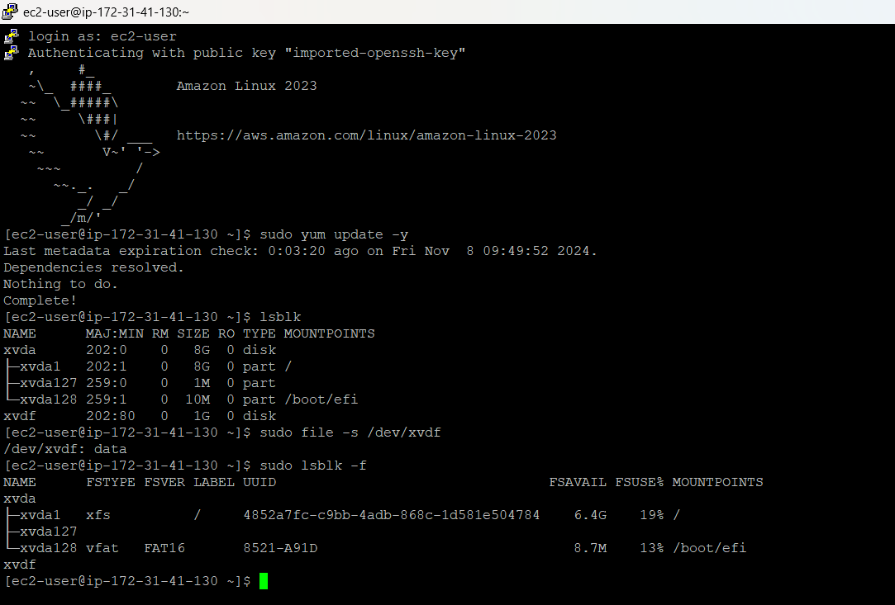

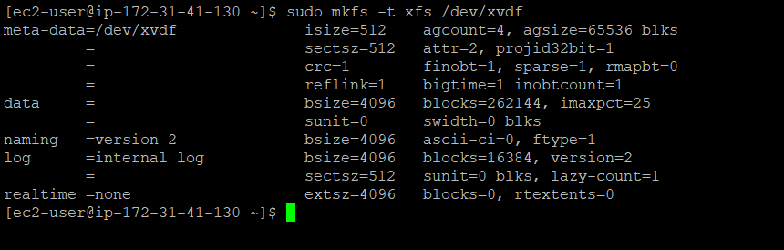

**STEP 4: CREATE A FILE, PROVIDE PERMISSIONS & EDIT THE FILE WITH DATA AND SAVE**.

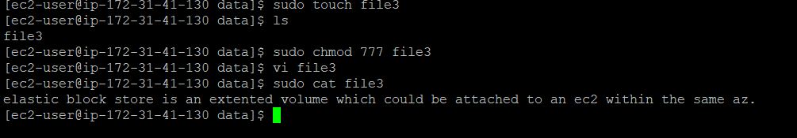

**STEP 4: DETACH EBS AND DELETE**

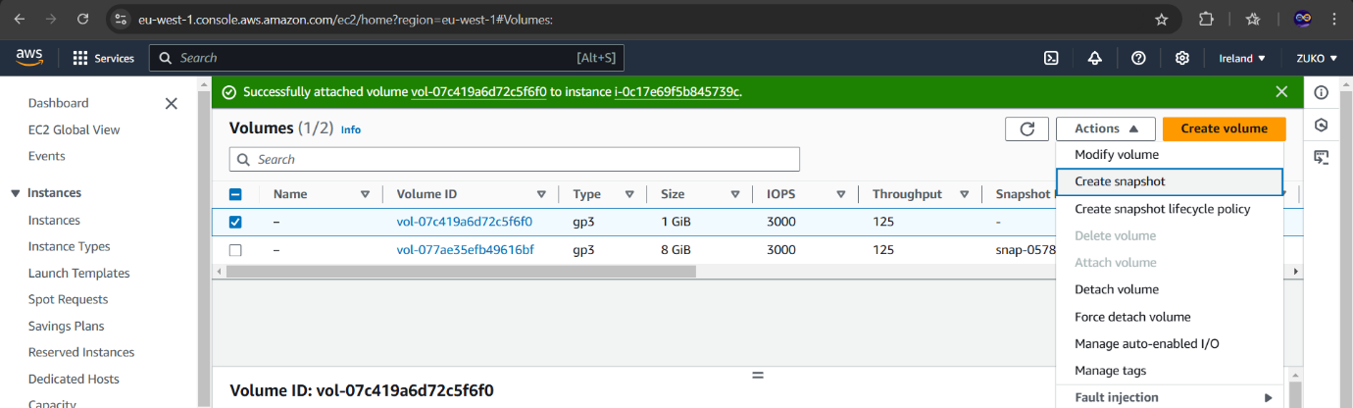

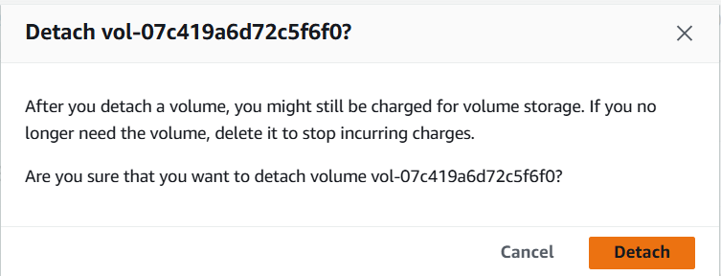

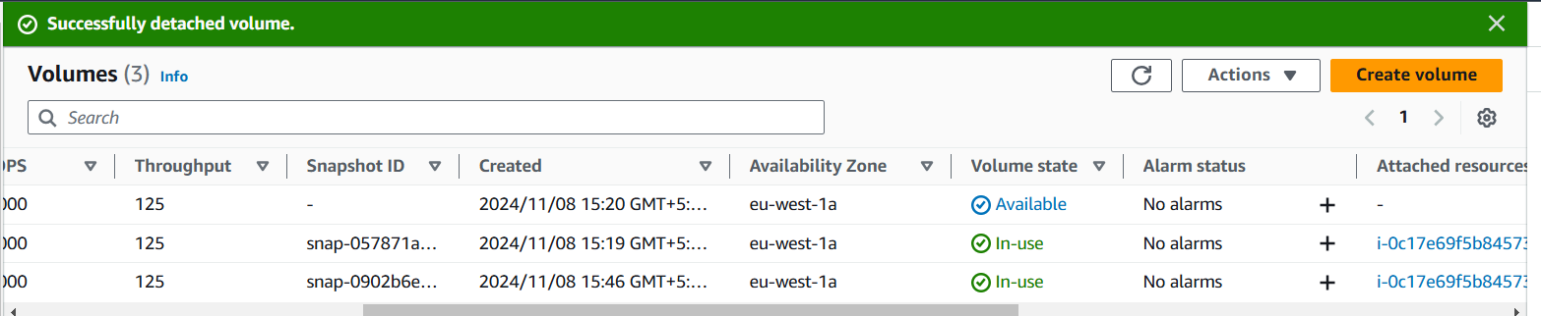

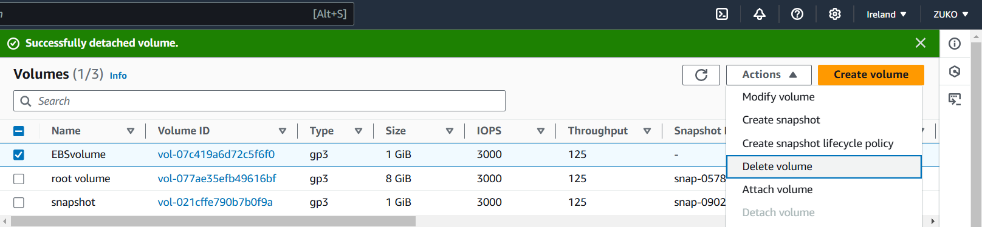

**STEP 5: CREATE VOLUME FROM SNAPSHOT**

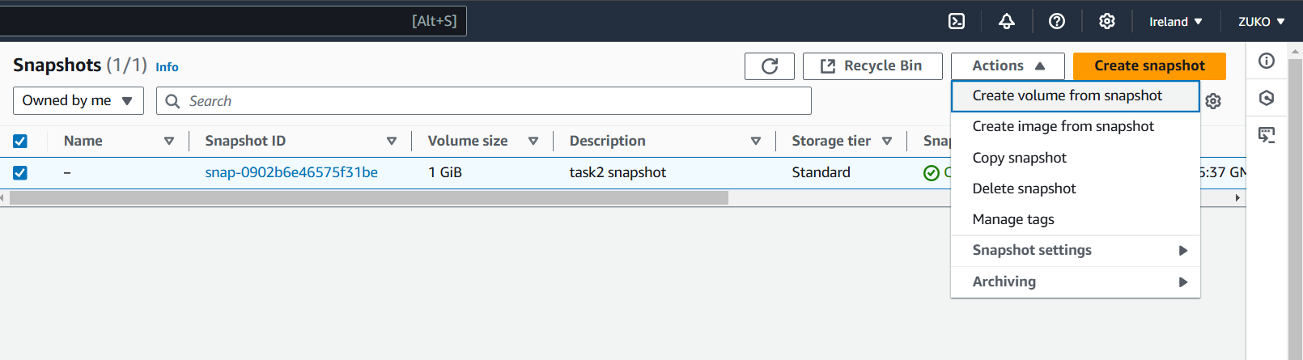

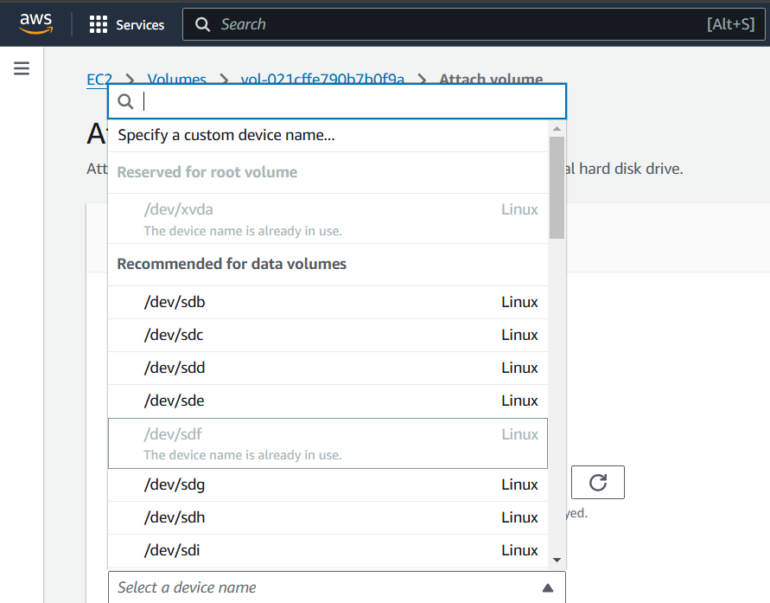

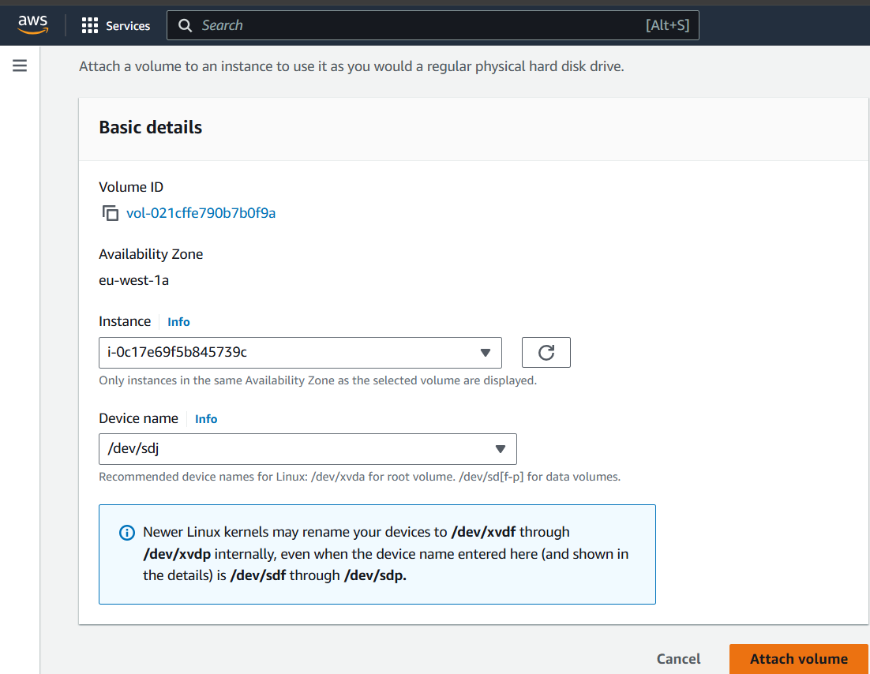

AFTER ATTACHING TO THE INSTANCE, THE SAME PROCESS WAS RECIPROCATED FROM THE AWS DOCUMENTATION PAGE AND NEW SNAPSHOT-EBSVOLUME WAS MOUNTED.

**STEP 6: FOLLOW THE SAME STEPS AND LIST OUT “file3” FROM DIRECTORY NAMED “/data**”.

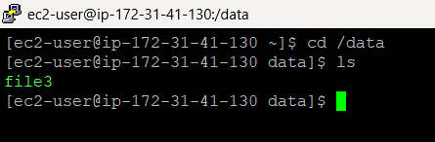

I CAN FETCH THE FILE INSIDE THE SAME DIRECTORY, BUT STILL COULD NOT VIEW ITS CONTENTS.

THEN I DESTROYED THIS INFRA AND LAUNCHED A NEW INSTANCE AND RE-DID THE PROCESS, BUT THIS TIME I DETACHED AND DELETED THE EBS VOLUME AFTER CREATING THE SNAPSHOT AND CREATED VOLUME FROM THE SNAP USING THE SAME CUSTOM DEVICE “/dev/sdf”. BUT STILL CAN'T VIEW THE CONTENTS OF THE FILE.

**Possible Reasons I Can’t View the Contents:**

1. **Corruption During Snapshot/Restore**: The issue I’m facing could be due to file system corruption during the snapshot and volume recreation process. If the file system wasn’t properly synced or recovered, large files might show up as inaccessible or corrupted.
2. **Mounting Issues**: If the file system wasn’t mounted properly after the snapshot restore, even though the file shows up when I list the directory, accessing it could fail. I should double-check that the volume is mounted correctly and that the file system is in a healthy state.
3. **Memory/Buffering Issues**: If the file is extremely large (multiple GBs), some commands like cat might have trouble handling it due to memory limitations. In such cases, tools like less or more (which paginate output) or head/tail (to view portions of the file) are often better suited.
4. **Permissions**: I should ensure that the file permissions (i.e., read access) are correct after recreating the volume. I can verify this by running ls -l and checking if the file has the right permissions for my user to read.