TASK-9 AWS-CLI

Launched an Ubuntu instance.

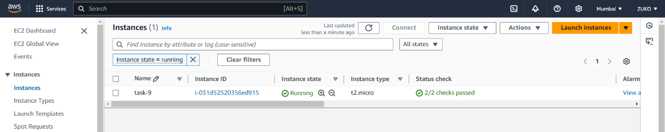

1. Aws-cli was installed by default, I had to install Python as pre-req and then installed aws-cli.

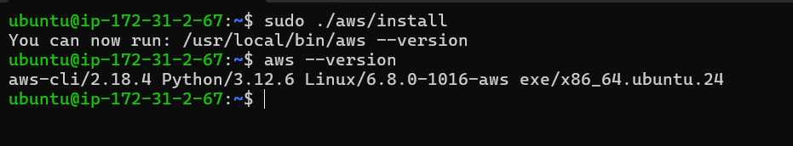

3.Created a s3 bucket as well and used the aws configure command.

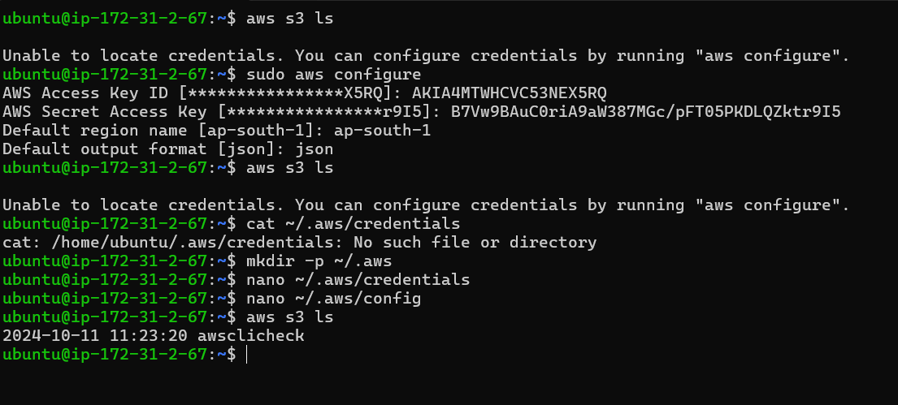

I faced some issues with configuring using aws configure, and with some help from Chat-GPT using the following commands, I could view my S3 bucket using cli but still could not view EC2.

(PS) awsclicheck was my S3 bucket.

