Launching EC2 Instance within the vpc & pub subnet created by me.

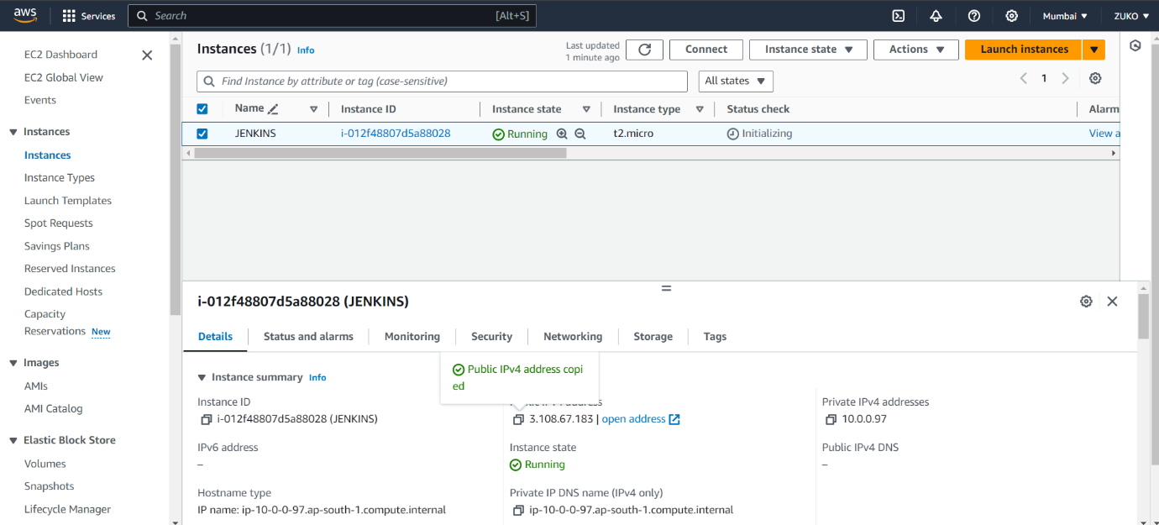

HITTING IP-1:3.108.67.183 over the web.

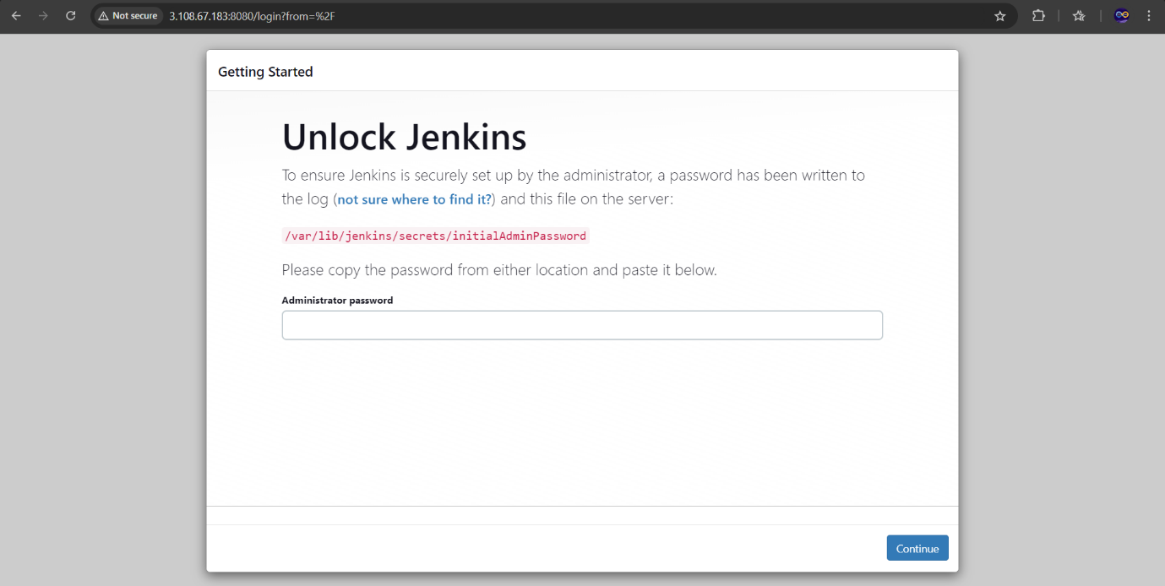

Stopped the EC2 instance and started again, resulting in change of PUB-IP because its DYNAMIC.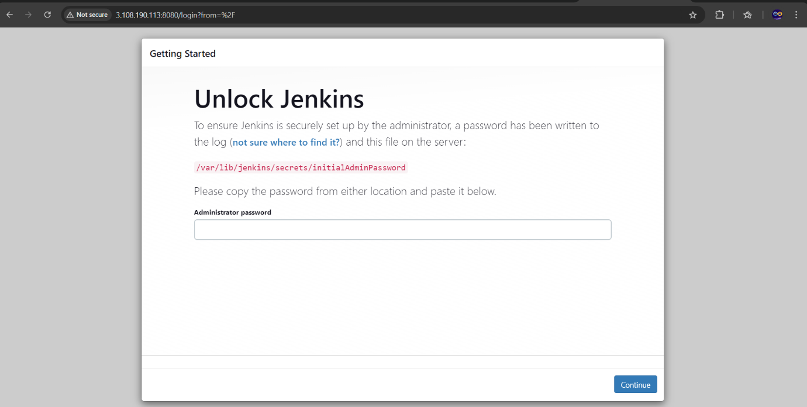

To resolve this issue we can allot Elastic IP (EIP), resulting in a static PUB IP.