TASK11- Set Cronjob Poll SCM to Trigger Build

Editing README file for changes

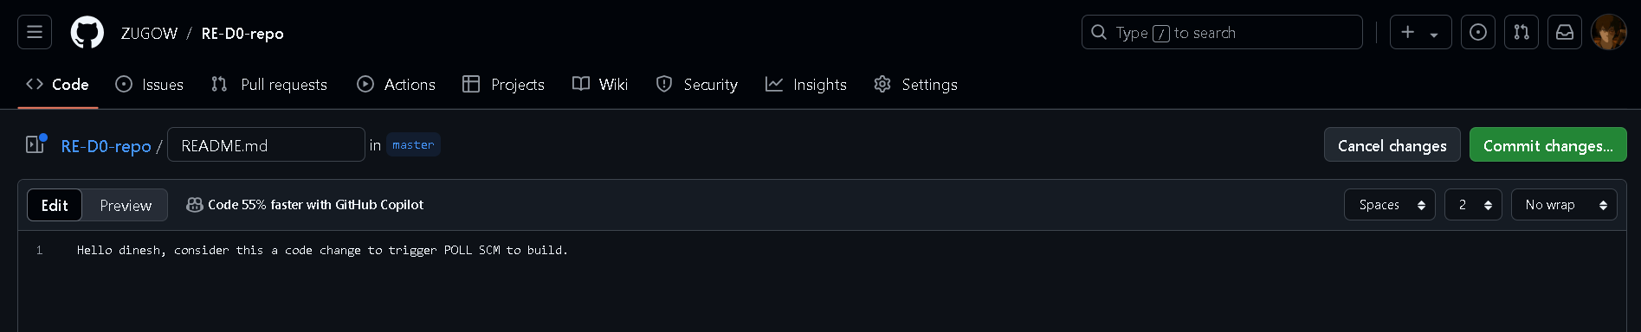

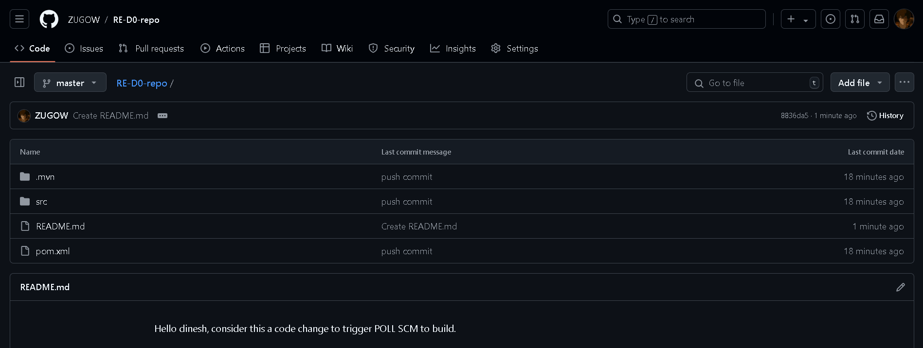

Adding Cronjob Syntax in SCM Polling

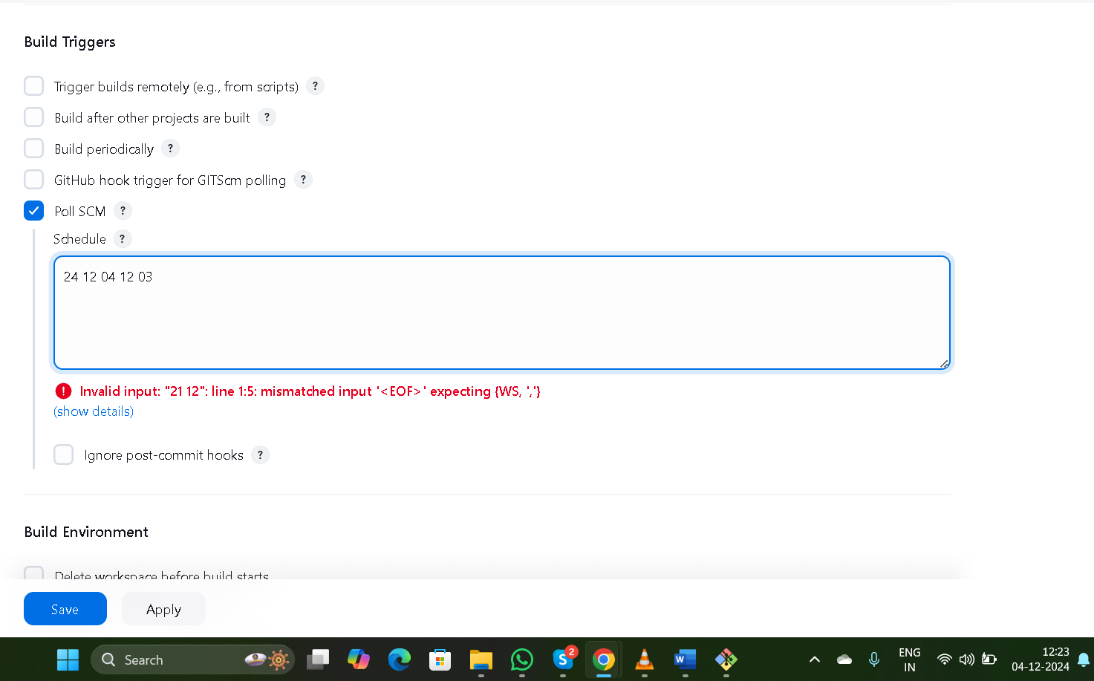

Build triggered

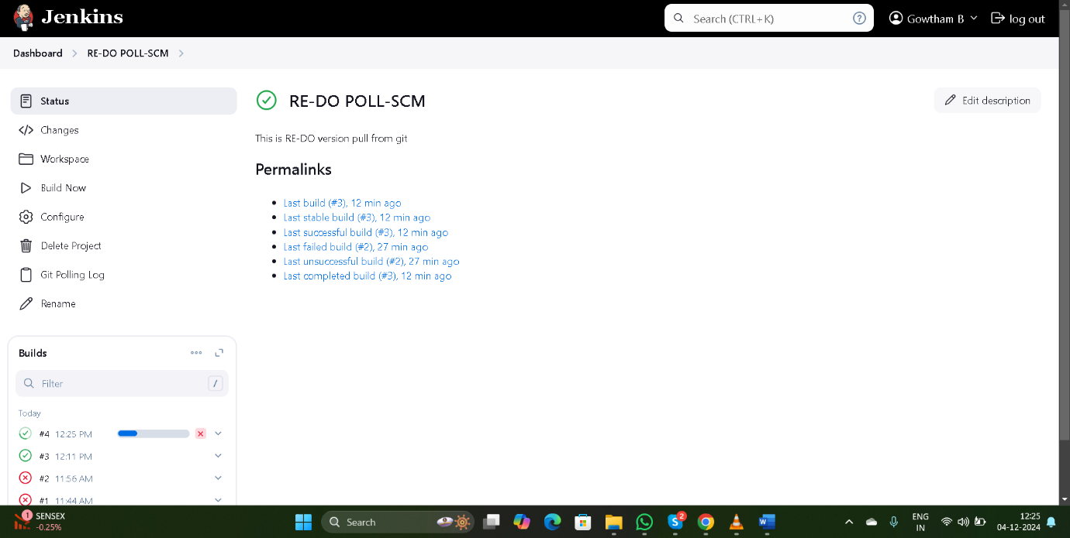

SUCCESSFULL

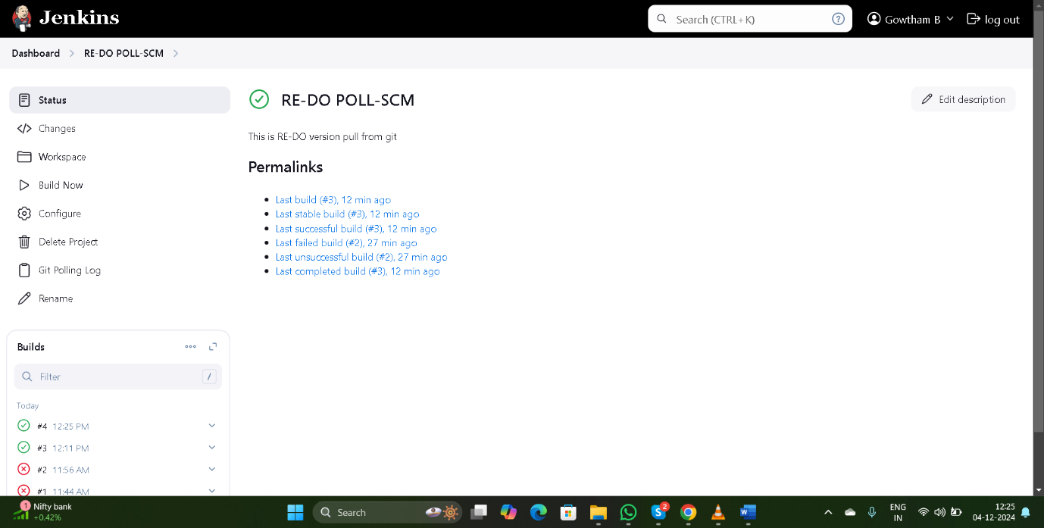

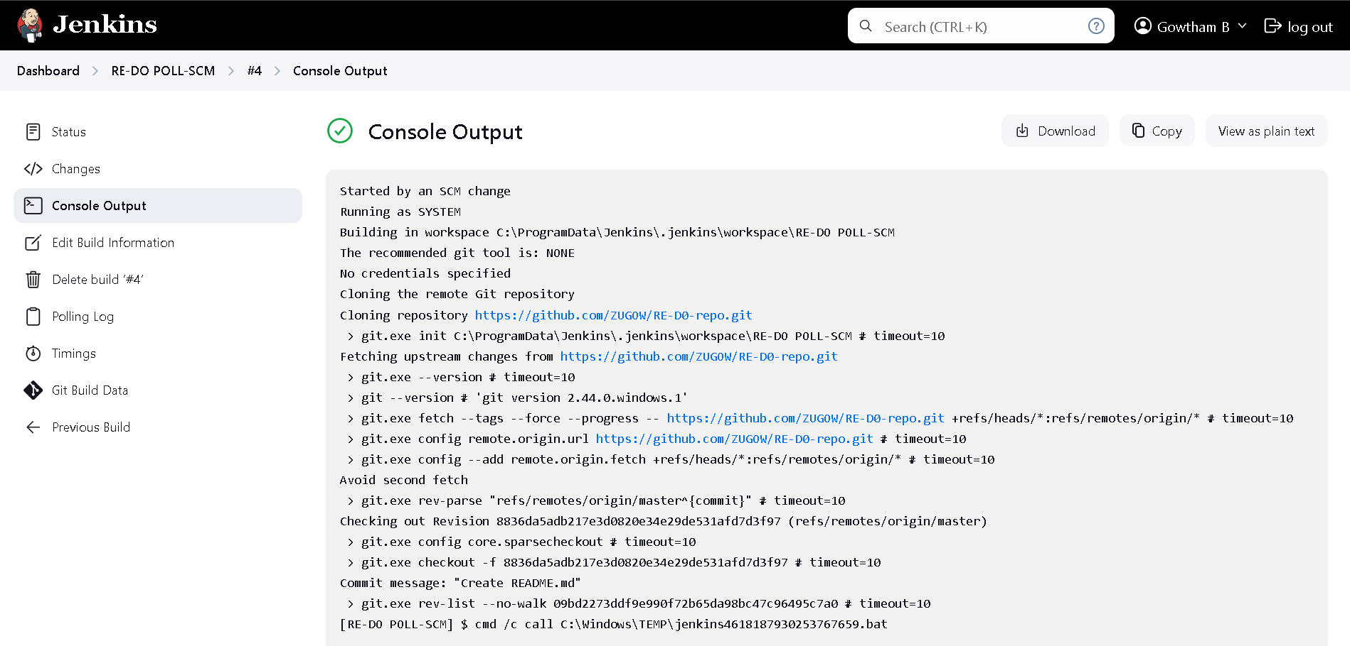

Verifying SCM Triggered Build