**TASK 13- JENKINS MASTER & SLAVE**

**Master-Slave Setup in Jenkins**

**1. Pre-requisites**

* **Jenkins Master**: A Jenkins server is already installed and running.
* **Jenkins Slave**: A remote server where you want to run jobs.
* **SSH Access**: Ensure the master can connect to the slave via SSH.
* **Java Installed**: Java must be installed on the slave node

LAUNCH TWO UBUNTU INSTANCES AND INSTALL JENKINS USING BOOTSTRAP METHOD

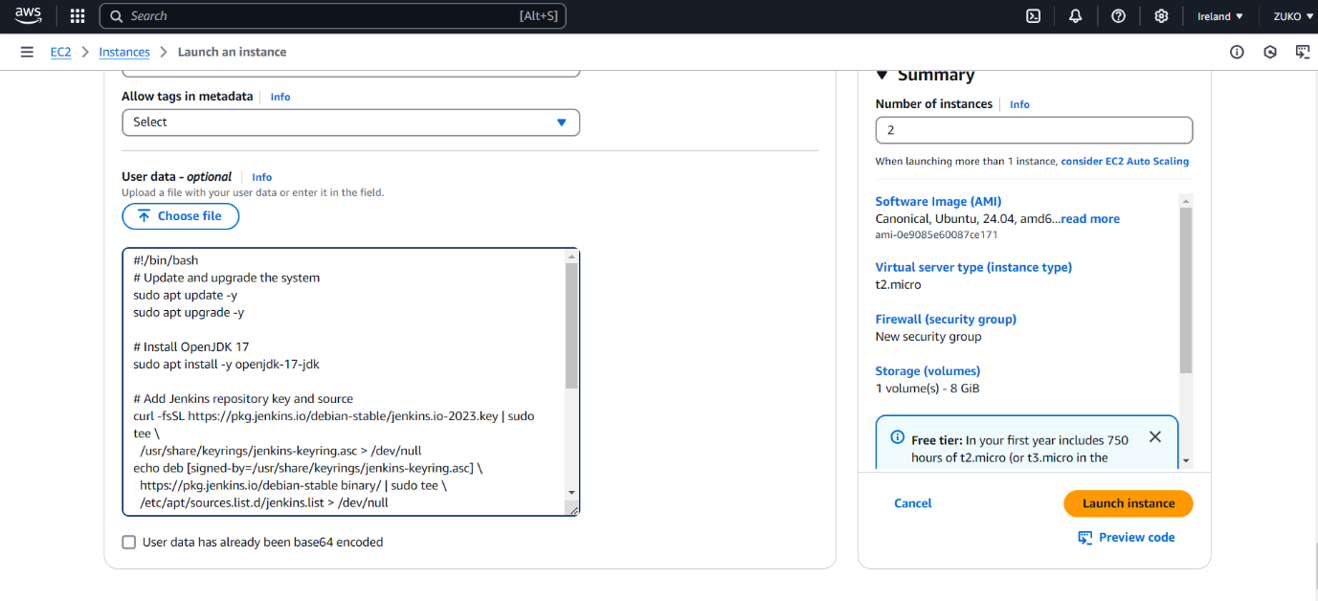

MASTER & NODE LAUNCHED

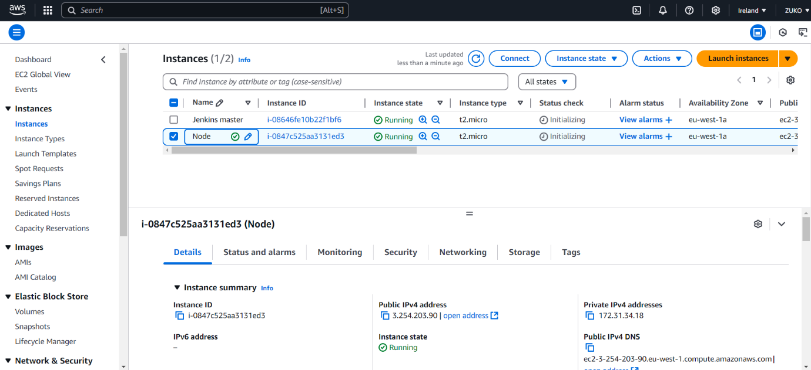

JENKINS STATUS

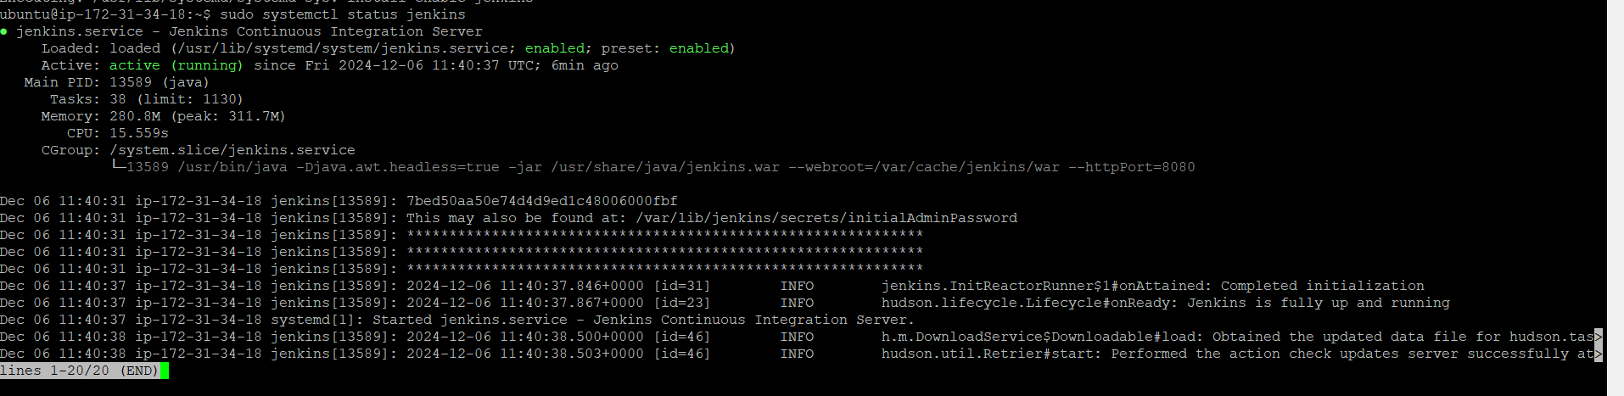

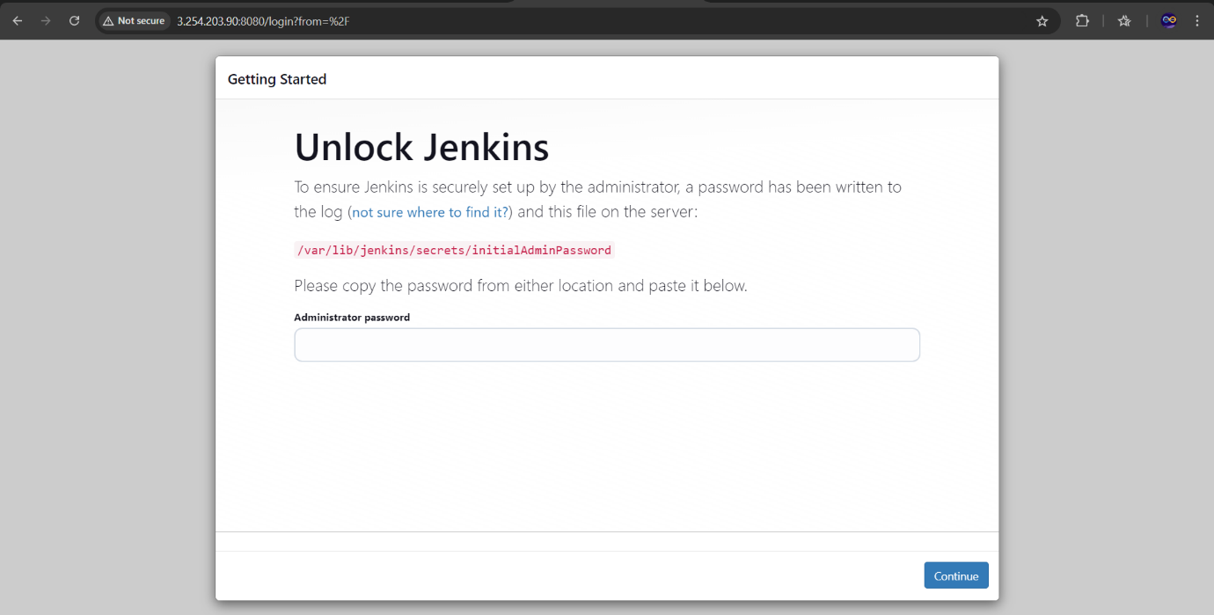

MANAGE JENKINS>NODES

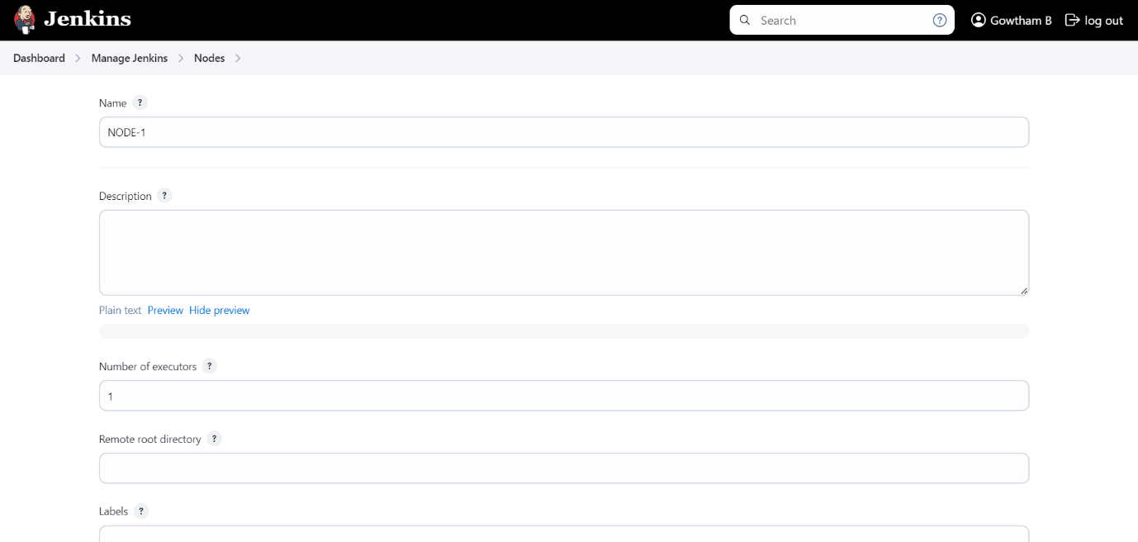

LAUNCHING AGENTS VIA SSH

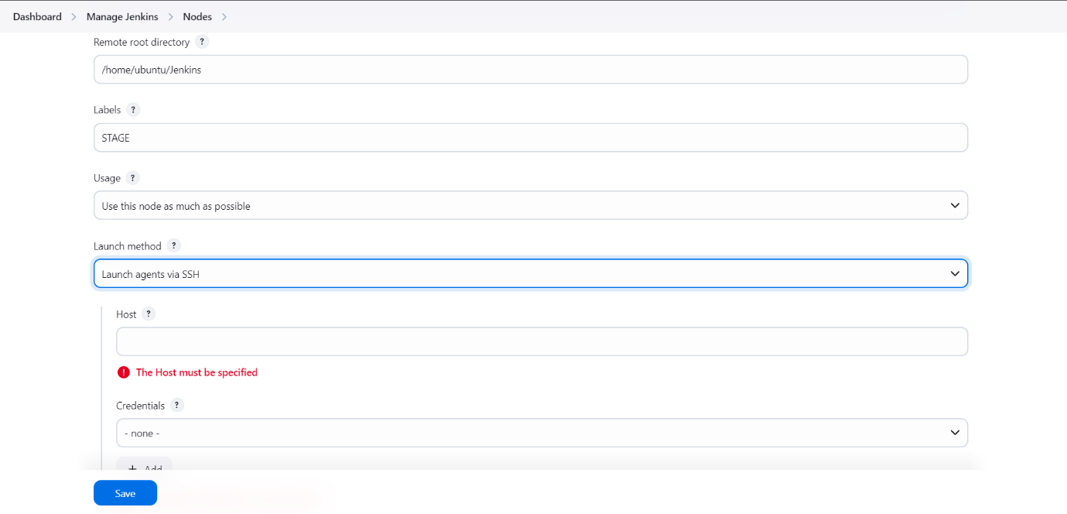

PROVIDING PEM.KEY

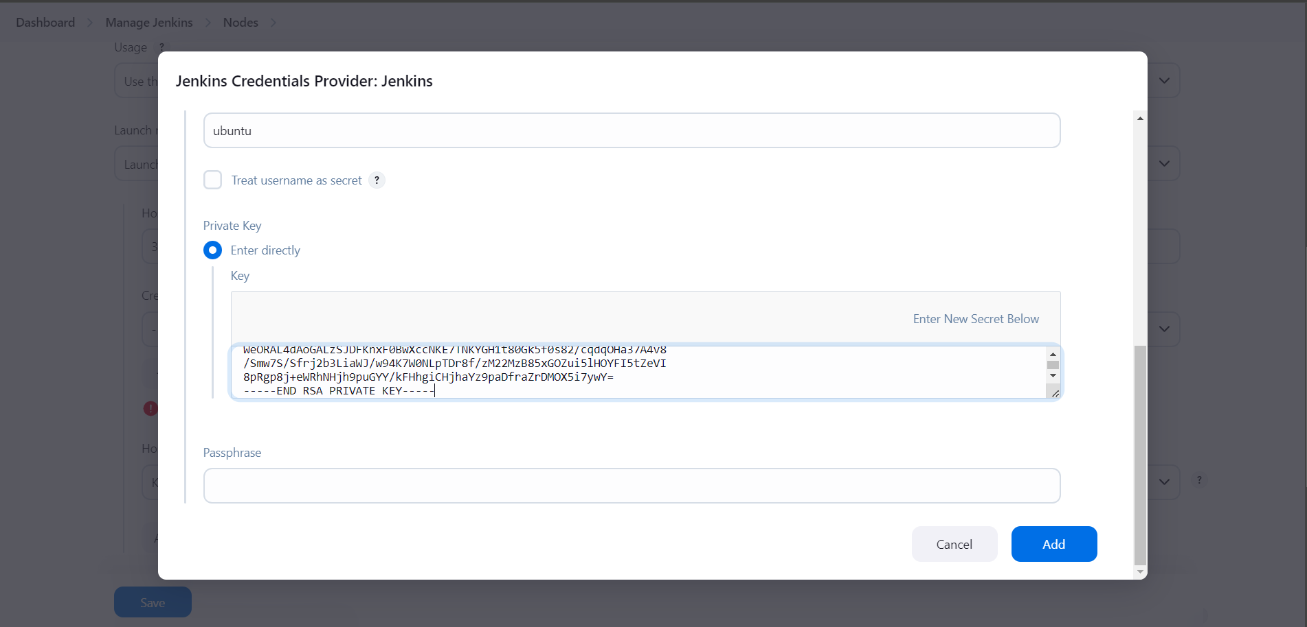

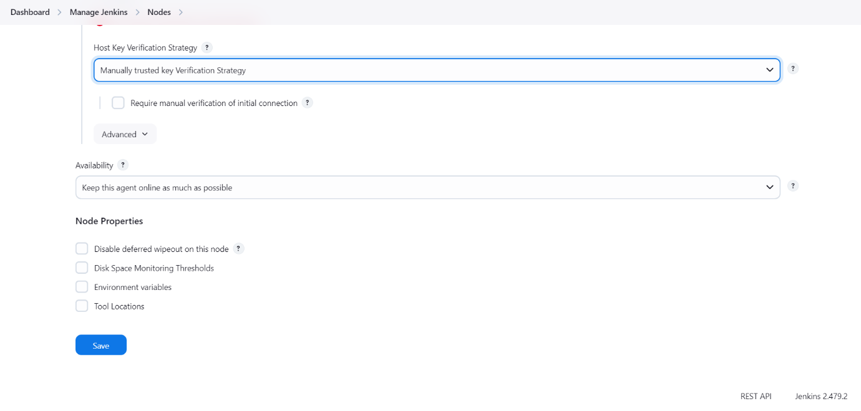

LAUNCH AGENT

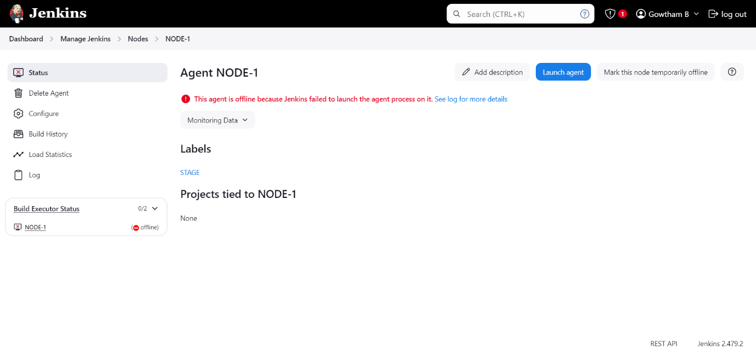

CONNECTED AND ONLINE

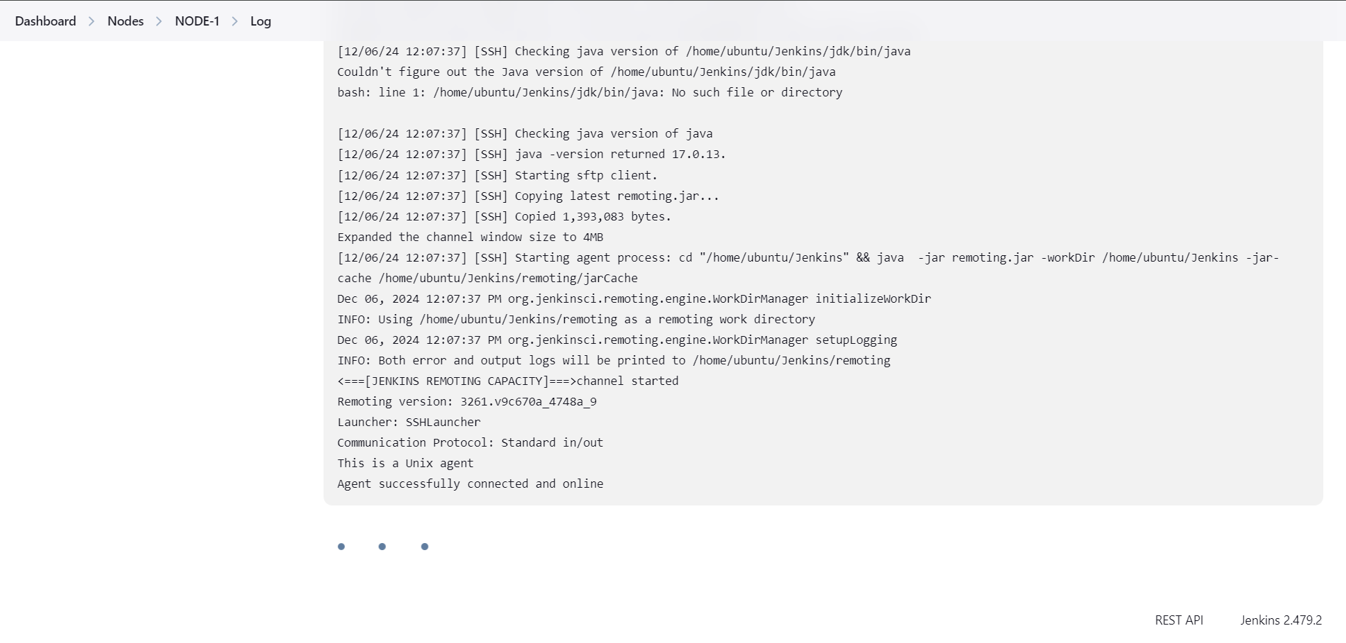

BUILD STEPS

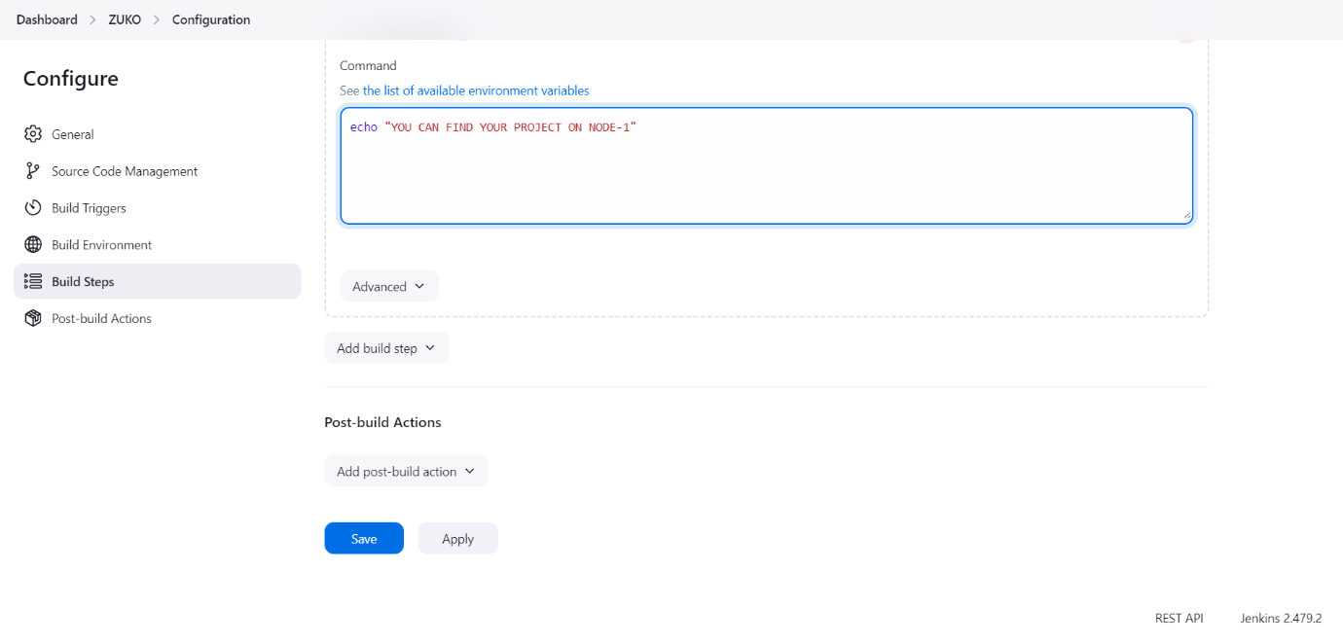

OUTPUT

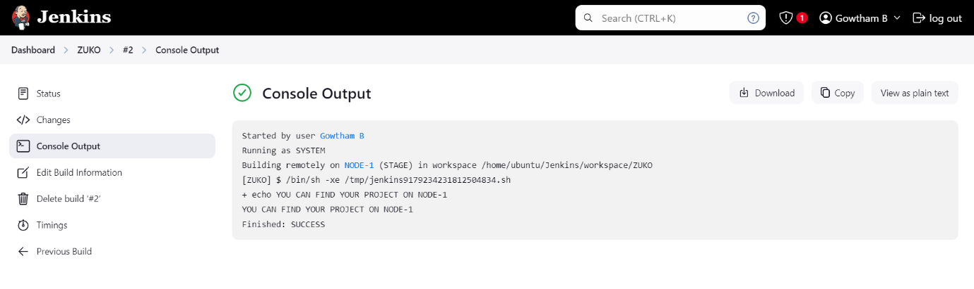

ZUKO- BUILD IN NODE

