**TASK 14 – DOCKER BASIC COMMANDS**

Docker is a platform that allows developers to package applications and their dependencies into lightweight, portable containers. These containers can run consistently across various environments, ensuring the application works seamlessly from development to production.

LAUNCH AN EC2

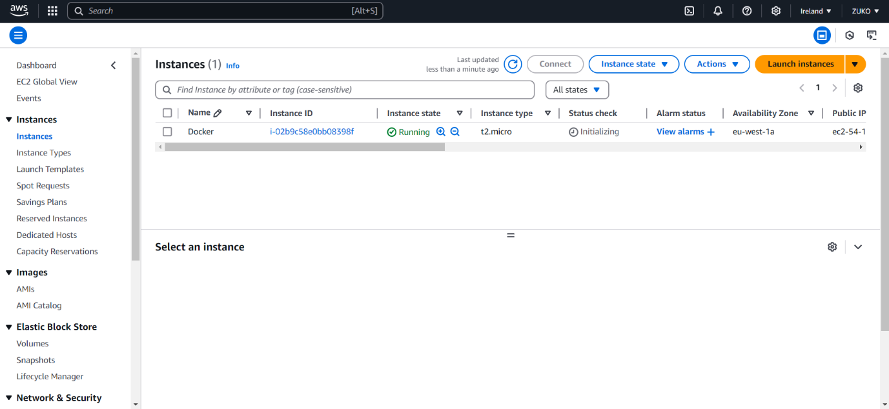

UPDATE SERVER AND INSTALL DOCKER

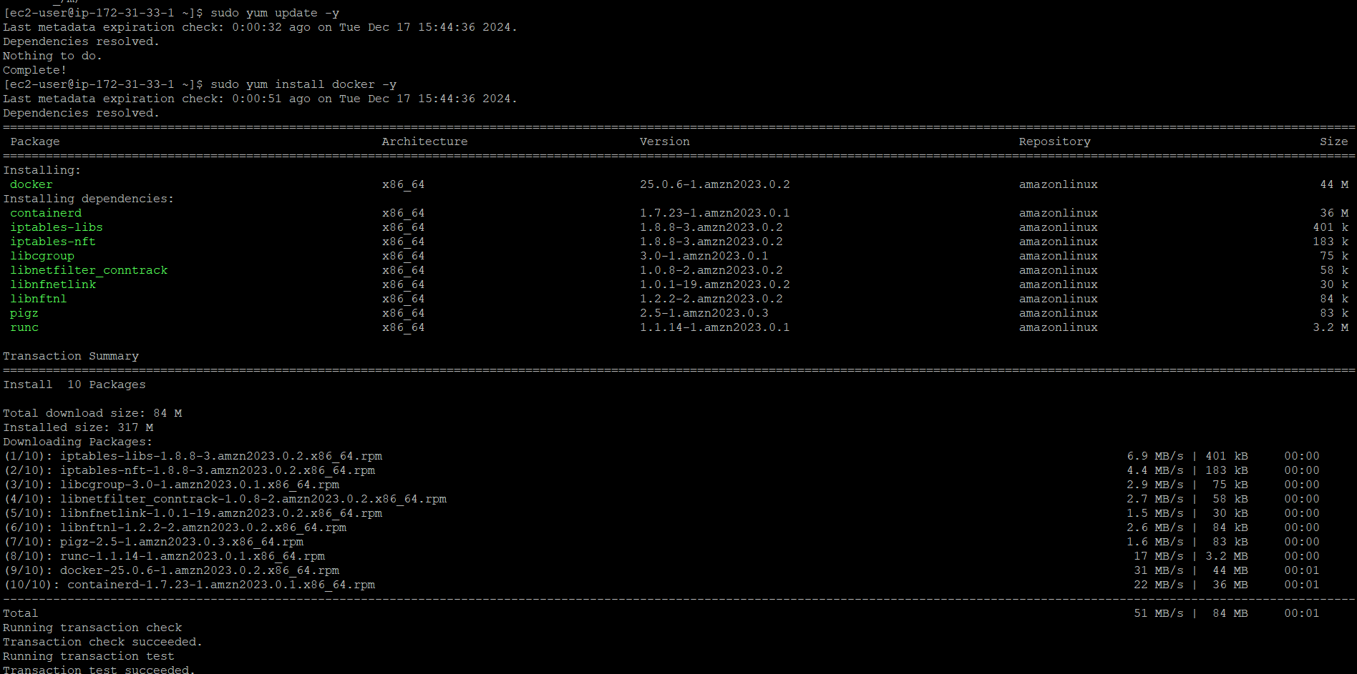

ALWAYS START DOCKER AGAIN AFTER CHECKING STATUS

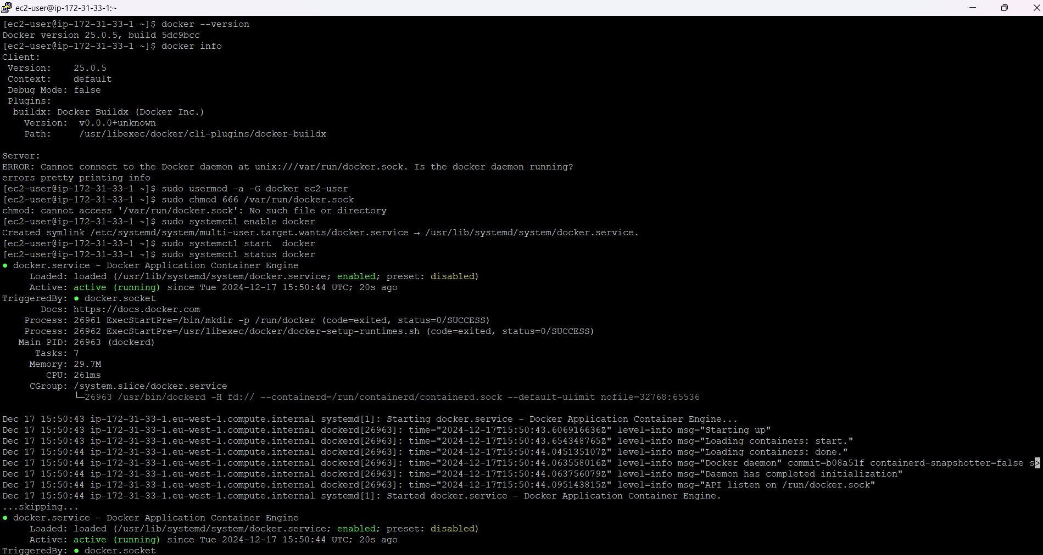

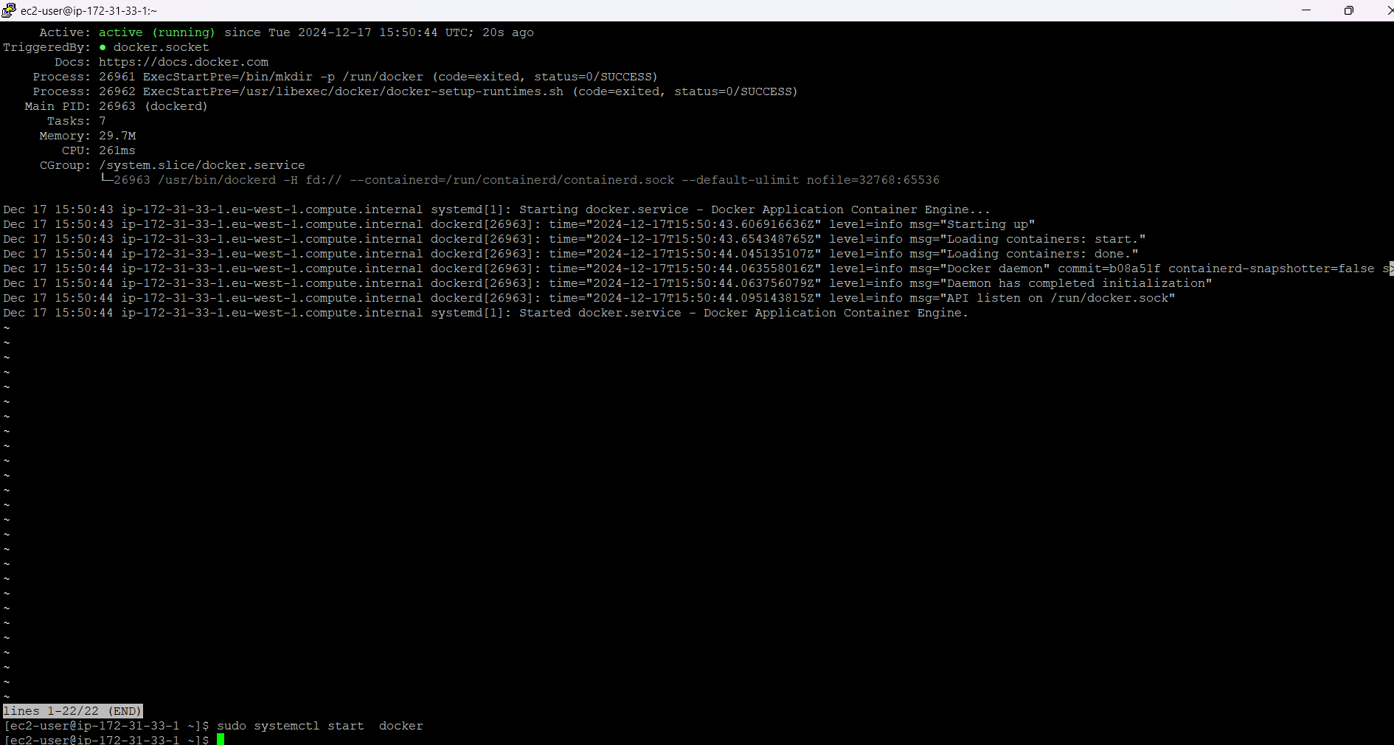

VISIT hub.docker.com

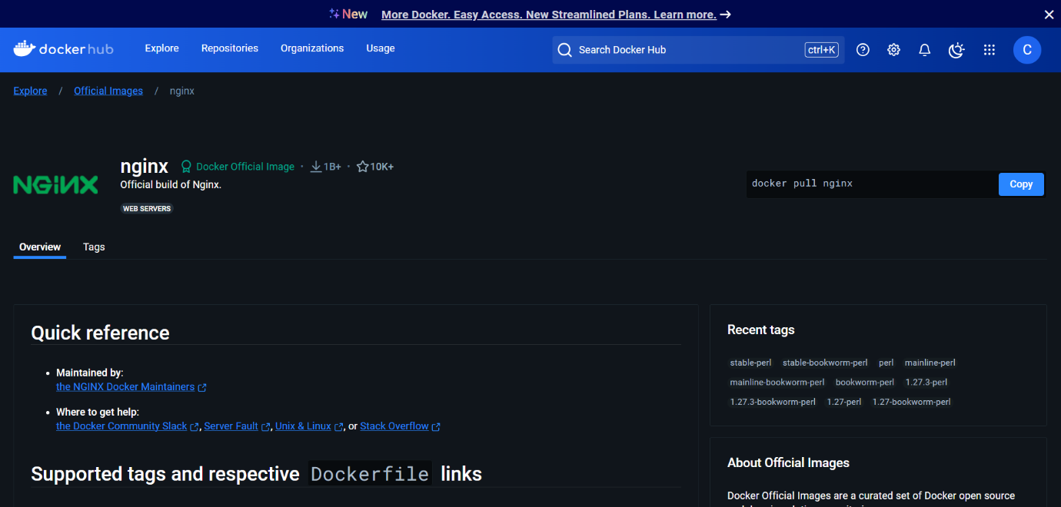

**Best practice** suggests using a non-root user with appropriate permissions (like being part of the docker group

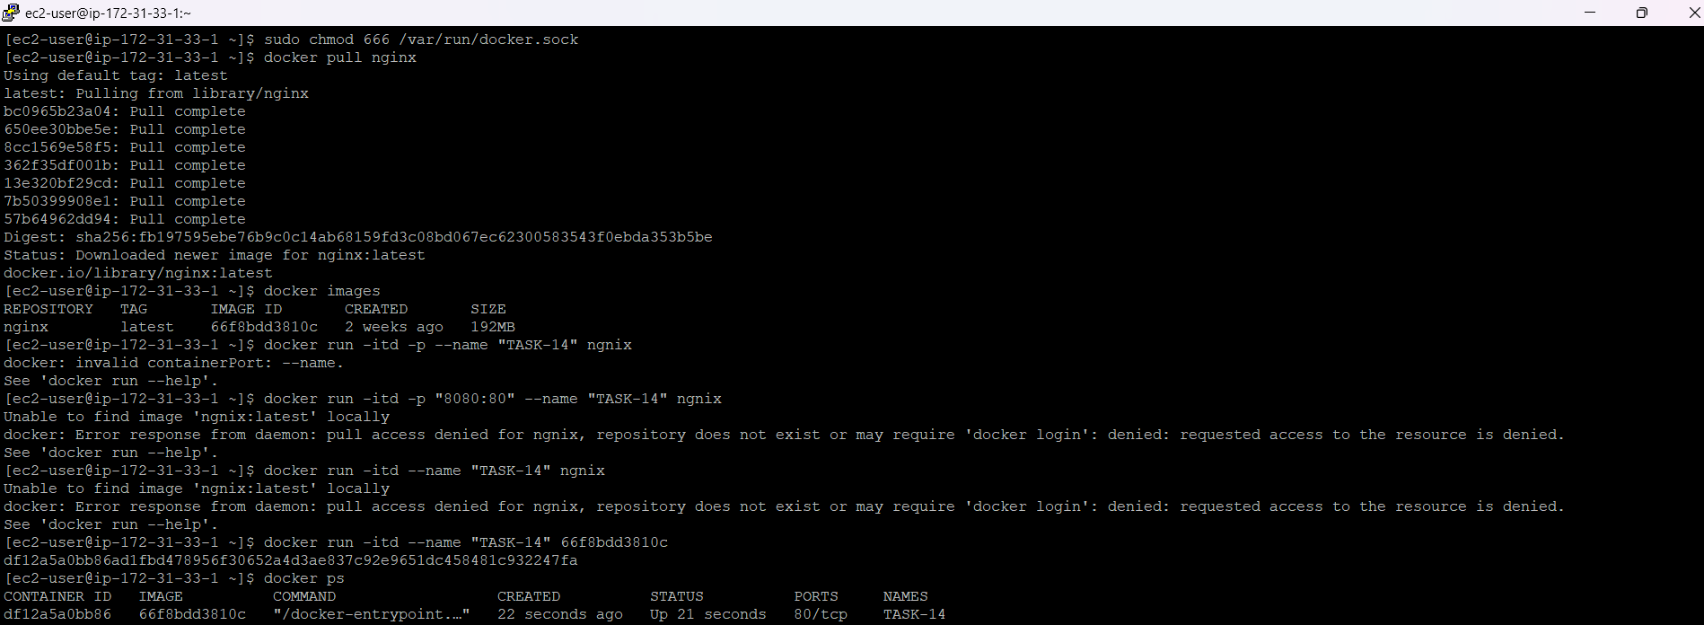

STOPPED ALL RUNNING CONTAINERS

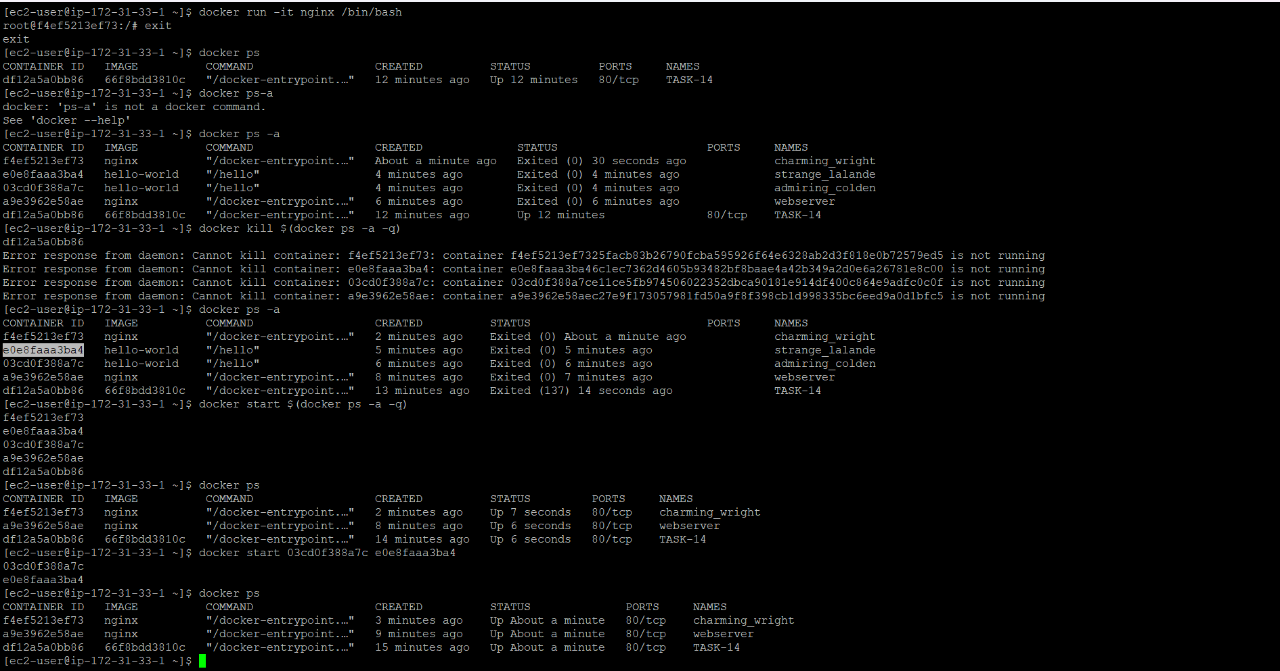

EXITED THE CONTAINER WITHOUT STOPPING IT CTRL+P+Q

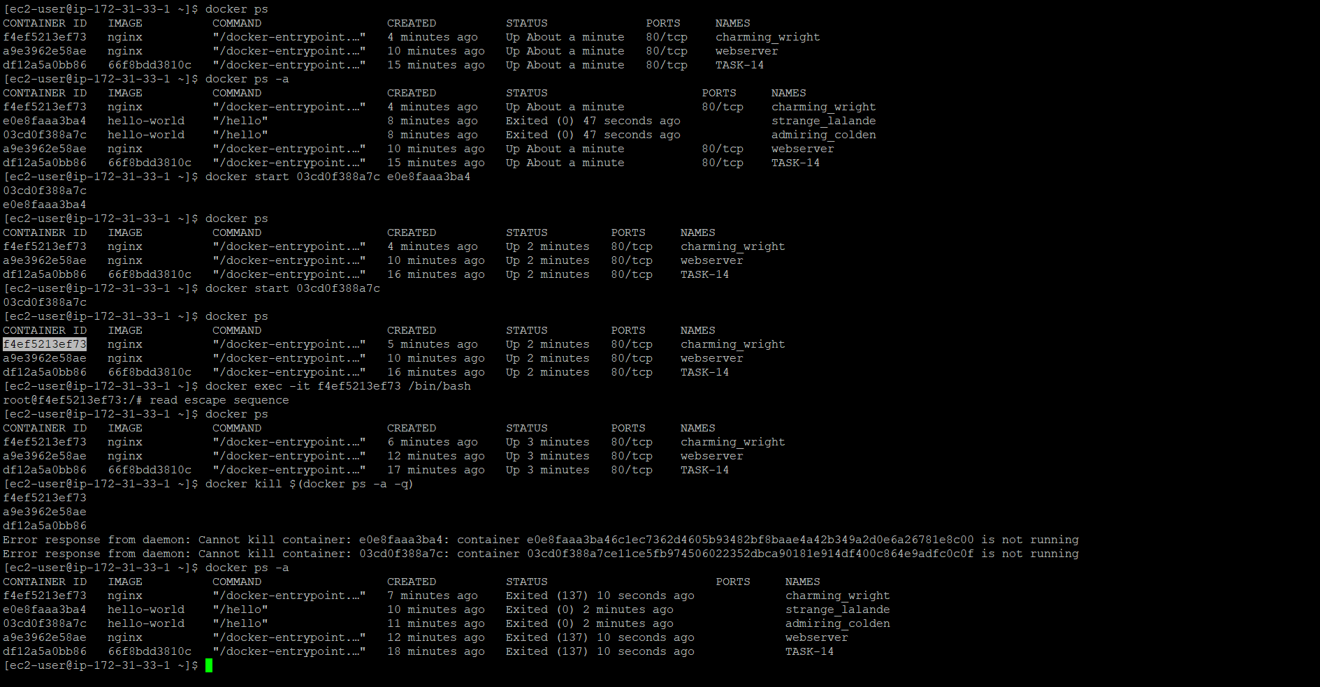

DELETED ALL CONTAINERS

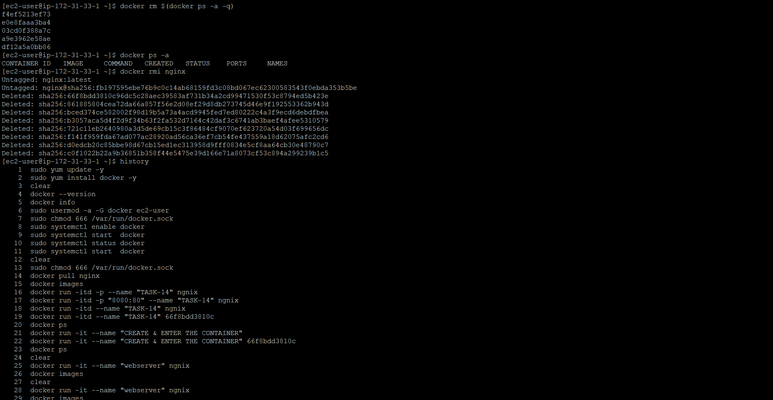

HISTORY OF COMMANDS USED

