**TASK 15- STREAMLINING DOCKER WORKFLOWS**

**OBJECTIVE: -**

Converting Containers to Images, Pushing to Docker Hub, and Exposing Applications with Port Mapping

A Docker container is a running instance of an image. When you make changes inside a running container (e.g., install software, modify files, etc.), you can save those changes by committing the container to a new Docker image.

By converting a container to an image, you create a reusable and version-controlled snapshot of the current state of the container. This is especially useful when you need to replicate the environment elsewhere or share it with other team members.

docker commit <container_id> <image_name>:<tag>

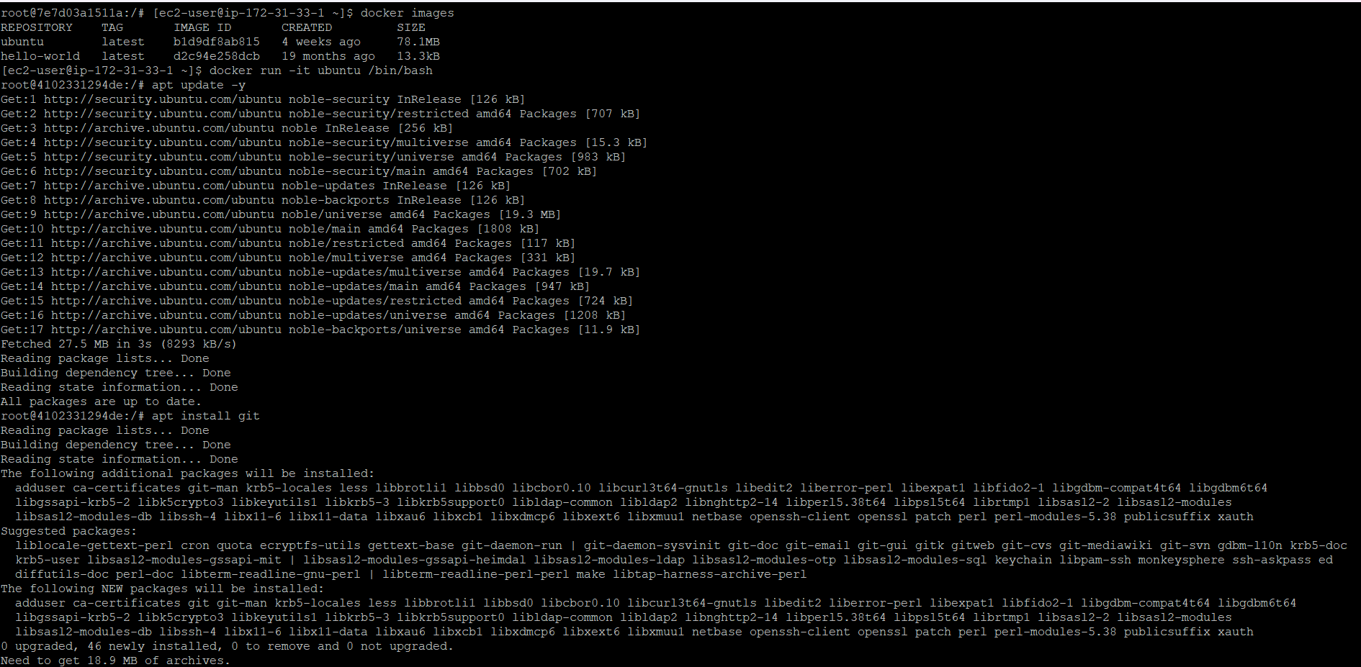

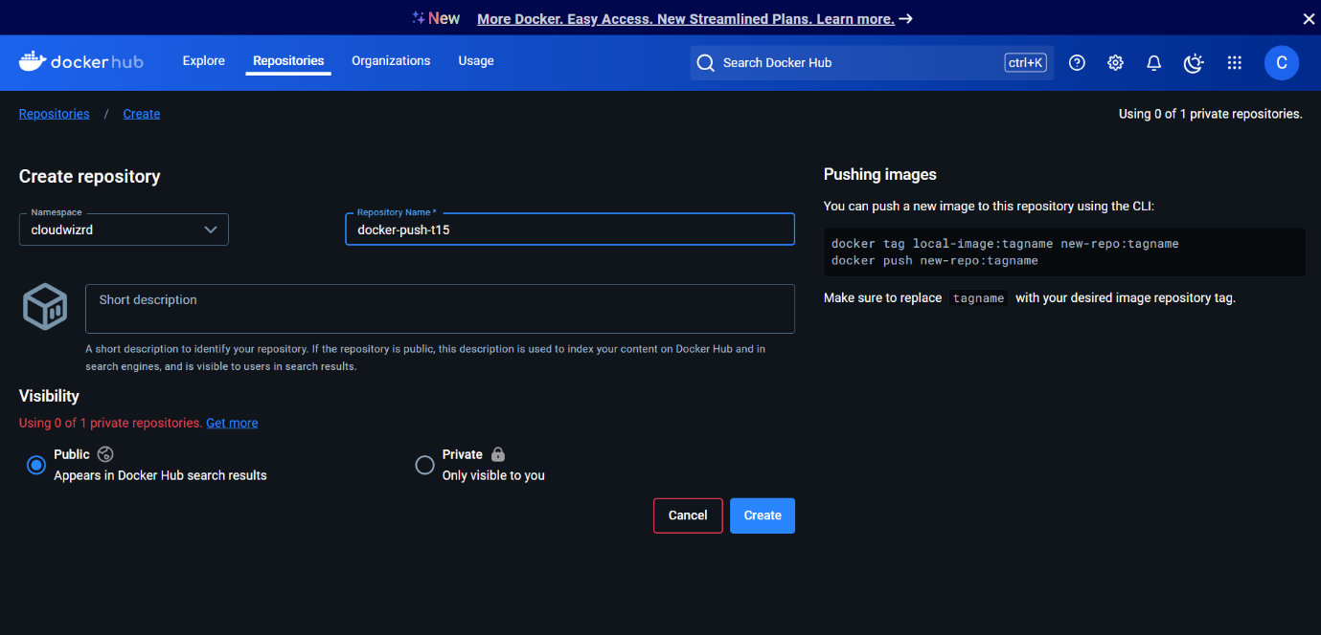

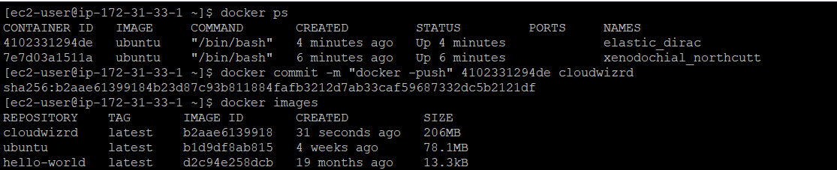

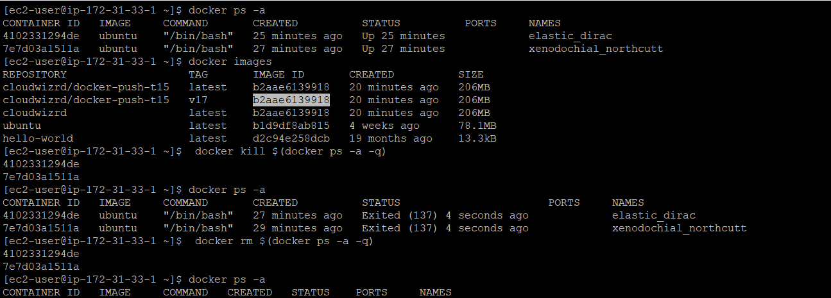

Docker Hub is a cloud-based repository where you can store, share, and distribute Docker images. Pushing an image to Docker Hub allows you to make it publicly or privately accessible for use across different environments.

After creating a Docker image, you can push it to Docker Hub so it can be accessed and used by other developers or systems. This is essential for collaboration, CI/CD pipelines, and deploying applications in distributed environments.

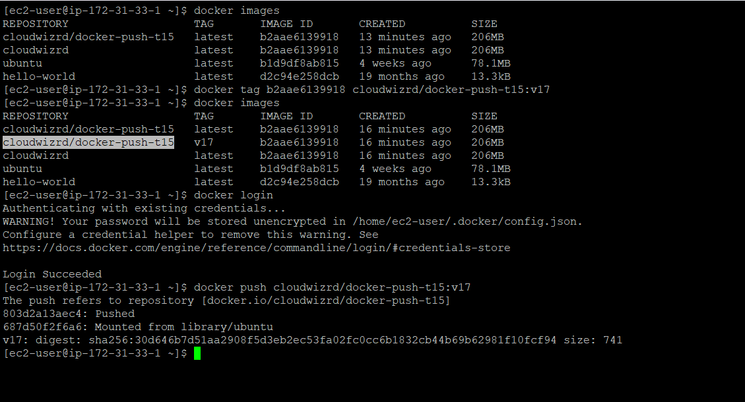

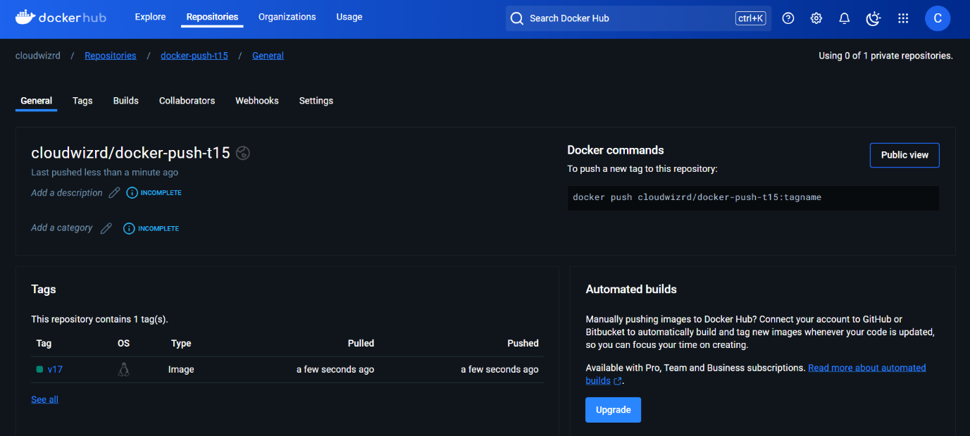

Port mapping (or port binding) connects a port on your host machine to a port on the container. This allows you to access the application running inside the container from your host system or external networks.When running a Docker container, the application inside it listens on a specific port (e.g., 80, 443).

However, by default, containers are isolated, and their ports are not exposed to the host. Using port mapping, you can bind the container's port to a port on the host system, enabling communication.

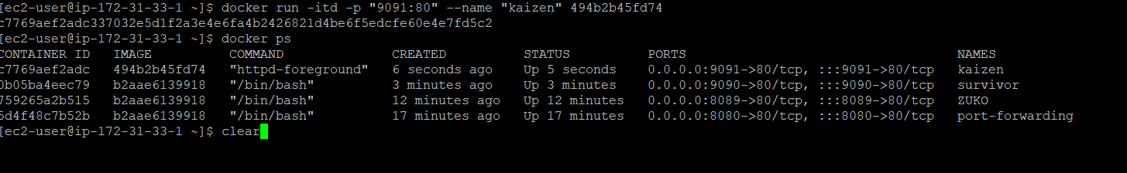

Accessing the application means interacting with the service running inside the container using the host's IP or domain name and the mapped port.

After mapping a port, you can use a browser or tools like curl to verify if the application is accessible. The format for accessing the application is typically:

http://<host_ip>:<host_port>

