How to Install MySQL on Ubuntu and CentOS
1. sudo apt-get install mysql-server

How to Access the MySQL shell
1. mysql -u root -p

How To Install and Secure phpMyAdmin on Ubuntu 14.04
1. sudo apt-get update
2. sudo apt-get install phpmyadmin

This will ask you a few questions in order to configure your installation correctly.
- For the server selection, choose apache2. Note: If you do not hit "SPACE" to select Apache, the installer will not move the necessary files during installation. Hit "SPACE", "TAB", and then "ENTER" to select Apache.
- Select yes when asked whether to use dbconfig-common to set up the database
- You will be prompted for your database administrator's password
- You will then be asked to choose and confirm a password for the phpMyAdmin application itself
The installation process actually adds the phpMyAdmin Apache configuration file into the /etc/apache2/conf-enabled/ directory, where it is automatically read.
The only thing we need to do is explicitly enable the php5-mcrypt extension, which we can do by typing:
sudo php5enmod mcrypt

Afterwards, you'll need to restart Apache for your changes to be recognized:
sudo service apache2 restart
You can now access the web interface by visiting your server's domain name or public IP address followed by /phpmyadmin:
http://localhost/phpmyadmin
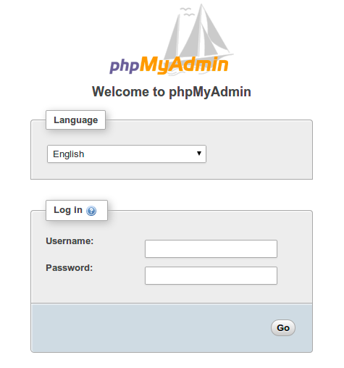

Username: root
Password: B4All

Test PHP Processing on your Web Server
1. sudo nano /var/www/html/info.php

This will open a blank file. We want to put the following text, which is valid PHP code, inside the file:
<?php
phpinfo();
?>
When you are finished, save and close the file.
Now we can test whether our web server can correctly display content generated by a PHP script. To try this out, we just have to visit this page in our web browser. You'll need your server's public IP address again.
The address you want to visit will be:
http://localhost/info.php
The page that you come to should look something like this:
