Where What When Why Who How

AI final project

Othello

Games With Perfect Information

Alternating move, complete information, …=> 2-player games

Use Minimax Algorithm, α-β pruning, ... to find optimal moves

Game Types:

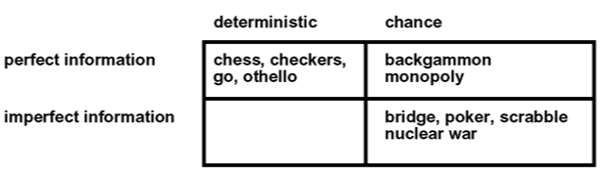

Minimax Algorithm

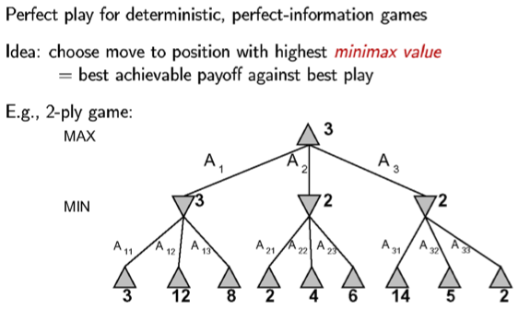

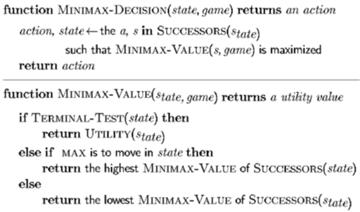

Resource Limits

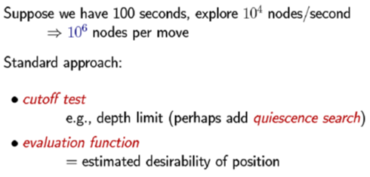

Evaluation functions

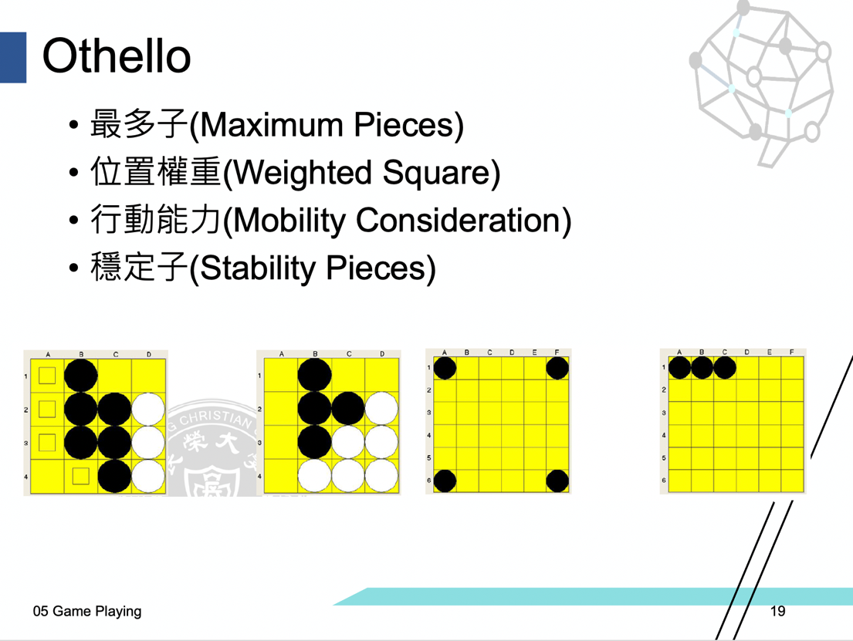

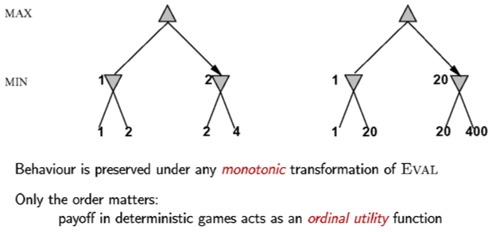

α-β pruning

Properties

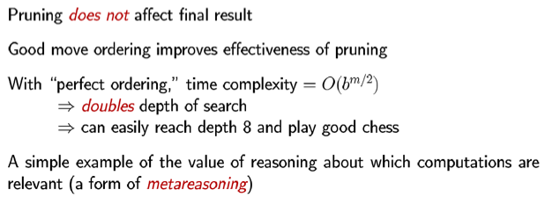

Why it’s called α-β pruning

