-- 1. Table joins with at least 3 tables in join

SELECT vin, make, model, saddress || ' ' || CAddress || ' ' || ZipCode AS "Office address"

FROM ZJY_OFFICE NATURAL JOIN ZJY_VEHICLE NATURAL JOIN ZJY_VELTYPE

ORDER BY vin;

-- list the detail of the vehicles and the office they belongs to

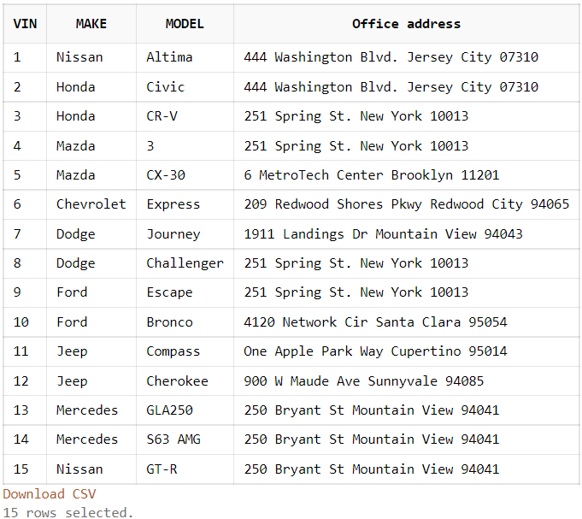

-- 2. Multi-row subquery

SELECT typeName, vin, make, model, year

FROM ZJY_VELTYPE JOIN

(

    SELECT typeID, vin, make, model, year

    FROM ZJY_VEHICLE a

    WHERE year >= ALL

    (

        SELECT year

        FROM ZJY_VEHICLE b

        WHERE a.typeID = b.typeID

    )

    ORDER BY typeID

) USING (typeID)

ORDER BY TYPEID;

-- list the vehicle in each type that has the newest year

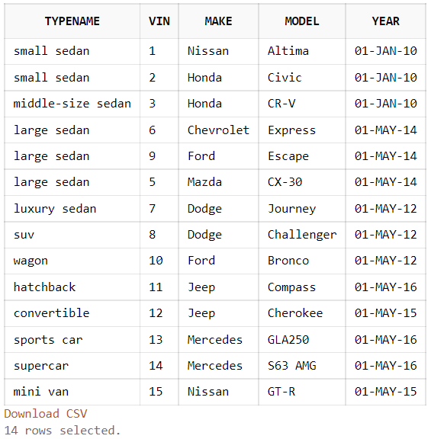

-- 3. Correlated subquery

SELECT typeName,

(

    SELECT count(*)

    FROM ZJY_VEHICLE b

    WHERE a.typeID = b.typeId

) as cnt

FROM ZJY_VELTYPE a

ORDER BY cnt;

-- list the number of vehicles of all type

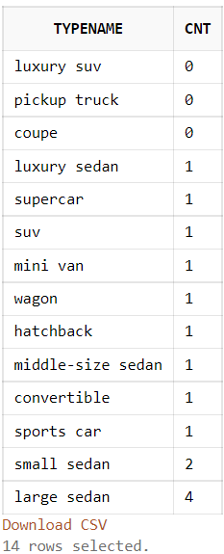

-- 4. SET operator query

SELECT vin, cid, pickdate, discount

FROM ZJY_VEH_CUST NATURAL JOIN ZJY_COUPON

UNION

SELECT vin, cid, pickdate, discount

FROM ZJY_VEH_CUST NATURAL JOIN ZJY_CUSTOMER NATURAL JOIN ZJY_CORPORATE_CUSTOMER NATURAL JOIN ZJY_CORPORATE

WHERE discount IS NOT NULL

ORDER BY pickdate;

-- list all the orders that uses a discount, either from a coupon or being a corporate customer with discount

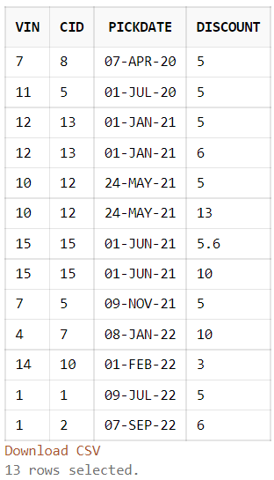

-- 5. Query with in line view or WITH clause

WITH maxType AS

(

    SELECT typeID, typeName, RentalRate

    FROM ZJY_VELTYPE

    WHERE RentalRate =

    (

        SELECT max(RentalRate)

        FROM ZJY_VELTYPE

    )

)

SELECT typeName, RentalRate, vin, make, model, year

FROM ZJY_VEHICLE JOIN maxType USING (typeID);

-- List the vehicle with the type of the highest rental rate

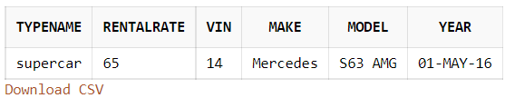

-- 6. TOP-N query

SELECT *

FROM

(

    SELECT vin, cid, pickdate, discount, rank() over (order by discount DESC) AS myrank

    FROM

    (

        SELECT vin, cid, pickdate, discount

        FROM ZJY_VEH_CUST NATURAL JOIN ZJY_COUPON

        UNION

        SELECT vin, cid, pickdate, discount

        FROM ZJY_VEH_CUST NATURAL JOIN ZJY_CUSTOMER NATURAL JOIN ZJY_CORPORATE_CUSTOMER NATURAL JOIN ZJY_CORPORATE

        WHERE discount IS NOT NULL

        ORDER BY pickdate

    )

    ORDER BY discount DESC

)

WHERE myrank <= 2;

-- list the order which are the top 2 in discount rate

