附：实验报告格式

信息与管理科学学院计算机科学系
实验报告

课程名称： 软件设计模式与体系结构
实验名称： 策略模式-排序

姓 名： 张扬

组号： 1 班级：2021级软件2班
指导教师： 王曼曼
实 验 室： 繁塔楼B409
日 期： 2024年4月14日

评分： （百分制）

作业要求(This Homework needs only a little bit coding)：The following class diagram represents a design in strategy pattern to sort integer arrays using different algorithms. This homework requires you
- Run the program StrategyGUI first to see how an integer array is sorted.
- Add a strategy sub-class to implement SortAlgorithm to do Bidirectional bubbleSort. Thus you can name this class BidirBubbleSort. Note that the BidirBubbleSort.java file is already in the same package and what you need to do is just add it to the strategy class hierarchy.
- In StrategyGUI, modify the JcomboBox part to add an option to allow bidirectional bubble Sort.

<<interface>>
SortAlgorithm
+sort(a: int [ ], c: Context)
BubbleSort
+sort(a:int[],c:Context)
StrategyGUI
HeapSort
+sort(a:int[],c:Context)
Context
+Context(s: SortAlgorithm)
+sortIntArray(): int[]
+startExecution(): void
+endExecution(): void
+getExeTime(): long
QuickSort
+sort(a:int[],c:Context)
InsertionSort
+sort(a:int[],c:Context)
context
sort
sort
Fig 1. The Design of the Sorting Integer Array Problem in example 7.2 of the book

Report Part:
- Describe your finished homework, including
    - What classes have been added to the existing class hierarchy?
    - The relationship between the existing classes and the newly added classes.
    - What code has been added to what class?

只添加了一个BidirBubbleSort的类
他实现了SortAlgorithm里的方法，并在StrategyGUI里被调用
只在SortAlgorithm里把BidirBubble加进来的代码，主要如下
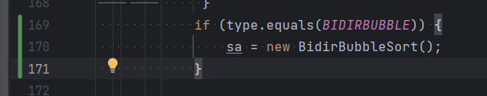

- Draw your new class diagram here
类图如下
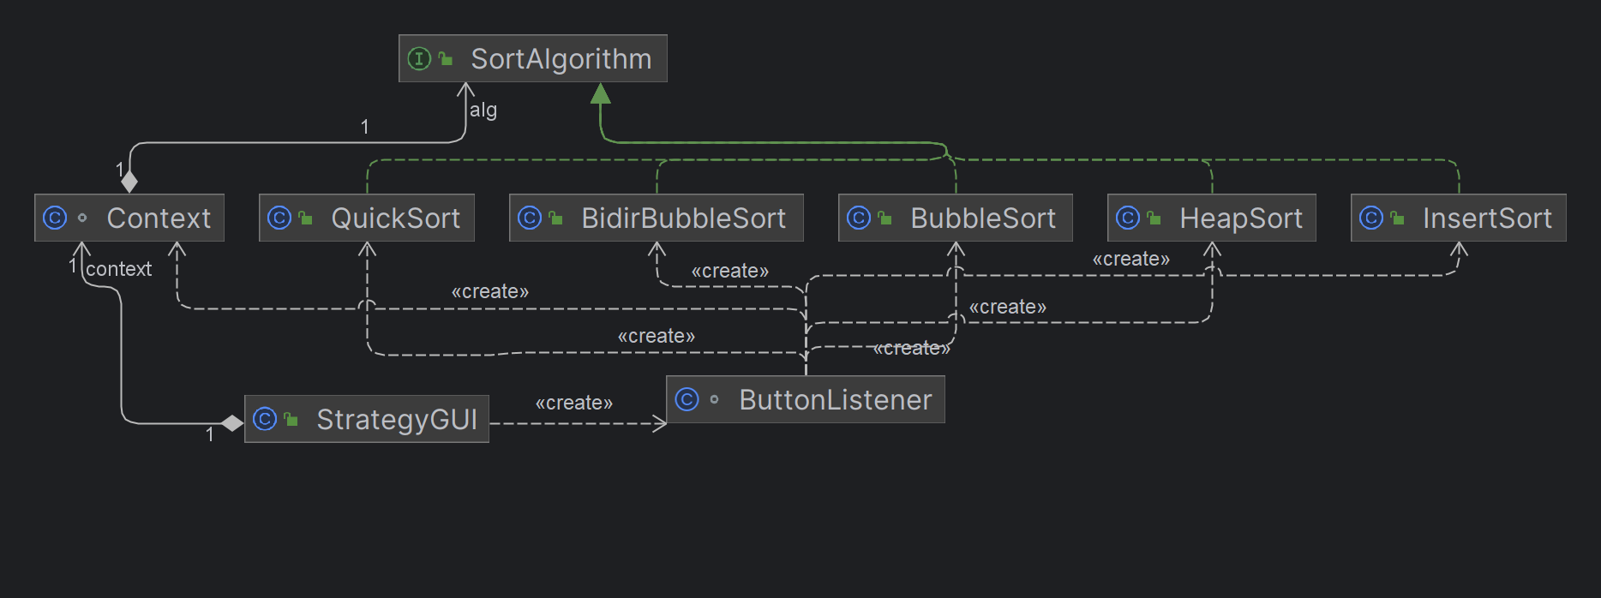

- Discussion of the extensibility issue.
  - After you add your new class BidirBubbleSort in the strategy class hierarchy,
    - Do you have to change the Context class?
    - Do you have to change the Client class StrategyGUI?
  - If you have changed the code for a sort(a:int[],c:Context) method in a sub-strategy class in the strategy class hierarchy,
    - Do you have to change or recompile the Context class?
    - Do you have to change or recompile the Client class StrategyGUI?

A)没有改Context 里的代码
在StrategyGUI里只添加了新的对BidirBubbleSort的引用的选项，没有更改原先的代码。
B)都不需要，只需要重新编译修改的那个排序算法的类即可

- Typical input and output from running your new program
如下图
