附：实验报告格式

信息与管理科学学院计算机科学系
实验报告

课程名称： 软件设计模式与体系结构
实验名称： 状态模式-天气

姓 名： 张扬

组号： 1 班级：2021级软件2班
指导教师： 王曼曼
实 验 室： 繁塔楼B409
日 期： 2024年4月14日

评分： （百分制）

本作业使用状态模式进行设计。由于本问题的特殊性：天有不测风云，即天气状态的改变假定是随意的，所以采用了依据层次架构的状态模式进行设计。该设计一方面具有状态模式的形状，另一方面，在方法调用方面，客户类StateAnimatGUI调用Context类；Context类调用状态类WeatherState（包括其子类）。改变状态与创建状态类对象的责任交给了WeatherState类。
This homework is about the state of weather. The weather state includes 3 states: sunny state, rainy state, and windy state. The program is about showing the randomly changing weather state. The weather state transition has no definite rules, actually, in the changeState() method below in the class WeatherState uses random function to decide which is the next Weather State.
Context
+getColor()
+getImgIcon()
+getWeatherState()
+doActionj()
state
SunnyState

+act()
+getCurrentState()
+setColor(): Clor
+setImgIcon():ImageIcon
StateAnimatGUI
WeatherState
+createStateObj()
+changeState( )
+act(): String
+getCurrentState(): String
+setColor(): Clor
+setImgIcon():ImageIcon
#state
RainyState

+act()
+getCurrentState()
+setColor(): Clor
+setImgIcon():ImageIcon
RainyState

+act()
+getCurrentState()
+setColor(): Clor
+setImgIcon():ImageIcon
Figure 1. Class diagram for the design of weather state using the State pattern

Requirement:
- Run the program first to see how the above design is implemented
- Add another state named “SnowingState”
- Subsequently you need to modify some part of the class WeatherState

- Describe your finished homework, including
  - What classes have been added to the existing class hierarchy?
  - The relationship between the existing classes and the newly added classes.
只添加了SnowingState类
它继承了WeatherState类

- Draw your new class diagram here
新类图如下
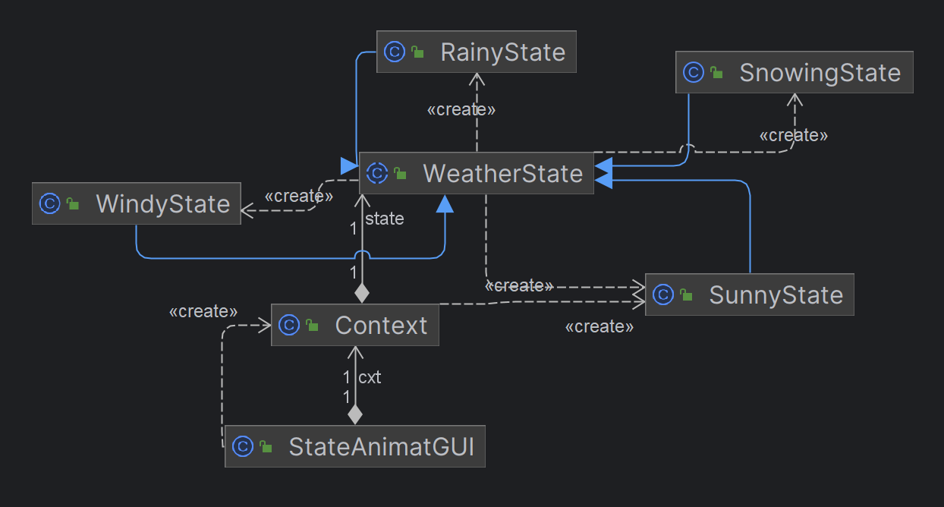
- What methods in what classes have you modified? What classes remain unchanged? Discuss the extensibility of this design.
  - When you add a new state subclass, what part of the design needs to be modified?
  - When you modified some code in one of the subclass, what other classes need to be modified also?
WeatherState类里的createStateObj方法被改了，除此之外其它所以的类都保持不变，即使被修改的createStateObj方法，也没有修改原有的代码，只是添加了新的代码，符合开闭原则。

- How the animation effects are achieved?

动画效果是通过随着天气状态的变化不断更新图GUI来实现的。这是使用一个无限期运行的循环来完成的。在循环的每次迭代中，程序都会更新GUI组件以反映当前的天气状态，更改背景颜色和显示不同的图标和文本。

- What class is responsible for changing the state?

负责改变状态的类是 WeatherState 类。在 WeatherState 类中的 changeState() 方法使用了随机数生成器来随机选择下一个天气状态，并将其保存在 state 属性中。这个方法使得天气状态能够随机地改变，从而模拟天气的变化。

