附：实验报告格式

信息与管理科学学院计算机科学系
实验报告

课程名称： 软件设计模式与体系结构
实验名称： 汽车保险管理应用程序

姓 名： 张扬

组号： 1 班级：2021级软件2班
指导教师： 王曼曼
实 验 室： 繁塔楼B409
日 期： 2024年3月10日

评分： （百分制）

作业要求：The following class diagram represents a design in factory method pattern to query the features of different types of auto insurances. See the source code for the implementation of the following class diagram.

- First in the following design, in the class hierarchy named AutoInsurance, add a class LuxeryCarInsurance
- The class LuxeryCarInsurance has the same interface and methods as every class in this class hierarchy
- You write a word description of the new insurance
- Then you need to add a sub class in the class hierarchy PolicyProducer to create object of class LuxeryCarInsurance
- Finally you need to modify the client class FactoryMethodGUI to allow the newly added insurance policy Luxery Car Insurance to be displayed as other insurance policies.
<<Interface>>
PolicyProducer
getPolicyObj()
CollisionPolicyProducer
getPolicyObj()
ComprehensivePolicyProducer
getPolicyObj()

BodyInjurPolicyProducer
getPolicyObj()
PersonInjuryPolicyProducer
getPolicyObj()
<<Interface>>
AutoInsurance
getInsurDescription()
CollisionCoverage
getInsurDescription
ComprehensiveCoverage
getInsurDescription
BodyInjurLiability
getInsurDescription
PersonInjuryProtection
getInsurDescription
FactoryMethodGUI

Fig 1 Design of the auto insurance information system in the factory method pattern

- Describe your finished homework, including
    - What classes have been added to the existing class hierarchy?
    - The relationship between the existing classes and the newly added classes.
    - What code has been added to what class?
etc.
我新加了两个类，一个是LuxeryCarInsurance.Java，它继承自AutoInsurance.java，代码内容与其它继承自AutoInsurance的类似，实现了getInfo方法，使用中文写了描述，代码具体实现如下图2
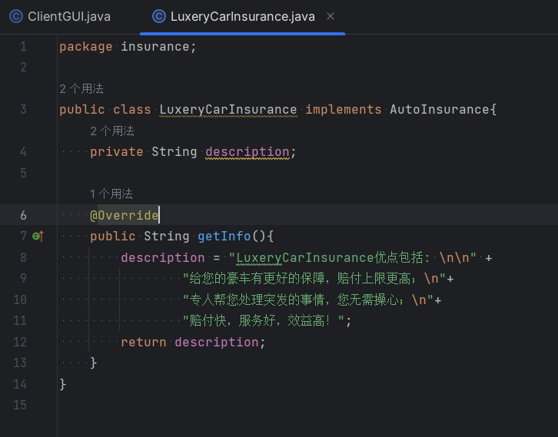
图2
添加的另一个类是LuxeryCarInsuranceProducer.java，它继承自PolicyProducer.java，实现了getInsurObj方法，代码具体实现如下图3
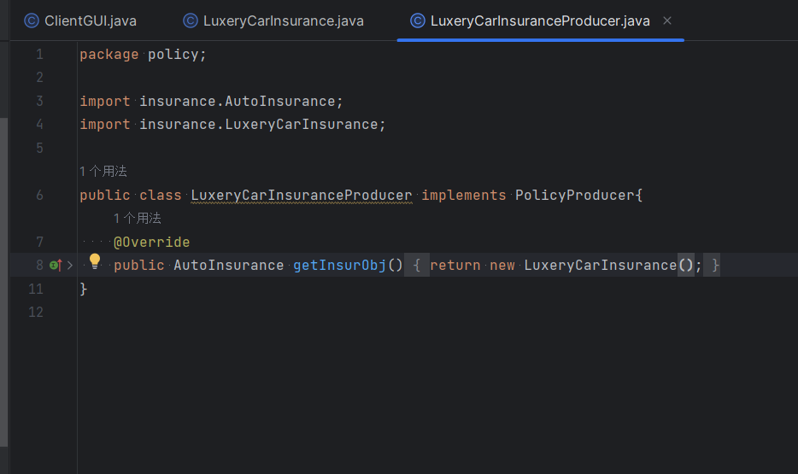
图3

- Run the ClientGUI class and you choose “Body Injur Liability”, and then click on “show Info” button. List all the methods called in correct order here.
调用的方法主要包含以下几个：
actionPerformed()判断是否点击
getSelectedItem()确定点的哪个保险
getInsurObj()获得该保险对象
getInfo()获取该对象存储的保险信息
setText()最后把信息展示出来
运行后如下图4所示：
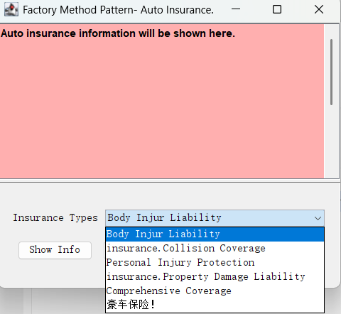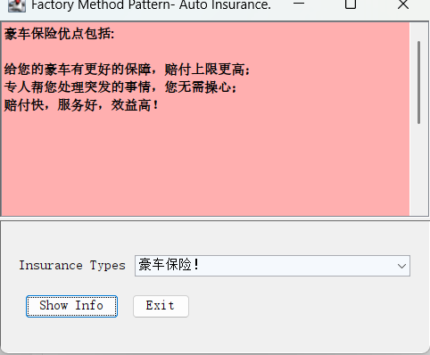
图4

- Draw your new class diagram here
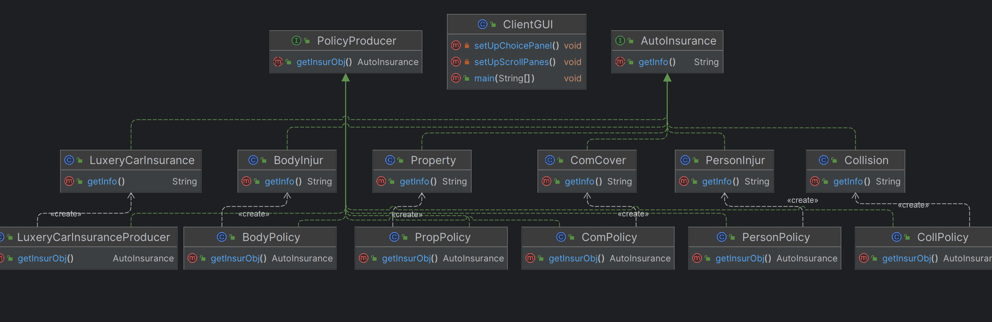
新类图如图5所示
图5

- After you add the new class LuxeryCarInsurance, what other classes have you changed? Does this design follow the open-closed principle? Why?
并没有修改其它的类，只是添加了LuxeryCarInsuranceProducer用于创建LuxeryCarInsurance的实例，并在ClientGUI中添加了代码，使得可以显示新的保险，但是没有动其它的代码，所以这应该并不算修改，只是添加，所以我觉得它符合开闭原则。

- (Testing) Typical input and output from running your program
新添加的类的输出已经在图4展示过了，下面再以insurance.Collision Coverage为例展示一下，如图6
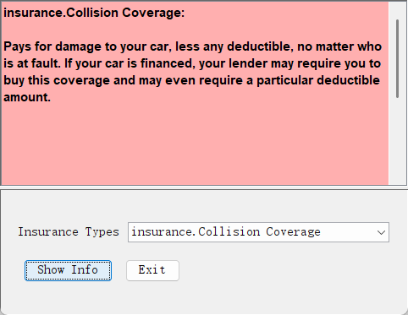
图6

