附：实验报告格式

信息与管理科学学院计算机科学系
实验报告

课程名称： 软件设计模式与体系结构
实验名称： 外观模式-毕业生信息

姓 名： 张扬

组号： 1 班级：2021级软件2班
指导教师： 王曼曼
实 验 室： 繁塔楼B409
日 期： 2024年3月24日

评分： （百分制）

Description of the Homework:

Now we have some student information documents classes:

StudentBasicInfo,

StudentBasicInfoModel,

AcademicRecord,

StudentAcademicModel,

Award and

StudentAwardModel.

The StudentBasicInfo class is responsible for reading student's basic information from a file containing student basic information. The StudentBasicInfoModel class provides the format of the student basic information that is stored in the text file. The returns data type is the ArrayList<StudentBasicInfoModel> type. In class StudentBasicInfo, class StudentBasicInfoModel is called.

Similarly, AcademicRecord is responsible for reading student's academic information, including the course title and the scores, with return data structure type as ArrayList<StudentAcademicModel>. Therefore, in class AcademicRecord, class StudentAcademicModel is called.

Class Award is responsible for reading the award information from a text file, including what kind of awards and the date to get them. The return type is ArrayList<StudentAwardModel>.

We use the façade pattern to design a student comprehensive information system, which will extract all the information including student basic information, student academic information, and student award information. The design is as below.

StudentInfoFacade
+extractStudentInfo(): String
+extractAcademicRecord(): String
+extractAllAwards(): String
+getStudentInfo(): String
- firstName: String;
- lastName: String;
- studNum: String;
StudentBasicInfo
+isExistingStudentName(String name)
+getStudentBasicInfo(): ArrayList
- name: String;
- birthDate: String;
- serialNum: String;
AcademicRecord
+getAllScores(String file): ArrayList
- firstName: String;
- lastName: String;
- studNum: String;
EllipseDrawerGUI
Award
+getAllAwards(String file): ArrayList
- firstName: String;
- lastName: String;
- studNum: String;
StudentAwardModel
+getAllAwards(String file): ArrayList
- studFirstName: String;
- studLastName: String;
- studSerialNum: String;
- awardName: String;
- awardDate: String
StudentAcademicModel
+getAllAwards(String file): ArrayList
- studFirstName: String;
- studLastName: String;
- studSerialNum: String;
- courseTitle: String;
- courseNum: String;
- score: String;
StudentBasicInfoModel
+getAllAwards(String file): ArrayList
- name: String;
- birthDate: String;
- serialNumber: String;
- ssNumber: String;
- major: String;
- degree: String;
+getStudFirstName(): String
+getStudLastName(): String
+getStudSerialNum(): String
+getAwardName(): String
+ getAwardDate(): String
+getStudFirstName(): String
+getStudLastName(): String
+getStudSerialNum(): String
+getCourseTitle(): String
+getCourseNum(): String
+getScore(): String
+getName(): String
+getBirthDate(): String
+getSerialNum(): String
+getSocialSecurityNum(): String
+getMajor(): String
+getDegree(): String

Figure 1 Student information system designed by using the façade pattern

The graphical user interface is as below.

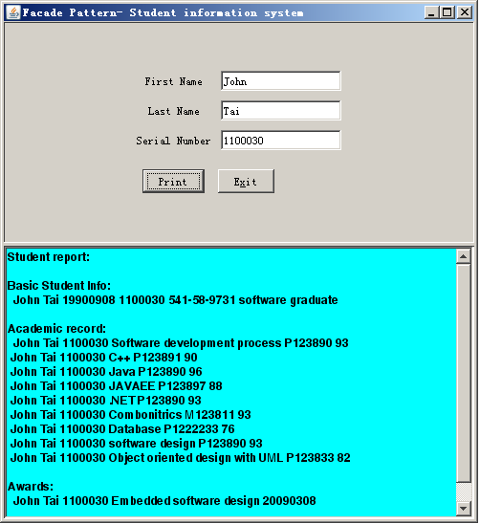

Figure 2 Graphical user interface for the student information system

Requirement: In the design above, add a class named Tuition, which has already been included in this file directory. You need to implement the method extractTuitionInfo() in the class StudentInfoFacade correctly. Then you also need to modify other part of the class StudentInfoFacade in order to extract the student tuition information in addition to the already existing functionalities.

- Describe your finished homework, including
    - What classes have been added to the existing class hierarchy?
    - The relationship between the existing classes and the newly added classes.
    - What code has been added to what class?
etc.

新添加了一个名为Tuition的类(不过题目中已经给了部分代码，我只是给实现了)。
和其它类几乎没有关系，只有StudentInfoFacade里调用了它。
除了Tuition之外只在StudentInfoFacade类中添加了调用的Tuition的部分，如下图1：
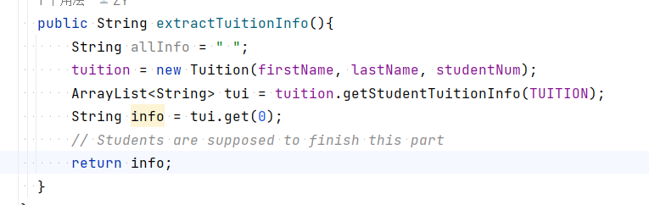
图1

- Original class diagram, and new class diagram
原类图和新类图如下图2和图3
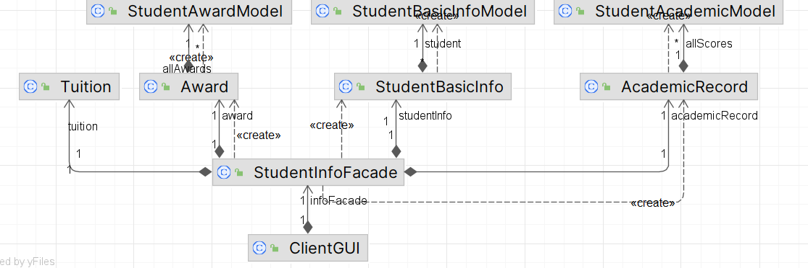

图2原类图

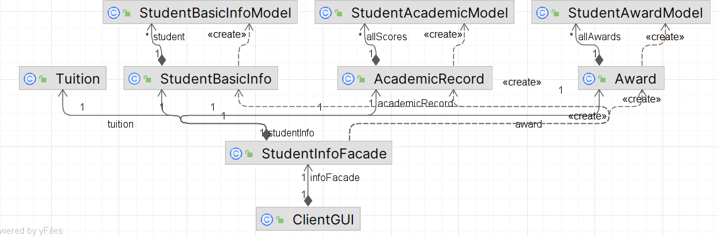

图3新类图

- Your new key code, and your new key parameters in order to finish the required new functionalities
主要就是Tuition里添加的查找学费的代码，如下图4
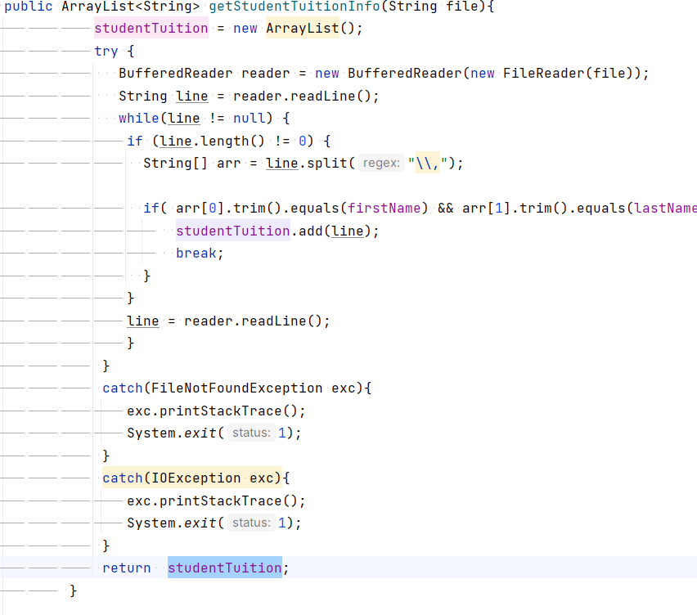
图4
- Typical input and output from running your finished program
如下图
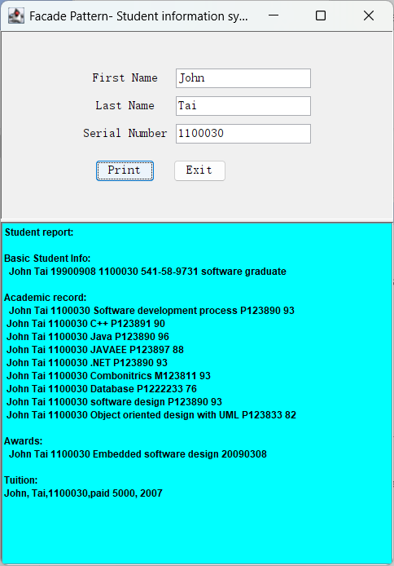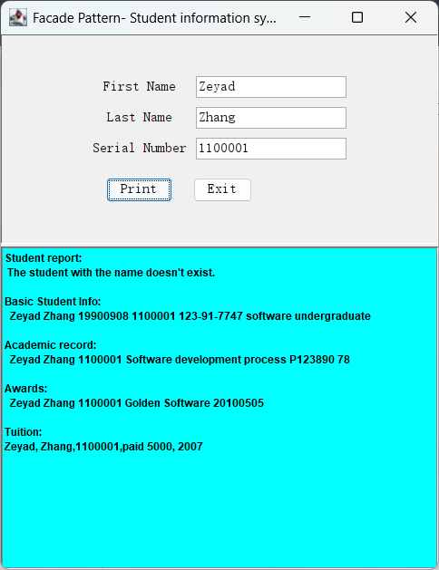
图5查询成功

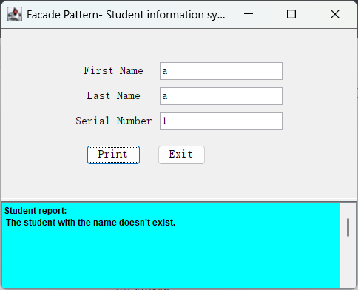
图6 查询失败

