附：实验报告格式

信息与管理科学学院计算机科学系
实验报告

课程名称： 软件设计模式与体系结构
实验名称： 桥接模式-特工信息

姓 名： 张扬

组号： 1 班级：2021级软件2班
指导教师： 王曼曼
实 验 室： 繁塔楼B409
日 期： 2024年3月24日

评分： （百分制）

作业要求（特工信息保密系统）：

The following design represents an agent information system. The agent information is encrypted and saved into text file or a database. There are two ways to encrypt agent’s name and code number, which are represented by classes

EncryptedInfo1 and

EncryptedInfo2.

Now you are required to write a class EncryptedInfo3 to encrypt agent’s last name, first name and code number.
- The class should be in the same format as EncryptedInfo1 and EncryptedInfo2, and provides a different encryption method
- EncryptedInfo3 should encrypt the last name, first name and code number as described below as CaesarCypher: To encrypt a word, we replace the letter a with b, b with c, and so on, up to z, which is replaced by a. This is called the rotate-1 Caesar cipher. When a digital number between 0 and 9 is encountered, the rule to rotate is 0→1, 1→2,…,8→9 and 9→0. For example:

Plain text: Mike

Encrypted text: Njlf

Plain text: Sun

Encrypted text: Tvo

Plain text: Shanben56

Encrypted text: Tibocfo67

Plain text: WildWolf7489

Encrypted text: XjmeXpmg8590
c) Modify the class AgentGUI to allow choice EncryptedInfo3 to be shown in the GUI.

Note:
- The length for a code is exactly 12, formed by mixed characters and digital numbers.

<<interface>>
AgentInfo
log(String lNm, String fNm, String cd)

EncryptedInfo1
encryptName(String inputStr)
encryptCode(String inputStr)
log(String lNm, String fNm, String cd)

writer: MessageWriter
<<interface>>
MessageWriter
logMsg(String lNm, String fNm, String cd)

FileWriter
logMsg(String lNm, String fNm, String cd)

DBWriter
logMsg(String lNm, String fNm, String cd)

EncryptedInfo2
writer: MessageWriter
encryptName(String inputStr)
encryptCode(String inputStr)
log(String lNm, String fNm, String cd)

AgentGUI

Answer questions as below:
a) After you add class EncryptedInfo3,
i) Do you need to recompile class EncryptedInfo1 and EncryptedInfo2?
ii) Do you need to recompile class AgentInfo?
iii)Do you need to recompile class FileWriter or DBWriter?

不需要，因为这两个类并没有修改，添加的EncryptedInfo3也不会影响它们。
不需要，因为添加的EncryptedInfo3也不会影响它们，它使用的依赖项和接口都没发生变化。
也不需要重新编译 FileWriter 或 DBWriter 类，因为添加的EncryptedInfo3也不会影响它们，它们的依赖项和接口也没发生变化。

b) In class EncryptedInfo1, there is an constructor
public EncryptedInfo1(MessageWriter l){
writer = l;
}
Why do we use type MessageWriter as the parameter type and why don’t we use type FileWriter or DBWriter as the parameter type?

在 EncryptedInfo1 类中，构造函数接受 MessageWriter 类型的参数，而不是特定类型如FileWriter或DBWriter可以促进灵活性和可维护性。通过使用MessageWriter作为参数类型，可以传递任何实现了MessageWriter接口的类，而无需修改EncryptedInfo1类。这样做有助于降低耦合。

c) In class AgentGUI , we have the source code

MessageWriter writer;
…
if( logWay.compareTo(AgentGUI.DBWRITER)==0 )
writer = new DBWriter();
if( logWay.compareTo(AgentGUI.FILEWRITER)==0 )
writer = new FileWriter();

What is the advantage of writing code above?

AgentGUI 类中以上代码的优点在于它促进了灵活性和可扩展性。通过使用字符串比较来确定实例化哪种类型的写入器，可以在不修改 AgentGUI 类的情况下轻松扩展应用程序以支持其他类型的写入器。如果添加了新的写入器类型，如ConsolWriter，只需要添加另一个条件语句来根据 logWay 的值实例化它。这种方法遵循开闭原则，使代码对扩展开放但对修改关闭。

e) If we add a class named ConsolWriter parallel to DBWriter, do we need to recompile any classes?

不需要重新编译任何类，除非存在影响正在编译的类的依赖项或接口的变化。添加一个名为 ConsolWriter 的新类与 DBWriter 平行不会影响现有的类，除非它们直接依赖于 ConsolWriter 或其接口。

- Describe your finished homework, including
    - What classes have been added to the existing class hierarchy?
    - The relationship between the existing classes and the newly added classes.
我添加了EncryptedInfo3新类，在AgentGUI里添加了EncryptedInfo3中CaesarCypher的新加密选项，没有对其它类进行修改，符合开闭原则

- Original class diagram, and new class diagram

原类图如下图1，新类图如下图2

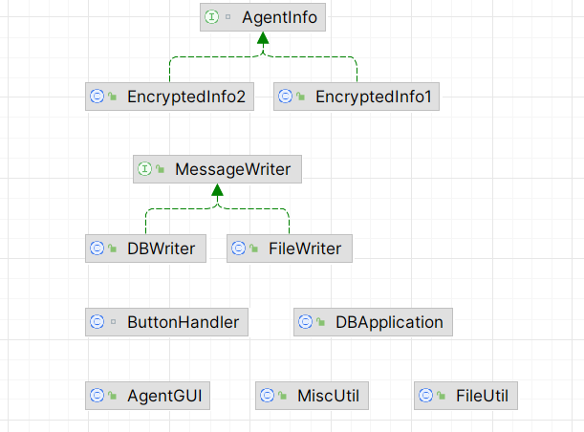
图1原类图
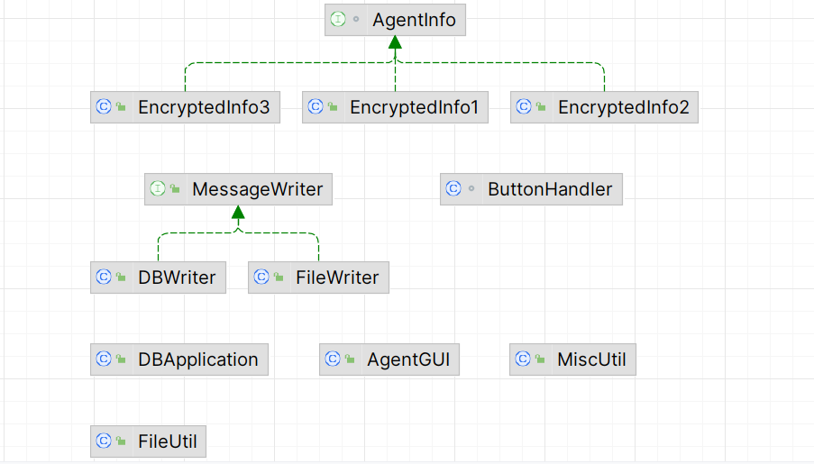
图2新类图
- Your new key code, and your new key parameters in order to finish the required new functionalities
下图3是我在EncryptedInfo3的主要代码，主要是用于实现CaesarCypher加密算法
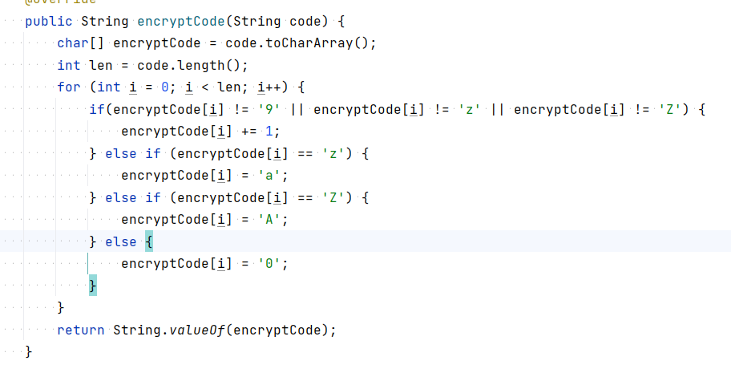
图3EncryptedInfo3的加密代码
- Typical input and output from running your program
运行结果如下图4图5
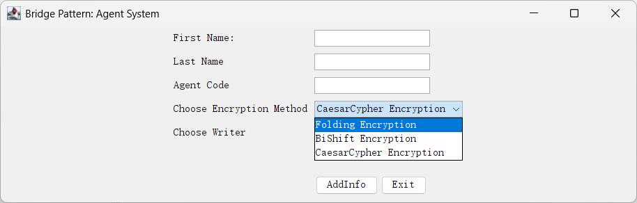
图4新增的加密选项
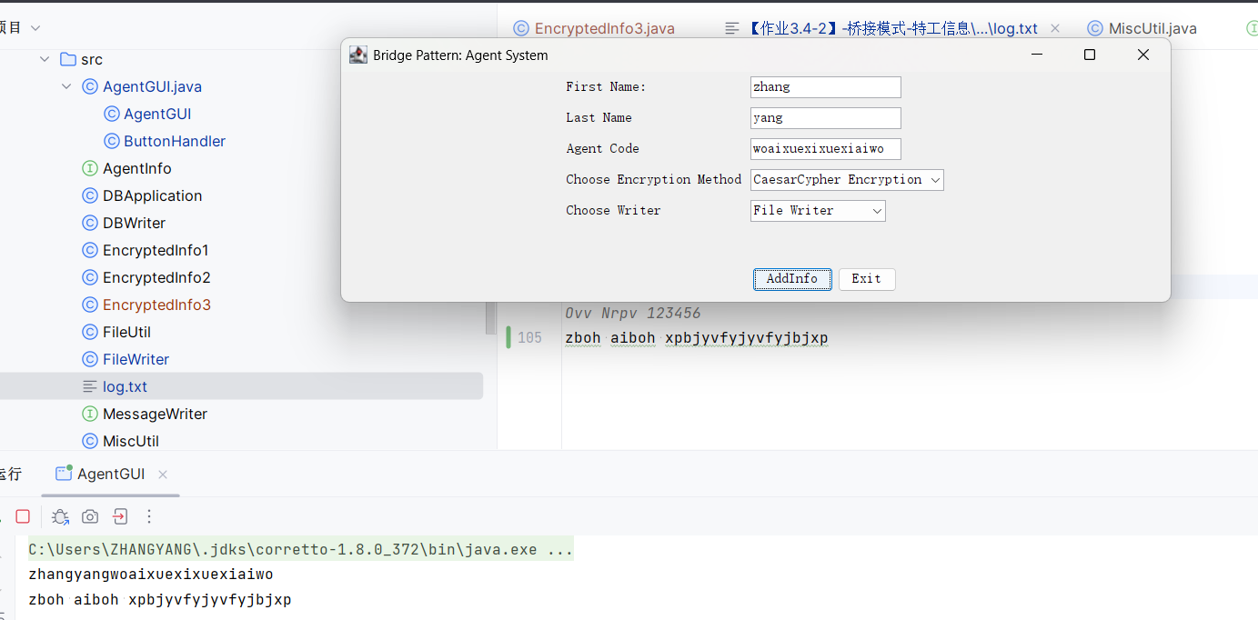
图5运行的加密结果

