附：实验报告格
信息与管理科学学院计算机科学系
实验报告

课程名称： 软件设计模式与体系结构
实验名称：

姓 名：

组号： 1 班级：2021级软件 班
指导教师：
实 验 室： 繁塔楼B409
日 期： 2024年 月 日

评分： （百分制）

作业要求：Study the following figure 1, figure 2 and figure 3 about the visitor solution of the sport-shoe store problem. Also you can read the source code about the implementation of the problem. Then,

- Write code for ShoeInfoVisitor to implement all the methods in this class to get descriptions of all the kind of shoes
- Also in the client class SportsShoesGUI, add necessary methods to get the information about the selected shoes

Figure 1. SportShoes hierarchy
SportShoes
+accept:void
+getPrice:double
+getDescription
RunningShoes
SkatingShoes
WalkingShoes
+accept:void
+getPrice:double
+getDescription
Nike
Mephisto
+accept:void
+getPrice:double
+getDescription

NorthFace
Adidas
Pony-Mexico
+accept:void
+getPrice:double
+getDescription

Salomon
GlobeBlitz
GlobeAppleyard
+accept:void
+getPrice:double
+getDescription

DCShoesRover
+accept:void
+getPrice:double
+getDescription
+accept:void
+getPrice:double
+getDescription
+accept:void
+getPrice:double
+getDescription
+accept:void
+getPrice:double
+getDescription
+accept:void
+getPrice:double
+getDescription
+accept:void
+getPrice:double
+getDescription
+accept:void
+getPrice:double
+getDescription
+accept:void
+getPrice:double
+getDescription

Visitor
+visitAdidas(Adidas e);
+visitSalomon(Salomon e);
+visitPonyMexico(PonyMexico e);
+visitNorthFace (NorthFace e);
+visitNike(Nike e);
+visitMephisto(Mephisto e);
+visitGlobeBlitz (GlobeBlitz e);
+visitGlobeAppleyard(GlobeAppleyard e);
+visitDCShoesRover(DCShoesRover e);
PriceVisitor
+visitAdidas(Adidas e);
+visitSalomon(Salomon e);
+visitPonyMexico(PonyMexico e);
+visitNorthFace (NorthFace e);
+visitNike(Nike e);
+visitMephisto(Mephisto e);
+visitGlobeBlitz (GlobeBlitz e);
+visitGlobeAppleyard(GlobeAppleyard e);
+visitDCShoesRover(DCShoesRover e);
ShoeInfoVisitor
+visitAdidas(Adidas e);
+visitSalomon(Salomon e);
+visitPonyMexico(PonyMexico e);
+visitNorthFace (NorthFace e);
+visitNike(Nike e);
+visitMephisto(Mephisto e);
+visitGlobeBlitz (GlobeBlitz e);
+visitGlobeAppleyard(GlobeAppleyard e);
+visitDCShoesRover(DCShoesRover e);

Figure 2. visitor hierarchy

SportShoes
+accept:void
+getPrice:double
+getDescription
RunningShoes
SkatingShoes
WalkingShoes
+accept:void
+getPrice:double
+getDescription
Nike
Mephisto
+accept:void
+getPrice:double
+getDescription

NorthFace
Adidas
Pony-Mexico
+accept:void
+getPrice:double
+getDescription

Salomon
GlobeBlitz
GlobeAppleyard
+accept:void
+getPrice:double
+getDescription

DCShoesRover
+accept:void
+getPrice:double
+getDescription
+accept:void
+getPrice:double
+getDescription
+accept:void
+getPrice:double
+getDescription
+accept:void
+getPrice:double
+getDescription
+accept:void
+getPrice:double
+getDescription
+accept:void
+getPrice:double
+getDescription
+accept:void
+getPrice:double
+getDescription
+accept:void
+getPrice:double
+getDescription
Visitor
PriceVisitor
ShoeInfoVisitor
SportsShoesGUI

Figure 3. the visitor pattern solution

Report Part

- Answer the following
    - Which class have you written code for?
    - What code have you added to what class to show the shoe information to the screen?

我给ShoeInfoVisitor编写(补全)了代码，代码如下
(其实就是给字符串数组每个元素赋值)
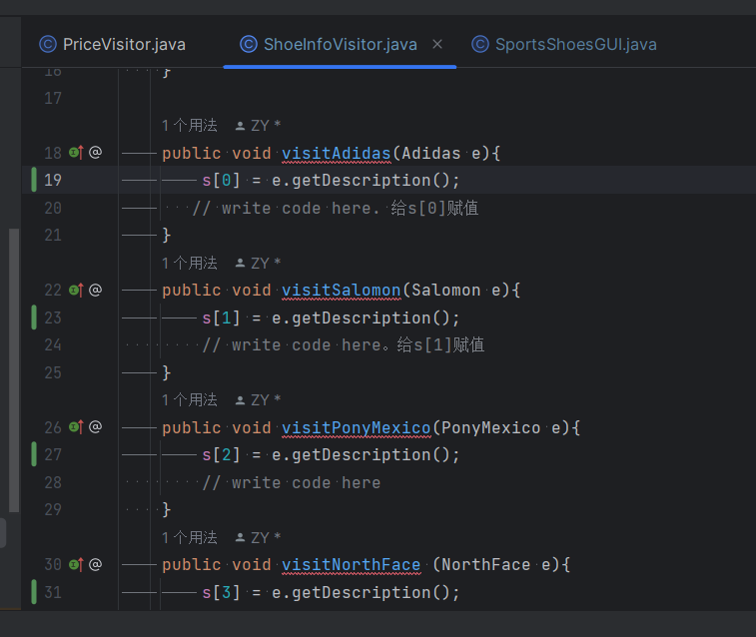

展示信息的代码在SportsShoesGUI中，具体如下图
(老师给的注释是让加两行，但是一行其实就够了)

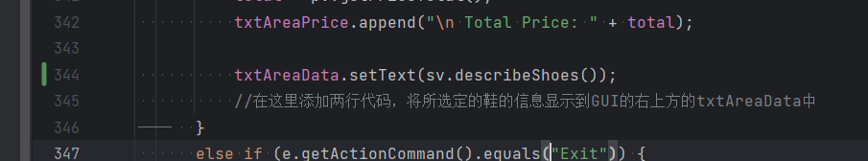

- Do the following
  - Explain how method accept(Visitor v) works.
  - How a node class is visited?

a) accept接受一个访问者对象，并调用该访问者对象的方法来执行对该元素的操作。当一个访问者对象被传递给 accept 方法时，元素会将自身作为参数传递给访问者对象的方法，从而使访问者对象能够访问并操作该元素。
b) 一个节点类被访问时，通常会调用该节点类的 accept方法，并将一个访问者对象作为参数传递给这个方法。当调用 accept 方法时，该节点类会将自身作为参数传递给访问者对象的相应方法。这样，访问者对象就可以根据自身的实现来执行特定于该节点类的操作。

- (测试) Typical input and output from running your finished program
如下图
