附：实验报告格式

信息与管理科学学院计算机科学系
实验报告

课程名称： 软件设计模式与体系结构
实验名称： 命令模式-空调

姓 名： 张扬

组号： 1 班级：2021级软件2班
指导教师： 王曼曼
实 验 室： 繁塔楼B409
日 期： 2024年4月7日

评分： （百分制）

Homework descriptions：
See the diagram below for example 11.2 designed by using the Command pattern. Run the source code before you do anything.

<<interface>>
Command
execute()
Invoker
+callCommand()
调用者类
ClientUI
<<creates>>
<<uses>>
GFan
+startRotate()
+stopRotate()
<<uses>>
<<creates>>
GWindow
+open()
+close()
FanOnCmd
execute()
FanOffCmd
execute()
WindowOpenCmd
execute()
WindowCloseCmd
execute()
Homework requirement: if your team leader asks you to cancel the Invoker class from the class diagram in the above design and merges it into the ClientUI class and you are not allowed to change any of the other classes. All the functionalities should be the same as the original software. You please redesign the program and implement your new design.

Hint: Consider putting the Invoker class into ClientUI as an inner class.

Report Part.
- Draw your new design class diagram

这是新的类图，其中的Invoker是ClientUI的内部类
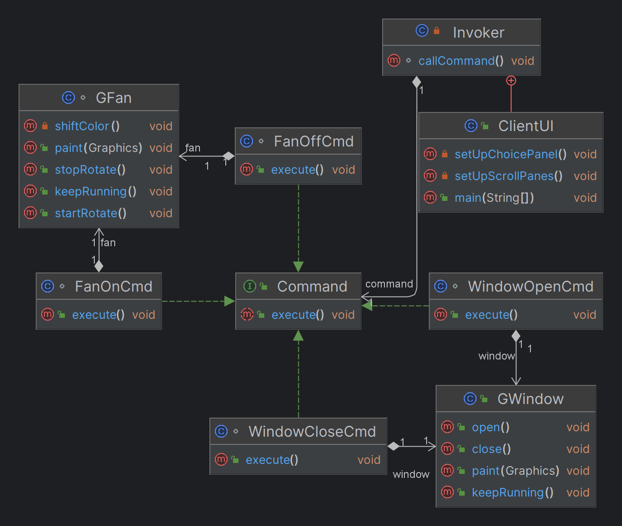

- Describe your new design:
    - What classes have been canceled from the existing class hierarchy?
    - What part of the ClientUI class has been changed?

我把原有的Invoker去掉了，在ClientUI里创建了一个内部类替代它。
ClientUI没有修改，只是在其中添加了一个新的内部类Invoker，如下图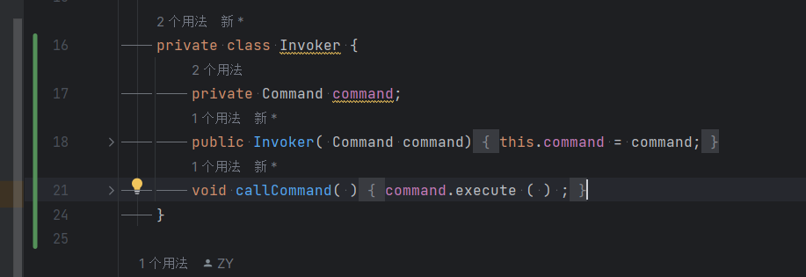

- If a user click on the button “Start Fan ”, what methods in this program have been called? List them in correct order.

先是ButtonListener.actionPerformed(ActionEvent ae)用于检测启动风扇的按钮是否被按。
然后是FanOnCmd.execute()它调用fan对象的execute()方法来启动风扇。
最后调用Invoker.callCommand()它负责调用分配的command对象的execute()方法，对风扇来说就是是FanOnCmd.execute()。

- Typical input and output from running your program
如下图
