## 读入数据，并将自变量设为1至样本个数

raw_data = read.table("./google_stock.txt")  
google12 = raw_data[c(1,2)]  
google34 = raw_data[c(3,4)]  
google56 = raw_data[c(5,6)]  
colnames(google34) = colnames(google12)  
colnames(google56) = colnames(google12)  
google = rbind(google12, google34, google56)  
google$V1 = c(1: nrow(google))  
google

A data.frame: 105 × 2
V1V2
<int><dbl>
1196.03
2198.64
3191.58
4187.98
5187.40
6192.99
7195.23
8198.41
9197.90
10197.95
11191.37
12193.95
13188.89
14185.87
15187.99
16186.06
17185.18
18187.01
19185.90
20188.81
21185.20
22181.35
23179.98
24177.80
25174.99
26178.61
27175.60
28179.29
29180.04
30180.88
⋮⋮
76260.81
77259.20
78266.00
79277.27
80288.00
81287.90
82280.26
83290.94
84293.12
85279.56
86286.31
87282.50
88282.75
89278.35
90274.80
91277.44
92280.30
93286.70
94287.84
95289.30
96289.71
97297.25
98304.10
99302.00
100292.72
101294.15
102291.25
103295.71
104291.52
105295.54

## 散点图

plot(google)

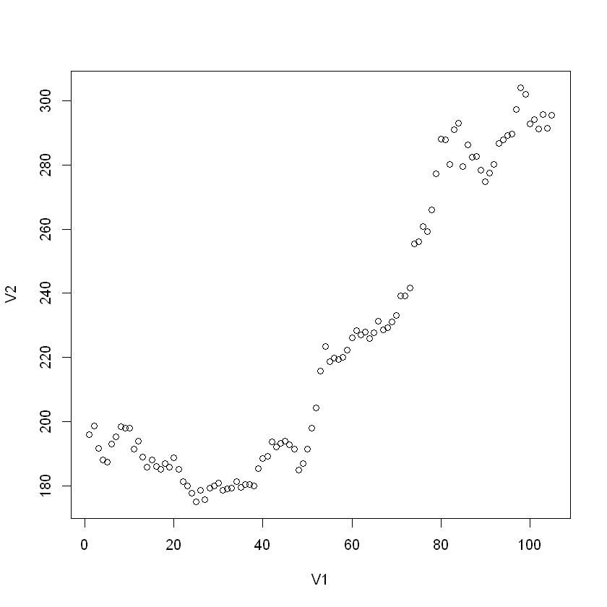

## 拟合一元线性回归模型

mdl0 = lm(V2~V1, data=google)  
summary(mdl0)

Call:  
lm(formula = V2 ~ V1, data = google)  
  
Residuals:  
 Min 1Q Median 3Q Max   
-33.297 -13.967 1.335 12.056 39.395   
  
Coefficients:  
 Estimate Std. Error t value Pr(>|t|)   
(Intercept) 156.67805 3.52517 44.45 <2e-16 ***  
V1 1.28372 0.05774 22.23 <2e-16 ***  
---  
Signif. codes: 0 '***' 0.001 '**' 0.01 '*' 0.05 '.' 0.1 ' ' 1  
  
Residual standard error: 17.93 on 103 degrees of freedom  
Multiple R-squared: 0.8276, Adjusted R-squared: 0.8259   
F-statistic: 494.3 on 1 and 103 DF, p-value: < 2.2e-16

## 画出拟合直线

plot(google$V1, google$V2,  
xlab = "t", ylab = "google stock")  
abline(mdl0)

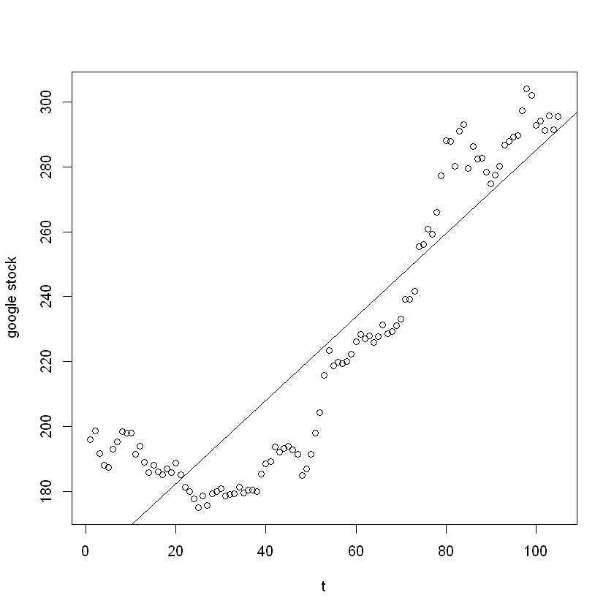

## 利用Durbin-Watson检验判断序列自相关性

library(lmtest)  
dwtest(mdl0)

Durbin-Watson test  
  
data: mdl0  
DW = 0.061858, p-value < 2.2e-16  
alternative hypothesis: true autocorrelation is greater than 0

dw0 = as.numeric(dwtest(mdl0)$statistic) # 将dw统计量保存到变量dw0里, 计算迭代法时需要用来估计rho  
dw0

0.0618582452309325

## DW检验结果

$DW=0.061858$ $p−value<2.2e−16$ 存在正自相关

## 利用迭代法处理自相关

首先假设模型存在一阶自相关  
需要做变换 $y_{t}′=y_{t}−ρy_{t−1}$ 和 $x_{t}′=x_{t}−ρx_{t−1}$ $ρ$
值不知道，用 $1−dw/2$ 来估计

rho0 = 1-dw0/2 # 用1-dw/2来估计rho  
n0 = nrow(google) # 样本个数  
y0 = google$V2  
x0 = google$V1  
y1 = y0[2:n0]-rho0*y0[1:n0-1] # 变换后的因变量, 共n0-1个  
x1 = x0[2:n0]-rho0*x0[1:n0-1] # 变换后的自变量, 共n0-1个  
mdl1 <- lm(y1~x1) # 用变换后的变量建立一元线性回归模型  
summary(mdl1)

Call:  
lm(formula = y1 ~ x1)  
  
Residuals:  
 Min 1Q Median 3Q Max   
-14.3720 -2.6945 -0.2969 2.4957 12.1304   
  
Coefficients:  
 Estimate Std. Error t value Pr(>|t|)   
(Intercept) 2.522 1.272 1.983 0.0501 .   
x1 2.045 0.457 4.474 2e-05 ***  
---  
Signif. codes: 0 '***' 0.001 '**' 0.01 '*' 0.05 '.' 0.1 ' ' 1  
  
Residual standard error: 4.327 on 102 degrees of freedom  
Multiple R-squared: 0.1641, Adjusted R-squared: 0.1559   
F-statistic: 20.02 on 1 and 102 DF, p-value: 1.998e-05

## 利用DW检验判断迭代一次后的模型的自相关性

dwtest(mdl1)  
dw1 = dwtest(mdl1)$statistic  
dw1

Durbin-Watson test  
  
data: mdl1  
DW = 1.8973, p-value = 0.2644  
alternative hypothesis: true autocorrelation is greater than 0

DW: 1.89732294556596

$DW=1.8973,p−value=0.2644$ $p>0.05$, 没有自相关  
迭代法结束

## 迭代一次后的模型估计值

$β_{0}′=2.522, β_{1}′=2.045,\hat{ρ}=0.969$ 根据变换前后模型系数的关系： $β_{0}′=β_{0}(1−ρ),β_{1}′=β_{1}$，可以计算原模型的系数估计值

b0 = 2.522 / (1-rho0)  
b1 = 2.045  
b0  
b1

81.5412720029396

2.045

## 原一元线性回归方程为

$y=81.541+2.045x$