# 5000元电脑配置

### CPU*

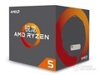

|  |
| --- |
| [AMD Ryzen 5 2600](http://detail.zol.com.cn/cpu/index1209679.shtml) |

-1+

￥1359

### 主板*

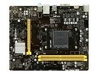

|  |
| --- |
| [映泰B450MHC](http://detail.zol.com.cn/motherboard/index1226992.shtml) |

-1+

￥499

### 内存*

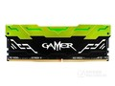

|  |
| --- |
| [影驰GAMER 8GB DDR4 2400](http://detail.zol.com.cn/memory/index1147009.shtml) |

-1+ ￥499

### 硬盘

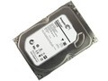

|  |
| --- |
| [希捷Barracuda 1TB 7200转 64MB 单碟（ST10](http://detail.zol.com.cn/hard_drives/index305156.shtml) |

-1+ ￥299

### 固态硬盘

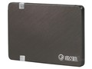

|  |
| --- |
| [影驰铁甲战将（240GB）](http://detail.zol.com.cn/solid_state_drive/index404879.shtml) |

-1+ ￥299

### 显卡

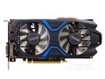

|  |
| --- |
| [影驰GeForce GTX 1050Ti大将](http://detail.zol.com.cn/vga/index1157727.shtml) |

-1+ ￥1099

### 机箱

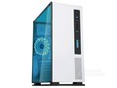

|  |
| --- |
| [先马工匠5号](http://detail.zol.com.cn/case/index1175517.shtml) |

-1+ ￥169

### 电源

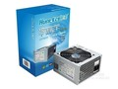

|  |
| --- |
| [航嘉冷静王钻石2.31版](http://detail.zol.com.cn/power/index351556.shtml) |

-1+ ￥189

### 散热器

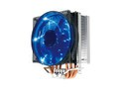

|  |
| --- |
| [超频三东海X4](http://detail.zol.com.cn/cooling_product/index375995.shtml) |

-1+ ￥99

### 显示器

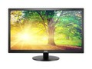

|  |
| --- |
| [AOC E2270SWN](http://detail.zol.com.cn/lcd/index383388.shtml) |

-1+ ￥549

### 键鼠套装

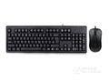

|  |
| --- |
| [双飞燕WKM-1000针光键鼠套装](http://detail.zol.com.cn/keyboards_mouse/index368523.shtml) |

-1+ ￥69