第一个类：Point
Point.h:
class Point
{
public:
Point();
Point(int xx,int yy,int zz);
double getLen();
void setData(int x1,int y1,int z1);
void printPoint();
virtual ~Point();
private:
int x;
int y;
int z;
};

Point.cpp:
#include "Point.h"
#include <math.h>
#include <iostream>
using namespace std;
Point::Point()
{
}
Point::Point(int xx,int yy,int zz){
x=xx;
y=yy;
z=zz;
}
double Point::getLen(){
double Len = sqrt(x*x+y*y+z*z);
return Len;
}
void Point::setData(int x1,int y1,int z1){
x=x1;
y=y1;
z=z1;
}
void Point::printPoint(){
cout<<"The point is("<<x<<","<<y<<","<<z<<")"<<endl;
}
Point::~Point()
{
}

main.cpp:
#include <stdio.h>
#include "Point.h"
int main(){
Point point(1,2,3);
point.getLen();
point.printPoint();
point.setData(4,5,6);
point.printPoint();
return 0;
}

第二个类：Dog
Dog.h:
class Dog
{
public:
Dog();
Dog(int Age,int Weight);
void setData(int Age1,int Weight1);
virtual ~Dog();
private:
int age;
int weight;
};

Dog.cpp:
#include "Dog.h"
#include <iostream>
using namespace std;
Dog::Dog()
{
}
Dog::Dog(int Age,int Weight){
age=Age;
weight=Weight;
}
void Dog::setData(int Age1,int Weight1){
age=Age1;
weight=Weight1;
}
Dog::~Dog()
{
}

main.cpp:
#include <stdio.h>
#include "Dog.h"
int main(){
Dog dog;
Dog dog1(2,3);
dog.setData(4,5);
return 0;
}

第三个类：Rectangle(两点决定面积)
Rectangle.h:
class Rectangle
{
public:
Rectangle();
Rectangle(double xx1,double yy1,double xx2,double yy2);
double getS();
double getx1();
double gety1();
double getx2();
double gety2();
void setData(double xxx1,double yyy1,double xxx2,double yyy2);
virtual ~Rectangle();
private:
double x1,y1,x2,y2;
};

Rectangle.cpp:
#include "Rectangle.h"
#include <iostream>
#include <math.h>
using namespace std;
Rectangle::Rectangle()
{
}
Rectangle::Rectangle(double xx1,double yy1,double xx2,double yy2){
x1=xx1;
y1=yy1;
x2=xx2;
y2=yy2;
}
double Rectangle::getS(){
double s = fabs((x2-x1)*(y2-y1));
cout<<"面积是"<<s<<endl;
return s;
}
double Rectangle::getx1(){
return x1;
}
double Rectangle::gety1(){
return y1;
}
double Rectangle::getx2(){
return x2;
}
double Rectangle::gety2(){
return y2;
}
void Rectangle::setData(double xxx1,double yyy1,double xxx2,double yyy2){
x1=xxx1;
y1=yyy1;
x2=xxx2;
y2=yyy2;
}
Rectangle::~Rectangle()
{
}

main.cpp:
#include <stdio.h>
#include "Rectangle.h"
int main(){
Rectangle rectangle(1.1,2.2,3.3,4.4);
rectangle.getS();
rectangle.setData(1.0,2.0,3.0,4.0);
rectangle.getS();
return 0;
}

第四个类：Rectangle(长和宽决定面积)
Rectangle.h:
class Rectangle
{
public:
Rectangle();
Rectangle(float Len,float Width);
float getS();
float getlen();
float getwidth();
void setData(float len1,float width1);
virtual ~Rectangle();
private:
float len;
float width;
};

Rectangle.cpp:
#include "Rectangle.h"
#include <iostream>
using namespace std;
Rectangle::Rectangle()
{
}
Rectangle::Rectangle(float Len,float Width){
len=Len;
width=Width;
}
float Rectangle::getS(){
float s = len*width;
cout<<"面积是"<<s<<endl;
return s;
}
float Rectangle::getlen(){
return len;
}
float Rectangle::getwidth(){
return width;
}
void Rectangle::setData(float len1,float width1){
len=len1;
width=width1;
}
Rectangle::~Rectangle()
{
}

main.cpp:
#include <stdio.h>
#include "Rectangle.h"
int main(){
Rectangle rectangle(2,3);
rectangle.getS();
rectangle.setData(4,5);
rectangle.getS();
return 0;
}
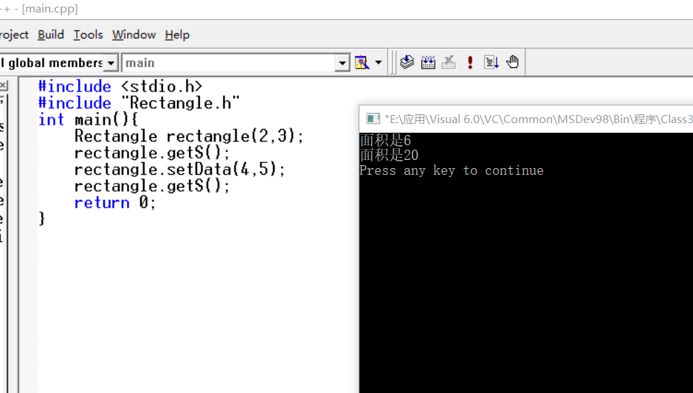

第五个类：Circle
Circle.h:
class Circle
{
public:
Circle();
Circle(float R);
float getArea();
float fetR();
virtual ~Circle();
private:
float r;

};

Circle.cpp:
#include "ircle.h"
Circle::Circle()
{
}
Circle::Circle(float R){
r=R;
}
float Circle::getArea(){
return 3.14*r*r;
}
float Circle::getR(){
return r;
}
Circle::~Circle()
{
}

main.cpp:
#include "ircle.h"
#include <iostream>
using namespace std;
int main(){
Circle c(2);
cout<<"半径为"<<c.fetR()<<"的圆的面积为"<<c.getArea()<<endl;
return 0;
}

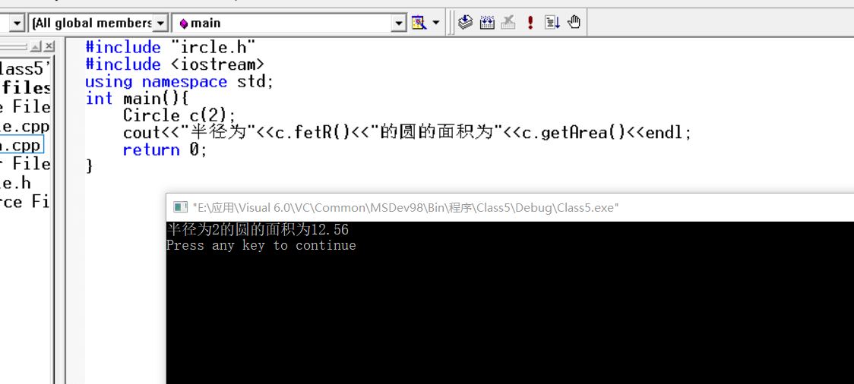
第六个类：Tree
Tree.h:
class Tree
{
public:
Tree();
Tree(int Age);
int getage();
void setAge(int age1);
virtual ~Tree();
private:
int age;
};

Tree.cpp:
#include "Tree.h"
Tree::Tree()
{
}
Tree::Tree(int Age){
age=Age;
}
int Tree::getage(){
return age;
}
void Tree::setAge(int age1){
age=age1;
}
Tree::~Tree()
{
}

main.cpp:
#include "Tree.h"
#include <iostream>
using namespace std;
int main(){
Tree tree(8);
cout<<"这棵树的年龄是"<<tree.getage()<<endl;
tree.setAge(12);
cout<<"这棵树的年龄是"<<tree.getage()<<endl;
return 0;
}
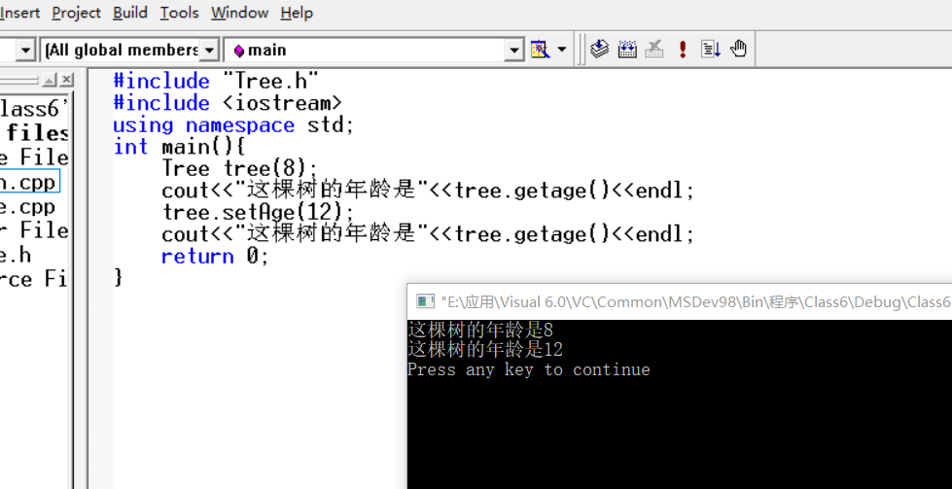

第七个类：book
book.h:
class book
{
public:
book();
book(int Page);
void setData(int Page1);
int getPage();
virtual ~book();
private:
int page;
};

Book.cpp:
#include "book.h"
book::book()
{
}
book::book(int Page){
page=Page;
}
void book::setData(int Page1){
page=Page1;
}
int book::getPage(){
return page;
}
book::~book()
{
}

main.cpp:
#include "book.h"
#include <iostream>
#include <stdlib.h>
using namespace std;
int main(){
book book1(3000);
cout<<"这本书的页数为"<<book1.getPage()<<endl;
book1.setData(2000);
cout<<"这本书的页数为"<<book1.getPage()<<endl;
return 0;
}
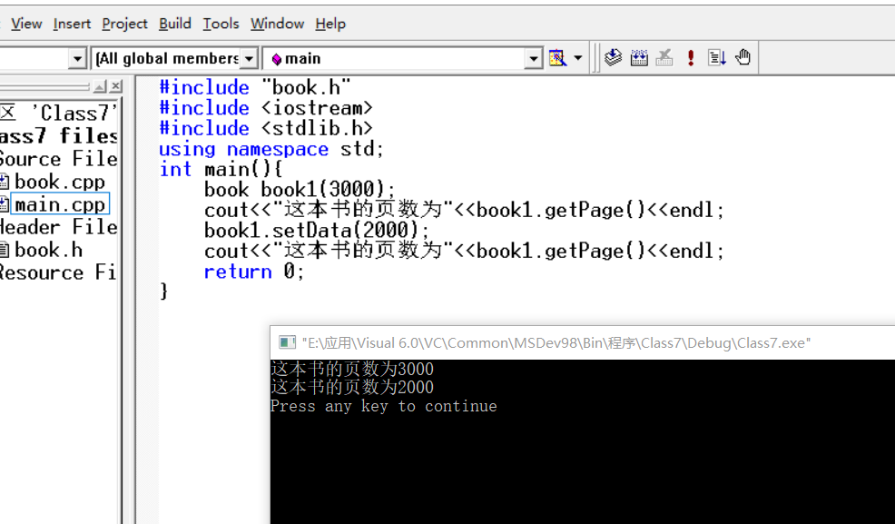

第八个类：Clock
Clock.h:
class Clock
{
public:
Clock();
Clock(int Hour,int Minute,int Second);
void setTime(int newH,int newM,int newS);
void showTime();
virtual ~Clock();
private:
int hour;
int minute;
int second;
};

Clock.cpp:
#include "lock.h"
#include <iostream>
using namespace std;
Clock::Clock()
{
}
Clock::Clock(int Hour,int Minute,int Second){
hour=Hour;
minute=Minute;
second=Second;
}
void Clock::setTime(int newH,int newM,int newS){
hour=newH;
minute=newM;
second=newS;
}
void Clock::showTime(){
cout<<"The time is"<<hour<<":"<<minute<<":"<<second<<endl;
}
Clock::~Clock()
{
}

main.cpp:
#include "lock.h"
#include <iostream>
using namespace std;
int main(){
Clock clock(12,12,12);
clock.showTime();
clock.setTime(11,11,11);
clock.showTime();
return 0;
}

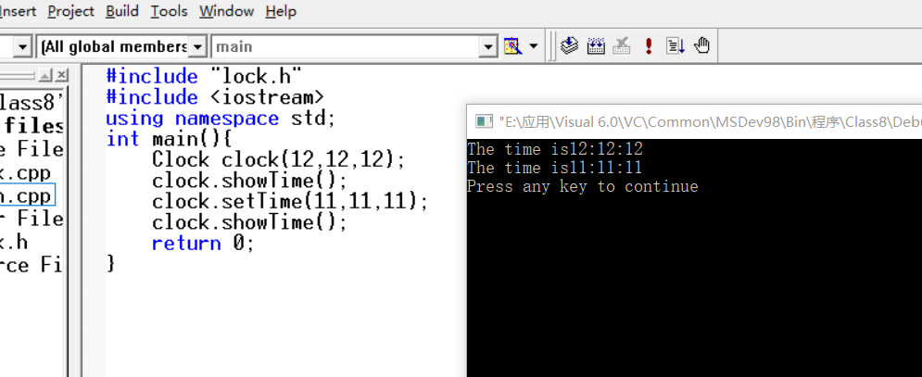

第九个类：Dog
CDog.h
class CDog
{
public:
CDog();
virtual ~CDog();
void run();
void set();
private:
char name[10];
char sex[5];
int age;

};
CDog.cpp

#include "Dog.h"
#include<cstring>
#include<iostream.h>
CDog::CDog()
{

}
void CDog::set()
{
char newName[10];
char newName[10];
char newSex[5];
int newAge;

cout<<endl<<"请输入小狗的姓名：";
cin>>newName;
cout<<endl<<"请输入小狗的性别：";
cin>>newSex;
cout<<endl<<"请输入小狗的年龄：";
cin>>newAge;
strcpy(name,newName);
strcpy(sex,newSex);
age = newAge;

}
void CDog::run()
{
cout<<"我是"<<name<<",我的性别是"<<sex<<",我今年"<<age<<",我能够跑了！";
}
CDog::~CDog()
{

}
#include "Dog.h"
#include<iostream.h>
void main()
{
CDog myDog;
myDog.set();
myDog.run();
}

第十个类：People
BirthDay.h
class BirthDay
{
public:
BirthDay();
BirthDay(int NewYear,int NewMonth,int NewDay);
BirthDay(BirthDay &d);
void setDate();
void showDate();
virtual ~BirthDay();
private:
int year;
int month;
int day;
};
BirthDay.cpp
#include "BirthDay.h"
#include<iostream.h>
BirthDay::BirthDay()
{

}
BirthDay::BirthDay(int NewYear,int NewMonth,int NewDay)
{
year = NewYear;
month = NewMonth;
day = NewDay;
}
BirthDay::BirthDay(BirthDay &d)
{
year = d.year;
month = d.month;
day = d.day;
}
void BirthDay::setDate()
{
int a,b,c;
cout<<endl<<"请输入出生年月日：";
cin>>a>>b>>c;
year = a;
month = b;
day = c;
}
void BirthDay::showDate()
{
cout<<endl<<year<<"年"<<month<<"月"<<day<<"日"<<endl;
}
BirthDay::~BirthDay()
{

}
People.h
#include "BirthDay.h"
class People
{
public:
People();
People(long num,char newSex[5],BirthDay aa,char NewID[]);
People(People &p);
void showPeople();
void inPutPeople();
virtual ~People();
private:
long number;
char sex[5];
BirthDay a;
char ID[19];
};
People.cpp

#include "People.h"
#include<iostream.h>
#include<cstring>
People::People()
{

}
People::People(long num,char newSex[],BirthDay aa,char NewID[]):a(aa)
{
number = num;
strcpy(sex,newSex);
a = aa;
strcpy(ID,NewID);
}
People::People(People &p):a(p.a)
{
number = p.number;
strcpy(sex,p.sex);
a = p.a;
strcpy(ID,p.ID);
}
void People::inPutPeople()
{
long num;
char newSex[5];
BirthDay aa;
char NewID[19];
cout<<"请输入编号：";
cin>>num;
cout<<endl<<"请输入性别：";
cin>>newSex;
aa.setDate();
cout<<endl<<"请输入身份证号码：";
cin>>NewID;

number = num;
strcpy(sex,newSex);
a = aa;
strcpy(ID,NewID);
}
void People::showPeople()
{
cout<<endl<<"number:"<<number<<endl;
cout<<"sex:"<<sex<<endl;
cout<<"birthday:";
a.showDate();

cout<<"ID Card:"<<ID<<endl;

}
People::~People()
{

}

