**Raspberry pi python sensor code explanation**

**Function introduction:**

This python code uses Ultrasonic sensor to check if the car passes the gate or not. When a car passes into the underground parking place, free parking places will minus one, and if a car passes out the underground parking place, free parking places will plus one. And then the number of free parking place will timely upload to the database. These data will offer for the android app and the website displaying.

**Ultrasonic sensor and raspberry pi introduction:**

**Ultrasonic sensor:** this sensor can launch ultrasonic and receive ultrasonic. Because the speed of ultrasonic in air is 343m/s. So we can record time spending when the ultrasonic launched and received. The formula is : Distance = (receive_time – launch_time)*343/2.

**Raspberry pi:** we use 14 and 15 ports (raspberry pi) to control the ultrasonic sensor in python code (line 14/15). In code line 21-38, there is a function using pi to control the sensor measuring the distance. If nothing is in front of the sensor(nothing can reflect the Ultrasonic), this function will return the WRONG/DEFAULT distance(>=2000cm), so if this data appeared, it means nothing in front of the sensor. And then we will analysis the distance to confirm the car passes or not in main code.

**Code file name: new_entrance.py**

1. **The location of the pie and the direction of sensor:**

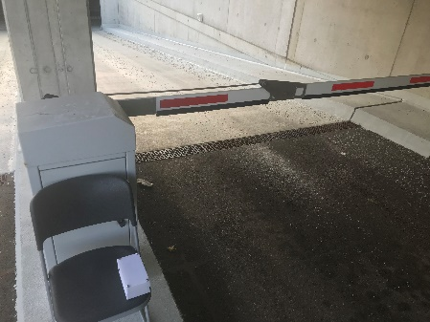 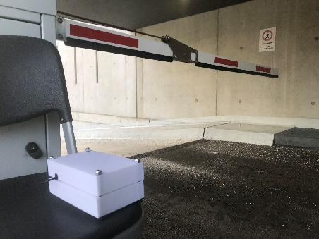

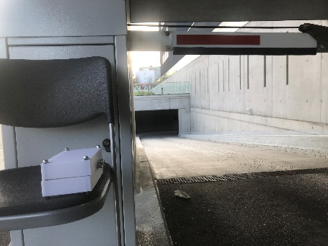 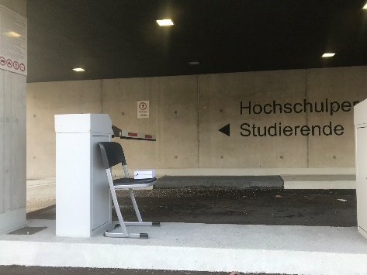

1. **flow chart**

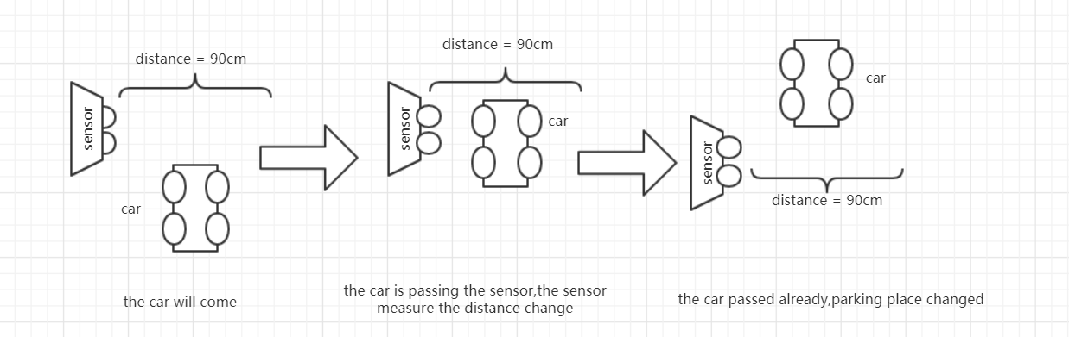

1. **Unexpected situation solution:**

If the sensor stops working, you can see the log file (**underground_entrance_log.txt**)to check the data. This file will record the time when the car passes and some useful data.

1. **Algorithm explanation:**

I use two states to confirm the car passes or not. The first one checks the car is in front of the sensor. The second one checks the car already passed the sensor. Every state I will use sensor check twice. And only if two states return True, the program is allowed to change the free parking place and changes it in the database. The data in code line 53/61/71/79 is the real distance between the sensor and the gate.