Auto-script to batch process TV.

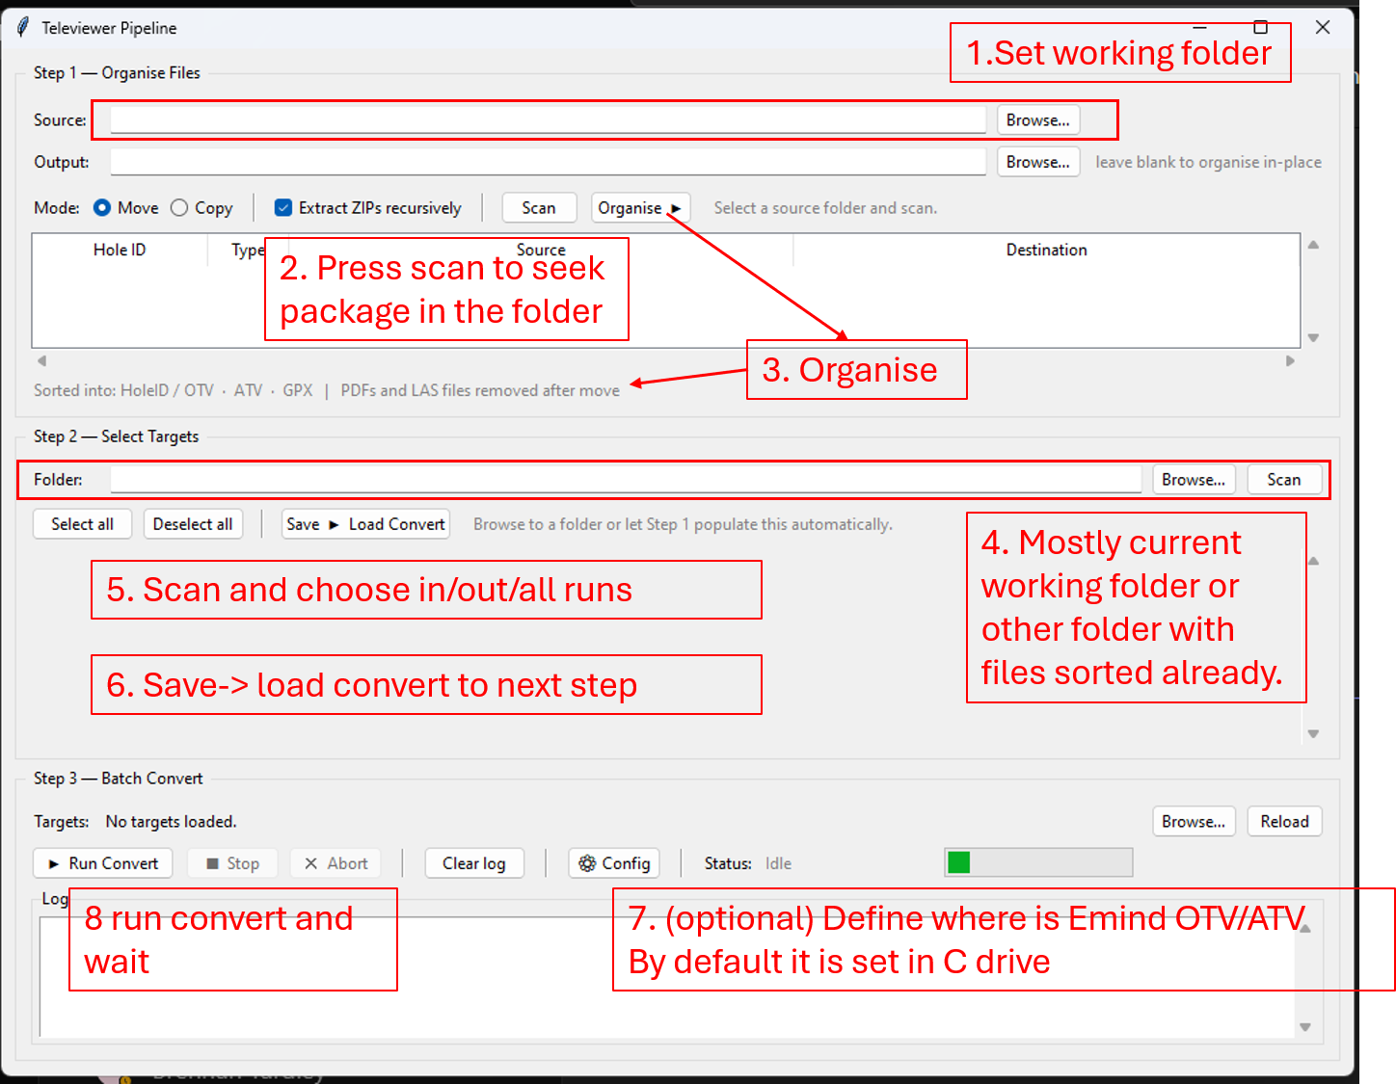
- Set working folder
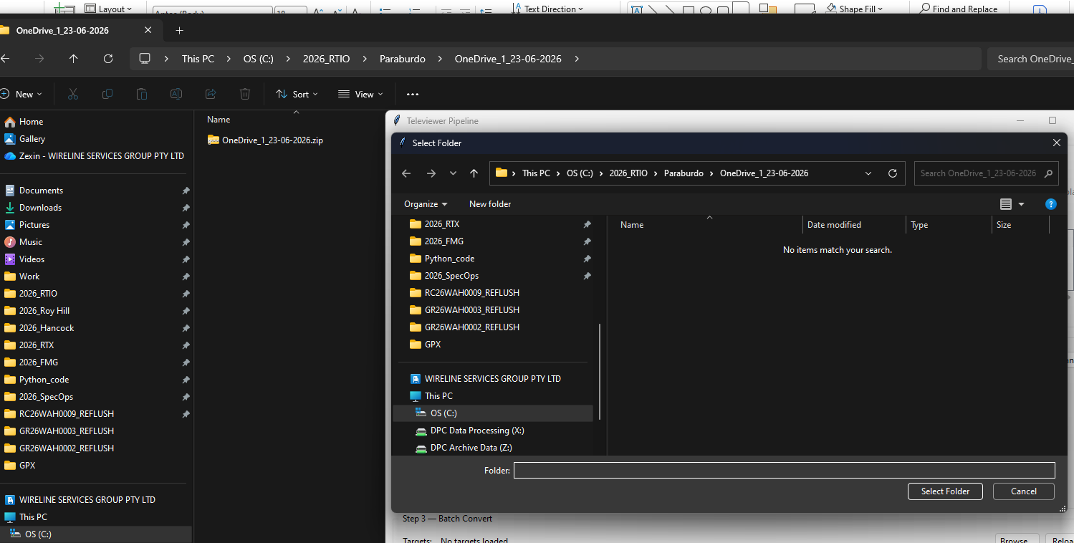
- Scan to look for holes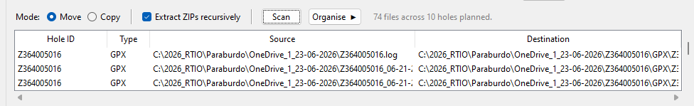
- Press organise so that holes are presented by hole_id and certain folder structure
- Set to the working folder
- Pick in/out or all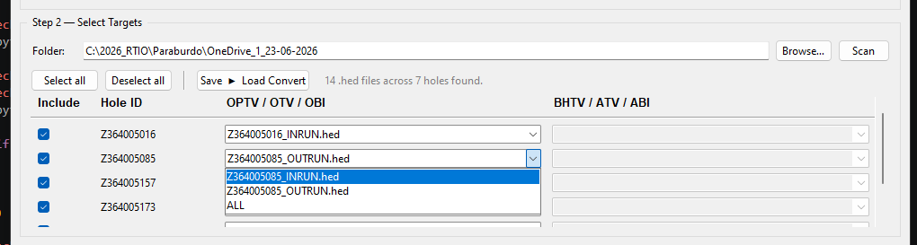
- Sace -> load content will record the selection
- Config TV software path. The defaults are set as follows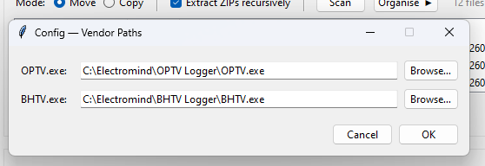
- Hit run, and it will take some time. Since it is click-based, using your desktop now may interrupt the process.

