19.2.2
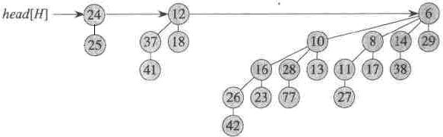

19.2.3
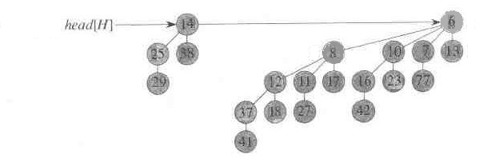

19.2.6
BINOMIAL-HEAP-DELETE(H,x)
1 z = sibling[head[H]]
2 min = key[head[H]]
3 while z ≠ NIL
4 do if key[z] < min
5 then min = key[z]
6 z = sibling[z]
7 BINOMIAL-HEAP-DECREASE-KEY(H,x,min-1)
8 BINOMIAL-HEAP-EXTRACT-MIN(H)
找最小值的复杂度为O(lgn)，BINOMIAL-HEAP-DELETE的复杂度为O(lgn)

