16.1.1
We are asked to come up with a dynamic programming formulation of the activity selection problem. First, we will clarify some notation.
1. S_{ij} is the set of mutually compatible activities. Activities a_{x} and a_{y} are compatible if s_{y}≥f_{x} or
s_{x}≥f_{y}. Thus S_{ij} = {a_{k} ∈ S : f_{i} ≤ s_{k} < f_{k} ≤s_{j}}.
2. c[i, j] = |S_{ij} |
Now we can clearly see the reasoning behind equation 16.3, the recursive formula for the activity selection problem:
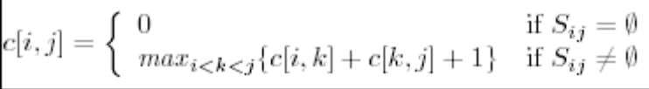
Since we have n activities in S, our matrix is an n × n matrix. Consider the following algorithm based on the above recursive formula:
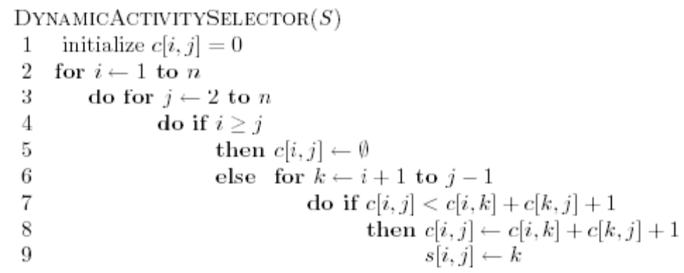
Thus, the running time of our algorithm is O(n³). In order to print the activity solution, we use a recursive algorithm that runs in linear time, and use the s[i, j] matrix to find the activity we included at any given step. Since the recursive greedy activity selector runs in linear time, it is clearly more efficient than the dynamic programming version.

16.1.3
Find the smallest number of lecture halls to schedule a set of activities S in. To do this efficiently move through the activities according to starting and finishing times. Maintain two lists of lecture halls: Halls that are busy at time t and halls that are free at time t. When t is the starting time for some activity schedule this activity to a free lecture hall and move the hall to the busy list. Similarly, move the hall to the free list when the activity stops. Initially start with zero halls. If there are no halls in the free list create a new hall.
The above algorithm uses the fewest number of halls possible: Assume the algorithm used m halls. Consider some activity a that was the first scheduled activity in lecture hall m. i was put in the mth hall because all of the m – 1 halls were busy, that is, at the time a is scheduled there are m activities occuring simultaneously. Any algorithm must therefore use at least m halls, and the algorithm is thus optimal.

The algorithm can be implemented by sorting the activities. At each start or finish time we can schedule the activities and move the halls between the lists in constant time. The total time is thus dominated by sorting and is therefore Θ(n lg n).

说明：本题直接调用书上的算法GREDDY-ACTIVITY-SELECTOR()来求是不对的，因为算法GREDDY-ACTIVITY-SELECTOR()求解的目标是同一个Halls可能容纳的活动数目最大，这就可能导致第一个Halls所选择的活动数目最多，但是时间利用率却较低，比如下面的实例：
i | 1 | 2 | 3 | 4 | 5 | 6 | 7
s | 0 | 0 | 3 | 4 | 7 | 8 | 6
f | 3 | 4 | 5 | 7 | 8 | 9 | 9
按算法GREDDY-ACTIVITY-SELECTOR()最后的结果是需要三个Halls,而事实上只需要两个就够了。

对于这种写算法的题目请大家一定要先写算法思想，然后再写伪码，而且伪码里面要有一定的注释，否则只写一段程序让别人怎么能读懂你的意思！

