首先在gitbash中输入ssh-keygen

然后复制生成文件中的内容，拷贝到key

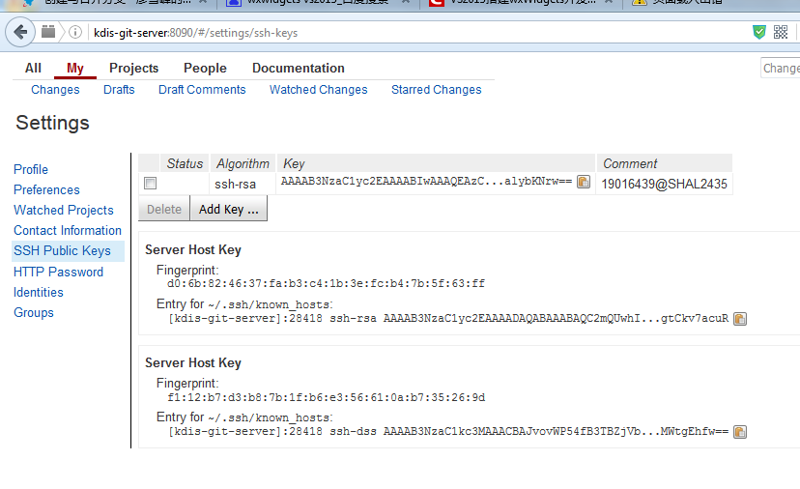

在这里注册邮箱

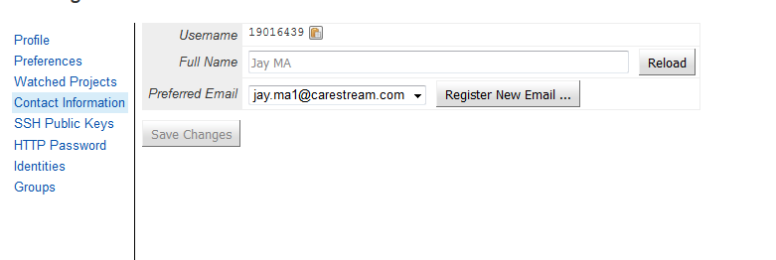

找到Url，在http://10.112.37.192:8080/ 进入项目配置，配置 搜索git

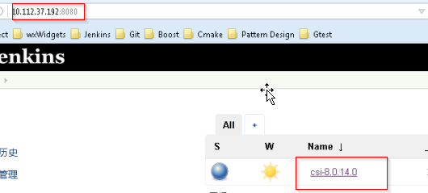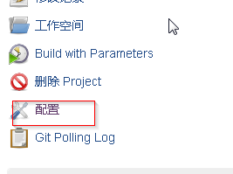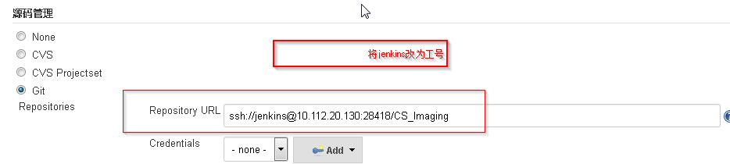

将jenkins改为自己的账号，也就是工号。

http://kdis-git-server:8090/login/

\\shgwp1009\CSHRDESOFTW\GIT

http://kdis-pc:8080/

命令：

git config --global user.name "19016439"

git config --global user.email "jay.ma1@carestream.com"

git config --global branch.autosetuprebase always

git pull origin master

git push origin HEAD:refs/for/master

scp -p -P 28418 19016439@kdis-git-server:hooks/commit-msg .git/hooks/

git clone ssh://19016439@10.112.20.130:28418/CS_Imaging

git commit -a -m "test git account"

<http://kdis-git-server:8090>

<http://kdis-pc:8080>

操作记录

19016439@shal2435 MINGW64 /d/Csi8

$ git clone

You must specify a repository to clone.

usage: git clone [<options>] [--] <repo> [<dir>]

-v, --verbose be more verbose

-q, --quiet be more quiet

--progress force progress reporting

-n, --no-checkout don't create a checkout

--bare create a bare repository

--mirror create a mirror repository (implies bare)

-l, --local to clone from a local repository

--no-hardlinks don't use local hardlinks, always copy

-s, --shared setup as shared repository

--recursive initialize submodules in the clone

--recurse-submodules initialize submodules in the clone

--template <template-directory>

directory from which templates will be used

--reference <repo> reference repository

--dissociate use --reference only while cloning

-o, --origin <name> use <name> instead of 'origin' to track upstream

-b, --branch <branch>

checkout <branch> instead of the remote's HEAD

-u, --upload-pack <path>

path to git-upload-pack on the remote

--depth <depth> create a shallow clone of that depth

--single-branch clone only one branch, HEAD or --branch

--separate-git-dir <gitdir>

separate git dir from working tree

-c, --config <key=value>

set config inside the new repository

-4, --ipv4 use IPv4 addresses only

-6, --ipv6 use IPv6 addresses only

19016439@shal2435 MINGW64 /d/Csi8

$ git clone ssh://19016439@10.112.20.130:28418/CS_Imaging

Cloning into 'CS_Imaging'...

The authenticity of host '[10.112.20.130]:28418 ([10.112.20.130]:28418)' can't be established.

RSA key fingerprint is SHA256:UFcuRhb0+210odc74Wz3WDKmqY5JJjegbXkhR1Tah50.

Are you sure you want to continue connecting (yes/no)? yes

Warning: Permanently added '[10.112.20.130]:28418' (RSA) to the list of known hosts.

remote: Counting objects: 120074, done

remote: Finding sources: 100% (120074/120074)

remote: Total 120074 (delta 78293), reused 120017 (delta 78293)

Receiving objects: 100% (120074/120074), 1.75 GiB | 9.27 MiB/s, done.

Resolving deltas: 100% (78293/78293), done.

Checking connectivity... done.

Checking out files: 100% (26221/26221), done.

19016439@shal2435 MINGW64 /d/Csi8

$ git config --global user.name "19016439"

19016439@shal2435 MINGW64 /d/Csi8

$ git config -l

core.symlinks=false

core.autocrlf=true

core.fscache=true

color.diff=auto

color.status=auto

color.branch=auto

color.interactive=true

help.format=html

http.sslcainfo=C:/Program Files/Git/mingw64/ssl/certs/ca-bundle.crt

diff.astextplain.textconv=astextplain

rebase.autosquash=true

credential.helper=manager

user.name=19016439

19016439@shal2435 MINGW64 /d/Csi8

$ git config --global user.email "jay.ma1@carestream.com"

19016439@shal2435 MINGW64 /d/Csi8

$ git config --global branch.autosetuprebase always

19016439@shal2435 MINGW64 /d/Csi8

$ git remote -v

fatal: Not a git repository (or any of the parent directories): .git

19016439@shal2435 MINGW64 /d/Csi8

$ git remote -l

fatal: Not a git repository (or any of the parent directories): .git

19016439@shal2435 MINGW64 /d/Csi8

$ cd CS_Imaging/

19016439@shal2435 MINGW64 /d/Csi8/CS_Imaging (master)

$ git remote -v

origin ssh://19016439@10.112.20.130:28418/CS_Imaging (fetch)

origin ssh://19016439@10.112.20.130:28418/CS_Imaging (push)

19016439@shal2435 MINGW64 /d/Csi8/CS_Imaging (master)

$ start .

19016439@shal2435 MINGW64 /d/Csi8/CS_Imaging (master)

$ git status

On branch master

Your branch is up-to-date with 'origin/master'.

Changes not staged for commit:

(use "git add <file>..." to update what will be committed)

(use "git checkout -- <file>..." to discard changes in working directory)

modified: 2DViewer/Build Instructions.txt

no changes added to commit (use "git add" and/or "git commit -a")

19016439@shal2435 MINGW64 /d/Csi8/CS_Imaging (master)

$ git commit -a -m "test git account"

[master b5115ae] test git account

1 file changed, 4 insertions(+), 4 deletions(-)

19016439@shal2435 MINGW64 /d/Csi8/CS_Imaging (master)

$ git push origin HEAD:refs/for/master

Counting objects: 4, done.

Delta compression using up to 4 threads.

Compressing objects: 100% (4/4), done.

Writing objects: 100% (4/4), 415 bytes | 0 bytes/s, done.

Total 4 (delta 2), reused 0 (delta 0)

remote: Resolving deltas: 100% (2/2)

remote: Processing changes: refs: 1, done

remote: ERROR: missing Change-Id in commit message footer

remote: Suggestion for commit message:

remote: test git account

remote:

remote: Change-Id: Ib5115ae8ddb3d8a427df2676122f06043cb6e259

remote:

remote: Hint: To automatically insert Change-Id, install the hook:

remote: gitdir=$(git rev-parse --git-dir); scp -p -P 28418 19016439@kdis-git-server:hooks/commit-msg ${gitdir}/hooks/

remote:

remote:

To ssh://19016439@10.112.20.130:28418/CS_Imaging

! [remote rejected] HEAD -> refs/for/master (missing Change-Id in commit message footer)

error: failed to push some refs to 'ssh://19016439@10.112.20.130:28418/CS_Imaging'

19016439@shal2435 MINGW64 /d/Csi8/CS_Imaging (master)

$ scp -p -P 28418 19016439@kdis-git-server:hooks/commit-msg .git/hooks/

The authenticity of host '[kdis-git-server]:28418 ([10.112.20.130]:28418)' can't be established.

RSA key fingerprint is SHA256:UFcuRhb0+210odc74Wz3WDKmqY5JJjegbXkhR1Tah50.

Are you sure you want to continue connecting (yes/no)? yes

Warning: Permanently added '[kdis-git-server]:28418' (RSA) to the list of known hosts.

commit-msg 100% 4363 4.3KB/s 00:00

19016439@shal2435 MINGW64 /d/Csi8/CS_Imaging (master)

$ git push origin HEAD:refs/for/master

Counting objects: 4, done.

Delta compression using up to 4 threads.

Compressing objects: 100% (4/4), done.

Writing objects: 100% (4/4), 415 bytes | 0 bytes/s, done.

Total 4 (delta 2), reused 0 (delta 0)

remote: Resolving deltas: 100% (2/2)

remote: Processing changes: refs: 1, done

remote: ERROR: missing Change-Id in commit message footer

remote: Suggestion for commit message:

remote: test git account

remote:

remote: Change-Id: Ib5115ae8ddb3d8a427df2676122f06043cb6e259

remote:

remote: Hint: To automatically insert Change-Id, install the hook:

remote: gitdir=$(git rev-parse --git-dir); scp -p -P 28418 19016439@kdis-git-server:hooks/commit-msg ${gitdir}/hooks/

remote:

remote:

To ssh://19016439@10.112.20.130:28418/CS_Imaging

! [remote rejected] HEAD -> refs/for/master (missing Change-Id in commit message footer)

error: failed to push some refs to 'ssh://19016439@10.112.20.130:28418/CS_Imaging'

19016439@shal2435 MINGW64 /d/Csi8/CS_Imaging (master)

$ ^C

19016439@shal2435 MINGW64 /d/Csi8/CS_Imaging (master)

$ git commit --ament --no-edit

error: unknown option `ament'

usage: git commit [<options>] [--] <pathspec>...

-q, --quiet suppress summary after successful commit

-v, --verbose show diff in commit message template

Commit message options

-F, --file <file> read message from file

--author <author> override author for commit

--date <date> override date for commit

-m, --message <message>

commit message

-c, --reedit-message <commit>

reuse and edit message from specified commit

-C, --reuse-message <commit>

reuse message from specified commit

--fixup <commit> use autosquash formatted message to fixup specified commit

--squash <commit> use autosquash formatted message to squash specified commit

--reset-author the commit is authored by me now (used with -C/-c/--amend)

-s, --signoff add Signed-off-by:

-t, --template <file>

use specified template file

-e, --edit force edit of commit

--cleanup <default> how to strip spaces and #comments from message

--status include status in commit message template

-S, --gpg-sign[=<key-id>]

GPG sign commit

Commit contents options

-a, --all commit all changed files

-i, --include add specified files to index for commit

--interactive interactively add files

-p, --patch interactively add changes

-o, --only commit only specified files

-n, --no-verify bypass pre-commit hook

--dry-run show what would be committed

--short show status concisely

--branch show branch information

--porcelain machine-readable output

--long show status in long format (default)

-z, --null terminate entries with NUL

--amend amend previous commit

--no-post-rewrite bypass post-rewrite hook

-u, --untracked-files[=<mode>]

show untracked files, optional modes: all, normal, no. (Default: all)

19016439@shal2435 MINGW64 /d/Csi8/CS_Imaging (master)

$ git commit --amend --no-edit

[master ebc47ee] test git account

Date: Tue Apr 26 01:26:33 2016 -0400

1 file changed, 4 insertions(+), 4 deletions(-)

19016439@shal2435 MINGW64 /d/Csi8/CS_Imaging (master)

$ git log

commit ebc47ee5358f9f2d5512306872711b654c4a82cc

Author: 19016439 <jay.ma1@carestream.com>

Date: Tue Apr 26 01:26:33 2016 -0400

test git account

Change-Id: I2eb4d551df0213ebba2fbcf5f2b789fa5a5d2942

commit 54261346fe83f0125d4f4f5fe483d085162845e6

Author: 19010602 <changxiong.chen@carestream.com>

Date: Tue Apr 26 10:47:38 2016 +0800

add tool tip to all image button

Change-Id: Icadbb79b16c897b3f6fd1dc3e0e6061a680dbd85

commit 2c8f0ce6c9175b50e15f9373b535aa9b813e44ed

Author: 19010744 <pengxian.li@carestream.com>

Date: Mon Apr 25 16:18:17 2016 +0800

2D SDK improvement:

1. Add external instance uid for presentation state.

2. Add functions Sdk2D_LoadGeneralStateFromFile & Sdk2D_SaveGeneralStateToFile

3. Fix defect of Sdk2D_SaveGroupToFile: windows error message appear if have no access to output directory.

:

19016439@shal2435 MINGW64 /d/Csi8/CS_Imaging (master)

$ git push origin HEAD:refs/for/master

Counting objects: 4, done.

Delta compression using up to 4 threads.

Compressing objects: 100% (4/4), done.

Writing objects: 100% (4/4), 459 bytes | 0 bytes/s, done.

Total 4 (delta 2), reused 0 (delta 0)

remote: Resolving deltas: 100% (2/2)

remote: Processing changes: new: 1, refs: 1, done

remote:

remote: New Changes:

remote: http://kdis-git-server:8090/274

remote:

To ssh://19016439@10.112.20.130:28418/CS_Imaging

* [new branch] HEAD -> refs/for/master

19016439@shal2435 MINGW64 /d/Csi8/CS_Imaging (master)

$ ^C

19016439@shal2435 MINGW64 /d/Csi8/CS_Imaging (master)

$