# 数据库第二次实验

1.

SELECT dept.deptno,COUNT(empno)  
FROM dept LEFT OUTER JOIN emp ON   
(dept.deptno=emp.deptno)  
GROUP BY dept.deptno  
ORDER BY dept.deptno ASC;

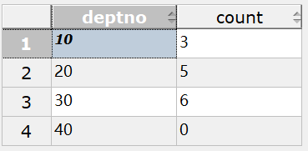

2.

SELECT mgr,COUNT(empno)   
FROM emp  
WHERE mgr is NOT NULL  
GROUP BY mgr;

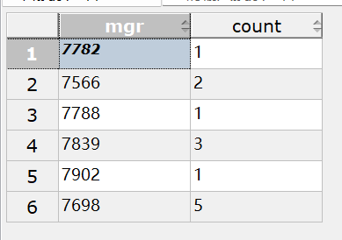

3.

SELECT empno,date_part('year',age(now(),hiredate)) AS hire_age  
from emp   
where hiredate=   
(  
SELECT min(hiredate)  
from emp  
);

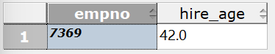

4.

SELECT deptno,AVG(sal)  
FROM emp  
GROUP BY deptno   
HAVING AVG(sal)>2000;

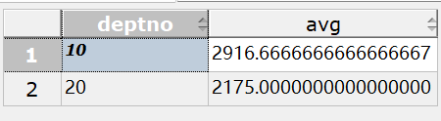

5.

SELECT min(sal)  
FROM emp  
GROUP BY deptno,job  
ORDER BY deptno ASC,job DESC;

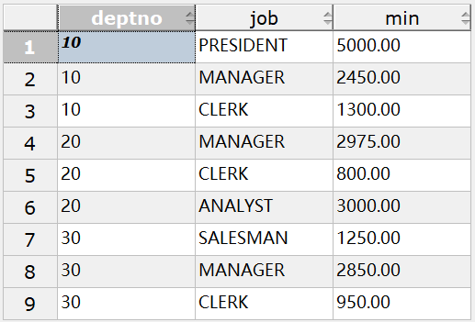

6.

SELECT empno,ename  
FROM emp  
WHERE ename LIKE 'S%' OR ename LIKE '%S';

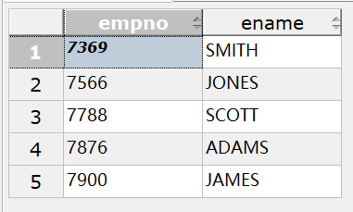

7.

SELECT deptno,empno,ename  
FROM emp  
WHERE sal IN  
(SELECT MAX(sal)  
FROM emp  
GROUP BY deptno  
)  
ORDER BY deptno ASC,empno ASC;

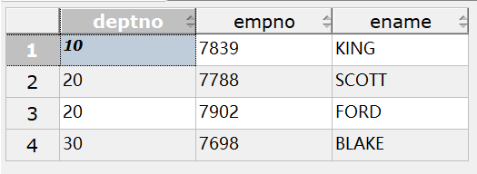

8.

SELECT *   
from emp   
where 4=   
(   
SELECT grade   
from salgrade   
where emp.sal   
BETWEEN salgrade.losal AND salgrade.hisal   
);

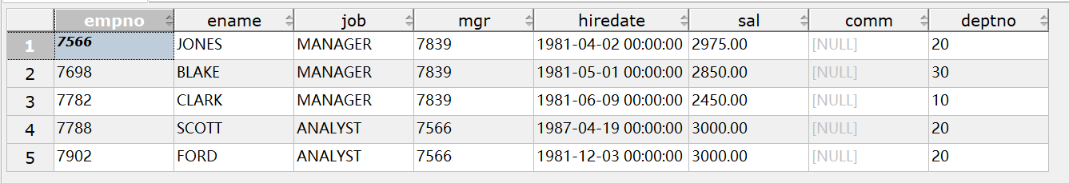

9.

--连接  
SELECT X.*  
FROM emp X,emp Y  
WHERE X.ename!='SMITH' AND X.deptno=Y.deptno  
AND X.job=Y.job AND Y.ename='SMITH';

--嵌套  
SELECT *  
FROM emp   
where ename!='SMITH'   
AND (deptno,job) IN  
(SELECT deptno,job  
FROM emp   
WHERE ename='SMITH')



10.

--连接  
SELECT ROUND(AVG(sal),2) AvgSal  
FROM emp,dept  
WHERE emp.deptno=dept.deptno AND dept.loc='NEW YORK';

--嵌套  
SELECT ROUND(AVG(sal),2) AvgSal  
FROM emp  
WHERE deptno IN  
(  
SELECT deptno  
FROM dept  
WHERE loc='NEW YORK'  
);



11.

SELECT X.*   
FROM emp X   
WHERE X.sal>   
(   
SELECT AVG(Y.sal)   
FROM emp Y   
WHERE x.deptno=Y.deptno   
);

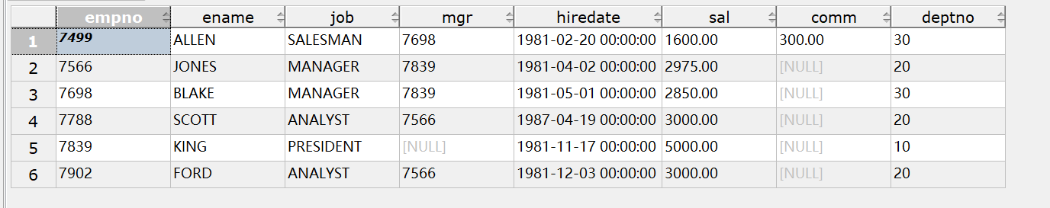

12.

SELECT salgrade.grade,COUNT(emp.empno)   
FROM emp,salgrade   
WHERE emp.sal BETWEEN salgrade.losal AND salgrade.hisal   
GROUP BY salgrade.grade;

