1.

**INSERT**

**INTO** books

**VALUES**(110,'Fundamentals of Database Systems',

'Ramez Elmasri',2011,'textbook');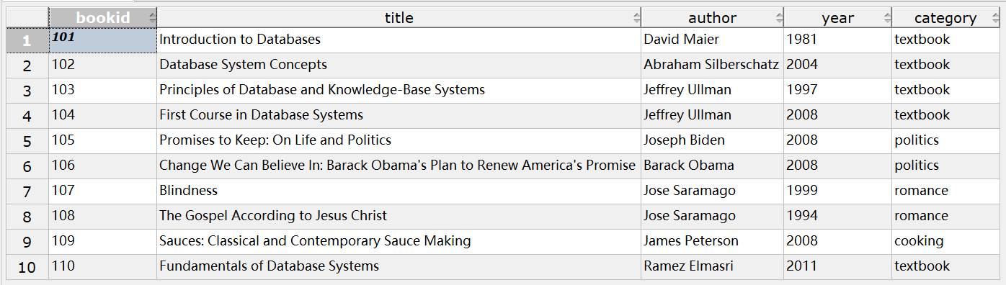

image-20230407173941365

**UPDATE** books

**SET** **year=**2012

**WHERE** bookid**=**110;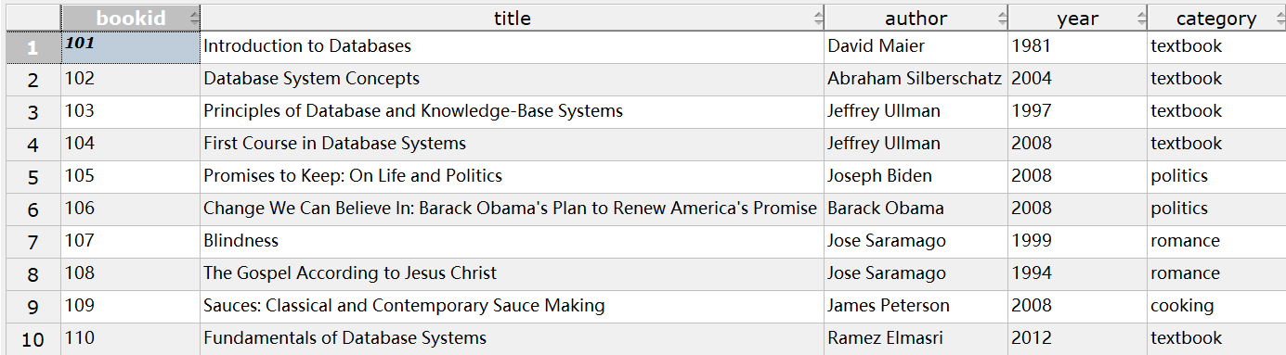

image-20230407174338315

**DELETE**

**FROM** books

**WHERE** bookid**=**110;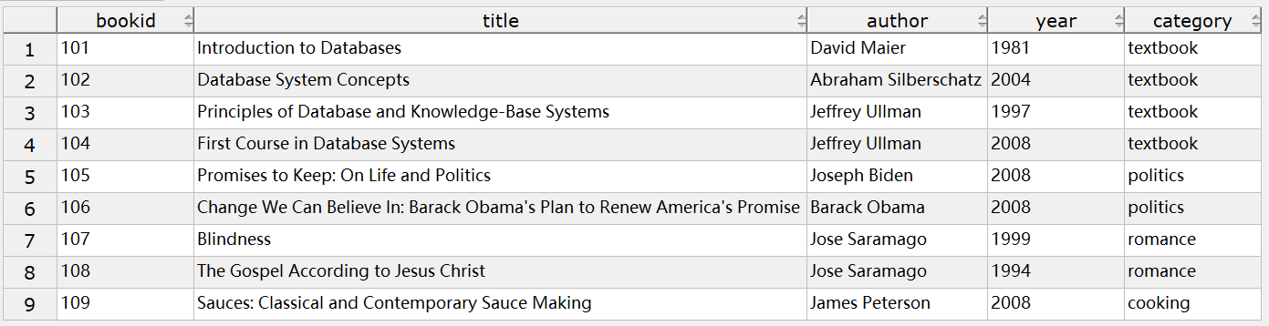

image-20230407174540934

2.

**CREATE** **VIEW** cus_book1(customer_id,book_name,**cost**)

**AS**

**SELECT** cid,title,pprice

**FROM** purchases,books

**WHERE** books.bookid**=**purchases.bookid;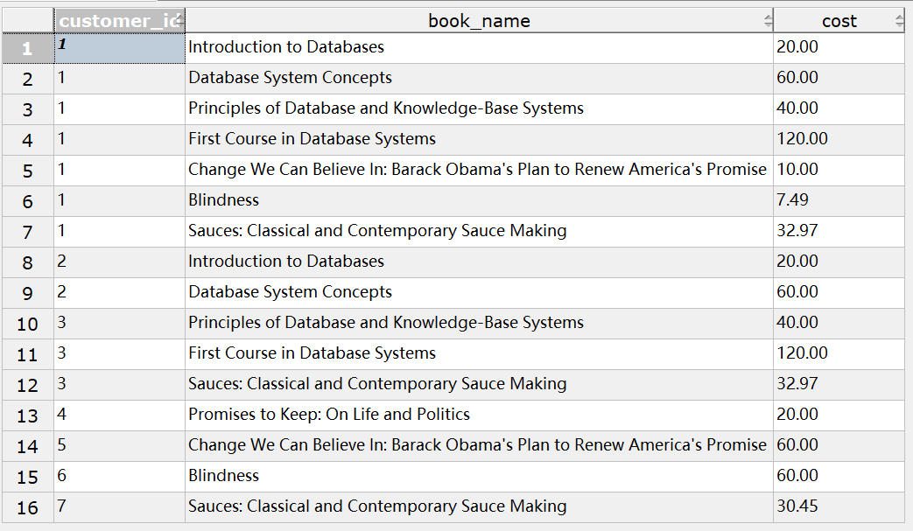

image-20230413214221023

3.

**CREATE** **VIEW** young_cus

**AS**

**SELECT** **\***

**FROM** customers

**WHERE** age **BETWEEN** 18 **AND** 35;

**SELECT** **\***

**FROM** young_cus;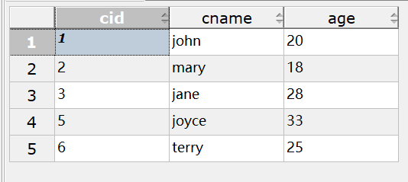

image-20230407180002981

4.

**CREATE** **VIEW** cus_book2(customer_id,customer_name,total_cost)

**AS**

**SELECT** customer_id,cname,SUM(**cost**)

**FROM** cus_book1,customers

**WHERE** customers.cid**=**cus_book1.customer_id**GROUP** **BY** customer_id,cname;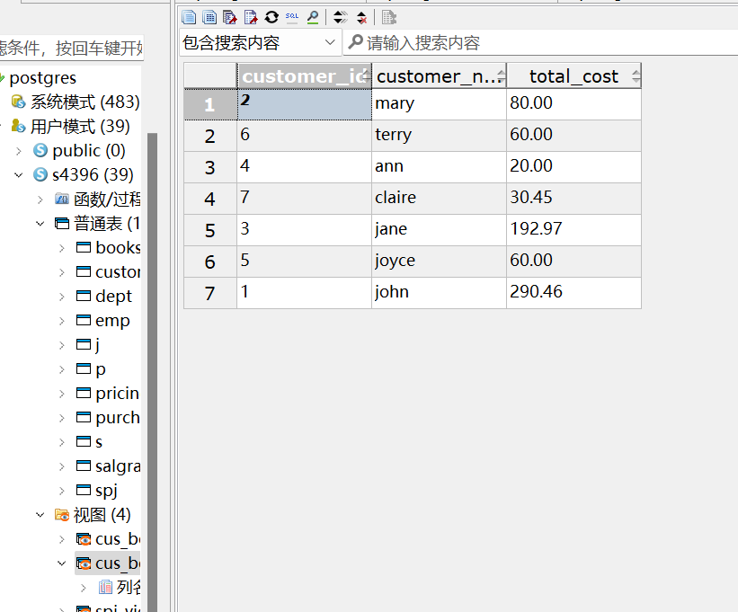

image-20230413203453473

4.(1)

**SELECT** **\***

**FROM** cus_book2

**ORDER** **BY** total_cost **DESC**;

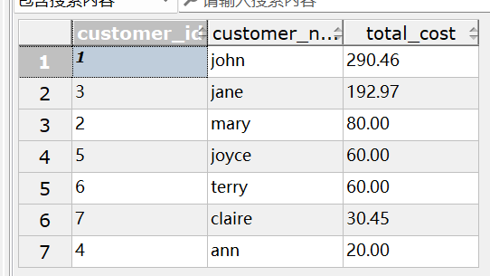

image-20230413203528054

4.(2)**DROP** **VIEW** cus_book1 **CASCADE**;

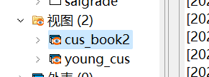

4.(3)

**SELECT** **\***

**FROM** cus_book2

**ORDER** **BY** total_cost **DESC**;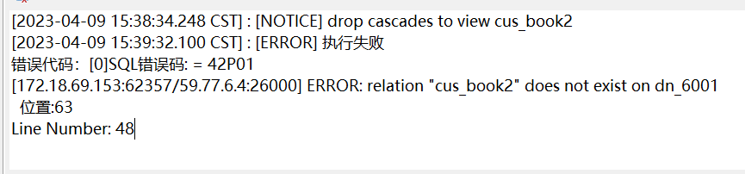

image-20230409154004049

查询视图cus_book2时出现报错，使用cascade删除cus_book1时基于此视图的cus_book2视图失效，但是cus_book2的定义并没有被删除

5.

**ALTER** **TABLE** customers **ADD** YOB **INTEGER**;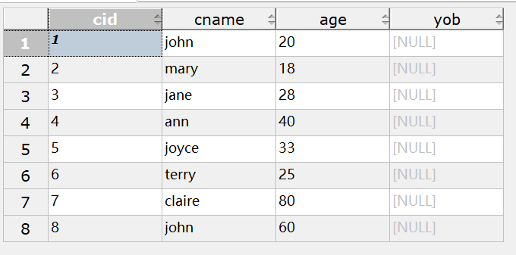

image-20230409155536912

6.

**UPDATE** customers

**SET** YOB**=**date_part('year',now())**-**age;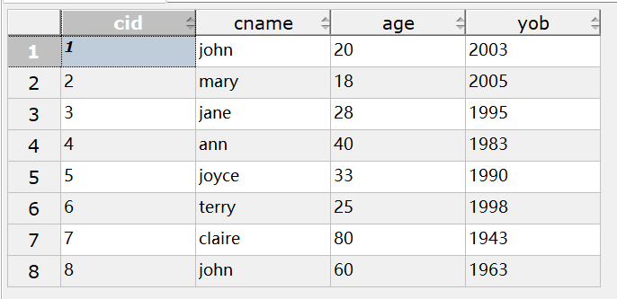

image-20230409160425150

7.

**SELECT** **\*FROM** young_cus;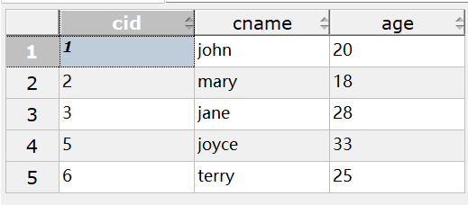

image-20230409160611935

查询结果和之前没有区别，因为根据young_cus的定义该视图不包括新增加的列

8.

4.

**CREATE** **TABLE** S

(SNO **CHAR**(4) **PRIMARY** **KEY**,

SNAME **VARCHAR**(20),

STATUS **INTEGER**,

CITY **VARCHAR**(8)

);

**INSERT** **INTO** S **VALUES**('S1','精益',20,'天津');

**INSERT** **INTO** S **VALUES**('S2','盛锡',10,'北京');

**INSERT** **INTO** S **VALUES**('S3','东方红',30,'北京');

**INSERT** **INTO** S **VALUES**('S4','丰泰盛',20,'天津');

**INSERT** **INTO** S **VALUES**('S5','为民',30,'上海');

**CREATE** **TABLE** P

(PNO **CHAR**(4) **PRIMARY** **KEY**,

PNAME **VARCHAR**(20),

COLOR **CHAR**(4),

WEIGHT **INTEGER**

);

**INSERT** **INTO** P **VALUES**('P1','螺母','红',12);

**INSERT** **INTO** P **VALUES**('P2','螺栓','绿',17);

**INSERT** **INTO** P **VALUES**('P3','螺丝刀','蓝',14);

**INSERT** **INTO** P **VALUES**('P4','螺丝刀','红',14);

**INSERT** **INTO** P **VALUES**('P5','凸轮','蓝',40);

**INSERT** **INTO** P **VALUES**('P6','齿轮','红',30);

**CREATE** **TABLE** J

(JNO **CHAR**(4) **PRIMARY** **KEY**,

JNAME **VARCHAR**(20),

CITY **VARCHAR**(8)

);

**INSERT** **INTO** J **VALUES**('J1','三建','北京');

**INSERT** **INTO** J **VALUES**('J2','一汽','长春');

**INSERT** **INTO** J **VALUES**('J3','弹簧厂','天津');

**INSERT** **INTO** J **VALUES**('J4','造船厂','天津');

**INSERT** **INTO** J **VALUES**('J5','机车厂','唐山');

**INSERT** **INTO** J **VALUES**('J6','无线电厂','常州');

**INSERT** **INTO** J **VALUES**('J7','半导体厂','南京');

**CREATE** **TABLE** SPJ

(SNO **CHAR**(4),

PNO **CHAR**(4),

JNO **CHAR**(4),

QTY **INTEGER**,

**PRIMARY** **KEY** (SNO,PNO,JNO),

**FOREIGN** **KEY** (SNO) **REFERENCES** S(SNO),

**FOREIGN** **KEY** (PNO) **REFERENCES** P(PNO),

**FOREIGN** **KEY** (JNO) **REFERENCES** J(JNO)

);

**INSERT** **INTO** SPJ **VALUES**('S1','P1','J1',200);

**INSERT** **INTO** SPJ **VALUES**('S1','P1','J3',100);

**INSERT** **INTO** SPJ **VALUES**('S1','P1','J4',700);

**INSERT** **INTO** SPJ **VALUES**('S1','P2','J2',100);

**INSERT** **INTO** SPJ **VALUES**('S2','P3','J1',400);

**INSERT** **INTO** SPJ **VALUES**('S2','P3','J2',200);

**INSERT** **INTO** SPJ **VALUES**('S2','P3','J4',500);

**INSERT** **INTO** SPJ **VALUES**('S2','P3','J5',400);

**INSERT** **INTO** SPJ **VALUES**('S2','P5','J1',400);

**INSERT** **INTO** SPJ **VALUES**('S2','P5','J2',100);

**INSERT** **INTO** SPJ **VALUES**('S3','P1','J1',200);

**INSERT** **INTO** SPJ **VALUES**('S3','P3','J1',200);

**INSERT** **INTO** SPJ **VALUES**('S4','P5','J1',100);

**INSERT** **INTO** SPJ **VALUES**('S4','P6','J3',300);

**INSERT** **INTO** SPJ **VALUES**('S4','P6','J4',200);

**INSERT** **INTO** SPJ **VALUES**('S5','P2','J4',100);

**INSERT** **INTO** SPJ **VALUES**('S5','P3','J1',200);

**INSERT** **INTO** SPJ **VALUES**('S5','P6','J2',200);

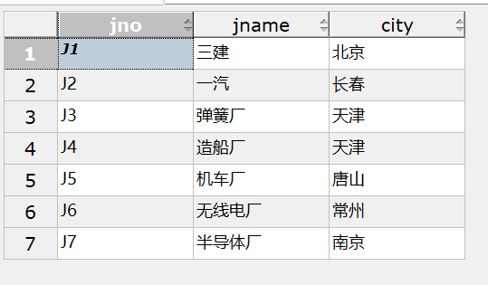**INSERT** **INTO** SPJ **VALUES**('S5','P6','J4',500); 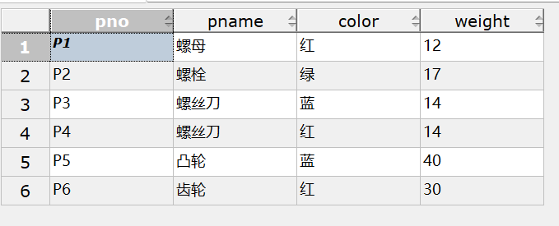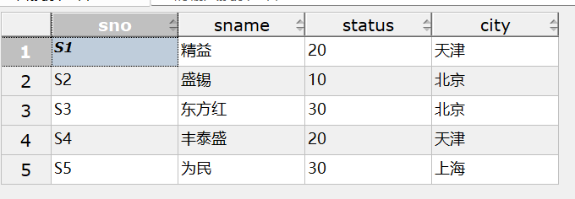

image-20230409164137996

image-20230409164444102

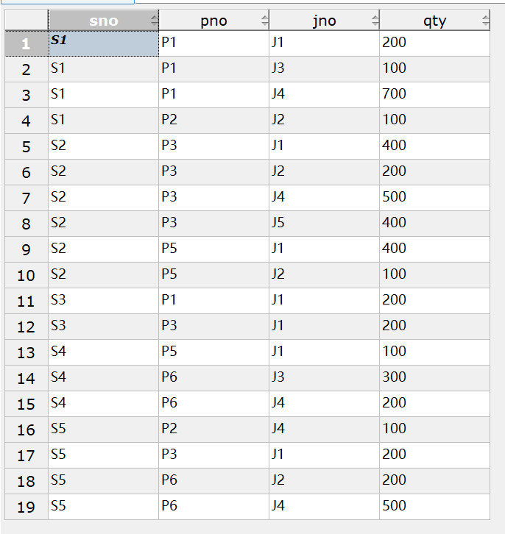

image-20230409164456363

(1)

**SELECT** **DISTINCT** SNO

**FROM** spj

**WHERE** JNO**=**'J1';

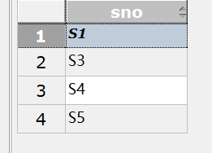

(2)

三者构成主码

**SELECT** SNO

**FROM** spj

**WHERE** JNO**=**'J1' **AND** PNO**=**'P1';

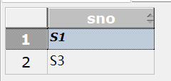

(3)

**SELECT** DISTINCT SNO

**FROM** spj,p

**WHERE** spj.JNO**=**'J1' **AND** spj.PNO**=**p.PNO **AND** p.COLOR**=**'红'; 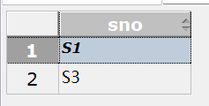

(4)

**SELECT** jno

**FROM** j

**WHERE** **NOT** **EXISTS**

(

**SELECT** **\***

**FROM** spj,s,p

**WHERE** spj.sno**=**s.sno **AND** j.jno**=**spj.jno **AND**

spj.pno**=**p.pno **AND** s.city**=**'天津' **AND** p.color**=**'红');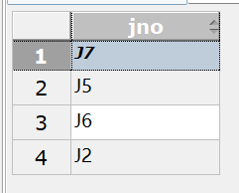

(5)--蕴含表达式   
**SELECT** **DISTINCT** jno

**FROM** spj spj1

**WHERE** **NOT** **EXISTS**

(

**SELECT** **\***

**FROM** spj spj2

**WHERE** spj2.sno**=**'S1' **AND**

**NOT** **EXISTS**

(

**SELECT** **\***

**FROM** spj spj3

**WHERE** spj3.jno**=**spj1.jno **AND** spj3.pno**=**spj2.pno

)

);

--集合   
**SELECT** jno

**FROM** j

**WHERE** **NOT** **EXISTS**

(

**SELECT** **DISTINCT** pno

**FROM** spj

**WHERE** spj.sno**=**'S1'

**EXCEPT**

**SELECT** pno

**FROM** spj

**WHERE** j.jno**=**spj.jno

);

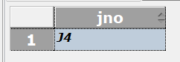

9.

**CREATE** **VIEW** spj_view(sno,pno,qty)

**AS**

**SELECT** sno,pno,qty

**FROM** spj

**WHERE** jno**=**

(

**SELECT** jno

**FROM** J

**WHERE** JNAME**=**'三建'

);

(1)

**SELECT** pno,SUM(qty)

**FROM** spj_view

**GROUP** **BY** pno;

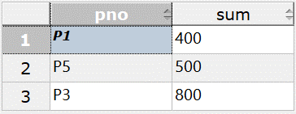

(2)

**SELECT** **\***

**FROM** spj_view

**WHERE** sno**=**'S1';

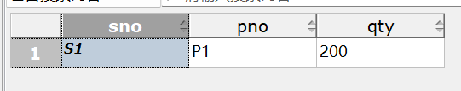

image-20230409223050101

5.

(1)

**SELECT** sname,city

**FROM** s;

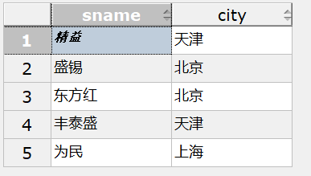

(2)

**SELECT** pname,color,weight

**FROM** p;

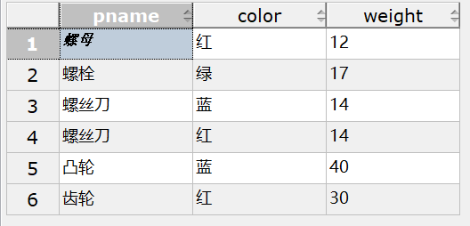

image-20230409205658590

(3)

**SELECT** jno

**FROM** spj

**WHERE** sno**=**'S1';

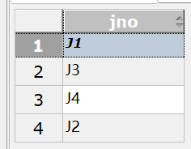

(4)

**SELECT** pname,qty

**FROM** spj,p

**WHERE** spj.pno**=**p.pno **AND** jno**=**'J2';

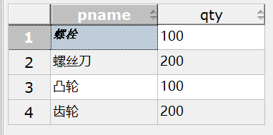

(5)

**SELECT** **DISTINCT** p.pno

**FROM** p,spj,s

**WHERE** spj.sno**=**s.sno **AND** spj.pno**=**p.pno **AND** s.city**=**'上海';

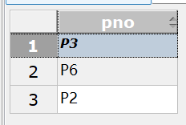

(6)

**SELECT** **DISTINCT** jname

**FROM** j,spj,s

**WHERE** spj.sno**=**s.sno **AND** spj.jno**=**j.jno **AND** s.city**=**'上海';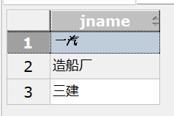

(7)

**SELECT** jno

**FROM** j

**WHERE** **NOT** **EXISTS**

(

**SELECT** **\***

**FROM** spj

**WHERE** spj.jno**=**j.jno

**AND** sno **IN**

(

**SELECT** sno

**FROM** s

**WHERE** city**=**'天津'

)

);

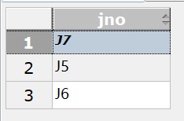

(8)

**UPDATE** p

**SET** color**=**'蓝'

**WHERE** color**=**'红';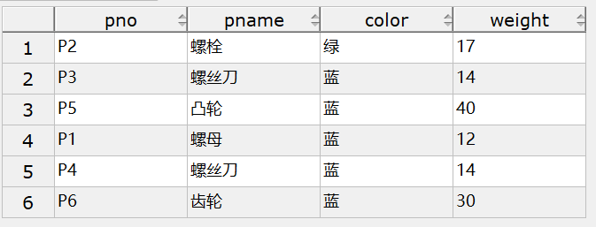

image-20230409213413437

(9)

**UPDATE** spj

**SET** sno**=**'S3'

**WHERE** sno**=**'S5' **AND** jno**=**'J4' **AND** pno**=**'P6';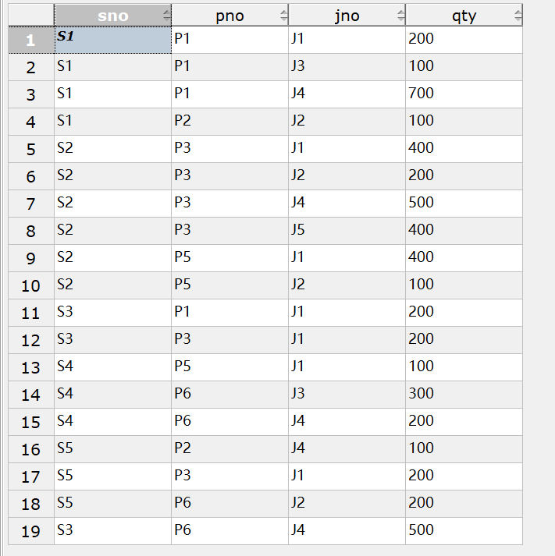

image-20230409214128614

(11)

顺序对应

**INSERT** **INTO** spj(sno,jno,pno,qty) **VALUES**('S2','J6','P4',200); 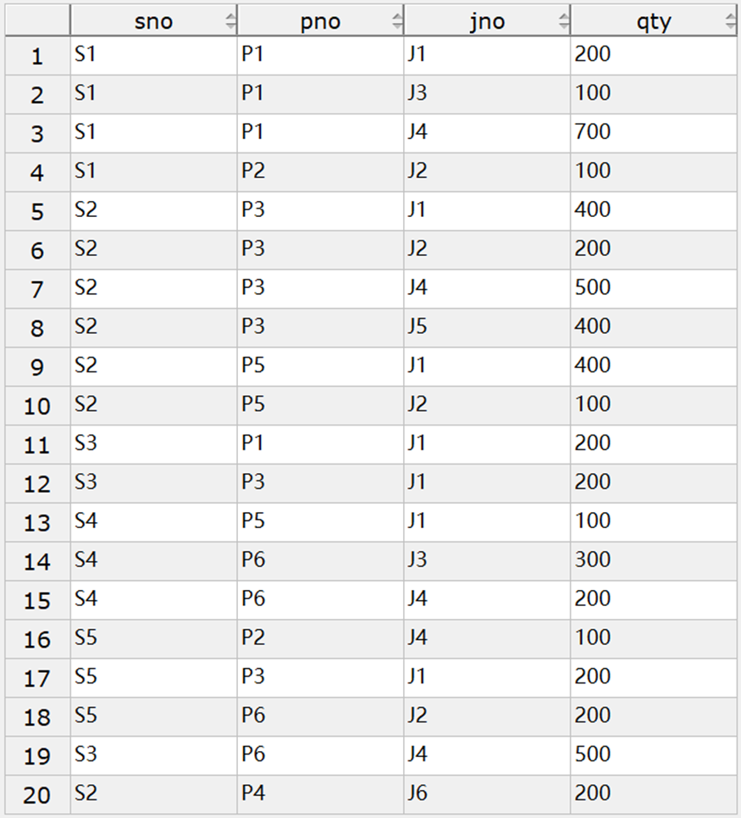

(10)

**DELETE**

**FROM** spj

**WHERE** sno**=**'S2';

**DELETE**

**FROM** s

**WHERE** sno**=**'S2';

