E-R图

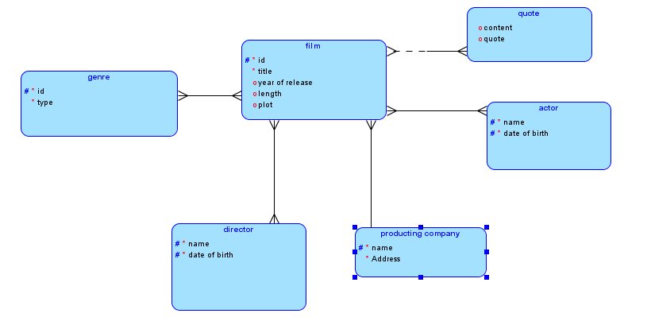

关系模式（没有进行合并）

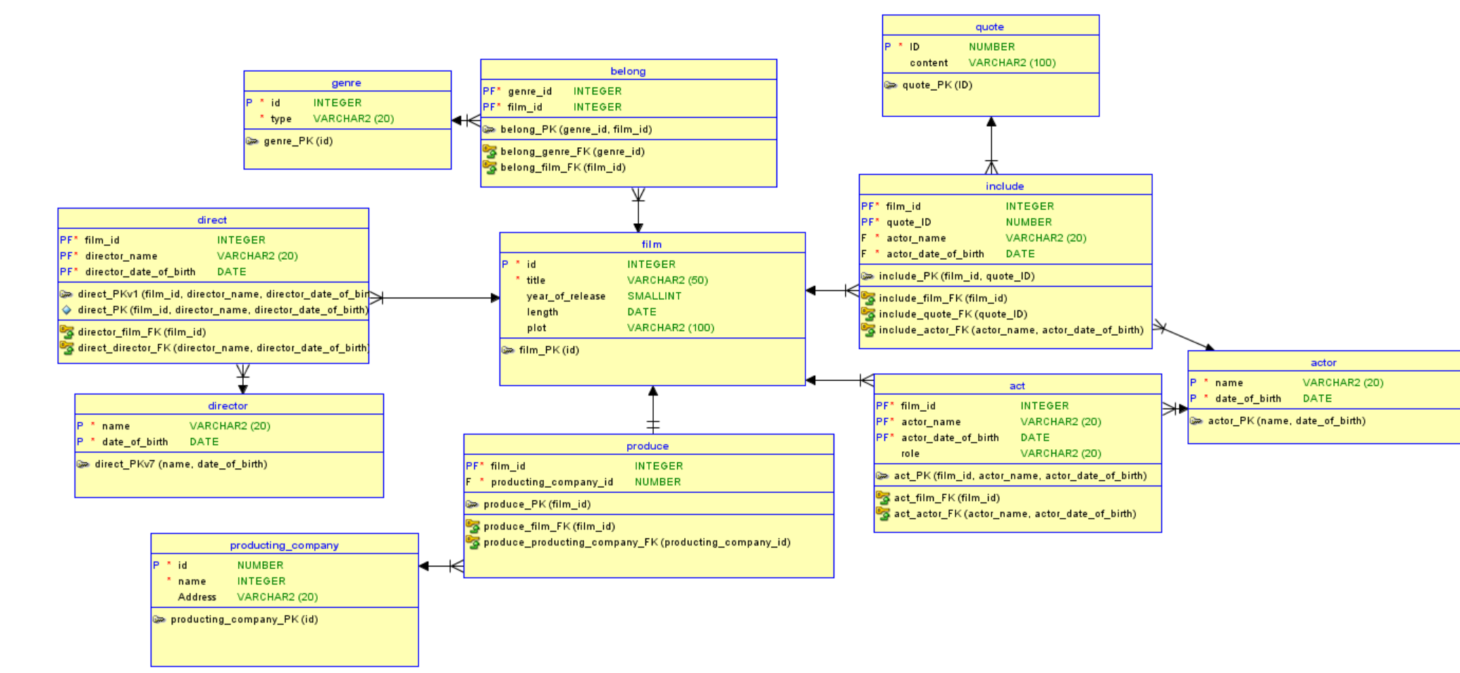

SQL脚本

**CREATE** **TABLE** act (

film_id **INTEGER** **NOT** **NULL**,

actor_name **VARCHAR2**(20) **NOT** **NULL**,

actor_date_of_birth **DATE** **NOT** **NULL**,

**role** **VARCHAR2**(20)

);

**ALTER** **TABLE** act

**ADD** **CONSTRAINT** act_pk **PRIMARY** **KEY** ( film_id,actor_name,actor_date_of_birth );

**CREATE** **TABLE** actor (

**name** **VARCHAR2**(20) **NOT** **NULL**,

date_of_birth **DATE** **NOT** **NULL**

);

**ALTER** **TABLE** actor **ADD** **CONSTRAINT** actor_pk **PRIMARY** **KEY** ( **name**,date_of_birth );

**CREATE** **TABLE** belong (

genre_id **INTEGER** **NOT** **NULL**,

film_id **INTEGER** **NOT** **NULL**

);

**ALTER** **TABLE** belong **ADD** **CONSTRAINT** belong_pk **PRIMARY** **KEY** ( genre_id,film_id );

**CREATE** **TABLE** **direct** (

film_id **INTEGER** **NOT** **NULL**,

director_name **VARCHAR2**(20) **NOT** **NULL**,

director_date_of_birth **DATE** **NOT** **NULL**

);

**ALTER** **TABLE** **direct**

**ADD** **CONSTRAINT** direct_pkv1 **PRIMARY** **KEY** ( film_id,director_name,director_date_of_birth );

**ALTER** **TABLE** **direct**

**ADD** **CONSTRAINT** direct_pk **UNIQUE** ( film_id,director_name,director_date_of_birth );

**CREATE** **TABLE** director (

**name** **VARCHAR2**(20) **NOT** **NULL**,

date_of_birth **DATE** **NOT** **NULL**

);

**ALTER** **TABLE** director **ADD** **CONSTRAINT** direct_pkv7 **PRIMARY** **KEY** ( **name**,date_of_birth );

**CREATE** **TABLE** film (

id **INTEGER** **NOT** **NULL**,

title **VARCHAR2**(50) **NOT** **NULL**,

year_of_release **SMALLINT**,

length **DATE**,

plot **VARCHAR2**(100)

);

**ALTER** **TABLE** film **ADD** **CONSTRAINT** film_pk **PRIMARY** **KEY** ( id );

**CREATE** **TABLE** genre (

id **INTEGER** **NOT** **NULL**,

**type** **VARCHAR2**(20) **NOT** **NULL**

);

**ALTER** **TABLE** genre **ADD** **CONSTRAINT** genre_pk **PRIMARY** **KEY** ( id );

**CREATE** **TABLE** include (

film_id **INTEGER** **NOT** **NULL**,

quote_id **NUMBER** **NOT** **NULL**,

actor_name **VARCHAR2**(20) **NOT** **NULL**,

actor_date_of_birth **DATE** **NOT** **NULL**

);

**ALTER** **TABLE** include **ADD** **CONSTRAINT** include_pk **PRIMARY** **KEY** ( film_id,quote_id );

**CREATE** **TABLE** produce (

film_id **INTEGER** **NOT** **NULL**,

producting_company_id **NUMBER** **NOT** **NULL**

);

**ALTER** **TABLE** produce **ADD** **CONSTRAINT** produce_pk **PRIMARY** **KEY** ( film_id );

**CREATE** **TABLE** producting_company (

id **NUMBER** **NOT** **NULL**,

**name** **INTEGER** **NOT** **NULL**,

address **VARCHAR2**(20)

);

**ALTER** **TABLE** producting_company **ADD** **CONSTRAINT** producting_company_pk **PRIMARY** **KEY** ( id );

**CREATE** **TABLE** **quote** (

id **NUMBER** **NOT** **NULL**,

**content** **VARCHAR2**(100)

);

**ALTER** **TABLE** **quote** **ADD** **CONSTRAINT** quote_pk **PRIMARY** **KEY** ( id );

**ALTER** **TABLE** act

**ADD** **CONSTRAINT** act_actor_fk **FOREIGN** **KEY** ( actor_name,actor_date_of_birth )

**REFERENCES** actor ( **name**,date_of_birth );

**ALTER** **TABLE** act

**ADD** **CONSTRAINT** act_film_fk **FOREIGN** **KEY** ( film_id )

**REFERENCES** film ( id );

**ALTER** **TABLE** belong

**ADD** **CONSTRAINT** belong_film_fk **FOREIGN** **KEY** ( film_id )

**REFERENCES** film ( id );

**ALTER** **TABLE** belong

**ADD** **CONSTRAINT** belong_genre_fk **FOREIGN** **KEY** ( genre_id )

**REFERENCES** genre ( id );

**ALTER** **TABLE** **direct**

**ADD** **CONSTRAINT** direct_director_fk **FOREIGN** **KEY** ( director_name,director_date_of_birth )

**REFERENCES** director ( **name**,date_of_birth );

**ALTER** **TABLE** **direct**

**ADD** **CONSTRAINT** director_film_fk **FOREIGN** **KEY** ( film_id )

**REFERENCES** film ( id );

**ALTER** **TABLE** include

**ADD** **CONSTRAINT** include_actor_fk **FOREIGN** **KEY** ( actor_name,actor_date_of_birth )

**REFERENCES** actor ( **name**,date_of_birth );

**ALTER** **TABLE** include

**ADD** **CONSTRAINT** include_film_fk **FOREIGN** **KEY** ( film_id )

**REFERENCES** film ( id );

**ALTER** **TABLE** include

**ADD** **CONSTRAINT** include_quote_fk **FOREIGN** **KEY** ( quote_id )

**REFERENCES** **quote** ( id );

**ALTER** **TABLE** produce

**ADD** **CONSTRAINT** produce_film_fk **FOREIGN** **KEY** ( film_id )

**REFERENCES** film ( id );

**ALTER** **TABLE** produce

**ADD** **CONSTRAINT** produce_producting_company_fk **FOREIGN** **KEY** ( producting_company_id )

**REFERENCES** producting_company ( id );