--1.1

**DROP** **VIEW** cus_book1;

**DROP** **VIEW** young_cus;

**DROP** **TABLE** purchases **CASCADE**;

**DROP** **TABLE** pricing;

**DROP** **TABLE** books;

**DROP** **TABLE** customers **CASCADE**;

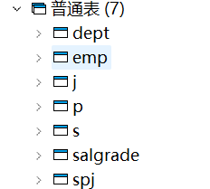

--1.2

**CREATE** **TABLE** books(

bookId **NUMBER**(9,0) **CONSTRAINT** books_pk **PRIMARY** **KEY** ,

title **VARCHAR**(80) **CONSTRAINT** books_title **NOT** **NULL** ,

author **VARCHAR**(40),

**year** **INTEGER**,

category **VARCHAR**(15)

);

**CREATE** **TABLE** customers(

cid **NUMBER**(9,0),

came **CHAR**(40),

age **INTEGER** **CONSTRAINT** customers_age **CHECK**(age **BETWEEN** 18 **AND** 80),

**PRIMARY** **KEY** (cid)

);

**CREATE** **TABLE** purchases(

cid **NUMBER**(9,0),

bookId **number**(9,0),

padate **DATE**,

pprice **number**(8,2),

**CONSTRAINT** purchases_pk **PRIMARY** **KEY** (cid,bookId),

**FOREIGN** **KEY** (bookId) **REFERENCES** Books(bookId) **ON** **DELETE** **CASCADE**,

**CONSTRAINT** purchases_fk **FOREIGN** **KEY** (cid) **REFERENCES** customers(cid)

);

**CREATE** **TABLE** pricing(

bookId **NUMBER**(9,0) **CONSTRAINT** pricing_pk **PRIMARY** **KEY**,

format **VARCHAR**(15),

price **NUMBER**(9,2),

**CONSTRAINT** price_check **CHECK**(format!='paperback' **OR** price**<=**50)

);

--1.3

**ALTER** **TABLE** books

**ADD** **CONSTRAINT** **CHECK**(category **IN** ('textbook','politics','romance','cooking'));

**ALTER** **TABLE** customers

**ALTER** **CONSTRAINT** customers_age **CHECK**(age**<=**85);

**ALTER** **TABLE** pricing

**RENAME** **CONSTRAINT** price_check **TO** price_check_paper;

--1.4

**CREATE** **TABLE** Score(

Sno **CHAR**(9) **PRIMARY** **KEY**,

Chinese **INTEGER** **CHECK**((Chinese **BETWEEN** 0 **AND** 100) **OR** (Chinese **is** **NULL**)),

Math **INTEGER** **CHECK**((Math **BETWEEN** 0 **AND** 100) **OR** (Math **is** **NULL**)),

English **INTEGER** **CHECK**((English **BETWEEN** 0 **AND** 100) **OR** (English **is** **NULL**)),

Total **INTEGER**,

**Check**(**NOT** (Chinese **is** **NULL** **AND** Math **is** **NULL** **AND** English **IS** **NULL**

**AND** Total **IS** **NOT** **NULL**))

);

--1.5

**CREATE** **OR** **REPLACE** **FUNCTION** ins_func()

**RETURNS** **TRIGGER** **AS**

$$

**DECLARE**

**BEGIN**

NEW.Total **:=** 0;

**if** (NEW.Chinese **is** **not** **null**) **then** NEW.Total **:=** NEW.Total **+** NEW.Chinese;

**end** **if**;

**if** (NEW.Math **is** **not** **null**) **then** NEW.Total **:=** NEW.Total **+** NEW.Math;

**end** **if**;

**if** (NEW.English **is** **not** **null**) **then** NEW.Total **:=** NEW.Total **+** NEW.English;

**end** **if**;

**IF** NEW.Total **=**0

**THEN** NEW.Total**:=NULL**;

**END** **IF**;

**RETURN** NEW;

**END**

$$ **LANGUAGE** PLPGSQL;

**CREATE** **TRIGGER** ins_trigger

**BEFORE** **INSERT** **OR** **UPDATE** **ON** score

**FOR** **EACH** **ROW**

**EXECUTE** **PROCEDURE** ins_func();

**INSERT** **INTO** score **VALUES**('201515121',90,80,70,250);

**INSERT** **INTO** score **VALUES**('201515122',90,**null**,70,150);

**INSERT** **INTO** score **VALUES**('201515123',**null**,80,**null**,**null**);

**INSERT** **INTO** score **VALUES**('201515124',**null**,**null**,**null**,100);

**INSERT** **INTO** score **VALUES**('201515125',110,90,80,280);

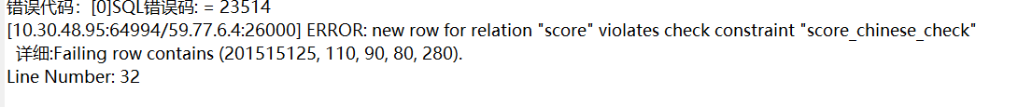

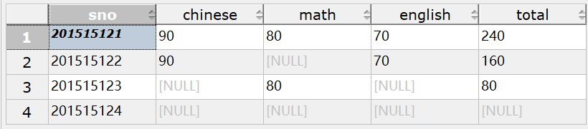

**UPDATE** score

**SET** English**=**90

**WHERE** sno**=**'201515124';

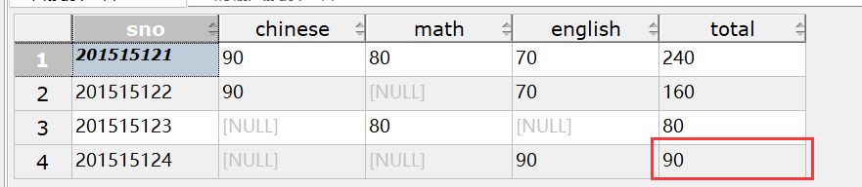

更改学号为201515124学生的英语成绩之后触发器被激活，总成绩被同步更新

--7.1

**GRANT** **SELECT**

**ON** **TABLE** 职工,部门

**TO** 王明;

--7.2

**GRANT** **INSERT**,**DELETE**

**ON** **TABLE** 职工,部门

**TO** 李勇;

--7.4

**GRANT** **SELECT**,**UPDATE**(工资)

**ON** **TABLE** 职工

**TO** 刘星;

--7.5

**GRANT** **ALTER** **TABLE**

**ON** **TABLE** 职工,部门

**TO** 张新;

--7.6

**GRANT** **ALL** **PRIVILEGES**

**ON** **TABLE** 职工,部门

**TO** 周平

**WITH** **GRANT** **OPTION**;

--7.7

**CREATE** **VIEW** salary_view

**AS**

**SELECT** 部门.名称，MAX(工资),MIN(工资),AVG(工资)

**FROM** 职工,部门

**WHERE** 职工.部门号**=**部门.部门号

**GROUP** **BY** 职工.部门号；

**GRANT** **SELECT**

**ON** salary_view

**TO** 杨兰;

--8.1

**REVOKE** **SELECT**

**ON** **TABLE** 部门

**FROM** 王明;

--8.2

**REVOKE** **INSERT**

**ON** **TABLE** 部门,职工

**FROM** 李勇;

--8.3

**REVOKE** **UPDATE**(工资)

**ON** **TABLE** 职工

**FROM** 刘星;

--8.4

**REVOKE** **ALL** **PRIVILEGES**

**ON** **TABLE** 部门,职工

**FROM** 周平 **CASCADE**;