Discrete Mathematics Automation System (DMSA)
Technical Project Report

1. Language Rationale
C++ was chosen as the primary implementation language because it provides both low-level performance control and high-level abstraction tools, which are essential for building a system that processes large-scale mathematical structures.
This project specifically leverages modern C++20 features to enhance safety and correctness:
- C++20 Concepts were used to enforce compile-time constraints on template parameters. This ensured that only valid types (e.g., comparable types) could be used in sets, relations, and graphs, preventing entire classes of logical errors before runtime.
- std::variant was used to safely store and manipulate multiple data types within unified containers.
- std::optional was used to represent potentially missing values, such as unreachable graph paths or invalid parse results.
- Functional utilities from <functional> enabled flexible predicate and logic evaluation.
- Advanced string utilities were used for trimming, tokenizing, and structured text parsing.
These features made C++ the most suitable choice for building a high-performance and type-safe automation system.

2. Project Structure (High-Level Architecture)
The system uses a controller-centric modular architecture, where responsibilities are clearly separated.
The DMSA_Controller manages the complete execution lifecycle, including:
- Orchestrating parsing
- Requesting data storage
- Dispatching operations
- Coordinating output generation
The File_IO_Manager handles structured input processing using string utilities such as:
- Substring extraction
- Token splitting
- Whitespace trimming
- Delimiter scanning
The Data_Registry stores system objects using std::variant, allowing heterogeneous objects to coexist safely.
All mathematical logic is isolated inside self-contained computational units such as Math_Set, Graph, Relation, and Function, ensuring clean separation between data processing and algorithmic logic.

3. Main Modules (One-Line Descriptions)
Module | Description
Math_Set | Stores unique sorted elements and performs core set operations.
Graph | Models vertex–edge structures and executes traversal algorithms.
Relation | Represents and analyzes binary relationships between elements.
Function | Handles domain-to-codomain mappings and property validation.
DMSA-Controller | Directs system execution and operation dispatch.
File-IO-Manager | Parses structured files using advanced string handling.
Data-Registry | Provides centralized storage using std::variant.
Quantifier-Validator | Evaluates logical statements via functional predicates.
Graph-Utility | Contains isolated implementations of graph algorithms.
Critical-Node-Generator | Determines enforced nodes used in constrained computations.

4. OOP Concepts Applied

Encapsulation
Private data members protect internal representations of:
- Sorted set arrays
- Adjacency matrices
- Relation grids
Access is controlled strictly through public member functions.

Abstraction
Users interact only with high-level system methods such as Run(), without needing to understand parsing, storage, or dispatch logic.

Polymorphism
Instead of classical inheritance, type-safe runtime polymorphism is implemented using:
- std::variant
- std::visit
- Callable wrappers from <functional>

Concepts (C++20)
C++20 Concepts were used to constrain templates such that only logically valid types could be used in mathematical contexts. For example:
- Set elements were required to satisfy comparability requirements.
- Graph node types were restricted to types supporting equality and ordering where needed.
This ensured invalid types were rejected at compile time, greatly increasing system reliability.

5. Solution Rationale

Shortest Path (Dijkstra)
Dijkstra’s algorithm was chosen due to its efficiency on non-negative weighted graphs. The implementation uses vector-backed structures and std::optional to signal unreachable nodes without unsafe sentinel values.

Minimum Spanning Tree (Prim)
Prim’s algorithm was selected to support constrained node inclusion. Optional return states clearly represent failure on disconnected graphs.

Transitive Closure (Warshall)
Warshall’s algorithm was used because it maps directly to matrix-based relation storage and provides deterministic performance.

Set Storage Strategy
Sets were implemented using sorted vectors to allow:
- Linear-time union and intersection
- Efficient binary searching
- Predictable memory locality

6. Results & Findings

Graph Algorithms
- Correct shortest path calculation in connected graphs.
- Safe detection of unreachable nodes using empty std::optional.
- Stable cycle handling with no infinite loops.

MST Performance
- Correct MST construction under node constraints.
- Safe failure behavior for disconnected graphs.

Logical Validation
- Accurate handling of universal and existential quantifiers.
- Proper evaluation of vacuous truth conditions for empty domains.
- Functional predicates executed reliably at runtime.

Set Operations
- Accurate union, intersection, and difference behavior.
- Correct rejection of duplicate insertions.

7. Performance Summary
Module | Observed Behavior
Set Operations | Linear-time performance due to sorted storage
Shortest Path | Efficient and stable for sparse and dense graphs
MST | Predictable and constraint-safe construction
Logical Engine | Consistent and formally correct evaluation

9. Conclusion

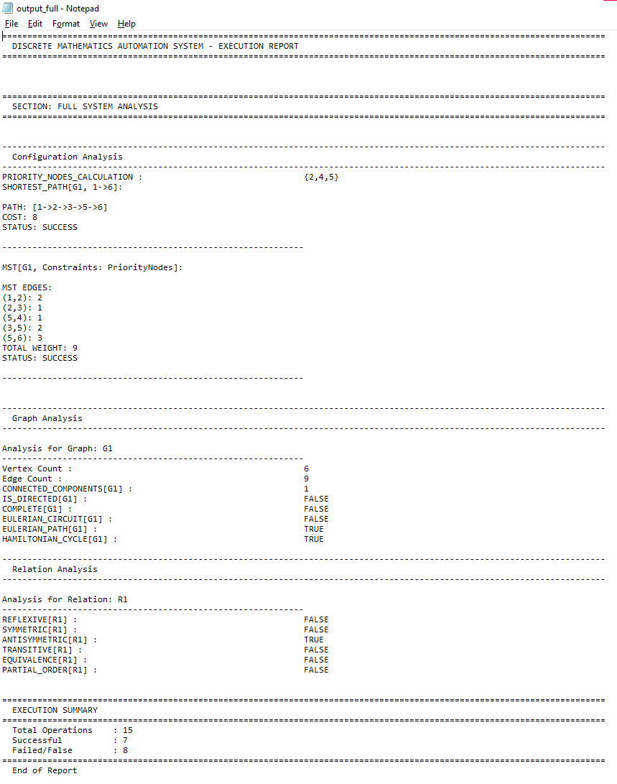
The Discrete Mathematics Automation System demonstrates the effective use of C++20 Concepts, std::variant, std::optional, functional programming utilities, and modern string handling to build a safe, fast, and mathematically reliable automation engine.
The system architecture cleanly separates responsibilities, ensuring long-term maintainability and extensibility while preserving strict type safety and performance guarantees.

