1.1What are the three main purposes of an operating system?

- 管理系统资源
- 建立用户界面
- 执行提供应用程序

1.6 Define the essential properties of the following types of operating systems:
a. Batch
b. Interactive
c. Time sharing
d. Real time
e. Network
f. Distributed

- 具有相似需求的作业将被批处理并由用户或程序作为序列在计算机中运行。通过尝试通过缓冲，脱机操作，假脱机和多重编程始终保持CPU和I/O设备繁忙，借此可以提高性能。
- 系统由许多较短的交互所构成。反馈时间应该尽可能短以提高用户的体验。
- 通过CPU调度以及多道程序来为用户提供经济高效的调用。CPU快速从用户间切换，来达到时间共享的需求
- 该系统通常在特定应用中使用，会从输入设备读取信息，并且在固定的时间内响应以确保连接性能.
- 提供网络支持
- 在多个处理器间分散运行。

2.3 What are the differences between a trap and an interrupt? What is the use of each function?

陷阱通常由处理机正在执行的现行指令引起，而中断则与现行指令无关的中断源引起。
陷阱处理程序提供的服务为当前进程所用，而中断处理程序的服务不是为了当前进程的。

2.5 Which of the following instructions should be privileged?
a. Set value of timer.
b. Read the clock.
c. Clear memory.
d. Turn off interrupts.
e. Switch from user to monitor mode.

- 是的
- 否
- 是的
- 是的
- 是的

3.6 List five services provided by an operating system. Explain how each provides convenience to the users. Explain also in which cases it would be impossible for user-level programs to provide these services.

a.程序执行。操作系统加载文件中的内容到内存并开始执行。一个用户级别的程序不能被随意信任或分配CPU的时间片
b. I/O操作。磁盘，磁带或者其他设备的通讯应当尽量减少。用户只需要特定设备与操作即可实现。
c.文件系统。文件系统是操作系统用于明确存储设备（常见的是磁盘，也有基于NAND Flash的固态硬盘）或分区上的文件的方法和数据结构；即在存储设备上组织文件的方法。 操作系统中负责管理和存储文件信息的软件机构称为文件管理系统，简称文件系统。
d. 通讯。与外界建立网络和电话通讯。
e.错误处理。良好的操作系统能够处理系统可能遇到的各种错误。

3.7 What is the purpose of system calls?

A system call is a way for programs to interact with the operating system. A computer program makes a system call when it makes a request to the operating system's kernel. System call provides the services of the operating system to the user programs via Application Program Interface(API).

3.10 What is the purpose of system programs?

What is the purpose of System Programs? System programs provide an environment where programs can be developed and executed. In the simplest sense, system programs also provide a bridge between the user interface and system calls.

6.3 Consider the following set of processes, with the length of the CPU-burst time given in
milliseconds:
Process Burst Time Priority
P1 10 3
P2 1 1
P3 2 3
P4 1 4
P5 5 2
The processes are assumed to have arrived in the order P1, P2, P3, P4, P5, all at time 0.
a. Draw four Gantt charts illustrating the execution of these processes using FCFS, SJF, a nonpreemptive priority (a smaller priority number implies a higher priority), and RR
(quantum = 1) scheduling.
b. What is the turnaround time of each process for each of the scheduling algorithms in
part a?
c. What is the waiting time of each process for each of the scheduling algorithms in part a d. Which of the schedules in part a results in the minimal average waiting time (over all
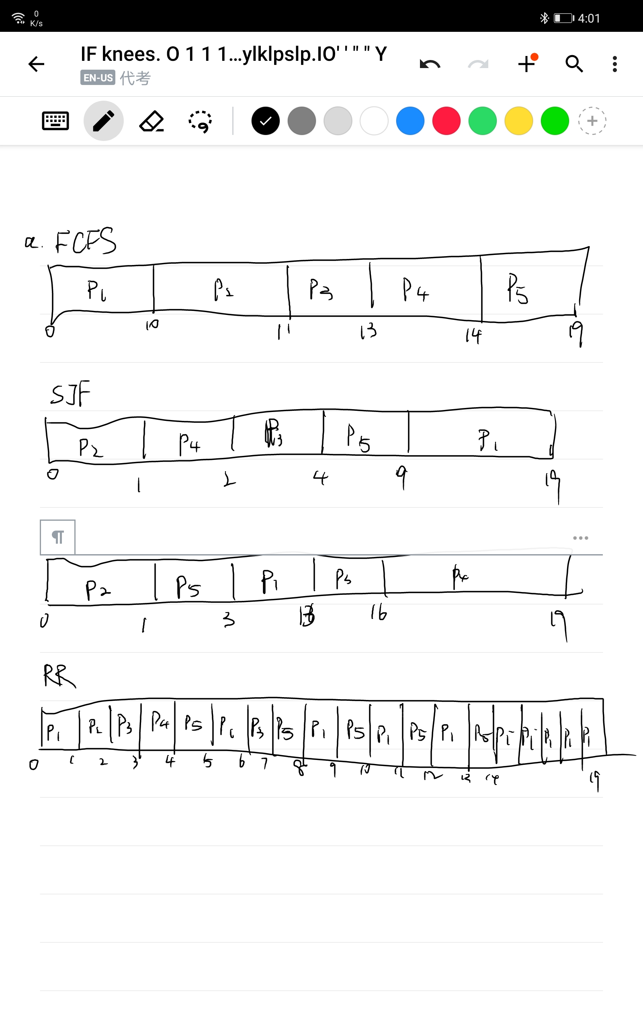

6.4 Suppose that the following processes arrive for execution at the times indicated. Each
process will run the listed amount of time. In answering the questions, use nonpreemptive
scheduling and base all decisions on the information you have at the time the decision
must be made.

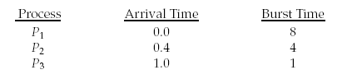
a. What is the average turnaround time for these processes with the FCFS scheduling
algorithm?
20/3=6.6666
b. What is the average turnaround time for these processes with the SJF scheduling algorithm?
(0+8+9)/3=5.666

c. The SJF algorithm is supposed to improve performance, but notice that we chose to
run process P1 at time 0 because we did not know that two shorter processes would
arrive soon. Compute what the average turnaround time will be if the CPU is left
idle for the first 1 unit and then SJF scheduling is used. Remember that processes P1
and P2 are waiting during this idle time, so their waiting time may increase. This
algorithm could be known as future-knowledge scheduling.

It should be (1+2+6)/3=3.00

7.8 The Sleeping-Barber Problem. A barbershop consists of a waiting room with n chairs and the barber room containing the barber chair. If there are no customers to be served,the barber goes to sleep. If a customer enters the barbershop and all chairs are occupied, then the customer leaves the shop.If the barber is busy but chairs are available, then the customer sits in one of the free chairs. If the barber is asleep, the customer wakes up the barber. Write a program to coordinate the barber and the customers.

Semaphore Customers = 0;
Semaphore Barber = 0;
Mutex Seats = 1;
int FreeSeats = N;

Barber {
while(true) {
/* waits for a customer (sleeps). */
down(Customers);

/* mutex to protect the number of available seats.*/
down(Seats);

/* a chair gets free.*/
FreeSeats++;

/* bring customer for haircut.*/
up(Barber);

/* release the mutex on the chair.*/
up(Seats);
/* barber is cutting hair.*/
}
}

Customer {
while(true) {
/* protects seats so only 1 customer tries to sit
in a chair if that's the case.*/
down(Seats); //This line should not be here.
if(FreeSeats > 0) {

/* sitting down.*/
FreeSeats--;

/* notify the barber. */
up(Customers);

/* release the lock */
up(Seats);

/* wait in the waiting room if barber is busy. */
down(Barber);
// customer is having hair cut
} else {
/* release the lock */
up(Seats);
// customer leaves
}
}
}

