1：

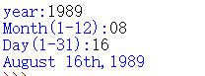

代码：

a = eval(input('year:'))

b = input('Month(1-12):')

c = input('Day(1-31):')

month = ['January','Faburary','March','April','May','June','July','August','Septemper','October','November','December']

if c==1:

c = '1st'

elif c==2:

c = '2nd'

elif c==3:

c = '3rd'

else:

c = c+'th'

print('{} {},{}'.format(month[int(b)-1],c,a))

2.1：



代码：

a = input('enter your name:')

print('“Hello {}, would you like to learn some Python today?”'.format(a))

2.2：

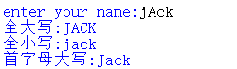

代码：

a = input('enter your name:')

print('全大写:'+a.upper())

print('全小写:'+a.lower())

print('首字母大写:'+a.capitalize())

2.3：



代码：

print('Stephen Hawking once said,"It would not be much of a universe if it was not home to the people you love."')

2.4：



代码：

famous_person = 'Stephen Hawking'

message = 'It would not be much of a universe if it was not home to the people you love.'

print('{},"{}"'.format(famous_person,message))

2.5：

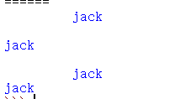

代码：

name = '\t jack \n \t'

print(name)

print(name.lstrip())

print(name.rstrip())

print(name.strip())

3：



代码：

b = list(map(int,' '.join(input('enter an int:')).split(' ')))

c = list(set(b))

c.sort(key=b.index)

for i in range(len(c)):

print(c[len(c)-1-i],end = '')