SNAKE GAME

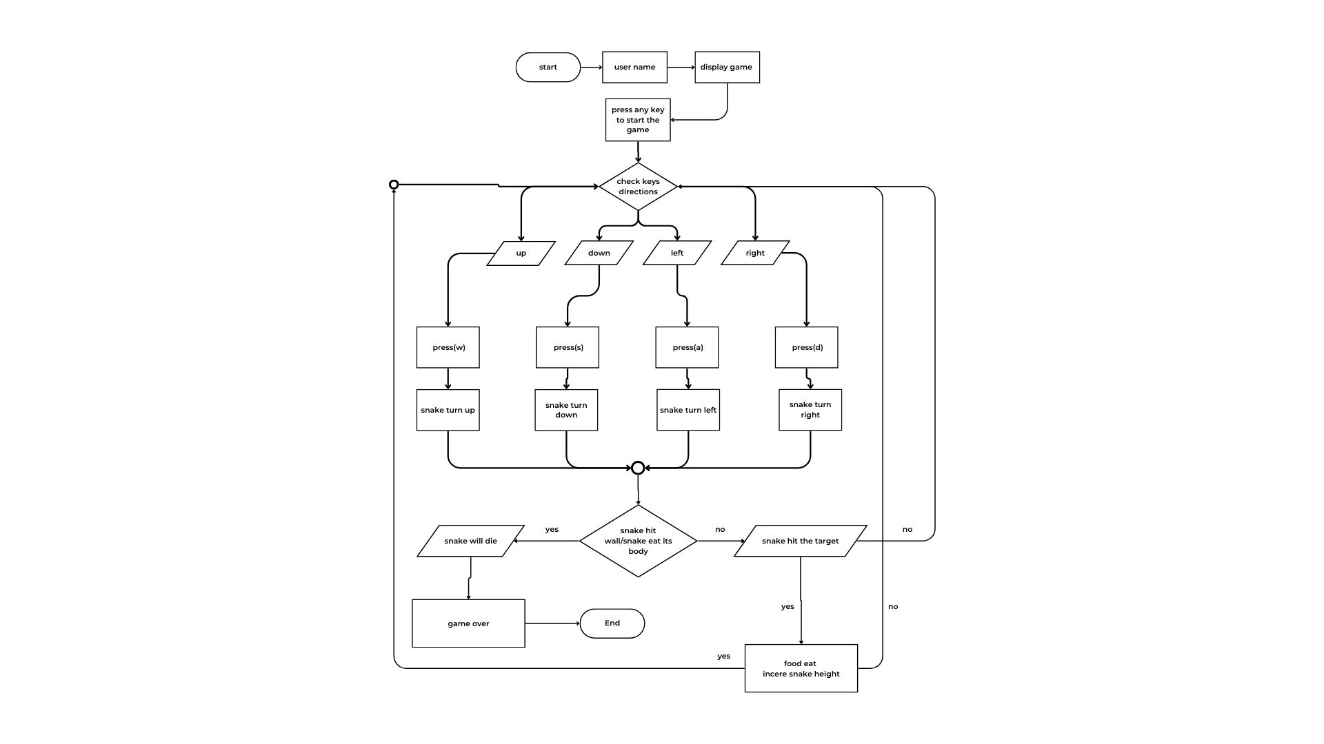1)FLOW CHART:

2)PROTOTYPE:
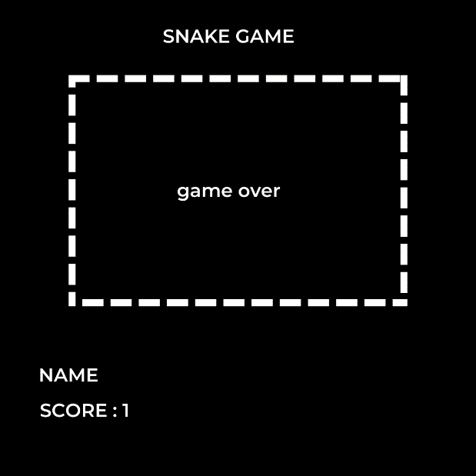

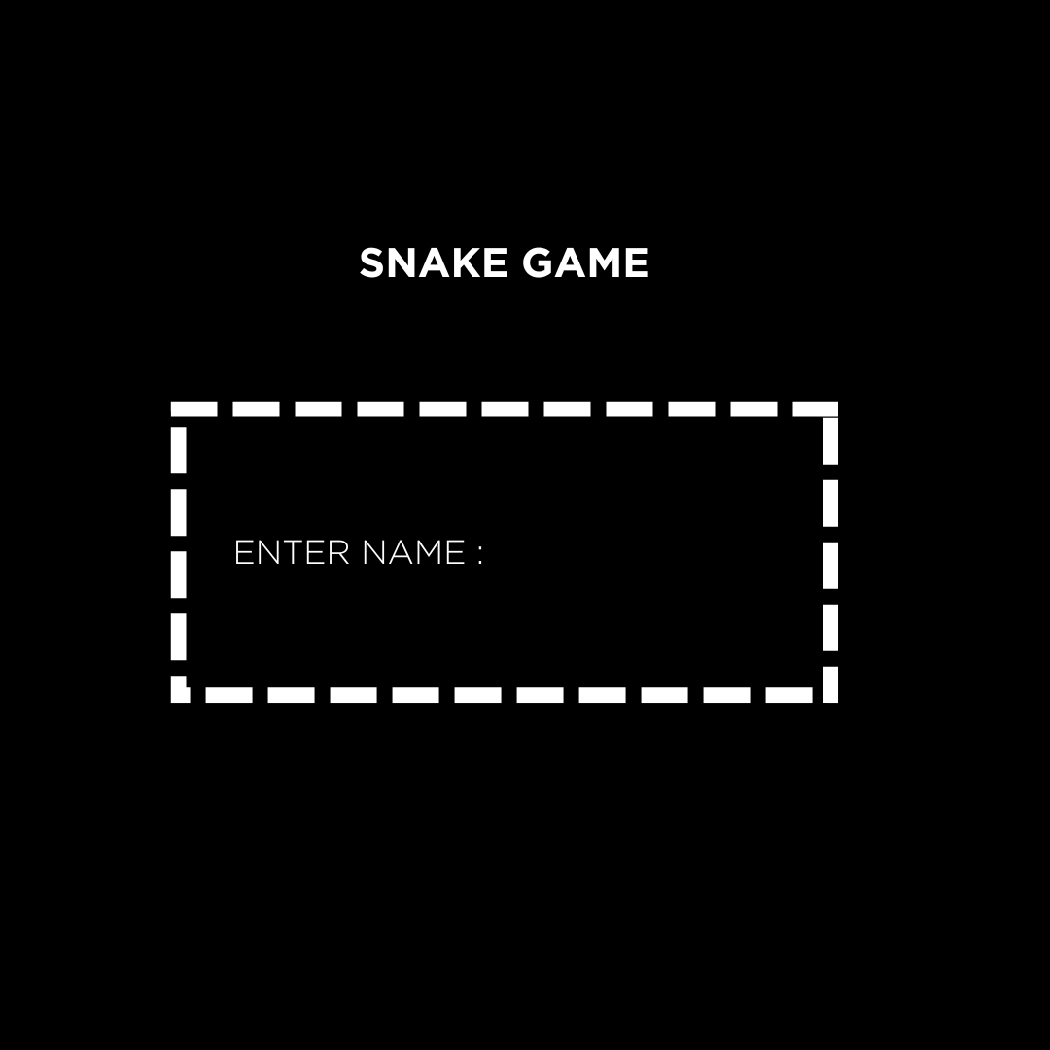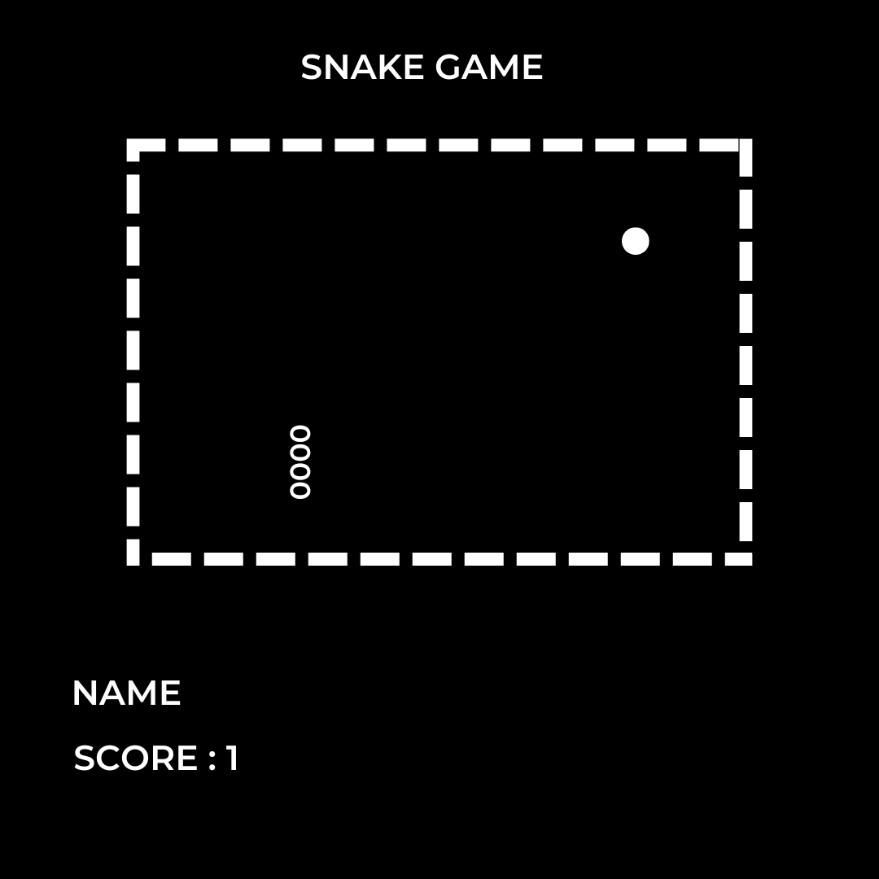

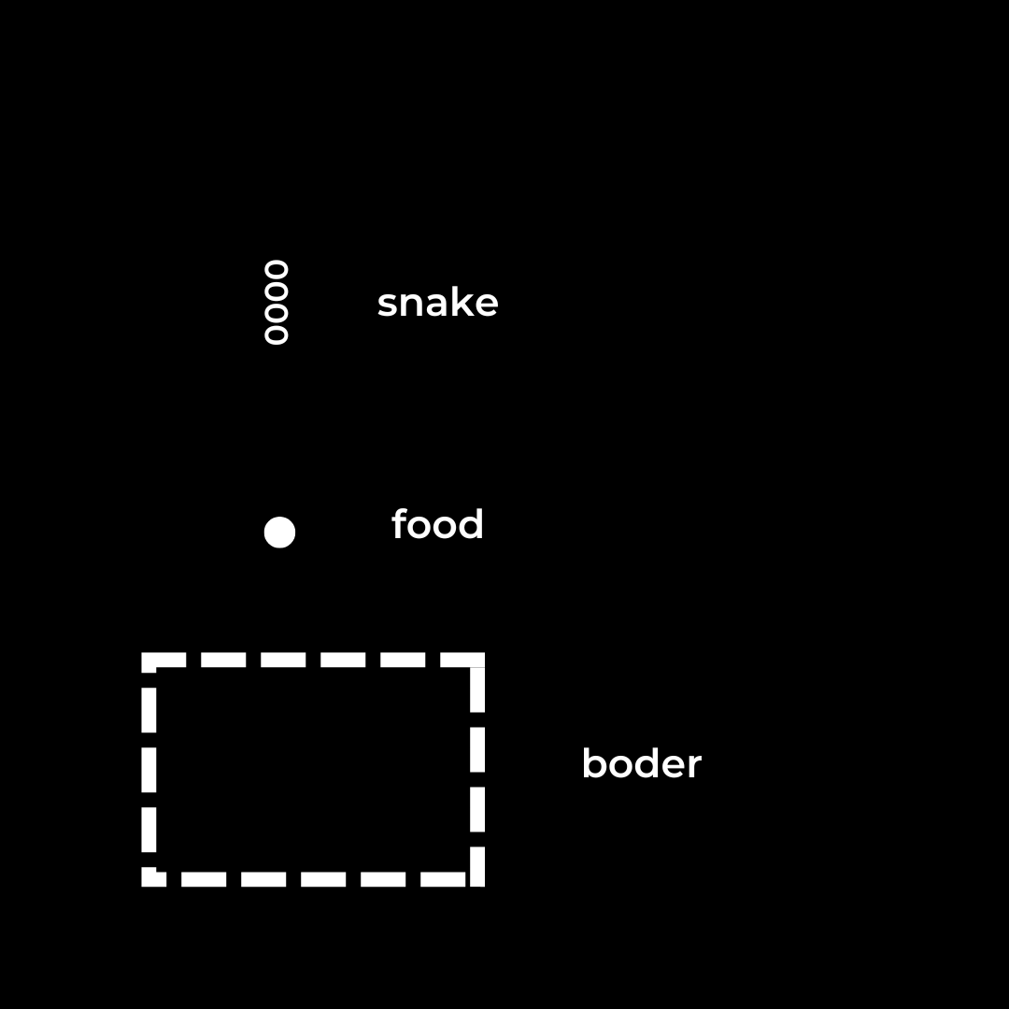

THIS WILL BE YOUR INTERFACE FOR THE SNAKE GAME

- In the start we will ask user to enter its name
- We will use 2d-array in which our snake will be move
- We will define the size of the box using length and width command
- We will use if else for snake that he will eat food the size ++ and if he does not then user will input another button
- If snake its body or hit the wall he will die and game will be over .
- We will use (w,s,a,d) for the movement of the snake
- We will store the score of the use in other using file handling fstream .
We will probley create 4 to 5 function for this .
2 file will be made 1 main file and other for storing the date .

3)Testing:

module | Test case | Expected output
char Enter User name | Number User name122 | string User name
If(snake=hit wall || snake= touch body)  dead  Else( take input from user for next dirxtion) | Snake will die(game over) | Snake move until other out input will we given
Score store in second file | Score store then show it after it end the game | Increase the score as the snake eat food and show continuously
If(snake==eat)  Size++  Else (give input) | Snake will move with increase size | Snake move until other out input will we given. Its size will increase

