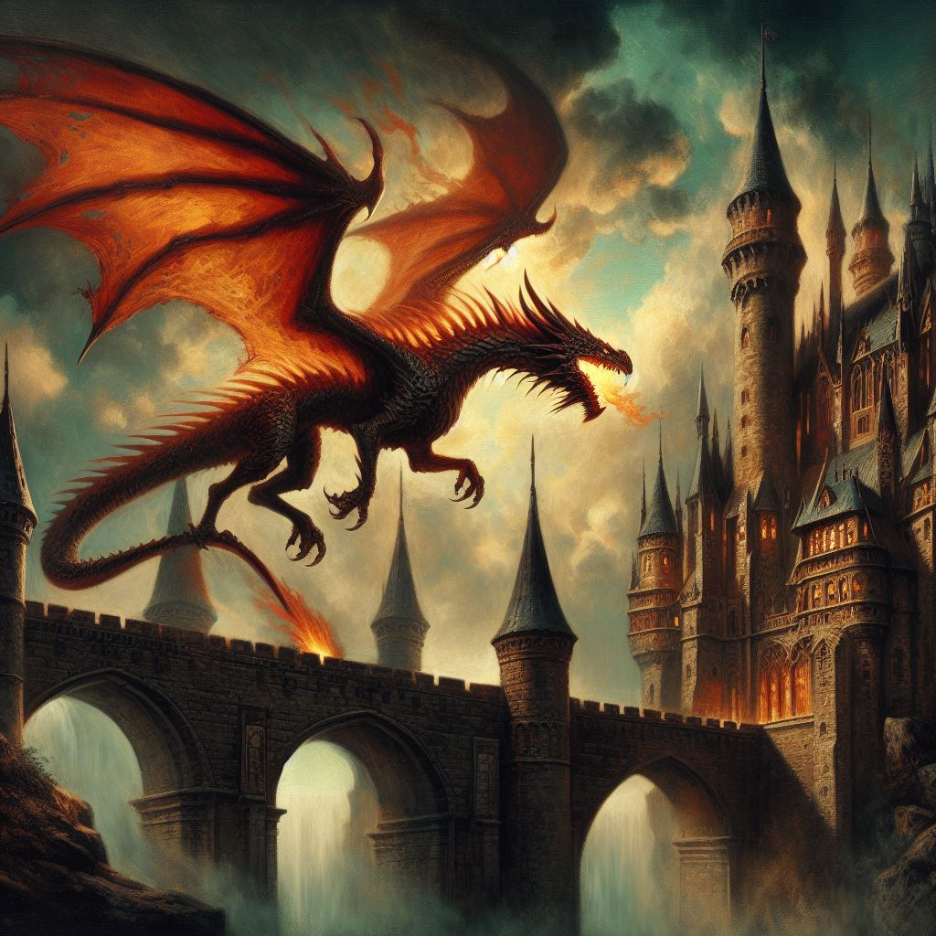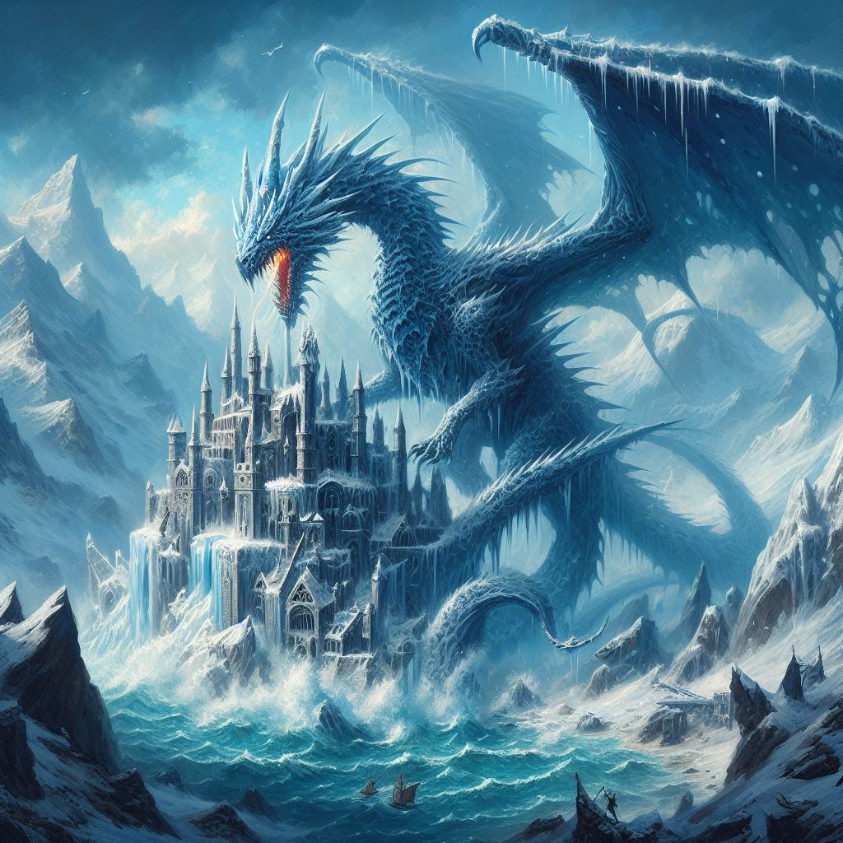

# Dragon Attack

POE Part 1 Report

Report by Angus Hayward van Eeden

Partnered with Riyaad Isaacs

Contents

Dragon Attack 1

Component List 3

**Form 1 (**GADE5121_POE_Riyaad_Angus1) 5

User Input for Form 1 5

Output Form 1 5

Form 2 (Battlephase) 6

User Input for Form 2 6

Outputs for Form 2 (BattlePhase) 6

# Component List

<https://github.com/RiyaadIsaacs/Dragon-attack-POE-.git>

Components:

PlayerNameLabel_Click

PlayerNametbx_TextChanged

DragonNameLabel_Click

DragonNametbx_TextChanged

PlayerNameLabel2_Click

DragonNameLabel2_Click

PlayerNametbx2_TextChanged

DragonNametbx2_TextChanged

IceDragonCheck_CheckedChanged

FireDragonCheck_CheckedChanged

EarthDragonCheck_CheckedChanged

WindDragonCheck_CheckedChanged

IceDragonCheck2_CheckedChanged

FireDragonCheck2_CheckedChanged

EarthDragonCheck2_CheckedChanged

WindDragonCheck2_CheckedChanged

FireDragonLabel_Click

IceDragonLabel_Click

WindDragonLabel_Click

EarthDragonLabel_Click

WindDragonPng_Click

FireDragonPng_Click

EarthDragonPng_Click

IceDragonPng_Click

StatTextBox2_TextChanged

StatTextBox1_TextChanged

SaveCharButton2_Click

SaveCharButton1_Click

StartButton_Click

playersTurnLbl

playerOneHp

opponentName

opponentDetailsArea

opponentDragonDetails

attackBtn

specialAttackBtn

defendBtn

BackButton_Click

BattleLogLbl_Click

battleLogArea

Background1_Click

Background2_Click

SaveCharButton_Click

SaveCharButton2_Click

# **Form 1 (**GADE5121_POE_Riyaad_Angus1)

Form 1 is set so that the players (Player One and Player Two) can both input their names, the dragon names, and select the species of dragon via a series of checkboxes which will then send the stats of the selected dragon species to a box which will display the stats which can change every time we select another box. We use this menu so that Player One and Player Two can save their inputs and transfer the stats of the dragons with the names to form 2 (the battle phase form), and to do this we will use the save button to transfer the variables from one form to the next trying to save the data when the Player One and Player Two save buttons are pressed. To the right of the form 1, I labelled some images I drew so that we can visually see each dragon with their respective names, these being fire dragon, earth dragon, wind dragon and ice dragon

### User Input for Form 1

Player Name – Player name is a label besides a text box which is created so the player can input their players name (which will act as their username). There are two player names and player name text boxes, one is for player one and one is for player two.

Dragon Name – Dragon name is a label besides a text box which is created so the player can input their dragons name. There are two dragon names and dragon name text boxes, one is for player one and one is for player two.

Dragon Type Check boxes – There are a series of 4 dragon text boxes on both player one and player twos sides of this menu form, the 4 check boxes are labeled with Ice dragon, Fire dragon, Wind dragon and Earth dragon. Selecting a dragon will display their stats underneath the check boxes in the text box space provided, this will change depending the dragon. If the player wishes to see what the dragons look like, there is a section at the right which shows all 4 dragons and images that I drew.

Save Button – When the player is happy with their inputs (Player Name, Dragon Name and the dragon type that they chose), they can click the save button which should save the variables to a specified variable so that the stats and names will be saved for the combat form.

Start Button – The start button will change the scene from Form 1 (the current menu form) to the Battlephase form (form 2).

### Output Form 1

////////////////////////////////////////////////////////////////////////////////////////////////////////////////////////////////////

////////////////////////////////////////////////////////////////////////////////////////////////////////////////////////////////////

////////////////////////////////////////////////////////////////////////////////////////////////////////////////////////////////////

////////////////////////////////////////////////////////////////////////////////////////////////////////////////////////////////////

# Form 2 (Battlephase)

Form 2 (BattlePhase) is set up so that we can take our Player One stats, name and dragon name and set it in so that we can display the Player One set up, and the same for Player Two although this would display in our other player screen where we display the person who is currently not deciding their turn. Whenever the player one or two are deciding what they will do for their turn, they will see a set of options such as Attack, block and Special attack, each one will perform a different action, the attack option will perform an attack which decreases the opponents Health Points, the block option will decrease or nullify the damage from the attack based on the difference between the two values, and then the special attack will perform an attack which will do a much higher amount of damage compared to the normal attack and it will skip the receiving players turn (almost as if you paralyzed the opponents dragon). After the player performs their action say it be block, attack or special attack, it will be shown in the battle log box at the bottom, this is used so that we can show the history of the battle.

### User Input for Form 2

Attack Button – The Attack Button will perform an attack which will do a specified damage based on what dragon type you have chosen. But the damage can be blocked by the Defend button if the defend was higher than the attack, otherwise it will just reduce the damage.

Special Attack Button – The Special Attack Button can perform an attack which will do a specified amount of damage but will do more than a normal Attack would do, this attack can still be blocked by the Defend option. On top of the extra damage this attack will also skip the opponents next turn, and then go on a slight cooldown before it can be used again.

Defend Button – The Defend Button enables a scenario where the opponents Attack or Special Attack will be blocked. This doesn’t guarantee a 0 damage result on the opponents attack, but instead it will just reduce the damage, potentially reducing the damage all the way to 0.

Back Button – When the player clicks on the back button, it will transfer the user from BattlePhase form and change the screen to instead display form1.

### Outputs for Form 2 (BattlePhase)

Battle Log – We have created a Battle Log Text Box so that whenever Player One or Player Two selects their move it will output a text in the text box based on which move they used and how much damage it did, if the move was blocked it will display a different damage based on how much it was reduced by.

Attack Button – The Attack button will output a process after it is clicked, this being the attack option chosen which will then lead to the damage dealt to the opponent after the opponent selects their move, the amount of damage that each dragon does varies based on their type such as the Fire Dragon doing the most damage.

Special Attack Button – The Special Attack button will output a process after it is clicked, this being the special attack option chosen will then lead to an increased amount of damage compared to the normal attack, and on-top of the extra damage it will then also skip the opponents next turn. Each dragon has their own amount of damage that Special Attack can do, such as the Fire dragon doing the most and the Earth dragon doing the least.

Defend Button – The Defend button will output a process after it is clicked, this being a defend option will thus either block all the damage dealt to the player or it will just reduce it based on the difference between the value of defend and attack.

Opponent Details – After the Player whose turn it is finishes choosing their move, the section labeled Opponent Details will then change as the position of both players switch. If it is currently Player Ones turn, it will then show Player Twos details in the box provided, and if it is Player Twos turn, then it will show Player Ones details in the box.

## Pseudocode (Form 1, GADE5121_POE_Riyaad_Angus1)

Start

Declarations

string playerNameOne

string playerNameTwo

string dragNameOne

string dragNameTwo

string dragTypeOne

string dragTypeTwo

string fireDrag = "Fire Dragon"

string iceDrag = "Ice Dragon"

string windDrag = "Wind Dragon"

string earthDrag = "Earth Dragon"

num hpOne = 0

num attackOne = 0

num spAttackOne = 0

num blockOne = 0

num hpTwo = 0

num attackTwo = 0

num spAttackTwo = 0

num blockTwo = 0

Stop

void FireDragonCheck_CheckedChanged()

if FireDragonCheck is checked then

set dragTypeOne = fireDrag

set hpOne = 20

set attackOne = 5 //this is to set the value of the variable

set spAttackOne = 12

set blockOne = 4

set StatTextBox1 text = "Hit Points: " , hpOne , "\r\n" , "Attack: " , attackOne , "\r\n" , "Special Attack: " , spAttackOne , "\r\n" , "Block: " , blockOne

endif

return

void IceDragonCheck_CheckedChanged()

if IceDragonCheck is checked then

set dragNameOne = iceDrag

set hpOne = 30

set attackOne = 4

set spAttackOne = 9

set blockOne = 5

set StatTextBox1 text = "Hit Points: " , hpOne , "\r\n" , "Attack: " , attackOne , "\r\n" , "Special Attack: " , spAttackOne , "\r\n" , "Block: " , blockOne

endif

return

void WindDragonCheck_CheckedChanged()

if WindDragonCheck is checked then

set dragNameOne = iceDrag

hpOne = 40

attackOne = 3

spAttackOne = 7

blockOne = 5

set StatTextBox1 text = "Hit Points: " , hpOne , "\r\n" , "Attack: " , attackOne , "\r\n" , "Special Attack: " , spAttackOne , "\r\n" , "Block: " , blockOne

endif

return

void EarthDragonCheck_CheckedChanged()

if EarthDragonCheck is checked then

set dragNameOne = earthDrag

hpOne = 50

attackOne = 2

spAttackOne = 5

blockOne = 6

set StatTextBox1 text = "Hit Points: " , hpOne , "\r\n" , "Attack: " , attackOne , "\r\n" , "Special Attack: " , spAttackOne , "\r\n" , "Block: " , blockOne

endif

return

void IceDragonCheck2_CheckedChanged

if IceDragonCheck2 is checked then

set dragNameTwo = iceDrag

hpTwo = 30

attackTwo = 4

spAttackTwo = 9

blockTwo = 5

set StatTextBox2 text = "Hit Points: " , hpTwo , "\r\n" , "Attack: " + attackTwo , "\r\n" , "Special Attack: " , spAttackTwo , "\r\n" , "Block: " , blockTwo;

endif

return

void WindDragonCheck2_CheckedChanged()

if WindDragonCheck2 is checked then

set dragNameTwo = windDrag

hpTwo = 40

attackTwo = 3

spAttackTwo = 7

blockTwo = 5

set StatTextBox2 text = "Hit Points: " , hpTwo , "\r\n" , "Attack: " + attackTwo , "\r\n" , "Special Attack: " , spAttackTwo , "\r\n" , "Block: " , blockTwo;

endif

return

void FireDragonCheck2_CheckedChanged()

if FireDragonCheck2 is checked then

set dragNameTwo = fireDrag

hpTwo = 20

attackTwo = 5

spAttackTwo = 12

blockTwo = 4

set StatTextBox2 text = "Hit Points: " , hpTwo , "\r\n" , "Attack: " + attackTwo , "\r\n" , "Special Attack: " , spAttackTwo , "\r\n" , "Block: " , blockTwo;

endif

return

void EarthDragonCheck2_CheckedChanged()

if EarthDragonCheck2 is checked then

set dragNameTwo = earthDrag

hpTwo = 50

attackTwo = 2

spAttackTwo = 5

blockTwo = 6

set StatTextBox2 text = "Hit Points: " , hpTwo , "\r\n" , "Attack: " + attackTwo , "\r\n" , "Special Attack: " , spAttackTwo , "\r\n" , "Block: " , blockTwo;

endif

return

void SaveCharButton_Click()

playerNameOne = PlayerNametbx text

dragNameOne = DragonNametbx text

return

void SaveCharButton2_Click()

playerNameTwo = PlayerNametbx2 text

dragNameTwo = DragonNametbx2 text

return

void StartButton_Click()

hide this form and load form BattlePhase

return

## Pseudocode (Form 2, BattlePhase)

Start

Declarations

string playerNameOne

string playerNameTwo

string dragNameOne

string dragNameTwo

string dragTypeOne

string dragTypeTwo

string fireDrag = "Fire Dragon"

string iceDrag = "Ice Dragon"

string windDrag = "Wind Dragon"

string earthDrag = "Earth Dragon"

num hpOne = 0

num attackOne = 0

num spAttackOne = 0

num blockOne = 0

num hpTwo = 0

num attackTwo = 0

num spAttackTwo = 0

num blockTwo = 0

string battleLog = " " // battle log is a string that will be added to after each //player's turn

bool blockBoolOne

bool blockBoolTwo

int turn = 1; //turn is initialised to one so that player one may start the first turn

void attackBtn()

if turn <= 1 then

if blockBoolTwo then

if blockTwo >= attackOne then

battleLog += "The attack was nullified" , "\r\n"

endif

else if attackOne > blockTwo then

hpTwo = hpTwo - (attackOne - blockTwo)

endelseif

endif

else

hpTwo = hpTwo - attackOne

endelse

blockBoolTwo = false

hpLbl text = "Hp: " , hpTwo

playerTurnLbl text = dragNameTwo , "'s turn"

opponentLbl text = playerNameOne , "'s details"

opponentDragLbl text = dragNameOne , "\r\n" , "Hp: " , hpOne

if hpTwo <= 0 then

battleLog += dragNameOne , " attacks " , dragNameTwo , " for " , attackOne , " damage. " , dragNameTwo , " has 0 hp left" , playerNameOne , " is the winner!"

endif

else

battleLog += dragNameOne , " attacks " , dragNameTwo , " for " , attackOne , " damage " , dragNameTwo , " has " , hpTwo , " hp left" , \r\n

endelse

battleLogTxt text = battleLog

turn++

endif

else if turn >= 2

if blockBoolOne

if blockOne >= attackTwo

battleLog += "The attack was nullified" , \r\n

endif

else if (attackTwo > blockOne

hpOne = (hpOne + blockOne) - attackTwo

endelseif

endif

else

hpOne = hpOne - attackTwo

endelse

blockBoolOne = false

hpLbl text = "Hp: " , hpOne

playerTurnLbl text = dragNameOne , "'s turn"

opponentLbl text = playerNameTwo , "'s details"

opponentDragLbl text = dragNameTwo , "\r\n" , "Hp: " , hpTwo

if hpOne <= 0

battleLog += dragNameTwo , " attacks " , dragNameOne, " for " , attackTwo , " damage. " , dragNameOne , " has 0 hp left" , playerNameTwo , " is the winner!"

endif

else

battleLog += dragNameTwo , " attacks " , dragNameOne , " for " , attackTwo , " damage " , dragNameOne , " has " , hpOne , " hp left" , \r\n

endelse

battleLogTxt text = battleLog

turn--

endif

return

void SpecialAttackBtn()

if turn <= 1 then

if blockBoolTwo then

if blockTwo >= spAttackOne then

battleLog += "The attack was nullified" , "\r\n"

endif

else if spAttackOne > blockTwo then

hpTwo = hpTwo - (spAttackOne - blockTwo)

endelseif

endif

else

hpTwo = hpTwo - spAttackOne

endelse

blockBoolTwo = false

hpLbl text = "Hp: " , hpTwo

playerTurnLbl text = dragNameTwo , "'s turn"

opponentLbl text = playerNameOne , "'s details"

opponentDragLbl text = dragNameOne , "\r\n" , "Hp: " , hpOne

if hpTwo <= 0 then

battleLog += dragNameOne , " special attacks " , dragNameTwo , " for " , spAttackOne , " damage. " , dragNameTwo , " has 0 hp left" , playerNameOne , " is the winner!"

endif

else

battleLog += dragNameOne , " special attacks " , dragNameTwo , " for " , spAttackOne , " damage " , dragNameTwo , " has " , hpTwo , " hp left" , \r\n

endelse

battleLogTxt text = battleLog

turn + 2

endif

else if turn >= 2

if blockBoolOne

if blockOne >= spAttackTwo

battleLog += "The attack was nullified" , \r\n

endif

else if (spAttackTwo > blockOne

hpOne = (hpOne + blockOne) - spAttackTwo

endelseif

endif

else

hpOne = hpOne - spAttackTwo

endelse

blockBoolOne = false

hpLbl text = "Hp: " , hpOne

playerTurnLbl text = dragNameOne , "'s turn"

opponentLbl text = playerNameTwo , "'s details"

opponentDragLbl text = dragNameTwo , "\r\n" , "Hp: " , hpTwo

if hpOne <= 0

battleLog += dragNameTwo , " special attacks " , dragNameOne, " for " , spAttackTwo , " damage. " , dragNameOne , " has 0 hp left" , playerNameTwo , " is the winner!"

endif

else

battleLog += dragNameTwo , " special attacks " , dragNameOne , " for " , spAttackTwo , " damage " , dragNameOne , " has " , hpOne , " hp left" , \r\n

endelse

battleLogTxt text = battleLog

turn - 2

endif

return

void defendBtn()

if turn <= 1

blockBoolOne = true

blockBoolTwo= false

hpLbl text = "Hp: " , hpTwo

playerTurnLbl text = dragNameTwo , "'s turn"

opponentLbl text = playerNameOne , "'s details"

opponentDragLbl text = dragNameOne , "\r\n" , "Hp: " , hpOne

battleLog += dragNameOne , " defends against " , dragNameTwo , "\r\n"

battleLog text = battleLog

turn++

endif

elseif turn >= 2

blockBoolOne = false

blockBoolTwo= true

hpLbl text = "Hp: " , hpOne

playerTurnLbl text = dragNameOne , "'s turn"

opponentLbl text = playerNameTwo , "'s details"

opponentDragLbl text = dragNameTwo , "\r\n" , "Hp: " , hpTwo

battleLog += dragNameTwo , " defends against " , dragNameOne , "\r\n"

battleLog text = battleLog

turn--

endelseif

return

# Reference List

Designer. 2024. Wingless Fire dragon climbing a castle, gothic style painting. [Online]. Available at: <https://designer.microsoft.com/image-creator> [Accessed 19 April 2024].

Designer. 2024. Ice dragon destroying a castle, painting [Online]. Available at: <https://designer.microsoft.com/image-creator> [Accessed 19 April 2024].

The above images are for the Cover page, I couldn’t copy a link to the image itself sadly, but I gave the site and the prompt I asked for.