x

ABOUT

* The **IoT-based Wireless Weather Station** PCB integrates various environmental sensors to monitor **Temperature, Humidity, Air Pressure, and Gas Sensor**.
* It uses **2** **Arduino Nano** for data processing and communication with external modules.
* Wireless connectivity options are as follows: -
  + **WiFi**- Send data to Other Weather Station PCBs
  + **Bluetooth**- Send the data to Cloud
  + **LoRa**- Send data to the Central Server.
* The **UART and I2C** communication protocol connects the sensors and Arduino for efficient data exchange.
* This compact design provides a versatile solution for continuous environmental monitoring and data accessibility from remote locations.

BLOCK DIAGRAM

Below is the Block Diagram of the Wireless Weather Station.

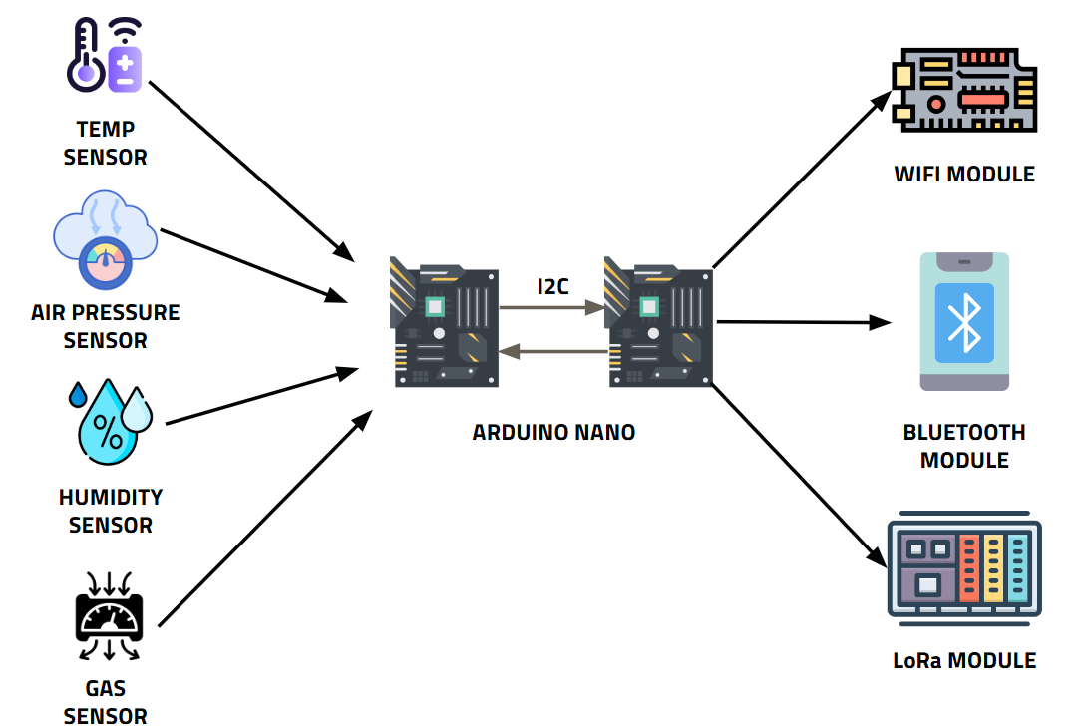

SOFTWARE USED



SCHEMATICS

Below is the Schematics of the Wireless Weather Station.

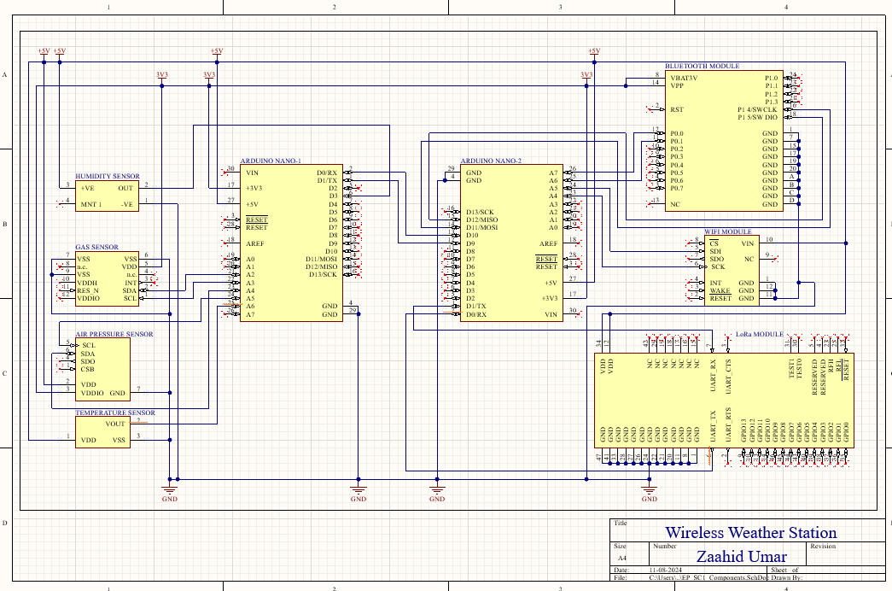

PCB LAYOUT AND ITS HIGHLIGHTS

Below are the PCB Layouts of the Wireless Weather Station.

1). PCB 2D Layout: -

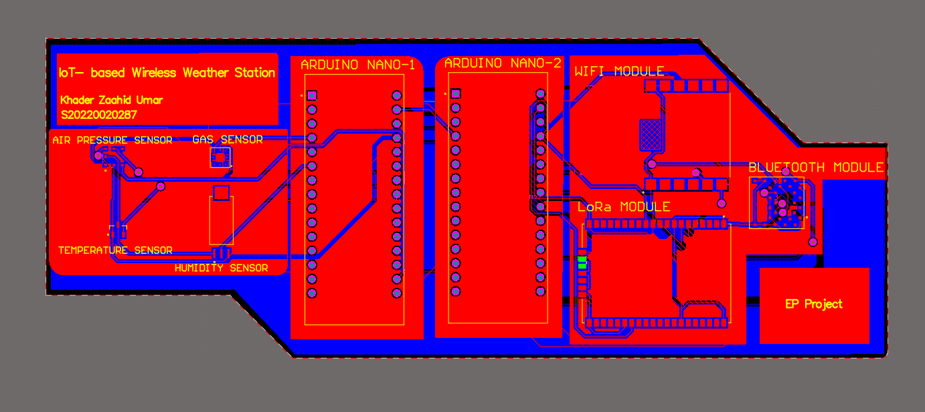

2D Top Layer

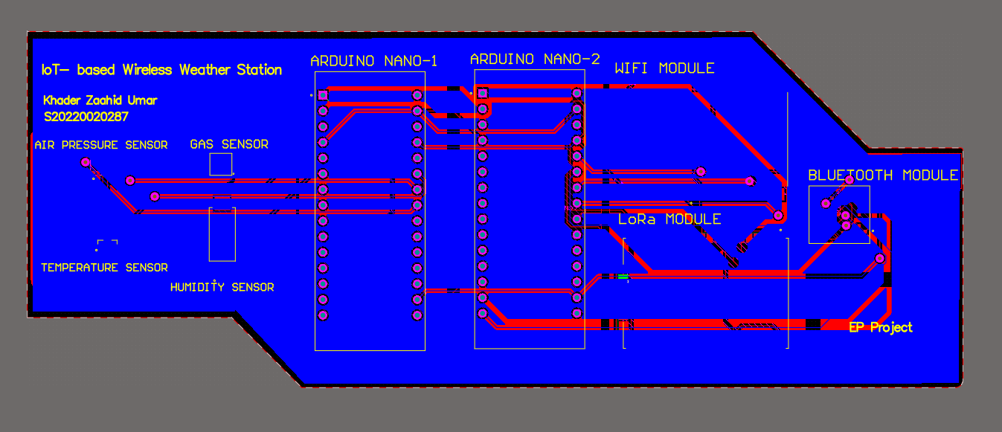

2D Bottom Layer

2). PCB 3D Layout: -

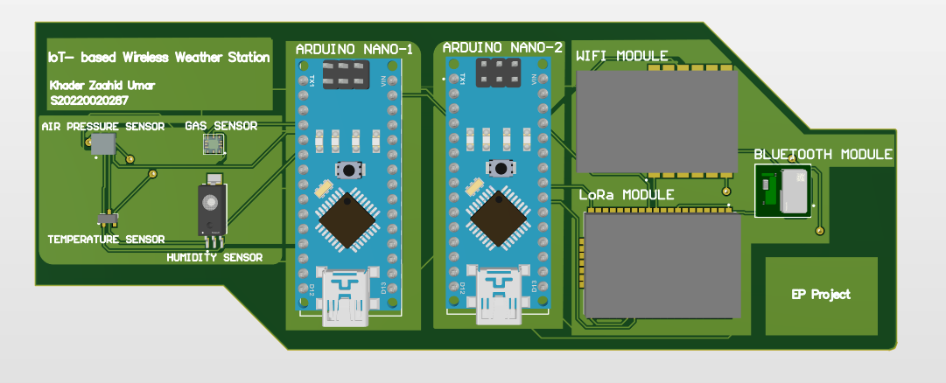

3D Top View

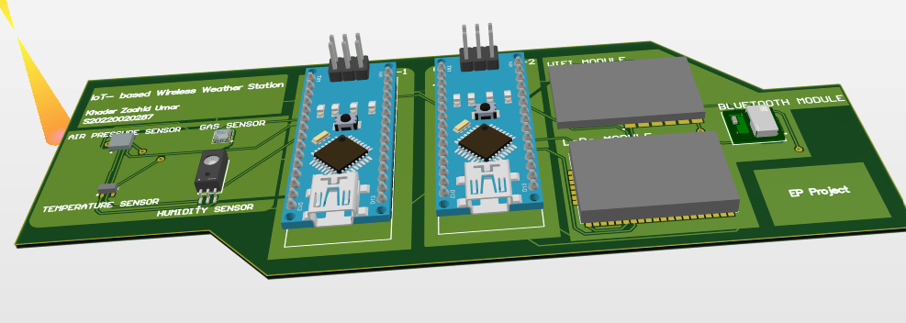

3D Front View

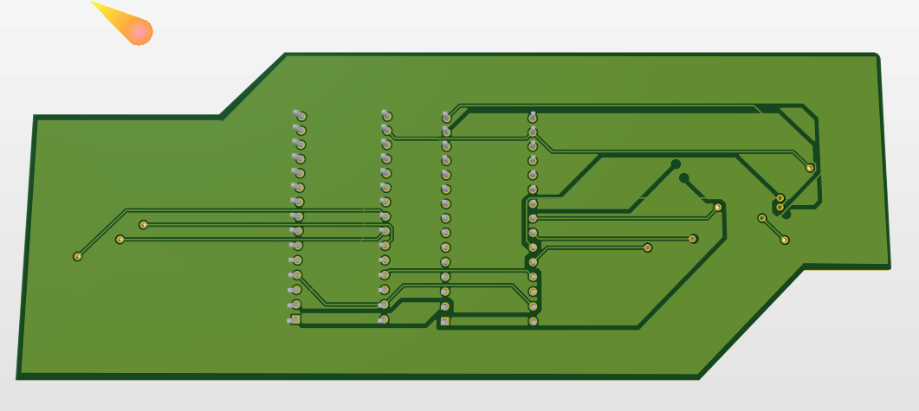

3D Bottom View

HIGHLIGHTS: -

1). Used 6 Layers in my PCB along with 2 Solder Masks

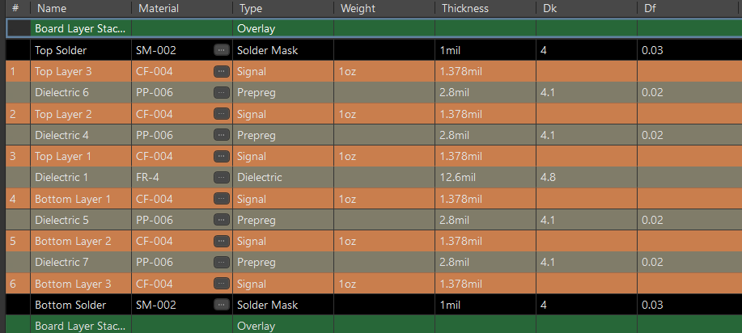

2). Polygon Pour

Performed Polygon Pour for **3 different Segments** in the **Top Layer** i.e. 1 pour for Sensors on the Right, 2 pours Arduinos in the middle, and 1 pour for Communication Modules on the Right. **Top Layer Polygon Pour is in Red Colour**.

Performed Polygon Pour in the **Bottom Layer, which is in Blue Colour.**

GERBER FILES

1). Silk Screen

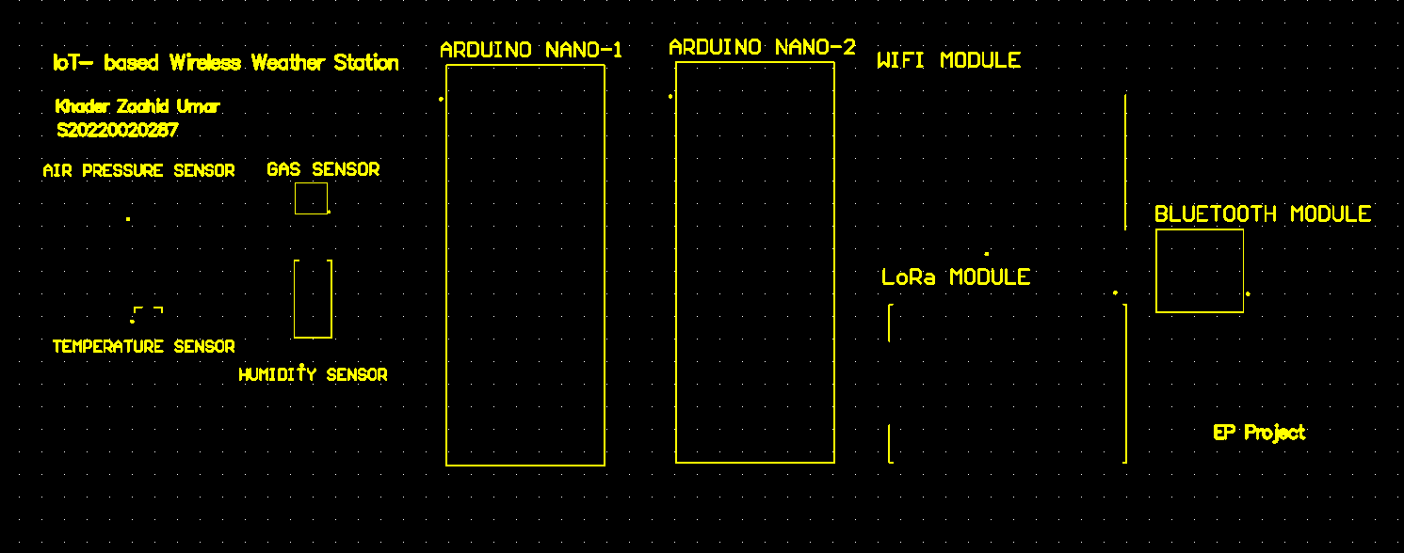

2). Polygon Pour

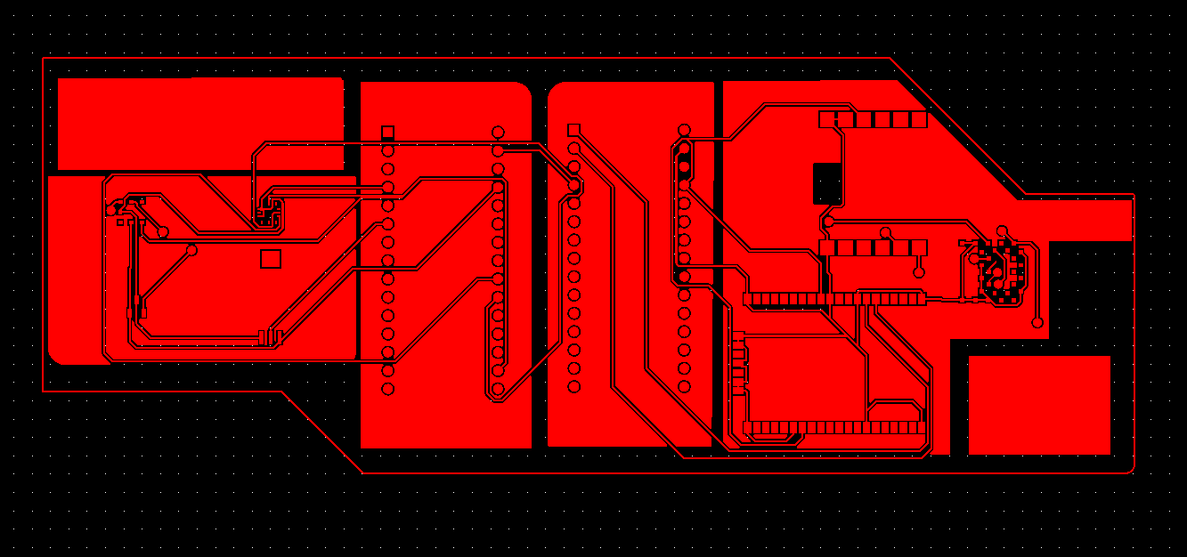

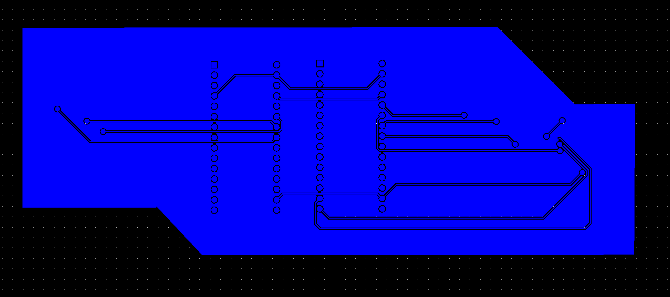

3). Gerber Files viewed in PCBWay

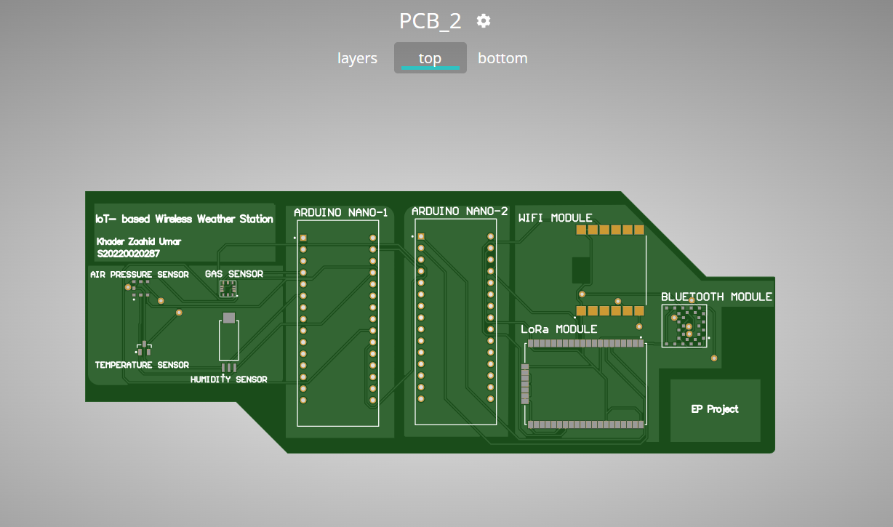 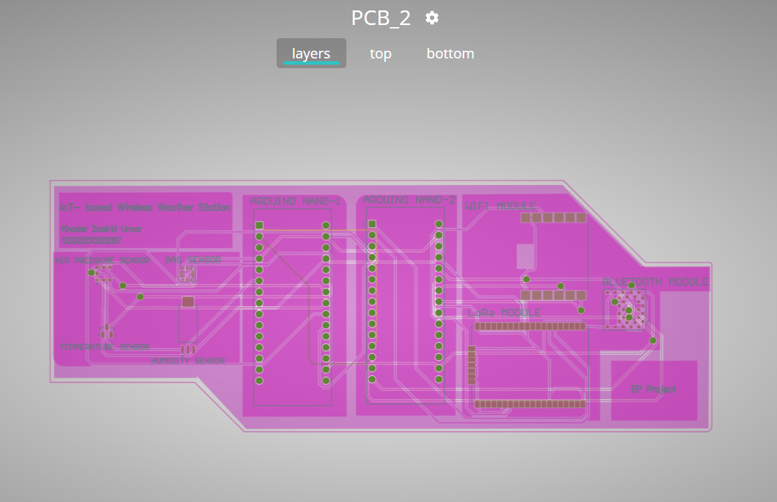

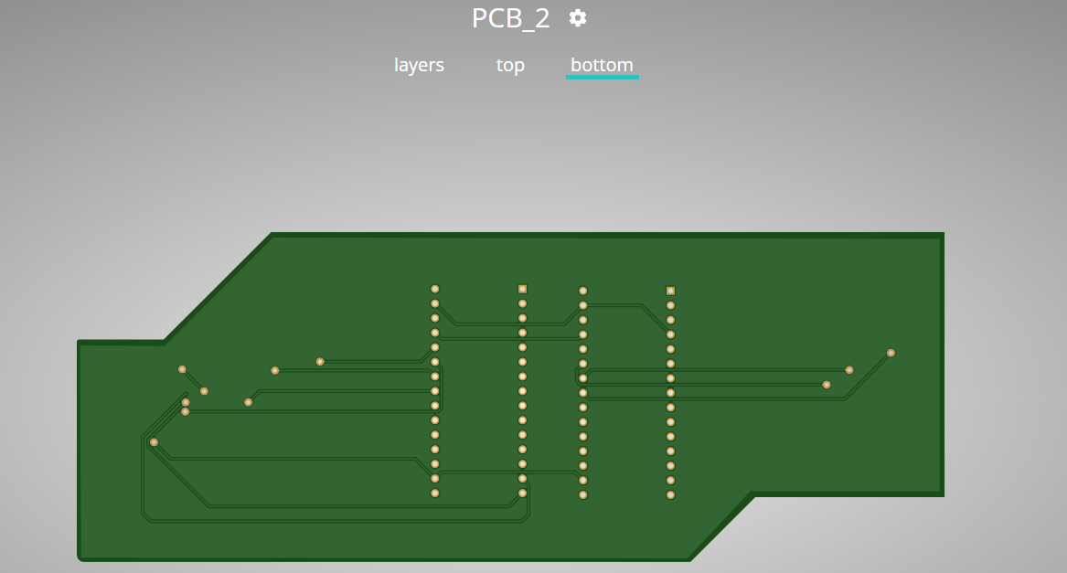

THANK YOU!!