**PART B**

(PART B : TO BE COMPLETED BY STUDENTS)

***(Students must submit the soft copy as per following segments within two hours of the practical. The soft copy must be uploaded on the Blackboard or emailed to the concerned lab in charge faculties at the end of the practical in case the there is no Black board access available)***

|  |  |
| --- | --- |
| **Roll No. 76** | **Name: Faraaz Khan** |
| **Class : TE/A/COMP** | **Batch :** |
| **Date of Experiment:** | **Date of Submission:** |
| **Grade :** |  |

**B.1 Snapshot of steps for free web hosting:**

**URL of hosted website:** https://whitebamboo.000webhostapp.com/

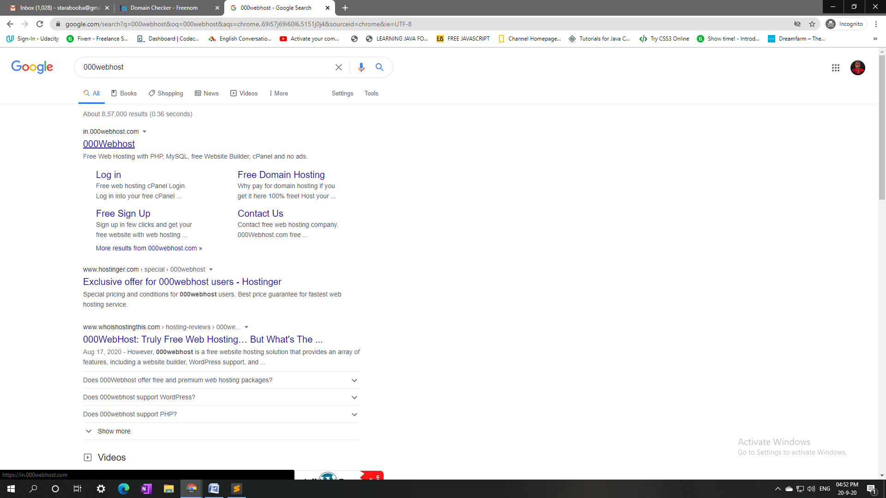

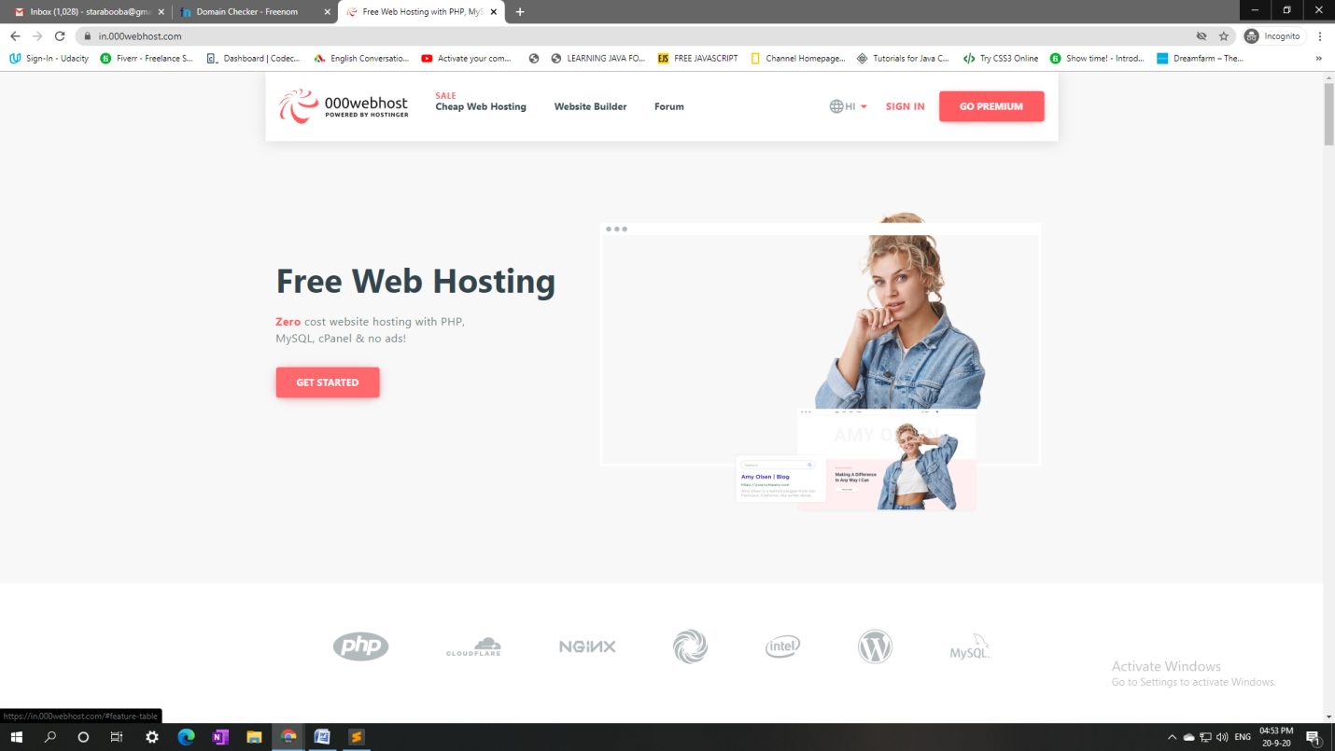



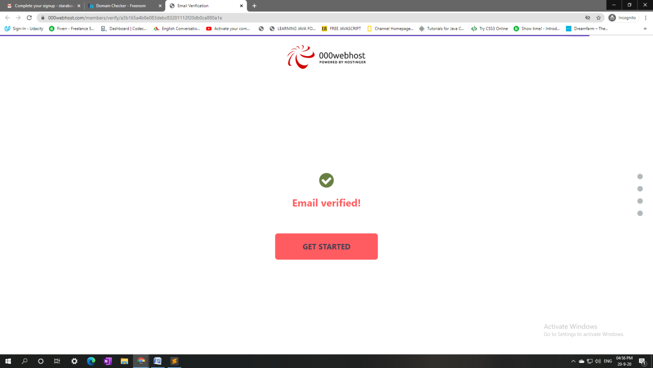

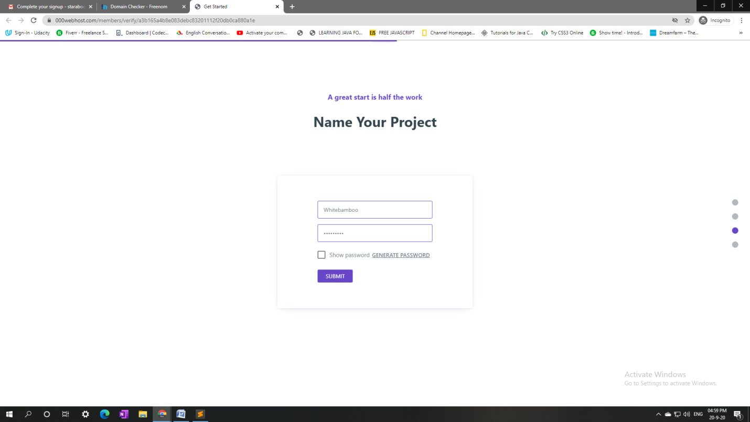

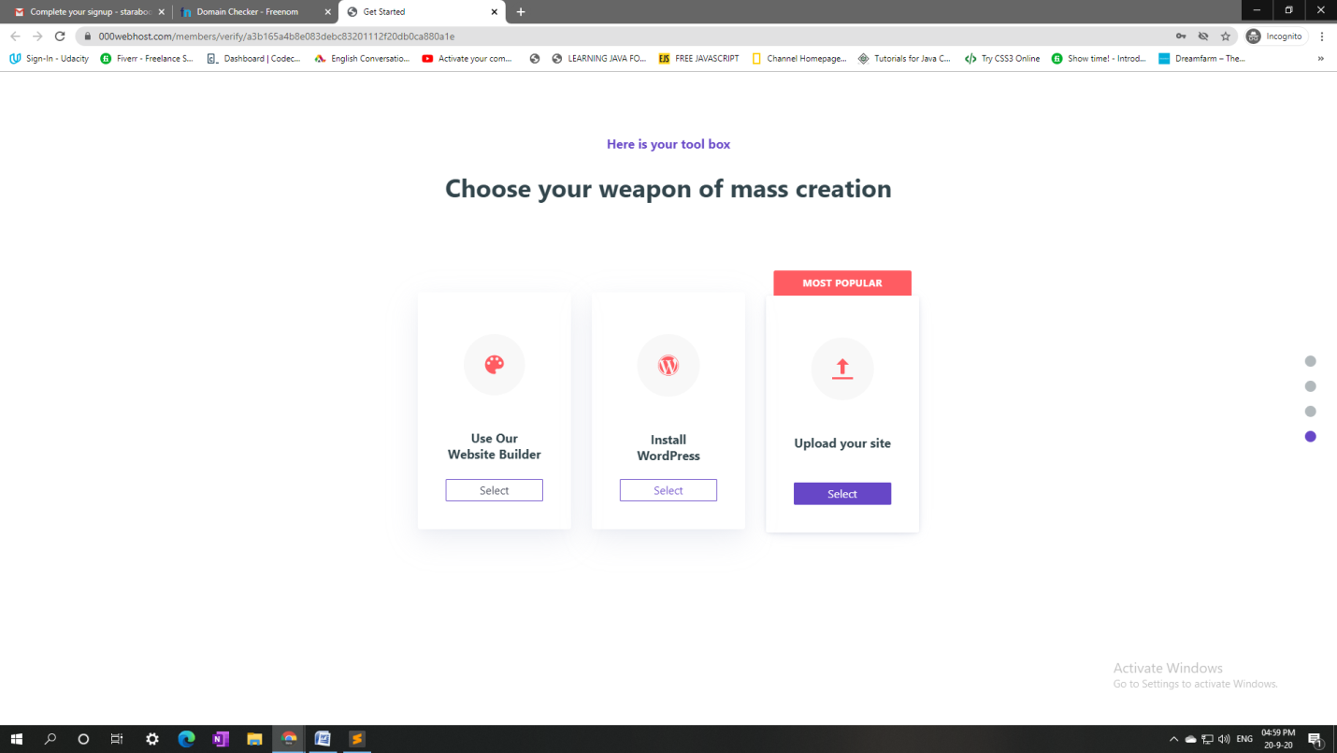

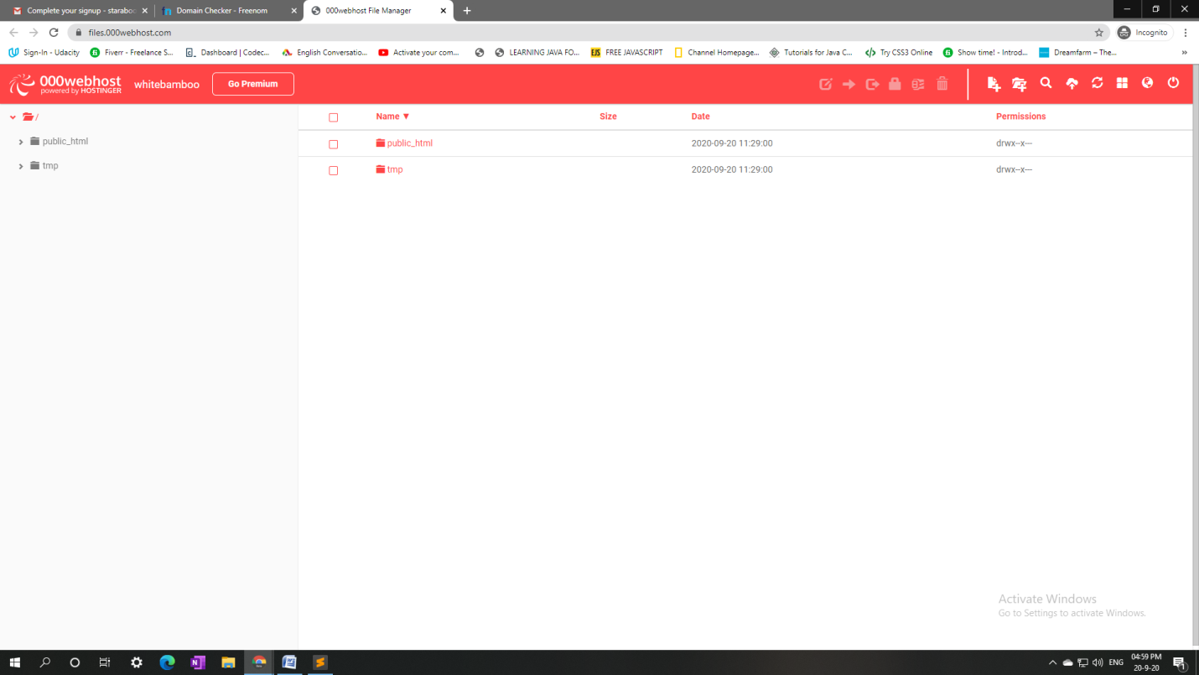

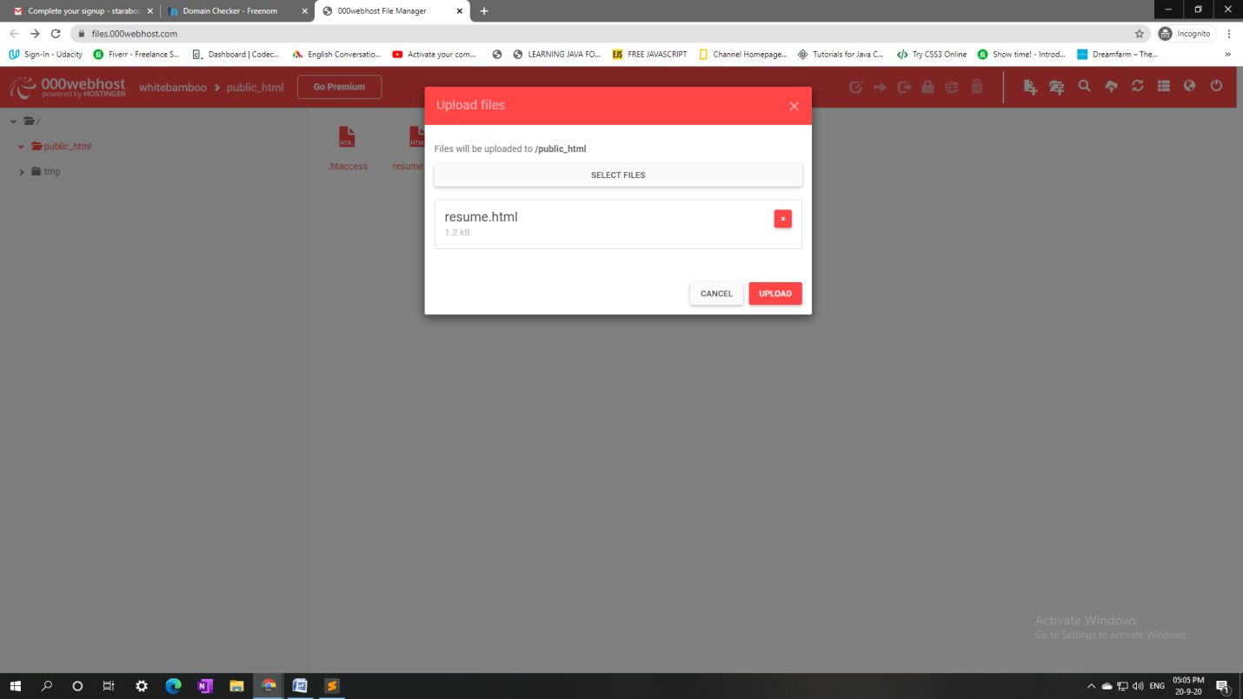

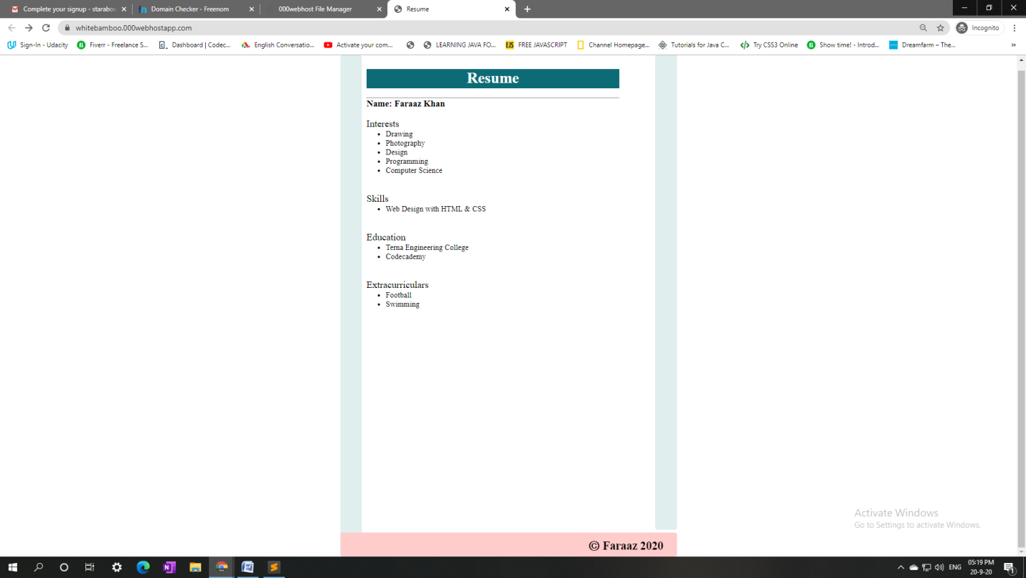

**B. 2 Conclusion:**

Hence, we learned how to register ourselves with a free hosting provider and we learned how to host our website using that free hosting.

**B4. Questions:**

**1. List out Free web hosting domain.**

🡪 Some free web hosting services are:

1. 000Webhost.com
2. InfinityFree.net
3. Firebase.google.com
4. Wix.com
5. Wordpress.com etc

**2. What are the limitations of free web hosting?**

🡪 Free Web Hosting has its limitations, for example

1) Effect on rankings:

The free hosting plans do not provide the separate domain name. Instead, they only offer the sub domain upon their own domain name. Many of the times search engines ignore the sub domains and hence your website will not be shown in the search results, however this does not happens all the time, for example some wordpress sites do come up in the Google’s search page.

2) Limited Resources:

In free web hosting you will always get limited resources like limited Disk space, Bandwidth, file upload types etc.

3) No support:

In free hosting services you won’t be getting any support and you will not receive and backup guarantee and hence you can lose your data anytime with free hosting services.

4) No advertisement:

You cannot put ads if you’re using free hosting, instead the hosting company can put advertisements on your site.