**Terna Engineering College**

**Computer Engineering Department**

**SH 2020**

**Program: Sem V**

**Course: Web Technology Laboratory (CSL504)**

**Faculty: Mr. V. B. Gaikwad**

**Experiment No.04**

**PART B**

|  |  |
| --- | --- |
| **Roll No.: A-22** | **Name: Siddhesh Laxman More** |
| **Class : TE-A Comp.** | **Batch : A-1** |
| **Date of Experiment:** | **Date of Submission:- 02/08/2020** |
| **Grade :** |  |

B.1.Web page Snapshot:

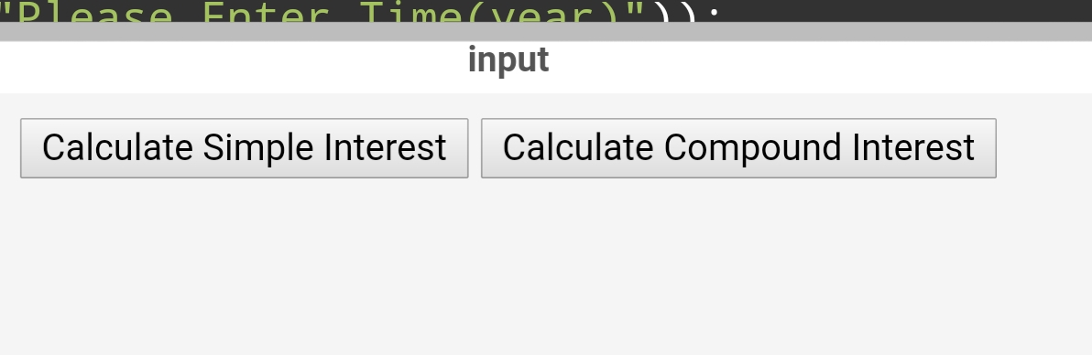

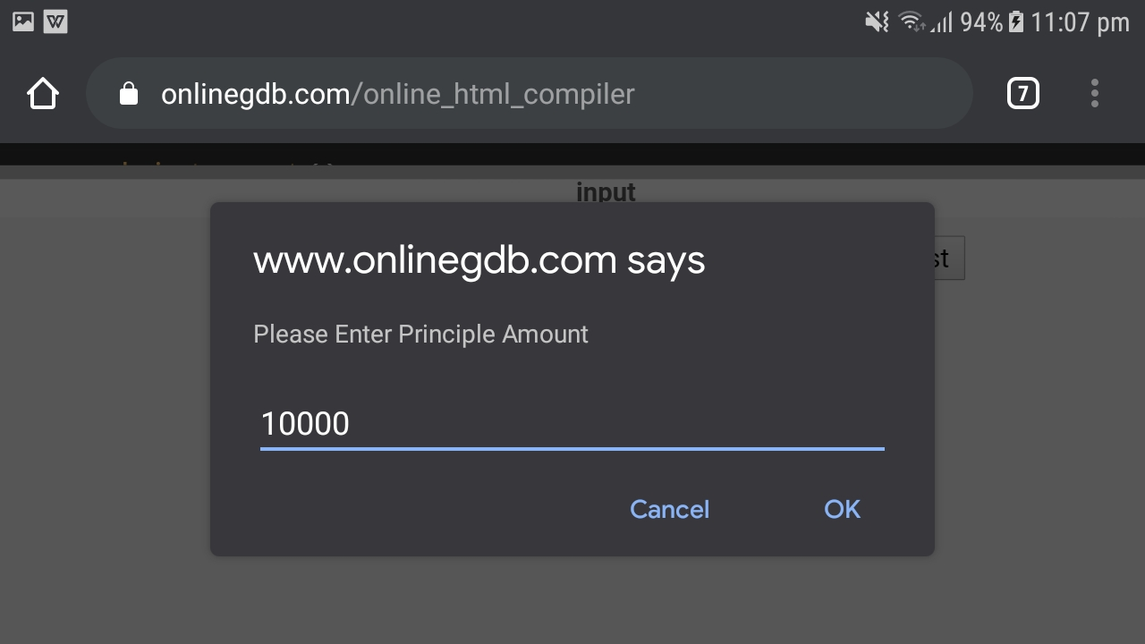

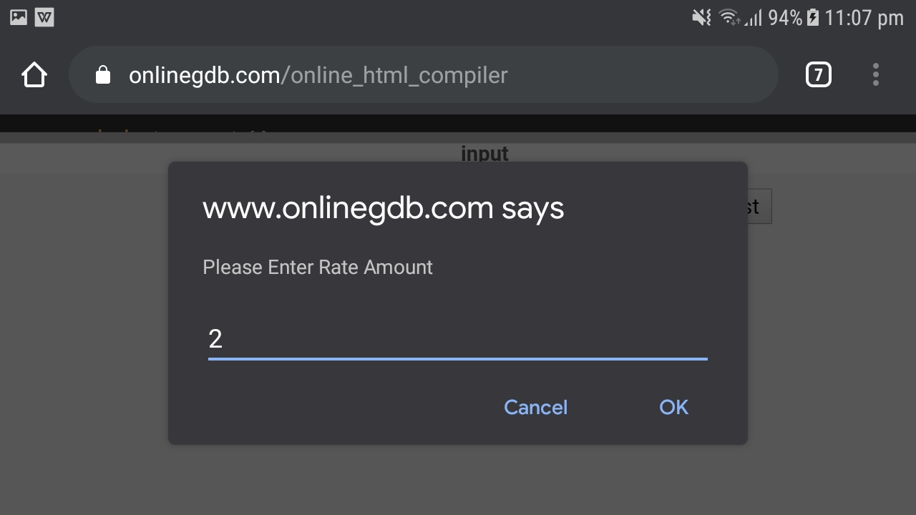

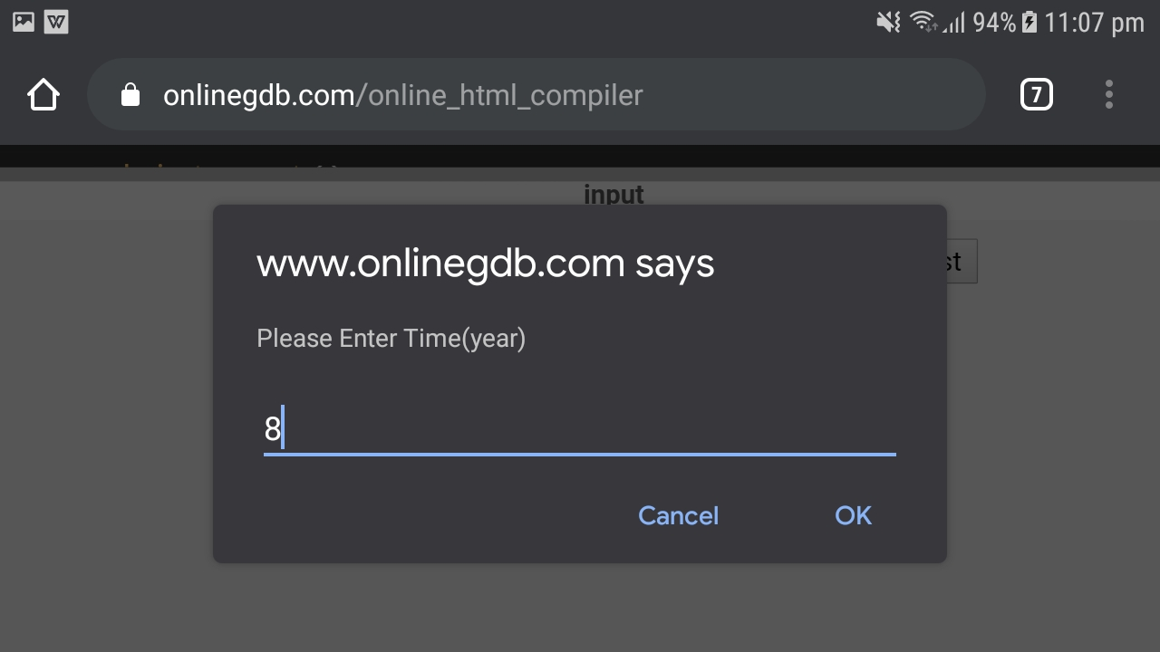

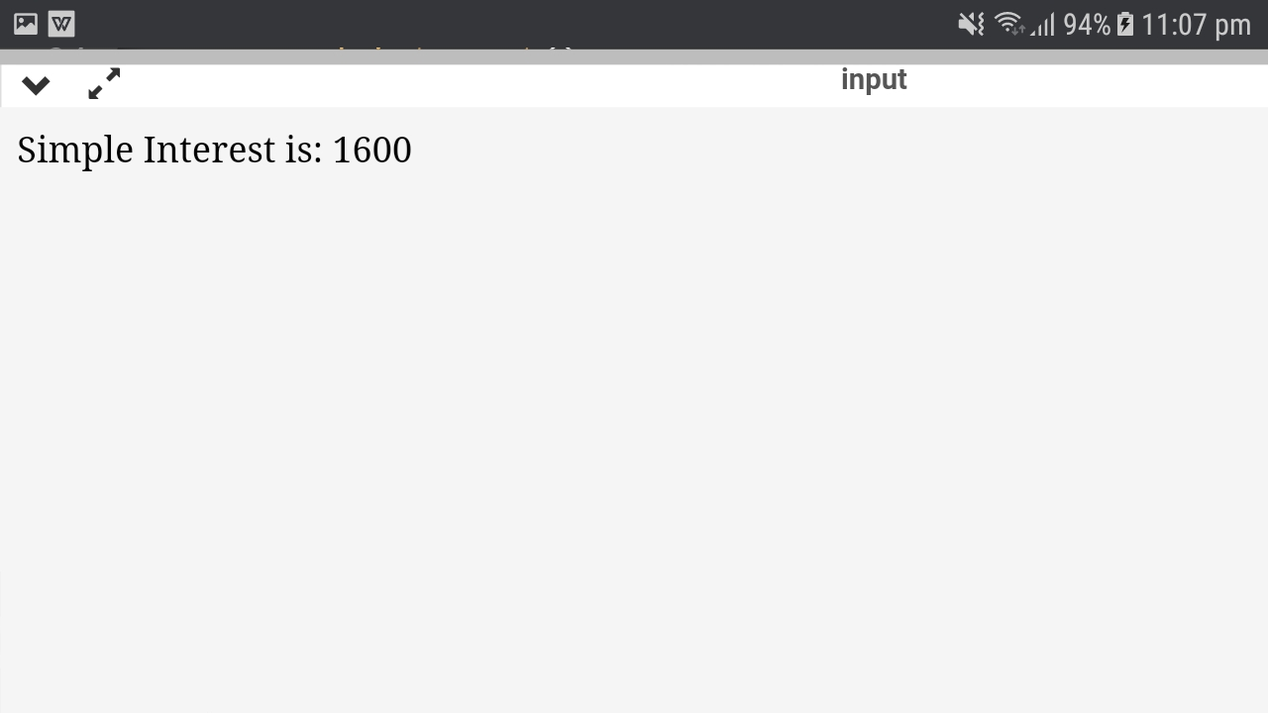

B.2.Web page source code:

Source code

<!DOCTYPE html>

<html lang="en">

<head>

<meta charset="utf-8">

<title>Simple Interest</title>

</head>

<script type="text/javascript">

function simple_interest()

{

var p,r,t;

p=parseFloat(prompt("Please Enter Principle Amount"));

r=parseFloat(prompt("Please Enter Rate Amount"));

t=parseFloat(prompt("Please Enter Time(year)"));

var simple_interest=(p*r*t)/100;

document.write("Simple Interest is: "+simple_interest);

}

function compound_interest()

{

var p = parseFloat(prompt("Enter Principle Amount"));

var r = parseFloat(prompt("Enter Rate Amount"));

var n = parseFloat(prompt("Enter no. of times that interest is compounded" ));

var t = parseFloat(prompt("Enter Time in (year)"));

var Compound_interest = ( p* Math.pow((1 + (r/(n*100))), (n*t)));

document.write("Compound Interest is: "+Compound_interest);

}

</script>

<body>

<center>

<input type="button" value="Calculate Simple Interest" onclick="simple_interest()" />

<input type="button" value="Calculate Compound Interest" onclick="compound_interest()" />

</center>

</body>

</html>

B. 3.Conclusion:

Learned how to take input from user.Learned to use JavaScript to perform arithematic calculations and calculated simple and compound interest.