**Terna Engineering College**

**Computer Engineering Department**

**SH 2020**

**Program: Sem V**

**Course: Web Technology Laboratory (CSL504)**

**Faculty: Mr. V. B. Gaikwad**

LAB Manual

**PART B**

**EXPERIMENT NO.7**

|  |  |
| --- | --- |
| **Roll No. :A-22** | **Name: Siddhesh Laxman More** |
| **Class : TE-A Comp.** | **Batch : A1** |
| **Date of Experiment:** | **Date of Submission:** |
| **Grade :** |  |

**B.1 Web page Snapshot:**

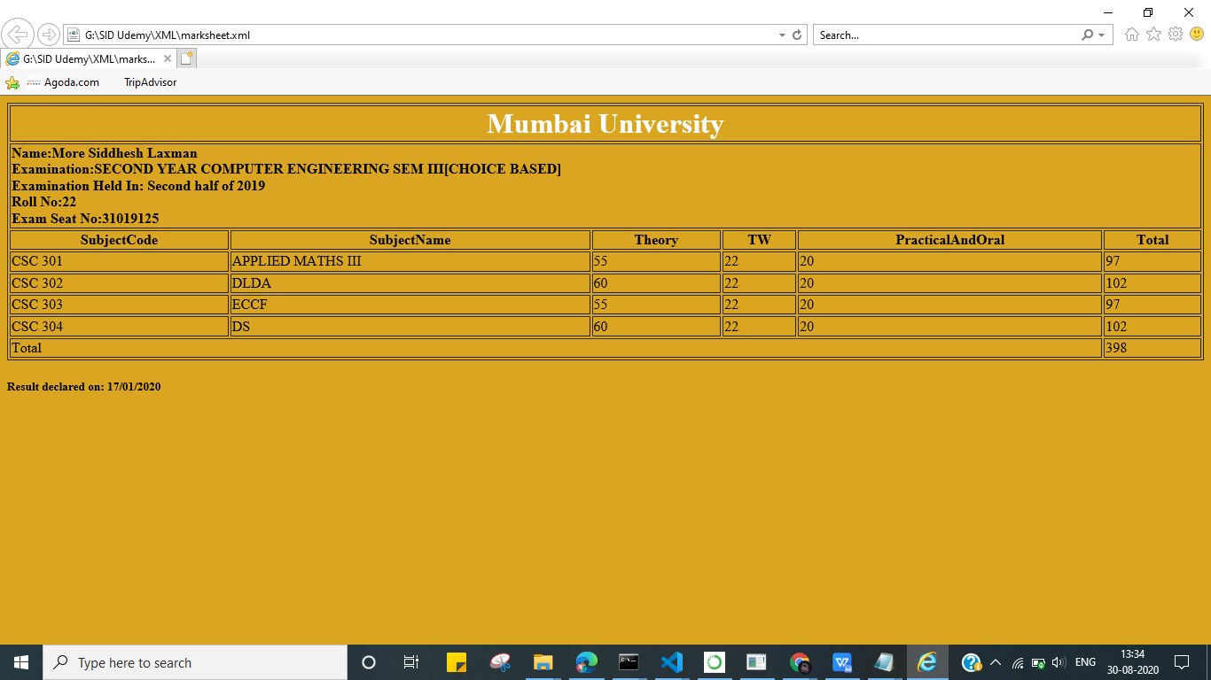

**B.2 Source code:**

**XML CODE:**

<?xml version="1.0" encoding="UTF-8"?>

<?xml-stylesheet type="text/xsl" href="marksheet.xsl"?>

<Marksheet>

<Subject>

<SubjectCode>CSC 301</SubjectCode>

<SubjectName>APPLIED MATHS III</SubjectName>

<Theory>55</Theory>

<TW>22</TW>

<PracticalAndOral>20</PracticalAndOral>

<Total>97</Total>

</Subject>

<Subject>

<SubjectCode>CSC 302</SubjectCode>

<SubjectName>DLDA</SubjectName>

<Theory>60</Theory>

<TW>22</TW>

<PracticalAndOral>20</PracticalAndOral>

<Total>102</Total>

</Subject>

<Subject>

<SubjectCode>CSC 303</SubjectCode>

<SubjectName>ECCF</SubjectName>

<Theory>55</Theory>

<TW>22</TW>

<PracticalAndOral>20</PracticalAndOral>

<Total>97</Total>

</Subject>

<Subject>

<SubjectCode>CSC 304</SubjectCode>

<SubjectName>DS</SubjectName>

<Theory>60</Theory>

<TW>22</TW>

<PracticalAndOral>20</PracticalAndOral>

<Total>102</Total>

</Subject>

<TotalMarks><Marks>398</Marks></TotalMarks>

</Marksheet>

**XSL CODE:**

<?xml version="1.0" encoding="UTF-8"?>

<xsl:stylesheet version="1.0" xmlns:xsl="http://www.w3.org/1999/XSL/Transform">

<xsl:template match="/">

<html>

<body bgcolor="#DAA520">

<table border="1" width="100%">

<tr>

<td colspan="6"><h1><center> <font color="white">Mumbai University</font></center></h1></td>

</tr>

<tr>

    <td colspan="6">

    <h4>

        Name:More Siddhesh Laxman

        <br />

        Examination:SECOND YEAR COMPUTER ENGINEERING SEM III[CHOICE BASED]

        <br />

        Examination Held In: Second half of 2019

        <br />

        Roll No:22

        <br />

        Exam Seat No:31019125

    </h4>

    </td>

</tr>

<tr>

<th> SubjectCode</th>

<th> SubjectName</th>

<th> Theory</th>

<th> TW</th>

<th> PracticalAndOral</th>

<th> Total</th>

</tr>

<xsl:for-each select="Marksheet/Subject">

<tr>

<td><xsl:value-of select="SubjectCode"/></td>

<td><xsl:value-of select="SubjectName"/></td>

<td><xsl:value-of select="Theory"/></td>

<td><xsl:value-of select="TW"/></td>

<td><xsl:value-of select="PracticalAndOral"/></td>

<td><xsl:value-of select="Total"/></td>

</tr>

</xsl:for-each>

<tr>

<td colspan="5">Total</td>

<xsl:for-each select="Marksheet/TotalMarks">

<td><xsl:value-of select="Marks"/></td>

</xsl:for-each>

</tr>

</table>

<h5>Result declared on: 17/01/2020</h5>

</body>

</html>

</xsl:template>

</xsl:stylesheet>

**B.3 Question of Curiosity**:

1.What are the features of XML?

Ans:

* Excellent for handling data with a complex structure or atypical data • Data described using markup language
* Text data description
* Human- and computer-friendly format
* Handles data in a tree structure having one-and only one-root element
* Excellent for long-term data storage and data reusability

2.Differentiate between XML and HTML.

Ans:

HTML was designed for data display to focus the data look while XML was designed for storing and transporting data. HTML is used for displaying web pages while XML does not used for displaying web pages. HTML was invented in 1990 while XML was invented in 1996. HTML is static type while MXL is dynamic type. In XML author can create custom tags but in HTML custom tags are predefined. XML can preserve white spaces while XML can’t preserve white spaces. HTML is presentation type language while XML is neither a presentation type language not programming type. HTML don’t have strict rules of processing while XML has to follow strict rule otherwise processing file will be terminated.

3.Explain XSL in detail.

Ans:

XSL is a language for expressing style sheets. An XSL style sheet is, like with CSS, a file that describes how to display an XML document of a given type. XSL shares the functionality and is compatible with CSS2 (although it uses a different syntax). It also adds:

* A transformation language for XML documents: XSLT. Originally intended to perform complex styling operations, like the generation of tables of contents and indexes, it is now used as a general purpose XML processing language. XSLT is thus widely used for purposes other than XSL, like generating HTML web pages from XML data.
* Advanced styling features, expressed by an XML document type which defines a set of elements called Formatting Objects, and attributes (in part borrowed from CSS2 properties and adding more complex ones.

**B.4 Conclusion:**

**Learned to create a structured document using XML .**Using Extensible Mark-up Language (XML) and Extensible style sheet language (XSL) marksheet has been created.