**Terna Engineering College**

**Computer Engineering Department**

**SH 2020**

**Program: Sem V**

**Course: Web Technology Laboratory (CSL504)**

**Faculty: Mr. V. B. Gaikwad**

**Experiment No.06**

**PART B**

(PART B : TO BE COMPLETED BY STUDENTS)

***(Students must submit the soft copy as per following segments within two hours of the practical. The soft copy must be uploaded on the Blackboard or emailed to the concerned lab in charge faculties at the end of the practical in case the there is no Black board access available)***

|  |  |
| --- | --- |
| **Roll No.: A22** | **Name: Siddhesh More** |
| **Class :TE_A (Comp.)** | **Batch :A1** |
| **Date of Experiment:** | **Date of Submission: 30/08/2020** |
| **Grade :** |  |

**B.1 Snapshots of steps followed to install XAMPP:**

**1) Downloaded XAMPP**

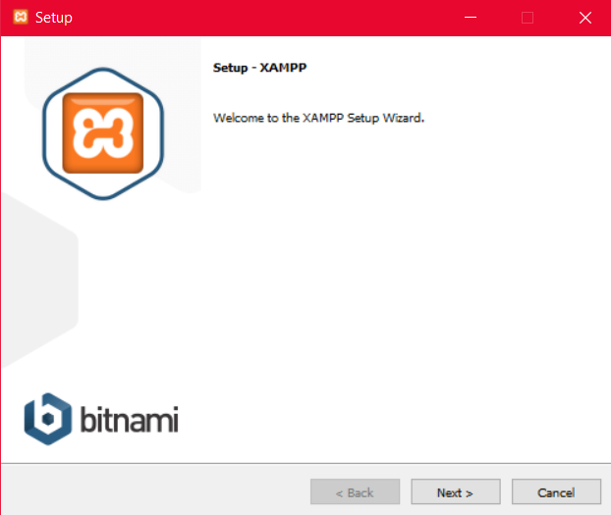

**2)Setting up XAMPP**

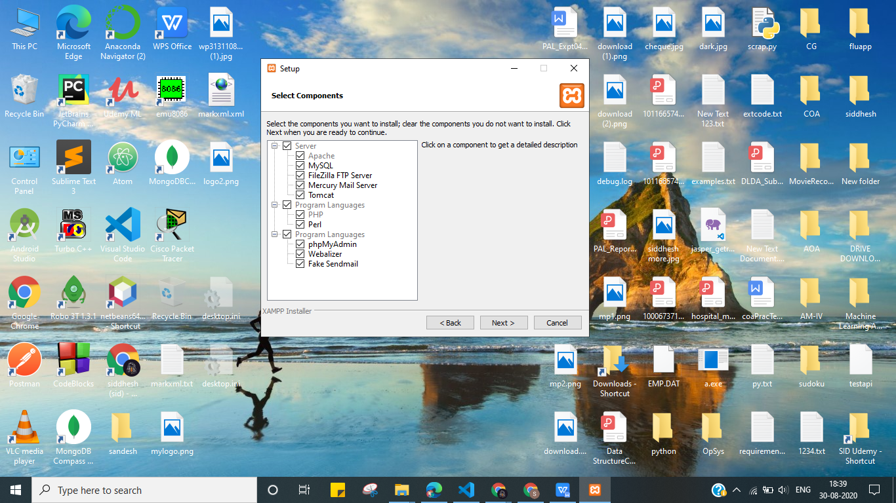

**3)INSTLLATION:**

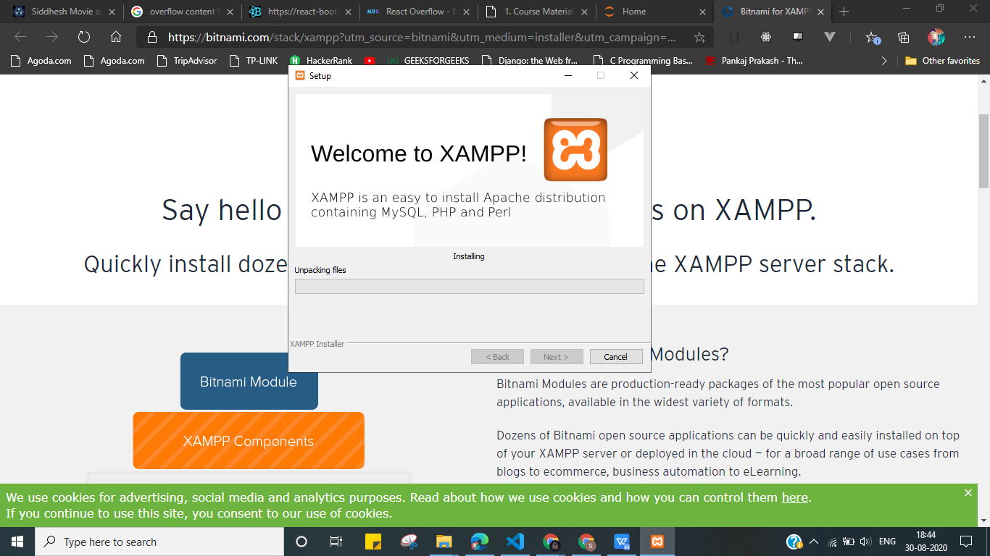

**4)INSTALLED SUCCESSFULLY**

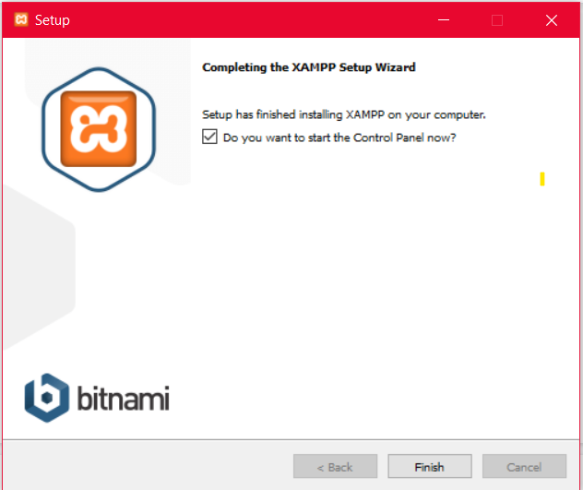

**5)DONE**

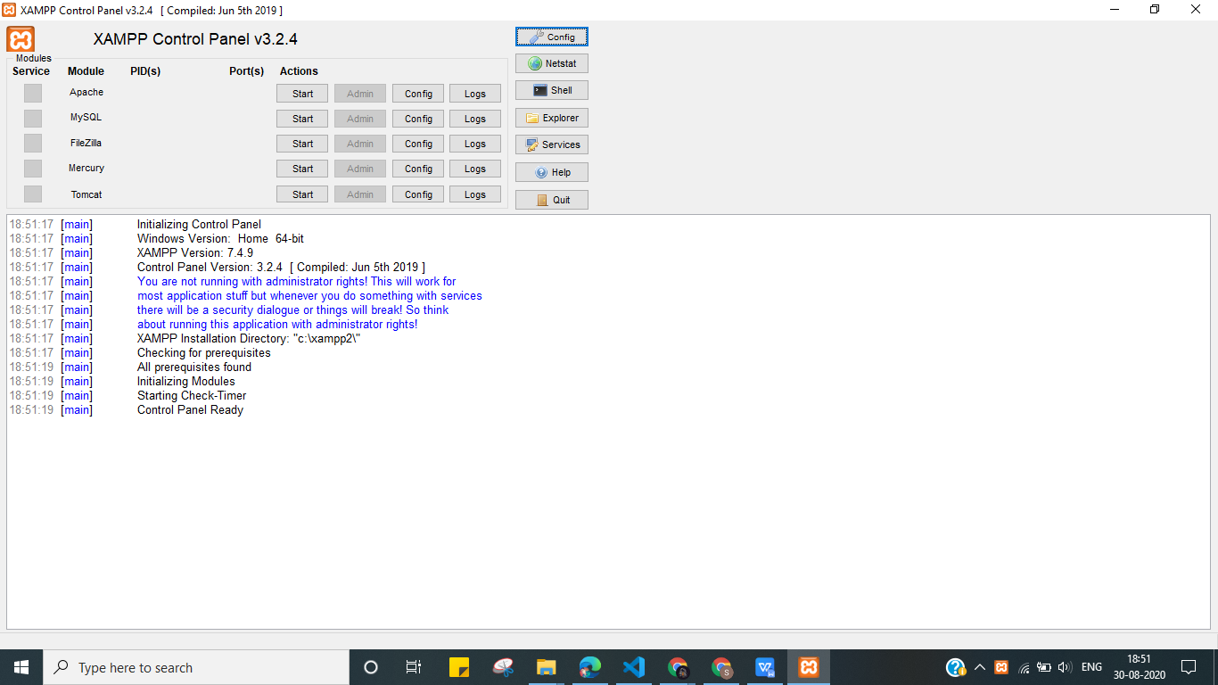

**B.2 Question of Curiosity:**

1. What are the Web Servers?

->A web server is server software, or hardware dedicated to running this software, that can satisfy client requests on the World Wide Web. A web server can, in general, contain one or more websites. A web server processes incoming network requests over HTTP and several other related protocols.

The primary function of a web server is to store, process and deliver web pages to clients.The communication between client and server takes place using the Hypertext Transfer Protocol (HTTP). Pages delivered are most frequently HTML documents, which may include images, style sheets and scripts in addition to the text content.

2. Differentiate between Xampp and Wamp.

->**WAMP works only in Windows operating system, whereas XAMPP is cross-platform, it works in Windows, Linux, Mac, etc.**

* **Configuring and setting up XAMPP is very easy compared to WAMP**
* **WAMP provides support only for the MySQL and PHP, whereas XAMPP provides support for MySQL, PHP, and Perl**
* **You can start the process easily in XAMPP but just clicking the start button, whereas in WAMP there is no such button**
* **In XAMPP you can add additional features like Perl, mercury mail, file server, and much more, whereas in WAMP you cannot add any additional features**
* **XAMPP is simple and lightweight compared to WAMP**

3. Explain phpmyadmin section of XAMPP Server.

->PHPMUADMIN is generally used to create the database and store some data in it.

The following are the steps to create the database:

**STEP1**->MAKE SURE THE APACHE AND MYSQL SERVICES ARE RUNNING IN XAMPP AND IF IT IS RUNNING IT WILL SHOW GREEN LIGHT ON IT

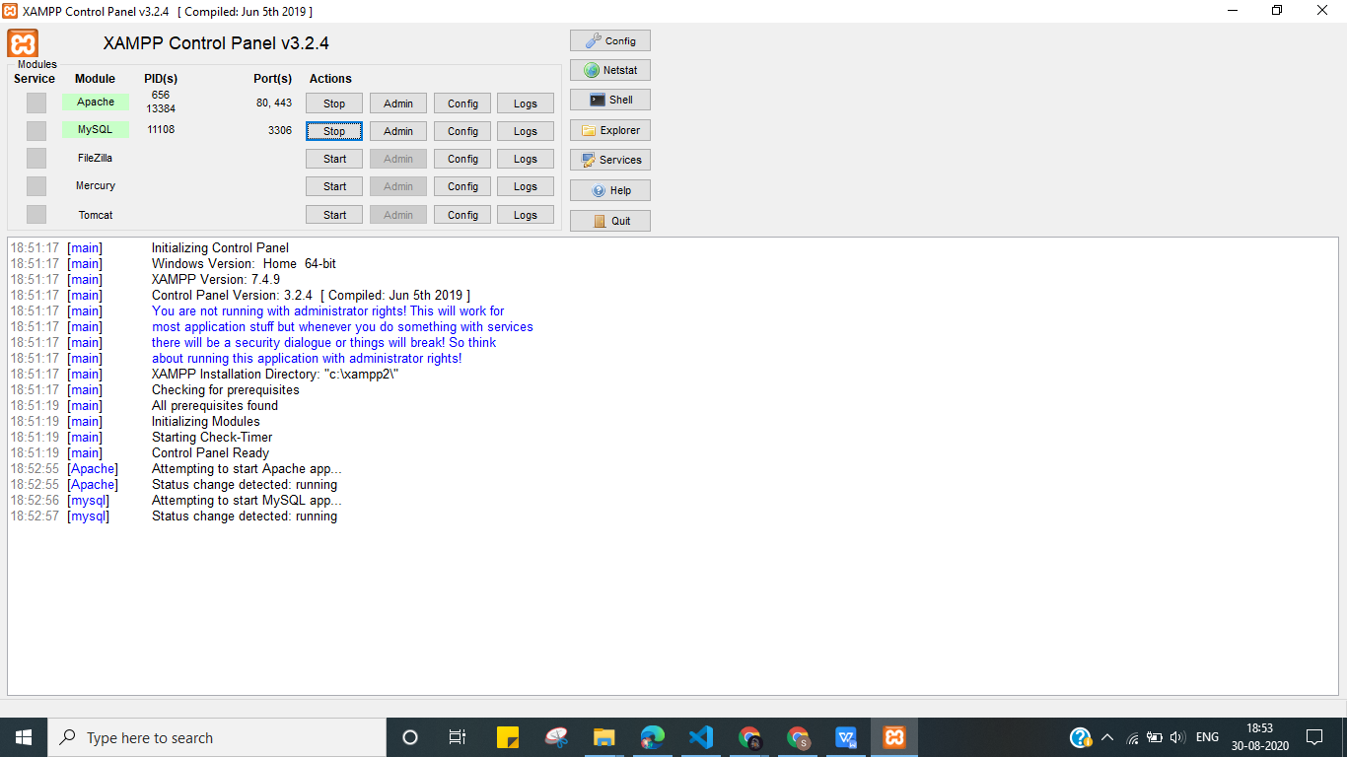

STEP-2->AFTER THAT CLICK ON ADMIN OPTION GIVEN IN APACHE SERVICE A SCREEN WILL OPEN IN YOUR BROWSER ON THAT PAGE CLICK ON PHPMYADMIN OPTION GIVEN IN RIGHT UPPER CORNER

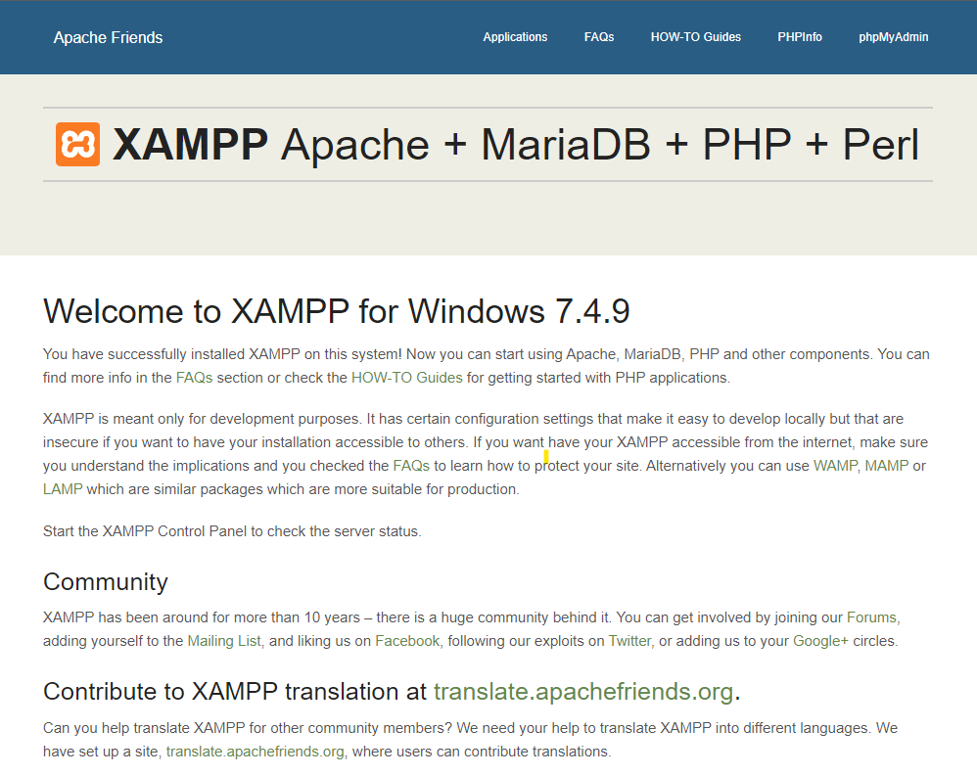

STEP-3->CLICK ON NEW OPTION TO CREATE DATABASE GIVE A NAME TO DATABASE GIVE A TABLE NAME AND THE NUMBER OF COLUMNS YOU WANT IN A TABLE THEN CLICK ON GO BUTTON AFTER THAT YOUR TABLE GETS CREATED AND AND YOU SHOULD ENTER THE YOUR DATA.

