**Terna Engineering College**

**Computer Engineering Department**

**SH 2020**

**Program: Sem V**

**Course: Web Technology Laboratory (CSL504)**

**Faculty: Mr. V. B. Gaikwad**

LAB Manual

PART A

(PART A: TO BE REFFERED BY STUDENTS)

**Experiment No.03**

**PART B**

(PART B : TO BE COMPLETED BY STUDENTS)

***(Students must submit the soft copy as per following segments within two hours of the practical. The soft copy must be uploaded on the Blackboard or emailed to the concerned lab in charge faculties at the end of the practical in case the there is no Black board access available)***

|  |  |
| --- | --- |
| **Roll No.: A-22** | **Name:Siddhesh Laxman More** |
| **Class : -TE A Comp.** | **Batch : A1** |
| **Date of Experiment:** | **Date of Submission: 2/08/2020** |
| **Grade :** |  |

**B.1.Web page Snapshot:**

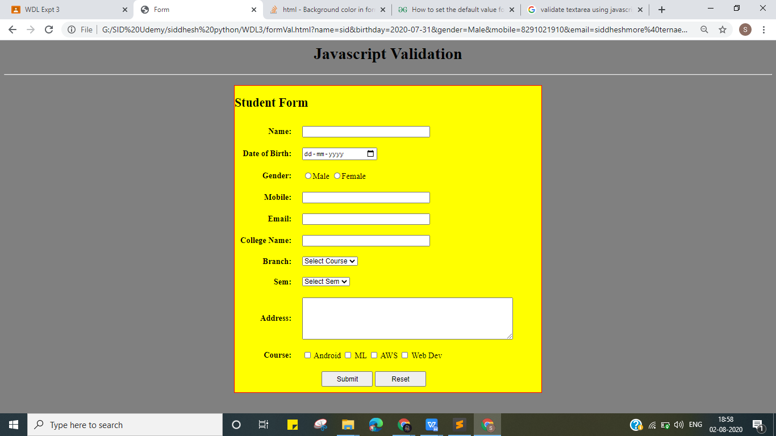

**When user forgot to enter a college name and clicks submit:**

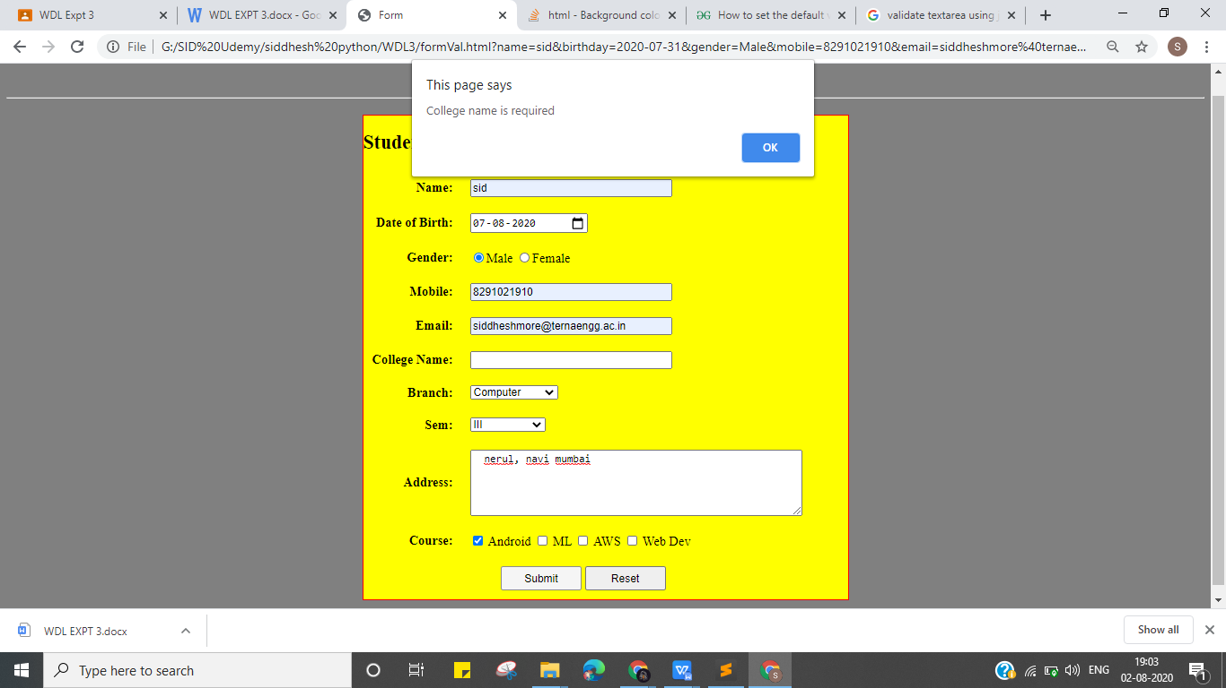

**When student forgot to select a course and clicks submit:**

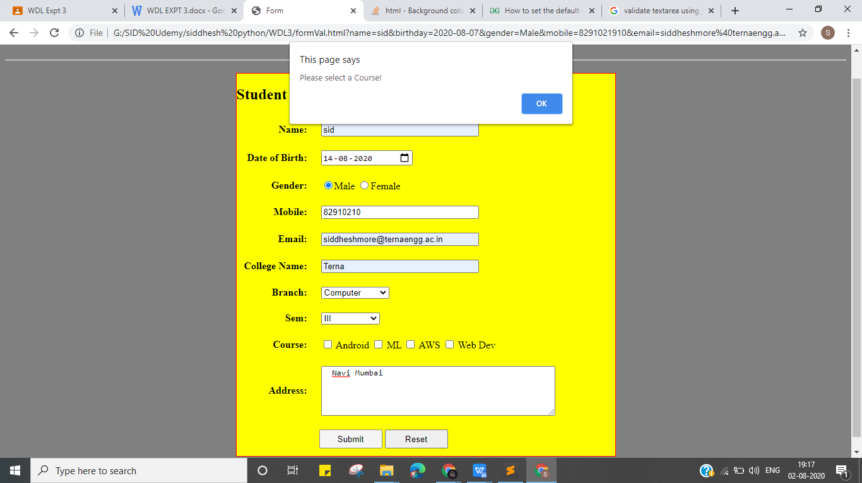

**When student forgot to enter an email id and clicks submit:**

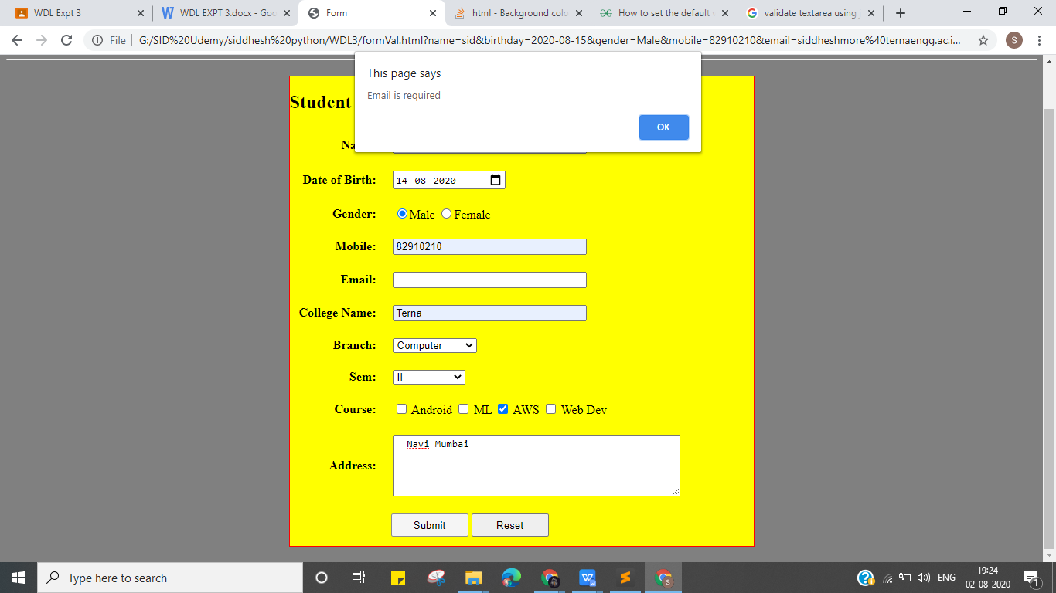

**After submitting fully filled and correct form and pressing submit:**

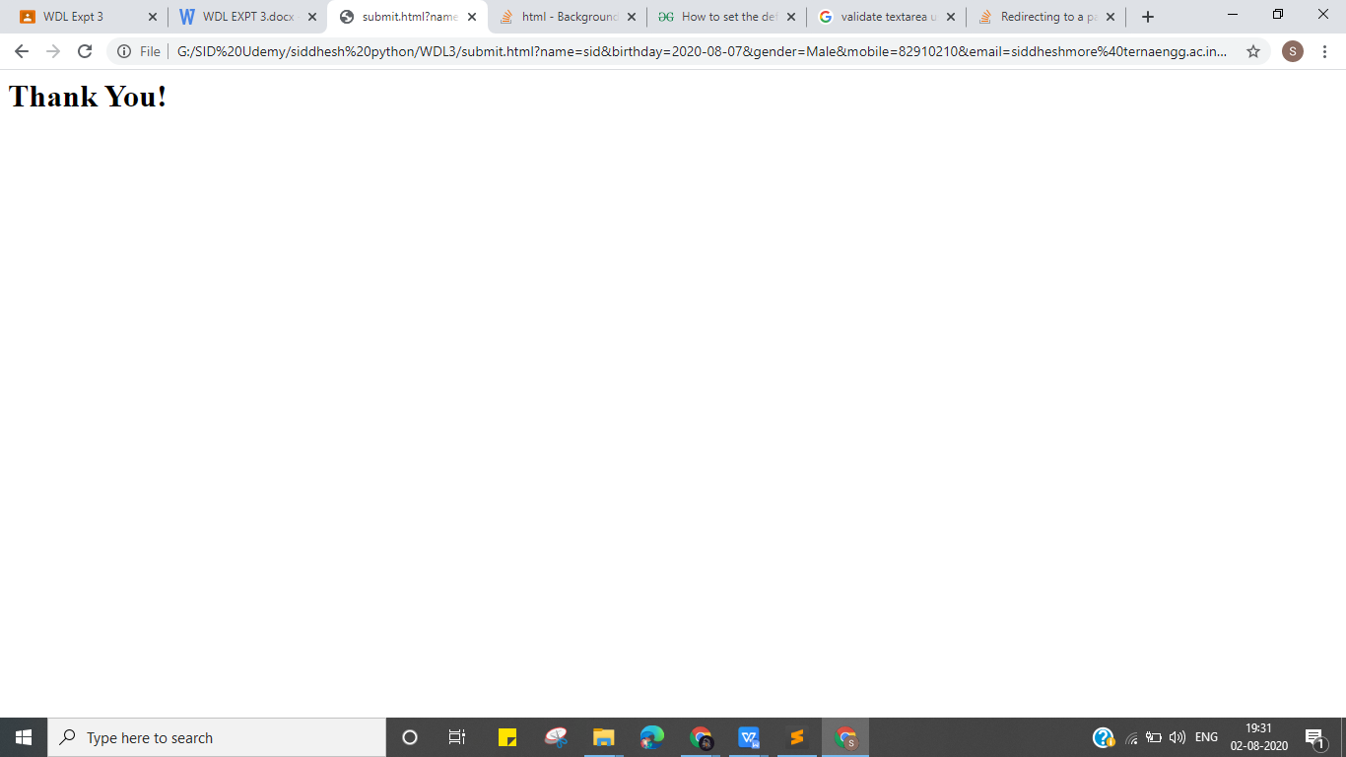

**The page will get redirected to submit.html file**

**B.2.Web page source code:**

<html>

<head>

<title>Form</title>

<style type="text/css">

input[type="text"] {

width: 250px;

}

input[type="submit"], input[type="reset"] {

width: 100px;

height: 30px;

}

form {

border: 1px solid red;

width: 600px;

margin: 20px auto;

background-color: yellow;

}

td { padding: 10px; }

td:first-child {

text-align: right;

font-weight: bold;

}

</style>

<script>

function validate() {

var name = document.stud_form.name;

var dob = document.stud_form.birthday;

var email = document.stud_form.email;

var mobile = document.stud_form.mobile;

var college = document.stud_form.college;

var address = document.stud_form.address;

var gender = document.stud_form.gender;

var branch = document.stud_form.branch;

var course = document.stud_form.course;

var sem = document.stud_form.sem;

if(name.value.length <= 0) {

alert("Name is required");

name.focus();

return false;

}

if(dob.value.length <= 0) {

alert("Date of Birth is required");

dob.focus();

return false;

}

if(gender.value.length <= 0) {

alert("Gender is required");

gender.focus();

return false;

}

if(mobile.value.length <= 0) {

alert("Mobile No. is required");

mobile.focus();

return false;

}

if(email.value.length <= 0) {

alert("Email is required");

email.focus();

return false;

}

if(college.value.length <= 0) {

alert("College name is required");

college.focus();

return false;

}

if(branch.value == "Select Course") {

alert("Branch name is required");

branch.focus();

return false;

}

if(sem.value == "Select Sem") {

alert("Current Semester is required");

sem.focus();

return false;

}

var check = false;

for (var i = course.length - 1; i >= 0; i--) {

if(course[i].checked) {

check = true;

}

};

if(check == false) {

alert("Please select a Course!");

}

if(stud_form.getElementById('address').value == '') {

alert("Please enter your Address!");

document.getElementById('address').focus();

return false;

}

alert("Thank you for filling this form.");

}

</script>

</head>

<body bgcolor="grey">

<center><h1>Javascript Validation</h1></center>

<hr>

<form method="POST" action="submit.html" name="stud_form" onsubmit=" return validate()">

<h2>Student Form</h2>

<table>

<tr>

<td><label >Name: </label></td>

<td>

<input type="text" name="name">

</td>

</tr>

<tr>

<td><label >Date of Birth: </label></td>

<td>

<input type="date" id="birthday" name="birthday">

</td>

</tr>

<tr>

<td><label >Gender: </label></td>

<td>

<input type="radio" name="gender" value="Male">Male

<input type="radio" name="gender" value="Female">Female

</td>

</tr>

<tr>

<td><label >Mobile: </label></td>

<td>

<input type="text" name="mobile">

</td>

</tr>

<tr>

<td><label >Email: </label></td>

<td>

<input type="text" name="email">

</td>

</tr>

<tr>

<td><label >College Name: </label></td>

<td>

<input type="text" name="college">

</td>

</tr>

<tr>

<td><label >Branch: </label></td>

<td>

<select name="branch">

<option value="Select Course" selected="">Select Course</option>

<option value="Computer">Computer</option>

<option value="Mechanical">Mechanical</option>

<option value="IT">IT</option>

</select>

</td>

</tr>

<tr>

<td><label >Sem: </label></td>

<td>

<select name="sem">

<option value="Select Sem" selected>Select Sem</option>

<option value="one">I</option>

<option value="two">II</option>

<option value="three">III</option>

<option value="four">IV</option>

<option value="five">V</option>

<option value="six">VI</option>

</select>

</td>

</tr>

<tr>

<td><label >Course: </label></td>

<td>

<input type="checkbox" id="android" name="course" value="android">

<label for="android">Android</label>

<input type="checkbox" id="ml" name="course" value="ML">

<label for="ml">ML</label>

<input type="checkbox" id="aws" name="course" value="AWS">

<label for="aws">AWS</label>

<input type="checkbox" id="web" name="course" value="Web Dev">

<label for="web">Web Dev</label>

</td>

</tr>

<tr>

<tr>

<td><label >Address: </label></td>

<td>

<textarea required id="address" name="address" rows="5" cols="50"> </textarea>

</td>

</tr>

<td colspan="2" style="position: relative; left: -170px;">

<input type="submit" name="submit" value="Submit">

<input type="reset" name="reset" value="Reset">

</td>

</tr>

</table>

</form>

</body>

</html>

1. **3.Conclusion:-**

**Understood the concepts of javascript validation and design dynamic web page using javascript and HTML.**