**PART B**

(PART B : TO BE COMPLETED BY STUDENTS)

***(Students must submit the soft copy as per following segments within two hours of the practical. The soft copy must be uploaded on the Blackboard or emailed to the concerned lab in charge faculties at the end of the practical in case the there is no Black board access available)***

|  |  |
| --- | --- |
| **Roll No.: 76** | **Name: Faraaz Khan** |
| **Class : Comps/TE/A** | **Batch :** |
| **Date of Experiment:** | **Date of Submission:** |
| **Grade :** |  |

**B.1 Web page Snapshot:**

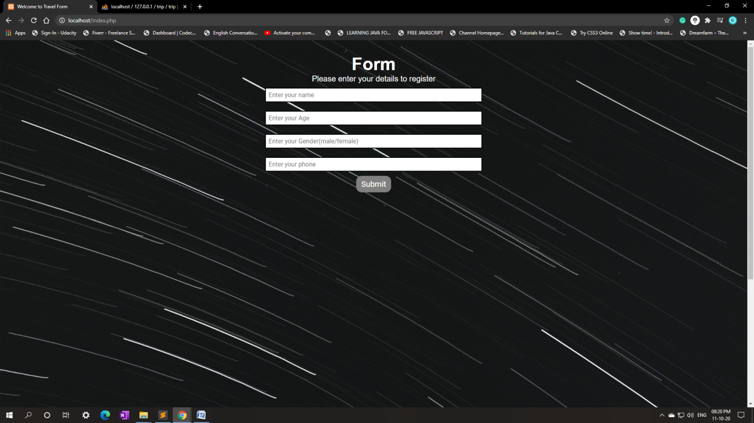

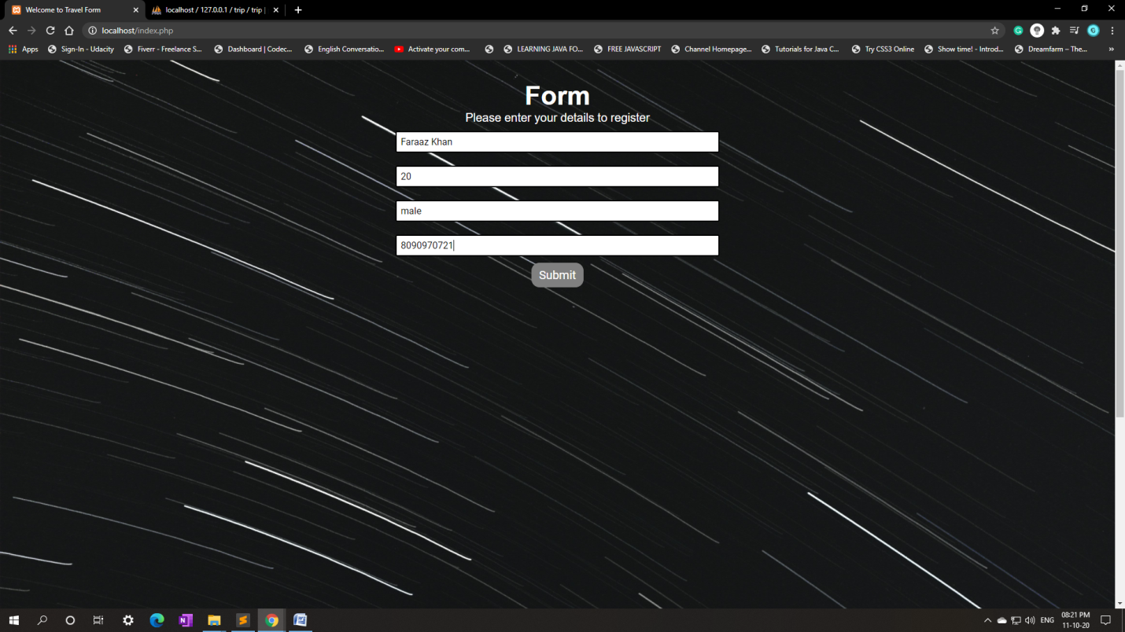

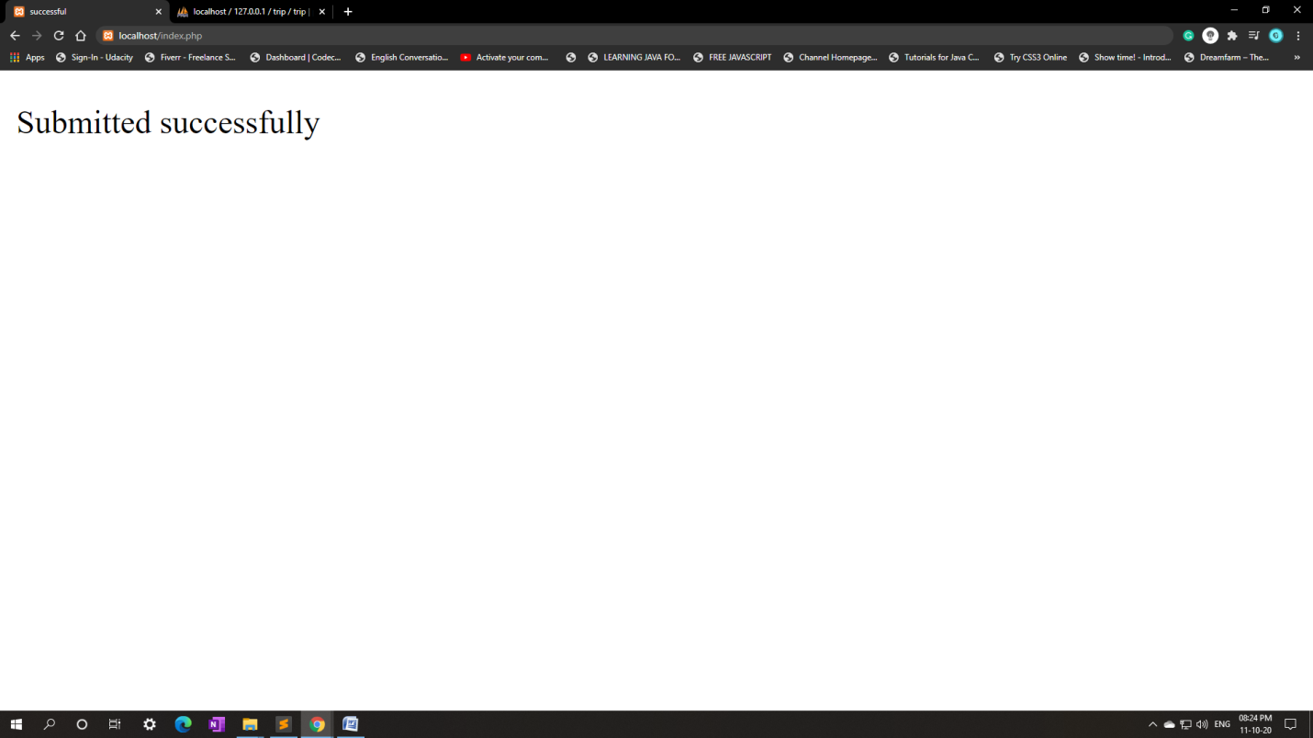

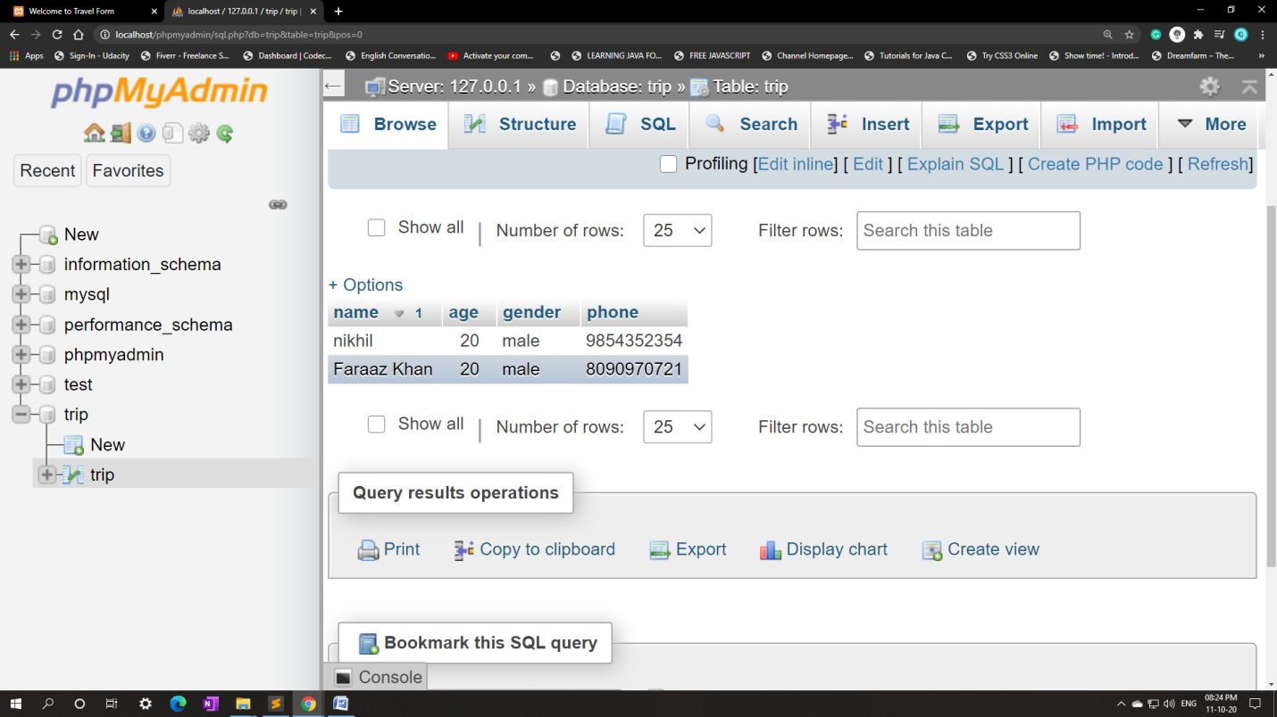

**B.2Source code:**

**index.php:**

<?php

$insert = false;

if(isset($_POST['name'])){

$server = "localhost";

$username = "root";

$password = "";

$con = mysqli_connect($server, $username, $password);

if(!$con){

die("connection to this database failed due to" . mysqli_connect_error());

}

$name = $_POST['name'];

$age = $_POST['age'];

$gender = $_POST['gender'];

$phone = $_POST['phone'];

$sql = "INSERT INTO `trip`.`trip` (`name`, `age`, `gender`, `phone`) VALUES ('$name', '$age', '$gender', '$phone');";

if($con->query($sql) == true){

$insert = true;

}

else{

echo "ERROR: $sql <br> $con->error";

}

$con->close();

}

?>

<?php

if($insert == true){

echo "<p class='submitMsg'>Submitted successfully</p>";

}

?>

<!DOCTYPE html>

<html lang="en">

<head>

<meta charset="UTF-8">

<meta name="viewport" content="width=device-width, initial-scale=1.0">

<title>Welcome to Travel Form</title>

<link href="https://fonts.googleapis.com/css?family=Roboto|Sriracha&display=swap" rel="stylesheet">

<link rel="stylesheet" href="style.css">

</head>

<body>

<img class="bg" src="bg.jpg" alt="background">

<div class="container">

<h1>Form</h3>

<p>Please enter your details to register</p>

<form action="index.php" method="post" action="message.html">

<input type="text" name="name" id="name" placeholder="Enter your name">

<input type="text" name="age" id="age" placeholder="Enter your Age">

<input type="text" name="gender" id="gender" placeholder="Enter your Gender(male/female)">

<input type="phone" name="phone" id="phone" placeholder="Enter your phone">

<button class="btn">Submit</button>

</form>

</div>

</body>

</html>

**style.css:**

*{

margin: 0px;

padding: 0px;

box-sizing: border-box;

font-family: 'Roboto', sans-serif;

}

.container{

max-width: 40%;

padding: 35px;

margin: auto;

}

.container h1 {

text-align: center;

font-family: sans-serif;

font-size: 45px;

color: white;

}

p{

font-size: 20px;

text-align: center;

font-family: sans-serif;

color: white;

}

input{

border: 2px solid black;

border-radius: 3px;

outline: none;

font-size: 16px;

width: 80%;

margin: 11px 0px;

padding: 7px;

}

form{

display: flex;

align-items: center;

justify-content: center;

flex-direction: column;

}

.btn{

color: white;

background: grey;

padding: 8px 12px;

font-size: 20px;

border: 1px solid grey;

border-radius: 14px;

cursor: pointer;

}

.bg{

width: 100%;

position: absolute;

z-index: -1;

opacity: 1.0;

}

**B.3 Conclusion:**

Hence, we have learned how to use php and created a webpage to accept details and save them into the database by using MYSQL.