**PART B**

(PART B : TO BE COMPLETED BY STUDENTS)

***(Students must submit the soft copy as per following segments within two hours of the practical. The soft copy must be uploaded on the Blackboard or emailed to the concerned lab in charge faculties at the end of the practical in case the there is no Black board access available)***

|  |  |
| --- | --- |
| **Roll No.: 76** | **Name: Faraaz Khan** |
| **Class : Comps/TE/A** | **Batch :** |
| **Date of Experiment:** | **Date of Submission:** |
| **Grade :** |  |

**B.1 Web page Snapshot:**

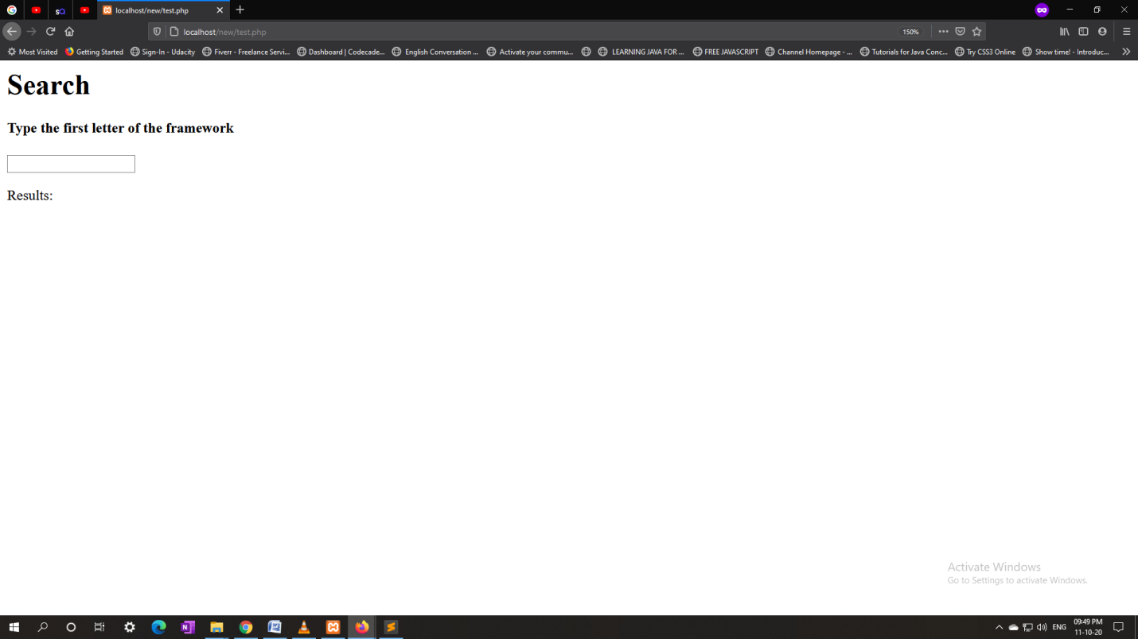

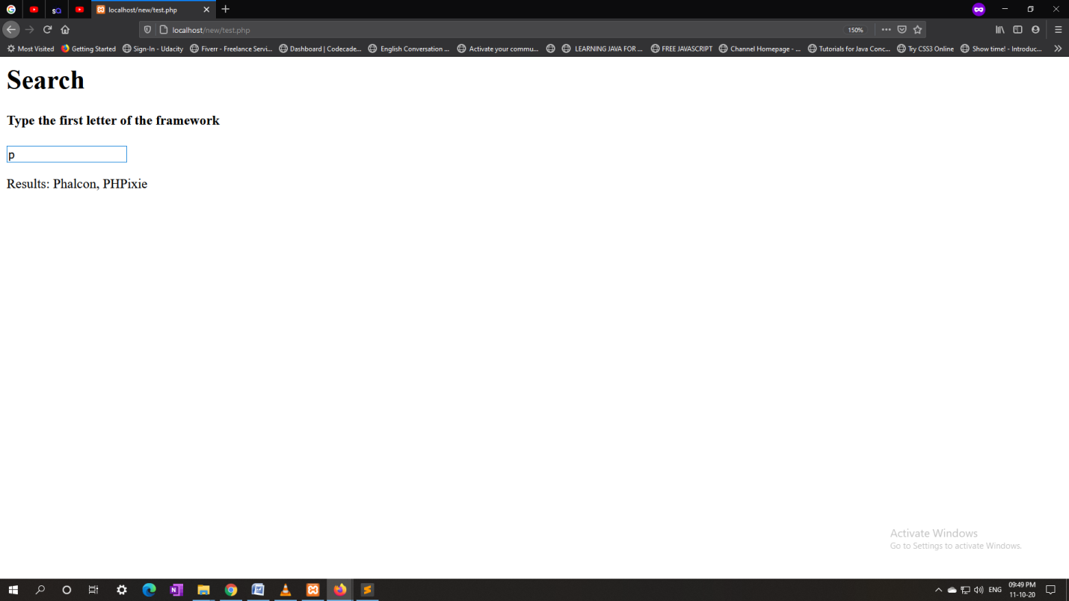

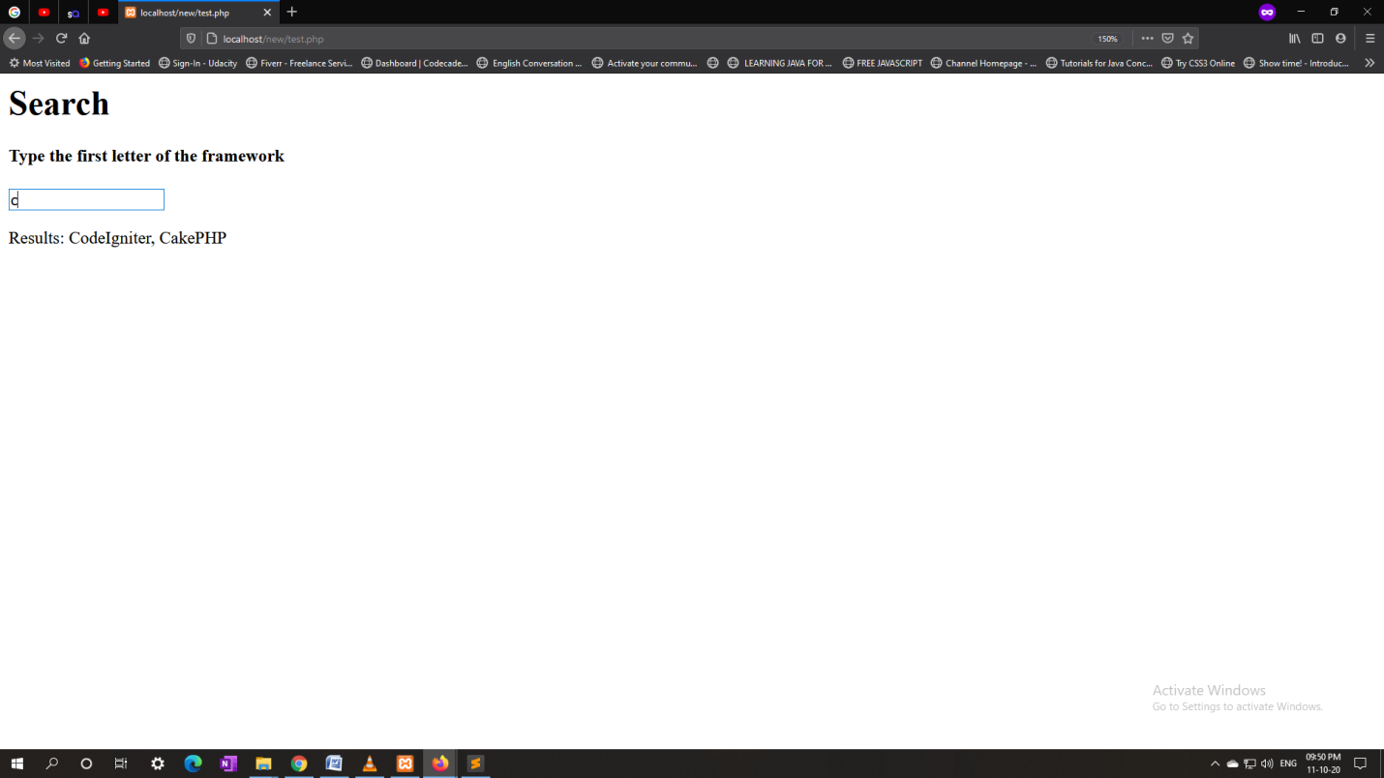

**B.2Source code:**

**test.php:**

<html>

<head>

<script>

function searchme(str) {

if(str.length == 0){

document.getElementById("src").innerHTML = "";

return;

}

else{

var xmlhttp = new XMLHttpRequest();

xmlhttp.onreadystatechange = function() {

if (xmlhttp.readyState == 4 && xmlhttp.status == 200) {

document.getElementById("src").innerHTML = xmlhttp.responseText;

}

};

xmlhttp.open("GET", "search.php?a=" + str, true);

xmlhttp.send();

}

}

</script>

</head>

<body>

<h1>Search</h1>

<h4>Type the first letter of the framework</h4>

<form>

<input type="text" onKeyUp="searchme(this.value)">

</form>

<p>Results: <span id="src"></span></p>

</body>

</html>

**Search.php:**

<?php

$arr [] = "Laravel";

$arr [] = "CodeIgniter";

$arr [] = "Symfony";

$arr [] = "Zend";

$arr [] = "CakePHP";

$arr [] = "FuelPHP";

$arr [] = "Slim";

$arr [] = "Phalcon";

$arr [] = "PHPixie";

$a = $_REQUEST["a"];

$search = "";

if ($a !== "") {

$a = strtolower($a);

$len=strlen($a);

foreach($arr as $name) {

if (stristr($a, substr($name, 0, $len))) {

if ($search === "") {

$search = $name;

} else {

$search .= ", $name ";

}

}

}

}

echo $search === "" ? "No result" : $search;

?>

**B.3 Conclusion:**

We have learned how to search and display contents in an array in php using AJAX, and we successfully made a search engine to search php frameworks.