**PART B**

(PART B : TO BE COMPLETED BY STUDENTS)

***(Students must submit the soft copy as per following segments within two hours of the practical. The soft copy must be uploaded on the Blackboard or emailed to the concerned lab in charge faculties at the end of the practical in case the there is no Black board access available)***

|  |  |
| --- | --- |
| **Roll No.: 76** | **Name: Mohd Faraaz Khan** |
| **Class : TE-A-COMP** | **Batch :** |
| **Date of Experiment:** | **Date of Submission: 9/9/20** |
| **Grade :** |  |

**B.1.Web page Snapshot:**

**Homepage:**

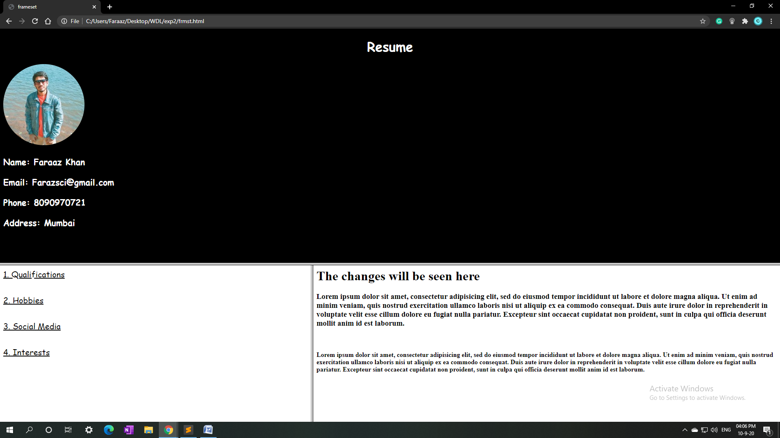

**Clicking Qualifications:**

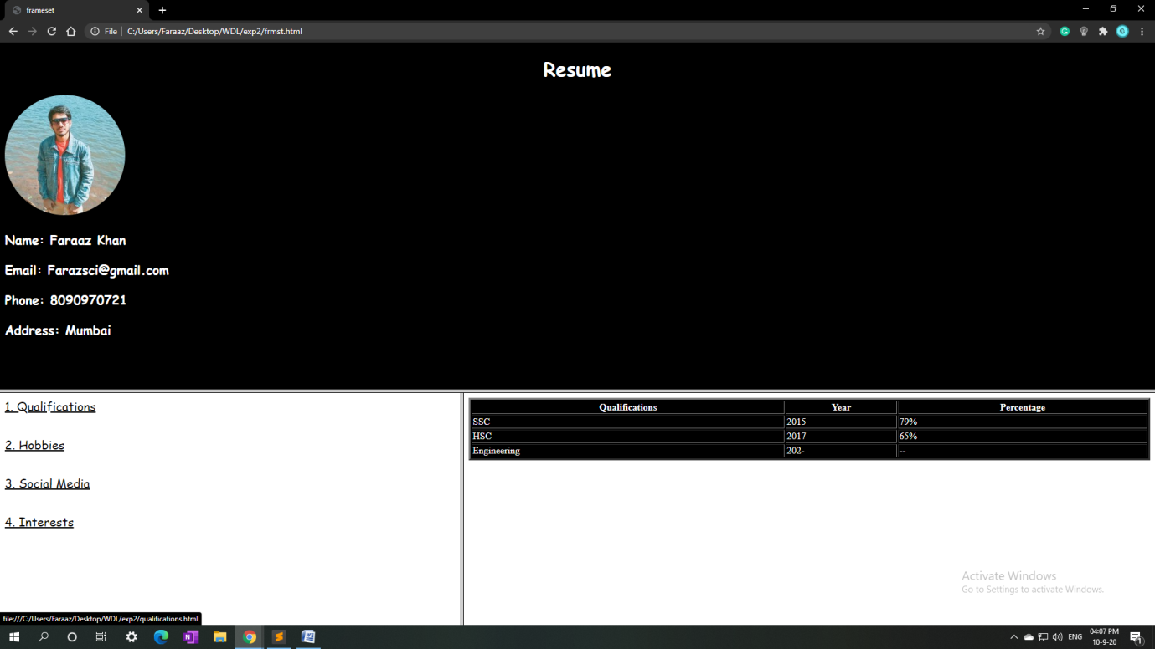

**Clicking Hobbies**

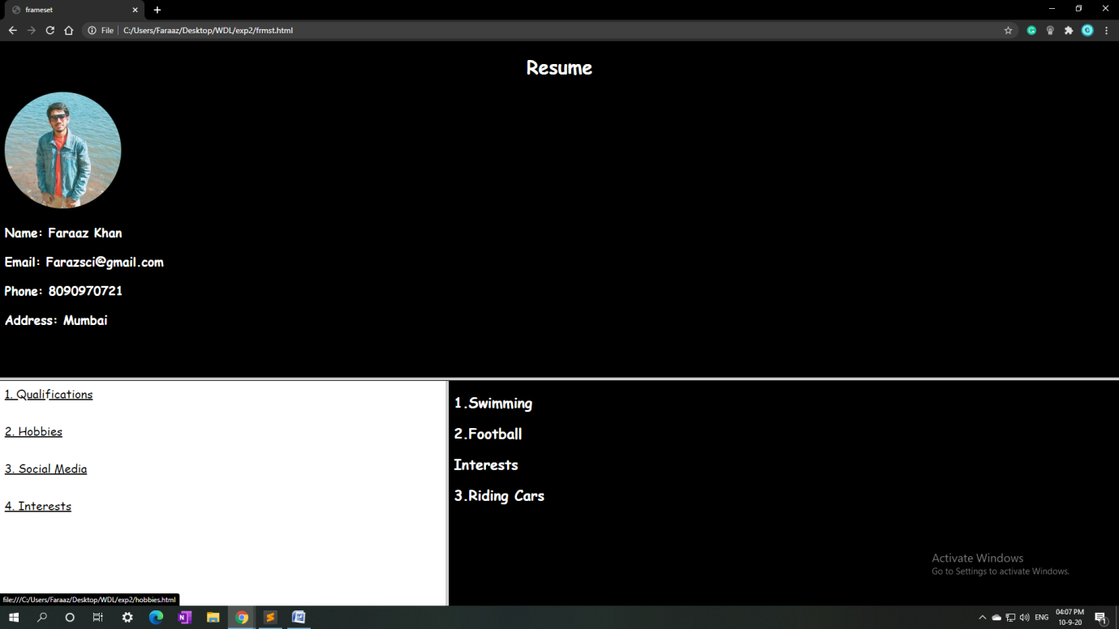

**Clicking Social Media:**

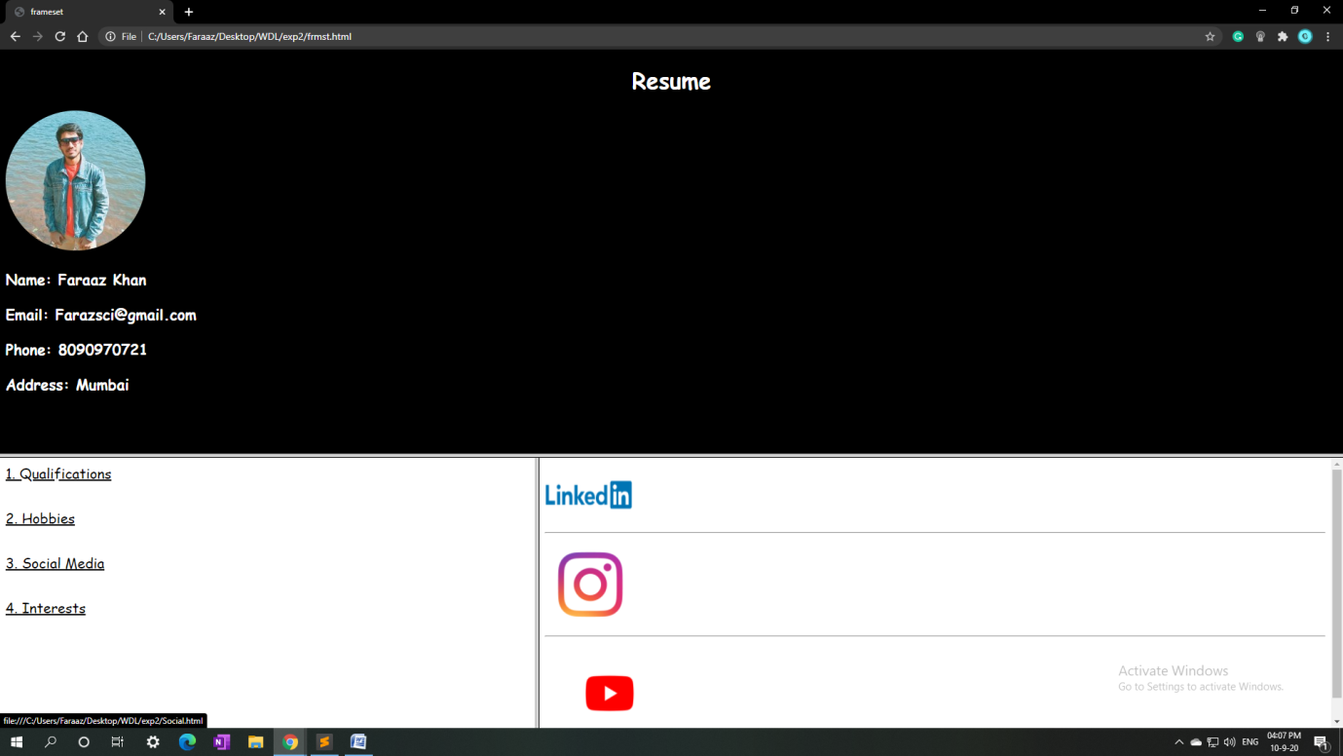

**Clicking Interests:**

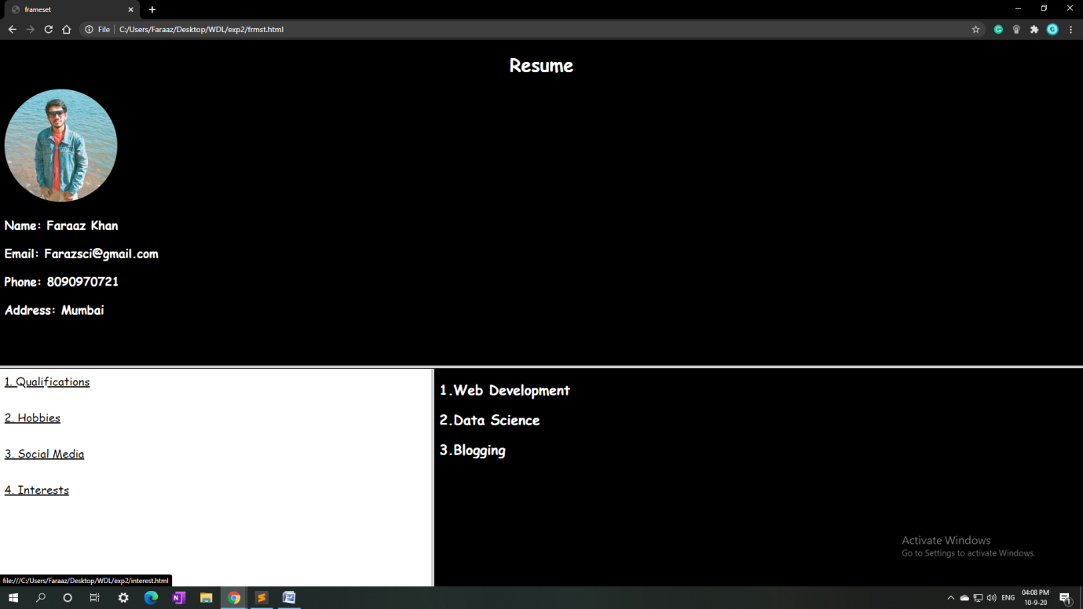

**B.2.Web page source code:**

**Frameset.html:**

<html>

<head>

<title>frameset</title>

</head>

<frameset rows="60%,40%" name="frame1">

<frame src="hyperlink1.html">

<frameset cols="40%,60%">

<frame src="hyperlink2.html" name="frame2">

<frame src="hyperlink3.html" name="frame3">

</frameset>

</frameset>

</html>

**Hyperlink1.html:**

<!DOCTYPE html>

<html>

<head>

<title>frame1</title>

<style type="text/css">

body {background-color: black;}

body {color: white;}

body {font-family: cursive; }

h3 {font-size: 21px;}

img {border-radius: 50%;}

</style>

</head>

<body>

<center> <h1>Resume</h1> </center>

<a href="">

<img src="https://media-exp1.licdn.com/dms/image/C5103AQFbOsABB8nvfA/profile-displayphoto-shrink_200_200/0?e=1605139200&v=beta&t=O_CdHHoB4dtoDmWKteT6SVHPTLbKxQXq_x5a2uFaZ8I">

</a>

<h3>Name: Faraaz Khan</h3>

<h3>Email: Farazsci@gmail.com</h3>

<h3>Phone: 8090970721</h3>

<h3>Address: Mumbai</h3>

</body>

</html>

**Hyperlink2.html:**

<!DOCTYPE html>

<html>

<head>

<title> Css1 </title>

<style type="text/css">

a {color: black;fo}

a {font-family: cursive; font-size: 20px;}

</style>

</head>

<body>

<a href="qualifications.html" target="frame3">1. Qualifications </a>

<br>

<br>

<br>

<a href="hobbies.html" target="frame3">2. Hobbies </a>

<br>

<br>

<br>

<a href="Social.html" target="frame3">3. Social Media </a>

<br>

<br>

<br>

<a href="interest.html" target="frame3">4. Interests </a>

</body>

</html>

**Hyperlink3.html :**

<html>

<head>

<title> Css1 </title>

</head>

<body>

<h1>The changes will be seen here</h1>

<h3>Lorem ipsum dolor sit amet, consectetur adipisicing elit, sed do eiusmod

tempor incididunt ut labore et dolore magna aliqua. Ut enim ad minim veniam,

quis nostrud exercitation ullamco laboris nisi ut aliquip ex ea commodo

consequat. Duis aute irure dolor in reprehenderit in voluptate velit esse

cillum dolore eu fugiat nulla pariatur. Excepteur sint occaecat cupidatat non

proident, sunt in culpa qui officia deserunt mollit anim id est laborum.</h3>

<br>

<h4>Lorem ipsum dolor sit amet, consectetur adipisicing elit, sed do eiusmod

tempor incididunt ut labore et dolore magna aliqua. Ut enim ad minim veniam,

quis nostrud exercitation ullamco laboris nisi ut aliquip ex ea commodo

consequat. Duis aute irure dolor in reprehenderit in voluptate velit esse

cillum dolore eu fugiat nulla pariatur. Excepteur sint occaecat cupidatat non

proident, sunt in culpa qui officia deserunt mollit anim id est laborum.</h4>

</body>

</html>

**Qualifications.html:**

<!DOCTYPE html>

<html>

<head>

<title>Qualifications</title>

<style type="text/css">

table {color: white}

table {border: 3;}

</style>

</head>

<body>

<table width="100%" border="3" bgcolor="black" color="white">

<tr>

<th>Qualifications</th>

<th>Year</th>

<th>Percentage</th>

</tr>

<tr>

<td>SSC</td>

<td>2015</td>

<td>79%</td>

</tr>

<tr>

<td>HSC</td>

<td>2017</td>

<td>65%</td>

</tr>

<tr>

<td>Engineering</td>

<td>202-</td>

<td>--</td>

</tr>

</table>

</body>

</html>

**Hobbies.html:**

<!DOCTYPE html>

<html>

<head>

<title>hobbies</title>

<style type="text/css">

body {background-color: black;}

body {color: white;}

body {font-family: cursive; }

</style>

</head>

<body>

<h2>1.Swimming</h2>

<h2>2.Football</h2>

<h2>3.Riding Cars</h2>

</body>

</html>

**Interest.html:**

<!DOCTYPE html>

<html>

<head>

<title>hobbies</title>

<style type="text/css">

body {background-color: black;}

body {color: white;}

body {font-family: cursive; }

</style>

</head>

<body>

<h2>1.Web Development</h2>

<h2>2.Data Science</h2>

<h2>3.Blogging</h2>

</body>

</html>

**Social.html:**

<!DOCTYPE html>

<html>

<head>

<title>Social</title>

<style type="text/css">

</style>

</head>

<body>

<a href="https://www.linkedin.com/in/thefaraazkhan" target="frame1">

<img src="https://logos-world.net/wp-content/uploads/2020/04/Linkedin-Logo.png" width="125" height="90" style="vertical-align: top">

</a>

<hr/>

<a href="https://www.instagram.com/thefaraazkhan" target="frame1">

<img src="https://www.freepnglogos.com/uploads/instagram-logo-png-transparent-0.png" width="130" height="130" style="vertical-align: middle" >

</a>

<hr/>

<a href="https://www.youtube.com/Cyanicofficial/" target="frame1">

<img src="https://www.freepnglogos.com/uploads/youtube-logo-hd-8.png" width="185" height="145" style="vertical-align: bottom" >

</a>

</body>

</html>

**B.3.Conclusion:**

Hence,

We have learned how to use css to style a website, and we have learned the target attribute, frameset attribute and used them to make an interactive Resume.