**PART B**

(PART B : TO BE COMPLETED BY STUDENTS)

***(Students must submit the soft copy as per following segments within two hours of the practical. The soft copy must be uploaded on the Blackboard or emailed to the concerned lab in charge faculties at the end of the practical in case the there is no Black board access available)***

|  |  |
| --- | --- |
| **Roll No.: 76** | **Name: Khan Mohd Faraaz** |
| **Class : TE/Comps/B** | **Batch :** |
| **Date of Experiment:** | **Date of Submission:** |
| **Grade :** |  |

**B.1 Web page Snapshot:**

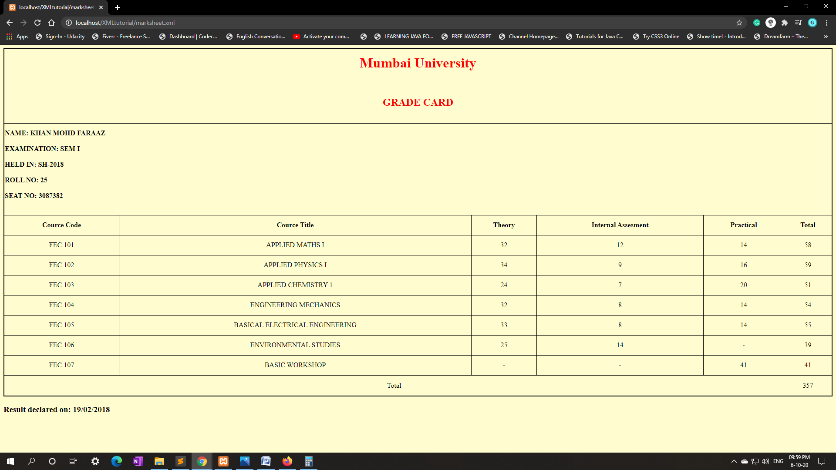

**B.2Source code:**

**Marksheet.xml:**

**<?xml version="1.0" encoding="UTF-8"?>**

**<?xml-stylesheet type="text/xsl" href="simple.xsl"?>**

**<Marksheet>**

**<Subject>**

**<SubjectCode>FEC 101</SubjectCode>**

**<SubjectName>APPLIED MATHS I</SubjectName>**

**<Theory>32</Theory>**

**<IA>12</IA>**

**<Practical>14</Practical>**

**<Total>58</Total>**

**</Subject>**

**<Subject>**

**<SubjectCode>FEC 102</SubjectCode>**

**<SubjectName>APPLIED PHYSICS I</SubjectName>**

**<Theory>34</Theory>**

**<IA>9</IA>**

**<Practical>16</Practical>**

**<Total>59</Total>**

**</Subject>**

**<Subject>**

**<SubjectCode>FEC 103</SubjectCode>**

**<SubjectName>APPLIED CHEMISTRY 1</SubjectName>**

**<Theory>24</Theory>**

**<IA>7</IA>**

**<Practical>20</Practical>**

**<Total>51</Total>**

**</Subject>**

**<Subject>**

**<SubjectCode>FEC 104</SubjectCode>**

**<SubjectName>ENGINEERING MECHANICS</SubjectName>**

**<Theory>32</Theory>**

**<IA>8</IA>**

**<Practical>14</Practical>**

**<Total>54</Total>**

**</Subject>**

**<Subject>**

**<SubjectCode>FEC 105</SubjectCode>**

**<SubjectName>BASICAL ELECTRICAL ENGINEERING</SubjectName>**

**<Theory>33</Theory>**

**<IA>8</IA>**

**<Practical>14</Practical>**

**<Total>55</Total>**

**</Subject>**

**<Subject>**

**<SubjectCode>FEC 106</SubjectCode>**

**<SubjectName>ENVIRONMENTAL STUDIES</SubjectName>**

**<Theory>25</Theory>**

**<IA>14</IA>**

**<Practical>-</Practical>**

**<Total>39</Total>**

**</Subject>**

**<Subject>**

**<SubjectCode>FEC 107</SubjectCode>**

**<SubjectName>BASIC WORKSHOP</SubjectName>**

**<Theory>-</Theory>**

**<IA>-</IA>**

**<Practical>41</Practical>**

**<Total>41</Total>**

**</Subject>**

**<TotalMarks><Marks>357</Marks></TotalMarks>**

**</Marksheet>**

**Simple.xsl:**

**<?xml version="1.0" encoding="UTF-8"?>**

**<xsl:stylesheet version="1.0" xmlns:xsl="http://www.w3.org/1999/XSL/Transform">**

**<xsl:template match="/">**

**<html>**

**<head>**

**<style type="text/css">**

**table{**

**border-collapse: collapse;**

**width: 100%;**

**border: solid 2px black;**

**text-align: center;**

**padding: 5px;**

**height: 800px;**

**}**

**#titles{**

**color:**

**}**

**#details{**

**text-align:left;**

**}**

**#header{**

**color:red;**

**text-align: center;**

**}**

**</style>**

**</head>**

**<body bgcolor="#fffdd0">**

**<table border="1" width="100%">**

**<tr id="header">**

**<td colspan="6"><h1>Mumbai University</h1> <br/> <h2>GRADE CARD</h2>**

**</td>**

**</tr>**

**<tr id="details">**

**<td colspan="6">**

**<h4>**

**NAME: KHAN MOHD FARAAZ**

**<br/>**

**<br/>**

**EXAMINATION: SEM I**

**<br/>**

**<br/>**

**HELD IN: SH-2018**

**<br/>**

**<br/>**

**ROLL NO: 25**

**<br/>**

**<br/>**

**SEAT NO: 3087382**

**</h4>**

**</td>**

**</tr>**

**<tr id="titles">**

**<th> Cource Code</th>**

**<th> Cource Title</th>**

**<th> Theory</th>**

**<th> Internal Assesment</th>**

**<th> Practical</th>**

**<th> Total</th>**

**</tr>**

**<xsl:for-each select="Marksheet/Subject">**

**<tr>**

**<td><xsl:value-of select="SubjectCode"/></td>**

**<td><xsl:value-of select="SubjectName"/></td>**

**<td><xsl:value-of select="Theory"/></td>**

**<td><xsl:value-of select="IA"/></td>**

**<td><xsl:value-of select="Practical"/></td>**

**<td><xsl:value-of select="Total"/></td>**

**</tr>**

**</xsl:for-each>**

**<tr>**

**<td colspan="5">Total</td>**

**<xsl:for-each select="Marksheet/TotalMarks">**

**<td><xsl:value-of select="Marks"/></td>**

**</xsl:for-each>**

**</tr>**

**</table>**

**<h3>Result declared on: 19/02/2018</h3>**

**</body>**

**</html>**

**</xsl:template>**

**</xsl:stylesheet>**

**B.3 Question of Curiosity:**

1. What are the features of XML?

* Some of the Features of XML language are:

1. Excellent for handling data with a complex structure or atypical data
2. Data described using markup language
3. Text data description
4. Human- and computer-friendly format
5. Handles data in a tree structure having one-and only one-root element
6. Excellent for long-term data storage and data reusability
7. Differentiate between XML and HTML.

🡪

|  |  |
| --- | --- |
| **HTML** | **XML** |
| HTML stands for **Hyper Text Markup Language.** | XML stands for **eXtensible Markup Language.** |
| HTML is static. | XML is dynamic. |
| HTML is a markup language. | XML provides framework to define markup languages. |
| HTML can ignore small errors. | XML does not allow errors. |
| HTML is not Case sensitive. | XML is Case sensitive. |
| HTML tags are predefined tags. | XML tags are user defined tags. |
| There are limited number of tags in HTML. | XML tags are extensible. |
| HTML does not preserve white spaces. | White space can be preserved in XML. |
| HTML tags are used for displaying the data. | XML tags are used for describing the data not for displaying. |
| In HTML, closing tags are not necessary. | In XML, closing tags are necessary. |

|  |  |
| --- | --- |
|  |  |
|  |  |
|  |  |
|  |  |
|  |  |
|  |  |
|  |  |
|  |  |

1. Explain XSL in detail.

XSL is a language for expressing style sheets. An XSL style sheet is, like with CSS, a file that describes how to display an XML document of a given type. XSL shares the functionality and is compatible with CSS2 (although it uses a different syntax).

It also adds a transformation language for XML documents: XSLT. Originally intended to perform complex styling operations, like the generation of tables of contents and indexes, it is now used as a general purpose XML processing language. XSLT is thus widely used for purposes other than XSL, like generating HTML web pages from XML data.And it also adds Advanced styling features, expressed by an XML document type which defines a set of elements called Formatting Objects, and attributes (in part borrowed from CSS2 properties and adding more complex ones.

**B.4.Conclusion:**

Hence,

We have learned the XML and XSL in detail and used them to make a Report card for displaying the result.