

**An Undergraduate Internship/** **In-house money transfer system.**

By

**Zaber Al Mamun**

Student ID: **2022676**

**Summer, 2024**

Supervisor:

**Md Abu Sayed**

**Senior Lecturer & Coordinator**

Department of Computer Science & Engineering

Independent University, Bangladesh

**October 8, 2024**

**Dissertation submitted in partial fulfillment for the degree of Bachelor of Science in Computer Science**

**Department of Computer Science & Engineering**

**Independent University, Bangladesh**

## Attestation

Please be informed that the paper has been publish by Zaber Al Mamun, and my ID:2022676, Submitted in Fulfillment of the Requirement for the Degree of Bachelor of Computer Science & Engineering at Independent University, Bangladesh (IUB) The internal supervisor was Md Abu Sayed, Senior Lecturer of IUB, for all above works. This report was the product of what I learned during my internships. Proper citation of all sources used in this project and report.

Signature Date

Zaber Al Mamun

Name

## Acknowledgement

In my initial days, as a first step I wanted to Thank Allah, the ability to work well and getting an internship in Palmal grouop of industries at that time. Firstly, I want to thanks all those who helped me in composing my internship report and guided me very well. Specially thanks to my internship supervisor Md Abu Sayed sir who has been guiding me throughout the time of my internship. And she has been really supportive of my internship journey since then and gave me a lot of important advices.

I would be eternally grateful to Palmal group of industries and his company for having me intern over there. They gave me plenty of resources and supported me a great deal in my internship career. When I was in any trouble, they always appeared to help me the best and always support me with different advice and suggestion to solve the problems.

## Letter of Transmittal

Md Abu Sayed

Senior Lecturer

Department of Computer Science and Engineering

School of Engineering and Computer Science

Independent University, Bangladesh

Subject: **Submission of the Undergraduate Internship Report is requested in order to fulfill graduation requirement.**

Dear Sir,

I am so happy to announce that I have finally completed my work of writing up the internship experience for my BSC in Computer Engineering degree. This is huge for me, being able to work under your guidance. Luckily, I did three months training in Palmal group of industries, under the industrial supervision of Md. Sanaul Huq (Sybal), Sr. Executive Officer, Palmal group of industries. I learnt from the internship both from the perspective of experience and theories. During my corporate life, learning to get connected with everyone in work place. This report will help provide a little bit of insight to what I got out of my internship experience My Lessons, my advice and where I went wrong. I agree with everything in this report. He will be done in this transfer…Hopefully, I have accomplished my goal.

If You Received this Report of Mine then Give Me Your Valuable Feedback. Pray for it will be relevant up to some extent. I would be extremely grateful for every kind of feedback.

Sincerely,

Zaber Al Mamun

ID:2022676

## Evaluation Committee

SupervisionPanel

..................................

AcademicSupervisor

..................................

IndustrySupervisor

PanelMembers

..................................

PanelMember1

..................................

PanelMember2

..................................

PanelMember3

..................................

PanelMember4

OfficeUse

..................................

InternshipCoordinator

..................................

HeadoftheDepartment

................................................

IndustryCoordinatoroftheDepartment

## Abstract

I completed my internship at Palmal group of industries and at this time, I worked as a software engineer for three months. This report signifies the end of my internship at Palmal group of industries. I was in the entire place for three months. I got to work as an intern in Palmal group of industries and that time I was very lucky because my main project goal was the production level-based money transfer system (In-house) developer team. This document describes the work done, results obtained, challenges faced and lessons learnt during In-house Money transfer system development. The site shows the lawn landscaping service which is nothing but a rental plantation service where one-time rentals set on the way with money. In the website, there are two parts — Admin Panel and Users. This website is built in HTML, CSS, Js, Bootstrap, Jquery, PHP and MYSQL database. The website was tested for functional, usability, performance, security and compatibility. The website received an overwhelming response from users and stakeholders, hitting the success bars of the project.

*Keywords—* Frontend Support, Admin Panel Dashboard, User-friendly interface Software enhancement.

Table of Contents

Attestation i

Acknowledgement i

Letter of Transmittal ii

Evaluation Committee ii

Abstract iii

Chapter 1 1

Introduction 1

1.1 Problem Identification 1

1.2 Objectives 1

1.3 Objectives of the Project 2

Chapter 2 2

Literature Review 2

2.1 Overview 2

2.2 Related works 2

2.3 Case Studies 3

2.4 Technology Trends 3

2.5 Summary of Gaps 3

Chapter 3 3

Methodology 3

3.1 Research Design 3

3.2 Website Development Life Cycle (SDLC) 4

3.3 Tools and Technologies 5

3.4 Data Collection 5

3.5 Testing and Evaluation 5

3.6 Challenges Faced 6

3.7 Gantt chart 6

Chapter 4 8

Project Management Plan and Budget 8

4.1 Introduction 8

4.2 Project Management Plan 8

4.2.1 Project Scope 8

4.2.2 WBS (Work Breakdown Structure) 8

4.2.3 Timeline and Milestones 8

4.2.4 Resource Allocation 9

4.2.5 Risk Management 9

4.2.6 Quality Assurance Plan 9

4.3 Financing 10

4.3.1 Budget Estimation 10

4.3.2 Funding Sources 10

4.3.4 Financial Risks 11

Chapter 5 11

Specifications and Requirements 11

5.1 Introduction 11

5.2 Functional Requirements 11

5.3 Nonfunctional Requirements 11

5.4 System Architecture 12

Chapter 6 13

System Design and Implementation 13

6.1 Introduction 13

6.2 User Interface Design 13

6.3 Backend Development 13

6.4 Integration 13

6.5 Development Challenges 13

Chapter 7 14

Testing and QA 14

7.1 Introduction 14

7.2 Testing Strategy 14

7.3 User Acceptance Testing (UAT) 14

7.4 Performance Testing 14

7.5 Security Testing 14

7.6 Results and Quality Metrics 15

Chapter 8 15

Deploying and Maintaining 15

8.1 Introduction 15

8.2 Deployment Process 15

8.3 Post-Deployment Monitoring 15

8.4 Maintenance Plan 16

8.5 Lessons and Suggestions 16

Chapter 9 16

Project Results & Conclusion 16

9.1 Introduction 16

9.2 Project Success 16

9.3 Impact on the Company 16

9.4 Future Recommendations 17

9.5 Conclusion 17

Chapter 10 17

Results and Analysis 17

10.1 Introduction 17

10.2 Project Outcomes 17

10.3 Performance Metrics 17

10.4 Security Analysis 18

10.5 Financial Impact 18

10.6 Comparative Analysis 18

10.7 Challenges Encountered 18

10.8 Lessons Learned 19

10.9 Conclusion 19

Chapter 11 19

Sustainability Environmental and Social Impact 19

11.1 Introduction 19

11.2 Sustainability 19

11.3 Environmental Effects 19

11.4 Social Effects 20

11.5 Challenges and mitigation 20

Chapter 12 20

Future Work 20

12.1 Introduction 20

12.2 Potential Enhancements 20

12.3 Scalability & Growth 21

12.4 User feedback and iteration 21

12.5 Research and Development 21

Chapter 13 21

Conclusion 21

13.1 Summary of Findings 21

13.2 Contributions and Impact 21

13.3 Lessons Learned 22

13.4 Final Thoughts 22

Chapter 14 22

Lessons Learned 22

14.1 Introduction 22

14.2 Key Successes 22

14.3 Challenges Faced 22

14.4 Problem-Solving Approaches 23

14.5 Familiarity with team processes and collaboration 23

14.6 User Feedback & Iteration 23

14.7 Project Management Lessons 23

14.8 Risk Management 23

14.9 Recommendations to be Considered for Future Projects 24

14.10 Conclusion 24

Chapter 15 24

Future Work 24

15.1 Introduction 24

15.2 Potential Enhancements 24

15.3 Stability and Extensibility 25

15.4 Integration with up-coming Technologies 25

15.5 Continuous Improvement 25

15.6 Research and Development 25

Chapter 16 26

Summary of Findings 26

16.1 Contributions and Impact 26

16.2 Lessons Learned 26

16.3 Suggestions for Future Work 26

16.5 Final Thoughts 26

Bibliography 27

**List of Figures**

Figure 3.2 Process-Based Time Allocation 4.

Figure 3.7: Gantt chart. 1 7

Figure 6.2: Home page. 1 13

Figure 7.2: Admin page. 1 15

Figure 7.6: User page. 1 16

**List of Tables**

Table 3.5: Resource Allocation Across Activities…………………………………………………………5

# Chapter 1

## Introduction

Internships have an important link to the objective of the student’s education and career. The main objective is to make the students interested in their careers and to give them an idea about the job sectors. Internships allow students a chance to put what they’ve applied what was learned in class to a practical and demanding professional environment. This internship programme requires that I must finish my internship in a well-known organisation in order to gain experience in the field, learn about environmental practices, and do practical work. I completed my internship in “Palmal group of industries” company which was for 3 months. In this report, I discuss my internship journey at “Palmal group of industries”, what I learned, what I experienced, what mistakes I made and how I learned from those mistakes.

## 1.1 Problem Identification

The Existing System Pain Points: Identify the specific pain points around your current system that have you gunning for a new money transfer solution. For instance:

* Ineffectiveness in carrying out financial transactions.
* This is also reliant on extraneous banking apps.
* Financial systems are not integrated with internal company processes.
* Specific needs: Provide clear explanation what specific needs the new system is intended to serve.
* Added security for all internal transactions.
* Enabling an enhanced user experience among employees.
* Custom Features focusing on specific operational needs of the company.

## 1.2 Objectives

The objective of In-house money transfer system project is to create a comprehensive software solution for efficiently managing landscaping services. This system aims to simplify the process of renting and maintaining plants for landscaping by offering an intuitive interface for both administrators and users. The main objectives include improving user experience, boosting operational efficiency, and effectively managing plant inventory and appointments.

## 1.3 Objectives of the Project

Explain why the money transfer system was being built initially. Example objectives could be:

* To enable real-time and secure internal money transfer.
* Implement the money transfer system into the company’s existing financial management tools.
* Make it incredibly user-friendly for employees.

# Chapter 2

## Literature Review

## 2.1 Overview

• The wider literature – why conduct a literature review, around existing research and projects in this space focused on money transfer systems. Previous Publications on Mobile Money Transfer Systems:

Refer to central studies, articles or white papers concerning money transfer systems

• Include findings on:

Security measures -Research studying encryption, OCR-bouncers and secure data handling.

* UX (User Experience): Research on UI design, user satisfaction or simplicity.
* Financial Systems integration: Money transfer system and some of the enterprises software to which its integrated with.

## 2.2 Related works

Currently, I’m actively engaged the development of Money Transfer Systems as an intern web developer. A user-friendly interface for the front end has been developed and deployed applying HTML, CSS, and JavaScript. To facilitate seamless integration with the MySQL-managed database. With my expertise in project planning and strategy, I have been able to delineate the development lifecycle of the system, encompassing its aims and specifications. Through the implementation of agile methodologies, we have successfully adapted to changing project dynamics, allowing us to make gradual improvements. The application of system testing principles presented in class has significantly improved the system’s functionality, reliability, and future maintenance readiness. By employing these skills and methodologies in my internship project, I significantly influenced the development and deployment of the Money Transfer Systems.

## 2.3 Case Studies

Case Studies of In-House Money Transfer Systems Developed or Deployed by Companies

• Examine how these projects were resulting and assess where you have been successful, the challenges encountered, and lessons learned.

## 2.4 Technology Trends

• Modern Technology trends in Mobile Banking:

* The growth of fintech solutions.
* Transactions in a way that are secured by blockchain.
* How AI and machine learning is changing the banking apps.

## 2.5 Summary of Gaps

• Explain how your project hopes to fill in any gaps that appear in the current body of research. This could include:

The absence of research in this domain to the best knowledge especially on in-house solutions for manufacturing industries i.e. Palmal Group.

- Insufficient Research on Integrating money transfer with legacy systems in large organizations.

# Chapter 3

## Methodology

## 3.1 Research Design

Describe more generally what you are doing to build the money transfer system For example:

* Qualitative – Interviews with stakeholders to collect requirements
* Quantitative: By examining the existing financial records, a system is designed.

## 3.2 Website Development Life Cycle (SDLC)

• The stages of the SDLC that you are following, eg:

* Planning- Determine the project scope, requirements and resources
* Analysis: Break down the user needs and system requirements giving a detailed view on them.
* Conceptualization: Drafting wireframes, designing UI/UX, and establishing System Architectures.
* Implementation: This is the coding exercise which involves writing, integrating with the existing systems, and deploying it.
* Testing: Manual and automation Testing to check that each part works as expected, is secure, and performance optimised.
* Maintenance: activities necessary to support the system continue to deliver as designed after deployment.

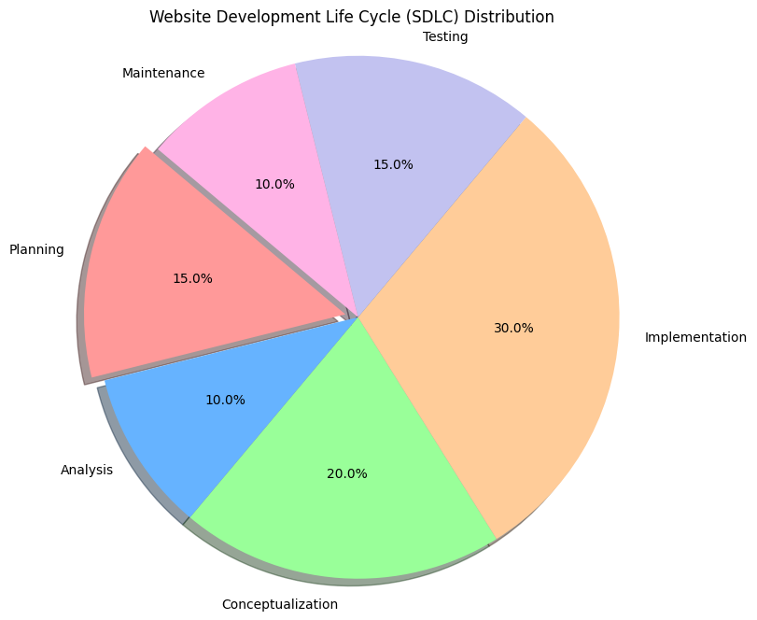

Figure 3.2: Process-Based Time Allocation.

## 3.3 Tools and Technologies

Tools, languages and frameworks used in the project e.g.

* Tools: Android Studio, Xcode or cross-platform tools like Flutter.
* Backend: RESTful APIs, cloud services and Databases.
* Testing Tools: Selenium, JIRA for bug tracking, and Manual testing techniques.

## 3.4 Data Collection

Describe the methodology employed in: • Collecting data for this project;

* Interview: We will be interviewing end-users to understand how they think about their needs

Assess: Surveys, get ideas directly from the end user

Observation: Let us observe how are existing financial tools being used in the company

## 3.5 Testing and Evaluation

* Describe the mirror testing strategies you used and are following. •
* Unit Testing: Test components independently.
* Integration Testing: If the modules work as one unit.
* User Acceptance Testing (UAT): Ongoing with End users using the complete business process to improve the system.
* Security Testing: To check whether the system meets security standards or not.

|  |  |  |
| --- | --- | --- |
| **Process** | **Time** | **Result** |
| Research Stage | 22 | 16.1% |
| Management of Project work | 19 | 20.7% |
| Implementation of work | 16 | 17.2% |
| Programming | 31 | 34.5% |
| Trail | 6 | 5.8% |
| Finalization | 6 | 5.7% |
| Entire | 100 | 100.0% |

Table 3.5: Resource Allocation Across Activities.

## 3.6 Challenges Faced

What do you reflect on the most about what went wrong during this project

* Integrate with current systems.
* Ensuring data security.
* Managing project timelines.

## 3.7 Gantt chart

This Gantt chart shows the timeline over 6 months (May2024-October 2024) development for Employee Money Transfer System. The project is divided into seven phases which collectively work in making the entire system from conception to final documentation. The following is a short intro to each phase:

Phase2 — Requirement Gathering and Analysis (May 1 to May 15)

This first phase is concerned with gathering and analyzing requirements of the system. Understanding User Needs External Quotes, Market Metrics & Standards includes defining the functional and non-functional needs of end user which helps in setting project goals.

System Design (May 16 — May31)

This is the await response, where we create a structure of project and design layout system. Wireframes, data flow diagrams and technical specifications are used to specify the development.

The front-end in 1 week (June 21–27).

Phase 3– code the user interface of your system The front end is made user-friendly using HTML, CSS and JavaScript.

Until Then (June 14 – July15) Back-End Integration (July 16 — August 15)

Instead, this will cover how to connect the front end with server-side logic. Linked the database, implemented server logic, developed API to secure transactions from our system side.

Testing (August 16 – September):

Also, it will make sure whether all system components work correctly. Unit, integration and system testing are performed to discover the bugs in codebase as well as helps getting closest possible metrics that whether a product meets some quality assertion or is secure.

Deployment and Wrap Up – September 16 -Something we learned from wrapping up Season Seve nether.

This is the production deploy phase The last changes are ©6nished and 0rst site of electiveness monitoring begins to check whether the system is working properly.

Documentation and Final Report Preparation (Oct 2 — Oct 15)

Finally, we prepare thorough documentation and a final report to deliver on the project. This phase involves user manuals, technical documentation, and project outcome evaluation.

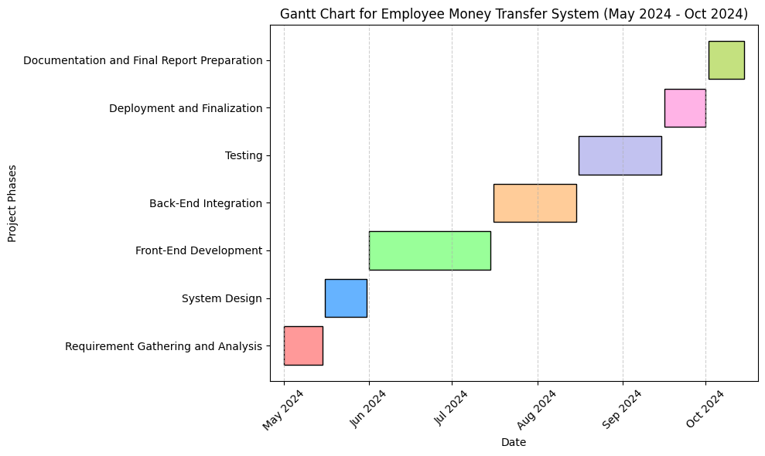

Figure 3.7: Gantt chart. 1

# Chapter 4

## Project Management Plan and Budget

## 4.1 Introduction

• Short intro to chapter discusses the management plan of your project ie what is going to be done when, how it will undertake and financed.

## 4.2 Project Management Plan

### 4.2.1 Project Scope

Project Goals: Restate the core reasons for why you are creating your in-house money transfer system

Deliverables: State what you believe are the deliverables like this; • Task A, B and C with 1, 2 and 3 requirements. • Resource X needs to complete Tasks A in order for Task Z to be documented. Set Focus on project outcomes rather than process steps.

A full-fledged money transfer application Integration with financial systems already in place.

* Full User Documentation and Training Materials

### 4.2.2 WBS (Work Breakdown Structure)

– Divide the project into at least these tasks or phases:

1. Identifying needs: Stakeholder face to face interviews & review current systems.

2. Design and Prototyping — Design wireframes, user interface design, system architecture.

3. Building: Programming the bank-transfer code, creating databases and connecting to existing systems.

4. Testing: Write unit tests, integration test and perform user acceptance testing.

5. Always the final step in deploying an application, your role is to prepare for users how will be using this new application.

6. Maintenance and Support: Ongoing optimization and support with regular updates.

### 4.2.3 Timeline and Milestones

Gantt Chart: Include a Gantt chart outlining the project timeline, depicting when each phase starts and finishes.

Key milestones: List out major milestones like

* Designer – completion stage
* Smooth transition to present financial system.
* SysTest sign-off. o User acceptance testing sign-off
* Deployment of the system. [Final]

### 4.2.4 Resource Allocation

Human Resources – Roles and Responsibilities in the team such as :

* Project Manager – Leads the project, keeps it on time, and communicates with others involved.
* Developers- They are the people associated with coding and integrating of the system.
* QA Testers: Tests to make sure the quality and standard are met as per client satisfaction.
* User Experience (UX) and User Interface Designers: They are all about developing smooth user interfaces.
* oIT Support: System deployment, and support after the Go-Live.

• List of Technical Resources: which are the following technical resources needed, for instance:

Development environments, cloud services, databases and testing tools.

Other Resources - include any other resources required, for example training materials, documentation tools and meeting spaces.

### 4.2.5 Risk Management

• Risk Identification: Recognize prospective risks to the project like Delays in development, often resulting from technical hurdles.

* Problems related to security that could leak user data.
* Integration issues with the pre-existing systems

• Strategies To Mitigate Risks: Suggest ways to minimize these risks, such as;

* Conducting regular code reviews in order to identify potential problems up front.
* Security tests and encrypts.
* Set a project embedded buffer in terms of few days for any delay that could not have foreseen.

### 4.2.6 Quality Assurance Plan

– Explain the QA plan (these plans are then implemented in Activities)

Testing Protocols: Highlight the phases of testing, like unit testing, integration testing, system testing, user acceptance test.

Performance Metrics: Key performance indicators (KPIs) to gauge the system performance, security and user satisfaction.

* Continuous Maintenance: Detail how the system will be in restarted post-launch state ready for PST File Spliter feedback, and that the system will continuously improve as per PST File Splitter measurements.

## 4.3 Financing

### 4.3.1 Budget Estimation

His post asks us only 2 things: Give a detailed budget estimation of the project by dividing it into sections e.g.,

* Human Resources: Project Team Member salaries.
* Software and Tools: Any licensing costs for the development environment, test tools, third party services etc.
* Hardware- Costs of any hardware needed, like servers or testing tools.
* Training and Documentation: This includes costs for the user manual creation, training materials, sessions offered to employees.
* Misc: Incorporate some cushion for the unknown, including extra resources or system emergency maintenance

### 4.3.2 Funding Sources

-How is the project being funded?

* Internal Funding: Company budget allocation for IT projects
* Cost-Cutting Measures: Talk about any cost-cuts you have been able to make—for instance use of open source tools, re-use of existing infrastructure.
* 4.3.3 Cost-Benefit Analysis
* Benefits:Specify what the project hopes to gain out of this, e.g.
* Cost savings due to minimal external banking usage.
* Better efficiency in financial data transactions all over the organization.
* Better financial control and reporting.
* benefits: compare these with the costs to be refereed from the budget estimation.

*. Return on Investment (ROI) — Explain how the system would actually save money in the long term, coupled with a description of how it will become cost effective over a specific period of usage; just about 3–5 years for commercial deployments.

### 4.3.4 Financial Risks

• Finding the financial risks of the project

* Budget overspending- This is the danger of moving over your budget due to spending that you did not anticipate.
* Underestimation of Costs: The potential to short-sell the cost on development or post-launch support.
* Mitigation strategies: Recommend specific strategies that could be used to mitigate these risks, for example;
* Building a safety account
* Regularly revisiting the budget and making necessary allocation changes

# Chapter 5

## Specifications and Requirements

## 5.1 Introduction

Summary- Give a brief intro (Money Transfer System project requirements & specifications) of this chapter.

## 5.2 Functional Requirements

* Antifraud Authentication: Explain how users log in to the system, how their passwords will be handled, and implement 2FA.
* Transaction Management: This is also the important class because it will talk about the user how they can do transaction with our application like Deposits, Withdrawals, Transfer and payment processing.
* Account Management – outline how users can see their balances, transaction history, statements and other financial information
* Notifications: Detail the ability of the system to share alerts and notifications for transactions, balance updates, or security information
* Reveal about the User Interface: Dialogue on design principles which were leveraged to create a very user-friendly interface.

## 5.3 Nonfunctional Requirements

• Service level agreement (SLA) metrics: Introduce the performance metrics, such as response times, uptime and transaction speeds desired.

Security —Outline the security measures that are in place to protect user data and perform safe transactions.

Scalability: Provide details on how the system can scale to address larger number of users or transactions.

Compliance: Any legal or regulatory requirements that state the system and its users must follow, like data protection laws or financial regulations.

## 5.4 System Architecture

Employee Money Transfer System: It is a web-based application developed for making financial transactions between employee and the enterprise fully automated which works as an agent on behalf of both employees — employer serving to update personal inventories electronically, minimizes efforts in handling cash etc., It is implemented in a client-server model with separate front-end and back-end components, connected to one central database that ensures the data integrity, security and makes it easier for all vector tiles users. The following is an architectural overview and how the components communicate with each other:

System Components and Relations Summary the system consists of:

Frontend: User interface for employees to use the system, fill in transfer requests and query transaction logs.

Backend — Business logic handling, request processing and Communicating with Database.

Data Store : Which stores all information from employee transactions to account details and user activity logs.

Integration-Level – Organizing the system with external financial services and its relationship with current internal tools for a finance-related matter.

Frontend system frontend is designed with: HTML/CSS and Tailwind CSS: For structuring the web app HTML/CSS with tailwind css is used. Tailwind CSS is a utility-first framework that has made designing much faster and responsive. It allows the user interface to look good no matter what device it's in, from phone viewports up through fully-fledged desktop browsers.

JavaScript (since it handles client-side logic, form validation and async operations). Browser-side JavaScript code that makes for rich user interaction — e.g. form submissions with real-time feedback in the UI.

# Chapter 6

## System Design and Implementation

## 6.1 Introduction

Chapter Introduction: This is the section of this chapter, which categorizes just how the task will certainly be developed.

## 6.2 User Interface Design

Wireframes: Showcase the wireframes built in the design process, revealing how screens are laid out.

— Prototyping: Any prototypes used to test the UI prior to full implementation.

User Experience (UX): Talk about the steps you took to make sure that users would find your website or app easy, intuitive and enjoyable to use – this would include how well navigation works, how accessible it is and what feedback mechanisms you have in place for your UX.

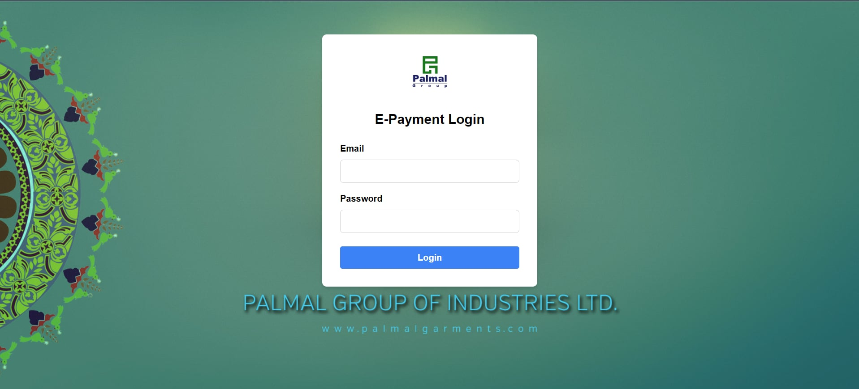

Figure 6.2: Home page. 1

## 6.3 Backend Development

APIs: Explain the process behind developing APIs, helping the front-end and back-end of an application interact and communicate within a client-server model

• Database Implementation: Here you would be explaining how tables, indices and stored procedures were created.

Security Measures - Explain how security features (e.g., data encryption, secure communication protocols like HTTPS and authentication methods) will be enforced.

## 6.4 Integration

• System Integration: Detail how different modules or components worked together as a whole.

• Third Party Services: Explain any third-party services consumed by the system such as payment gateways, SMS notification services, cloud storage etc.

## 6.5 Development Challenges

Technical Challenges: Any bugs, performance bottlenecks or compatibility issues in development.

• The Solutions: Detail what was done to address these challenges, if it involve re-factor the code or using other libraries/tools or changing the design.

# Chapter 7

## Testing and QA

## 7.1 Introduction

The chapter will be an overview of the testing and quality assurance processes that were adhered to in ensuring the system reliability as well as met the required performance levels.

## 7.2 Testing Strategy

Unit Testing: Describe how each individual component or module were tested to work as expected.

Integration Testing: Explain how you made sure that the communication of various modules went fine.

System Testing: Describe the testing of the entire system, where all components work specifically together.

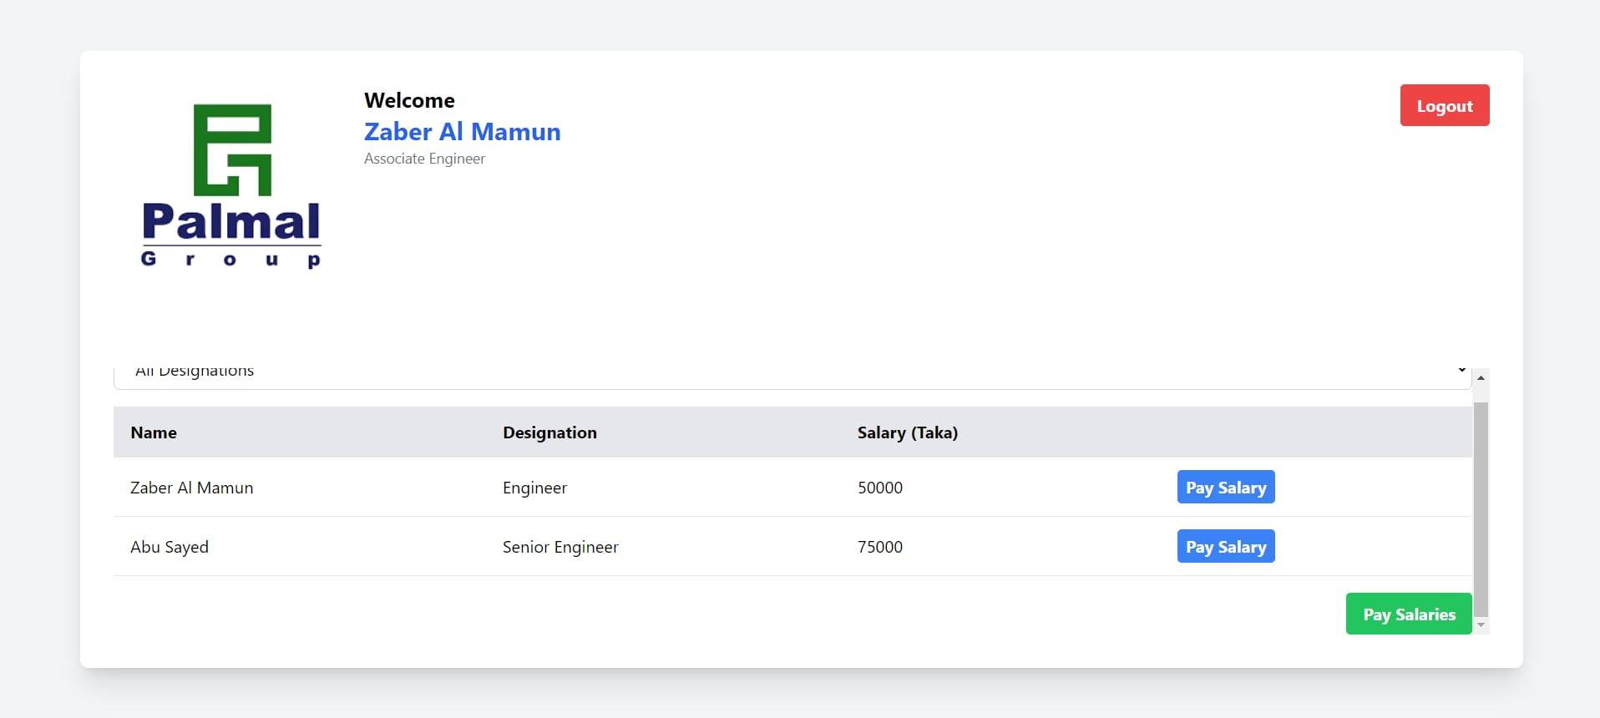

Figure 7.2: Admin page. 1

## 7.3 User Acceptance Testing (UAT)

• Test Scenarios: Defines the scenarios to test the system from an end-user perspective, so that each requirement is mapped against a scenario and those are tested ensuring we get satisfied customer experience.

• Passing on the User feedback summary in UAT testing and what it eventually resulted into.

## 7.4 Performance Testing

Load Testing — How did we test for the same load on system?

Stress Testing: Specify the type of stress testing conducted to determine when system will break and its performance under load.

## 7.5 Security Testing

– Vulnerability Assessment: Describe how the system was evaluated for security vulnerabilities (i.e. SQL injection, cross-site scripting (XSS), or non-authorized access).

Penetration Testing: Describe any penetration testing carried out to test the system and explore vulnerabilities.

## 7.6 Results and Quality Metrics

• Test Results: Include outputs from testing phases, along with any defects encountered and how they were fixed.

o Quality Metrics: A list of metrics that illustrates the quality of the system, such as defects, performance requirements and security scans.

Continuous Integration and Deployment (CI/CD) 7.7

CI/CD Pipeline Described the CI/CD pipeline established to automate testing, integration, and deployment processes.

Automated Testing: Describe how automated testing plays a part in maintaining quality while new system features are developed and delivered.

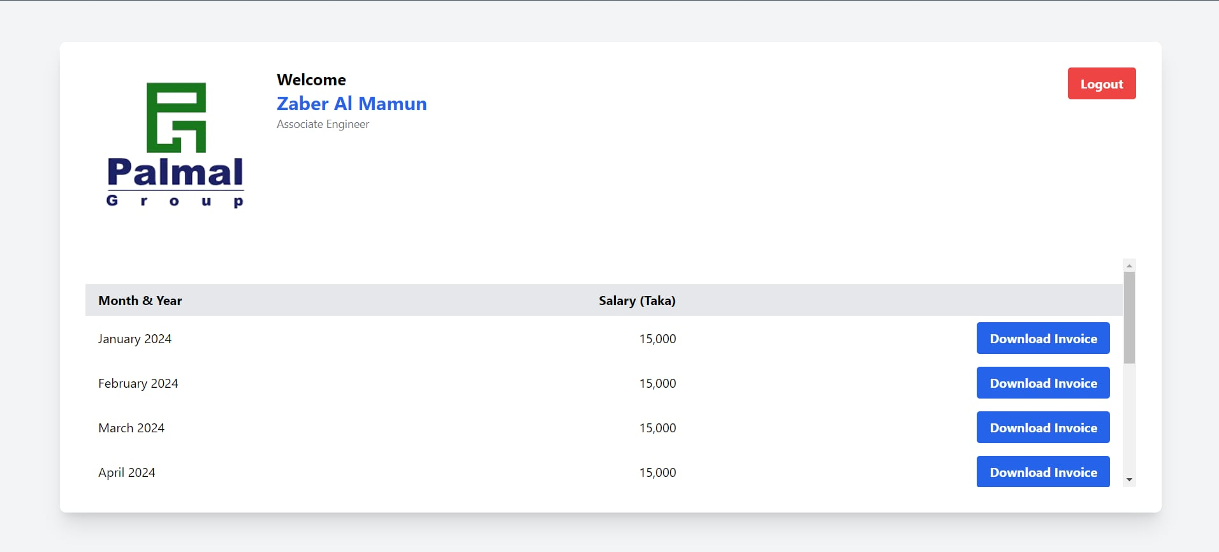

Figure 7.6: User page. 1

# Chapter 8

## Deploying and Maintaining

## 8.1 Introduction

Chapter Introduction: This chapter will cover the deployment of the system and continued maintenance plan.

## 8.2 Deployment Process

• Environment of deployment: A brief introduction to the deployment setting like cloud infrastructure, on-premise servers etc.

• Deploy Steps: Explain what you have done to deploy the system by setting up servers, configuring databases or launching application.

## 8.3 Post-Deployment Monitoring

• Monitoring : How do the monitor to make sure system is up and running post-deployment.

Performance + Tracking How are you doing to tracking performance and uptime (limit your self to a few lines)

## 8.4 Maintenance Plan

• Support Post-launch: Talk about how you are going to provide support for users post go-live, helpdesk, patching and user training.

Updates: Indicate how system updates, new features, security patches and performance upgrades will be handled.

Provide details on how feedback will be gathered from users and applied to evolve the system including:

## 8.5 Lessons and Suggestions

Deployment Challenges — Think about any deployment challenges you encountered further it be related to configurations, user adoption or scaling issues.

o Important lessons: Brief bullet list of the most important lessons learned during the deployment and maintenance phases—how it can be generalized for other projects.

# Chapter 9

## Project Results & Conclusion

## 9.1 Introduction

Overview of project results and key project points

## 9.2 Project Success

• Objectives: Evaluate the accomplishment of objectives in relation to project management plan goals • Cost of quality

Key Deliverables Describe the deliverables created during the project (for example, money transfer application), Documentation and Training materials.

## 9.3 Impact on the Company

•Efficiency Gains: Explain how it became easier to execute transactions, decline errors or automate amazing financial reports due to the new system.

User Satisfaction — Information on how users have reacted to the system such as increases in satisfaction or efficiency.

## 9.4 Future Recommendations

System Enhancements: Recommend modifications to the system, such as new functions, growth alternatives, or higher systems integration.

Long-term maintenance: suggest procedures for long term upkeep, along with regular design updates, security checks, and user training.

## 9.5 Conclusion

– Provide a summary of the project including lessons learned and discuss overall project success.

In this section, explain who it has helped you grow as a person and as a human specialist with the development of new skills, or something that inspired about life.

# Chapter 10

## Results and Analysis

## 10.1 Introduction

Introduce the chapter–To discuss the project results and to analyze the data that has been collected (specifically, to evaluate how well you achieved success of your project).

## 10.2 Project Outcomes

• System Working: Describe the work of system designed for funds transfer. Emphasize the features which are basic and were implemented successfully like user can do login, transaction management and account setting.

• User Acceptance: Elaborate on the feedback received from users during test and post-deployment. If applicable, name surveys or feedback forms by which this data was collected.

## 10.3 Performance Metrics

• Transaction processing speed: report the performance data of transactions in the system, e.g. how long a transaction is supposed to take on average according to initial goals vs actual system performance.

• System Uptime: Render information on the system availability as in uptime percent and downtimes if any

• Scalability — how well did the system deal with more users or transactions, what about if stress tests were executed

## 10.4 Security Analysis

Vulnerability Testing Results: Display the results of security testing and whatever vulnerabilities were discovered and remediated. This Time, Discuss How System Now Meets Security Standards.

Data Protection – evaluates how well data is protected, including use of encryption methods and strong authentication.

UX-analysis We performed the qualitative analysis of our product in form of Real-Time User Experience Recording.

• Usability Testing: Report the usability testing outcomes and how easy was the UX for users to understand.

User Engagement: Measure user engagement by tracking usage frequency, feature adoption and NPS scores

## 10.5 Financial Impact

Cost Efficiency: Scholen how the company is saving money on transaction costs with our money transfer system or managing finances better.

ROI: Calculate the ROI of both the development and the deployment phase, and compare them against each other during post-deployment.

## 10.6 Comparative Analysis

Benchmarking Against Industry Standards: When applicable, compare the performance of the system against industry benchmarks or comparable systems. Point out the things where your system shines vs. cases where it doesn't.

Competitor Analysis: If applicable, compare your system to competitors' solutions of the same genre emphasizing unique features or advantages

## 10.7 Challenges Encountered

Technical Challenges: Break down technical challenges encountered along the way (i.e — issues regarding integration, scalability, performance bottlenecks).

User Adoption Difficulties: Bring up hurdles in trying to get users to switch over to the this new system, and how those difficulties were addressed.

## 10.8 Lessons Learned

• Major Learnings — Summarize what you learn both things which worked well and others which could have been done differently.

• Project Enhancements: Provide recommendations for overall enhancements on future projects, e.g. improve testing processes, user training execution or performance tuning

## 10.9 Conclusion

Results Summary: Brief summation of the main takeaways of what was found in the examination.

Overall, Success — Conclude with an evaluation of the project in its totality; specifically, evaluate how it did relative to what it was aiming to accomplish and its impact on both the company.

# Chapter 11

## Sustainability Environmental and Social Impact

## 11.1 Introduction

.• Chapter introduction, explaining that it will discuss sustainability and the environmental and social impact of project with an outlook of what the future might hold.

## 11.2 Sustainability

• Sustaining practices–mention specific sustainable practices used in a project like energy efficient technologies in the project or green materials used.

Ask: Real-World Utility — Where does the money transfer process fit in with the business and operations of the company, and how well does it leverage cost optimization & operational efficiency over time?

## 11.3 Environmental Effects

— Resource Utilization: Evaluate the resource usage of the design (energy consumption, material waste in design and deployment)

Paper Reduction: Cover paper saving if any effected by the transfers being conducted in a digital facilitation, this all helps with conservation efforts for our planet.

- Carbon Footprint: Describe the carbon footprint of the system, server usage and data transmission along with some actions (if any) have been taken in order to mitigate negative environmental impact.

## 11.4 Social Effects

- Enhanced Financial Inclusion: Study the empowerment of money transfer system in providing financial inclusion to users, especially around underbanked regions.

Accessibility of user: To what extent does the system aid in access to different categories of users especially those that may be challenged)

Review the system's direct financial or community impact, i.e., did it create local jobs, support economic development in the area

## 11.5 Challenges and mitigation

Sustainability Challenges: Discuss issues faced during the implementation of sustainable techniques and how were they tackled.

Environmental/Social Challenges: Introduction of environmental reasons, social motivations to an ESG item/solutions applied for the environmental/social challenges

# Chapter 12

## Future Work

## 12.1 Introduction

• Begin this chapter by summarising what is achieved here: the fourth focuses on what may come next and how it might be done better.

## 12.2 Potential Enhancements

Additional Features — Recommend the features and functions that should be append to the system for adding on its value.

• Integration with Emerging Technologies – talk about how the system could work in tandem with new technologies, such as using blockchain to improve security or AI to offer personalized financial advice.

## 12.3 Scalability & Growth

Running system and how it can be scaled-up, e.g. dealing with increase of user load or expansion to new regions

• Market-Expand market to new markets or user segments.

## 12.4 User feedback and iteration

Feedback Mechanisms: Suggest ways to continually collect user feedback for future updates. •

• Long term maintenance and development, edit the state after release plan with a regular cadence of updates for minor improvements or gladwellian content releases with meaningful new features to enhance effectiveness as potential provide value or contributions peculiarly in response to feedback.

## 12.5 Research and Development

Research Thought Pasts Offer insight (stimulis) to Repose On Further research Revitalize the system and its function or study the constraints that were found.

Collaboration Opportunities: The potential to partner with higher learning institutions, subject matter authorities, or technology providers for an innovative push.

# Chapter 13

## Conclusion

## 13.1 Summary of Findings

Project Overview: Contains a brief based on the project, key objectives, what this means for the success and significant completions.

Results Recap and Analysis: The results and analysis will be summarized in addition to the previous chapters with emphasis on showing the successful capabilities of project objectives.

## 13.2 Contributions and Impact

2.Project Impact: Consider the impact of the remittance system on your company in terms of operational efficiency, financial gains and customer satisfaction.

1- Broader Impact: Describe the broader impact of the work on the field or community, with a focus on contributions to financial inclusion, environmental sustainability or social advancement.

## 13.3 Lessons Learned

o What I learned from doing this project (including any new techniques, skills and addressing any unexpected problems faced)

Project Insight: Provide insight into the successful elements of your project, as well as insights on what you could have done differently to get better results in that area for future projects.

## 13.4 Final Thoughts

A final assessment of how well did the project went, how good was attaint for its objectives.

– Future Outlook: End with what the next steps can be for that project and how much more it can scale.

# Chapter 14

## Lessons Learned

## 14.1 Introduction

Chapter Opening (Reflecting on the Process) (what this chapter is about how we reflect on what you learned from your experience)

## 14.2 Key Successes

Effective Strategies: Talk about the strategies or methods that you found very useful in attaining your project objectives. Such as specific project management techniques that have worked, how you build relationships and collaborate with team members, or innovative problem-solving approaches.

• Outstanding Features: Here, point out the features or functionalities of the money transfer software that excelled in their performance or were praised by users.

## 14.3 Challenges Faced

Technical Challenges: Describe the technical hurdles you faced while working on this project – integration issues, poor performance or sudden appearance of a bug. How did these challenges get handled and ultimately resolved;

Project Management Issues: Think about all the issues related to project management (for example, scheduling difficulties, resource constraints or changes in scope). Detailing how these were addressed and what their consequences for the project.

## 14.4 Problem-Solving Approaches

Afro-Coders went on to list and explain the solutions, which were later implemented in order to push through these difficulties. Add in any creative or unique methods that worked the best.

• Problem-solving Lessons: By providing the lessons learned in identifying and solving problems, these are skills tested and usable in future projects dealing with similar issues.

## 14.5 Familiarity with team processes and collaboration

• Team work success: Reminisce on your team working capabilities such {(when did you communicated within the time or how well you had coordinated among your designated team etc.) Call out anything that contributed to the team doing well.

Areas for Improvement: Provide an overview of the struggles the group encountered, such as a fight within the team or difficulties in expressing thoughts. How To Improve: Provide suggestions for how the team could have made their project better.

## 14.6 User Feedback & Iteration

Feedback Utilisation - how the user feedback was taken, based which changes were done on system. Talk about any major pivots or changes made as a result of feedback.

• User First Design: Think about how taking a user first approach helped shape the design and development process.

## 14.7 Project Management Lessons

• Time Management- Discuss what were the best practices about time which has been followed in the project and if any strategies have been used to keep the project on right path.

• Resource Allocation: Monitor what resources were allocated and how during the life of the project. • Describe any problems and the resolution to one.

## 14.8 Risk Management

Risk Identification This section of the final report will contain how risks were identified and assessed throughout the project. List any risks that were realized and how it impacted the project.

Mitigation Strategies– Look at what risk mitigation strategies were used and how well they worked in containing potential problems.

## 14.9 Recommendations to be Considered for Future Projects

Labeling best practices on the basis of experiences and lessons learned from this, industries may offer ideas for practices in the future Provide recommendations for process, communication, and project execution improvements.

• Opportunity for betterment: Find out where we could have executed better in terms of project management and technical implementations to generate a better outcome on future projects.

## 14.10 Conclusion

Summary Insights- there are many details learned and how will the implications of that in your next projects.

Final Reflections (offer some final reflections on the overall learning from DART 101 and how it has helped you in your professional and personal development) • Block 1 –_ASSIGNMENTACC100Reflectoire_apposit-1

# Chapter 15

## Future Work

## 15.1 Introduction

• Background the chapter by presenting what future developments, enhancements, or extensions that could result from the project provide a context for the topic of interest

## 15.2 Potential Enhancements

- New Features: Add/Enhance existing features in the money transfer system. For example, additional security features such as biometric authentication, new tools for financial management or AI insights.

• User Experience Enhancements: Provide recommendations for improved user interface and experience based off user feedback, e.g., better navigation clarity, more customization options, increased accessibility features.

## 15.3 Stability and Extensibility

System Scalability – Suggesting enhancements to support the system in scalability for user base and number of transactions. Brainstorm any infrastructure changes or software updates that could help accommodate the influx of users.

Market = New Market / User Demographic Development: Consider the market development opportunity, to grow the system into new markets or user demographics. Think about ways the system could be scaled or adjusted for different regions/funding environments.

## 15.4 Integration with up-coming Technologies

• Integration for blockchain: Check the possible ways that may help you integrate blockchain technology for secure and transparent transactions.

• Artificial Intelligence (AI): This is where you can touch on the integration opportunities for AI in benefits like fraud detection, tailored financial advice or predictive analytics

## 15.5 Continuous Improvement

• Feedback Loops: Target approaches for keeping honest systems so qualified feedback (e.g., user surveys) will lead to improved system performance.

Regular Updates: Another requirement you should keep in mind before getting through mobile app development is planning the method for system updates and general oversight to get rid of bugs, fix security faults, and adjust user needs.

## 15.6 Research and Development

• Potential Future Research: Avenues of research that may provide helpful insights to inform the money transfer system or projects with similar goals. This could be research on new financial technologies, or user behavior study, or some complex security protocols.

Collaboration Opportunities — Propose partnerships with educational institutions, tech partners or even subject matter experts to grow and enhance the ecosystem.

# Chapter 16

## Summary of Findings

Project Overview: Give a short brief introduction about the project, its aims and features and that you have created in the end.

Results and Achievements: Summaries the main achievements from the project, emphasis on how it achieved its objectives and what outcomes it has had for you and your stakeholders.

## 16.1 Contributions and Impact

Company Impact – Consider how the transfer has helped the company, in terms of operational proficiency, purchase prices and user satisfaction.

• Beliefs on Impact: Discuss the overarching purpose of the project that could relate to financial inclusion, environmental sustainability or other social benefits.

## 16.2 Lessons Learned

## Insights & Reflections

## It made me understand how to develop a software, manage a project and work in professional environment. I have been through my ups and downs over the course of this project that made me grow in both a personal as well as professional level. Important Lessons We Learned

## 1. Planned & Collecting the Requirement

## A very big lesson learnt: thorough planning and requirement gathering are indeed the two most important items to do at start of a project. Engaging project sponsors, owners and other IT officers during the earlier stages of objectives specification process helped instill a common notion on what was expected as an end result virtually eliminating surprises in this area late in the game. What I will do from now on is to focus much more effort onto this phase to ensure that we find the genuine project opportunities and/or needs in concert with users.

## 2. Collaboration and Communication

## This project drove home the necessity of communication and teamwork. Frequent touch points with the IT & MIS team along and management updates kept in check that project did not go of track. This was a testament to the importance of listening carefully to what employees had to say and looking for opportunities figure out together. I want to keep the lines of communication open for future projects and create a space where partners feel safe in contributing their ideas as we are all trying to get something from the work experience.

## 3. Agile and Problem solving

## I hit some unexpected difficulties, in connecting the front end interface to a back-end database. Overcoming these problems is what taught me the importance of adaptability and persistence. This included picking up new technologies as we worked, like particular server-side scripting methods. This was a lesson that will help any global citizen whether on their first grant or fifteenth because it made me realize just how important flexibility and the ability to problem solve are in light of complications.

## 4. Technical Skills Development:

## Technically, I learned frontend development and back-end integration in depth. Student developers had ample experience in the process of assembling an entire web application when using tools like Tailwind CSS (or Javascript for UI) next to some back-end technology, such as PHP and MySQL — putting them together piece by peace. The primer I had with end-to-end will definitely help me better understand the creation of a full solution that got exposed in this experience.

## 5. The Value of Full Testing:

## It also helped the importance of testing in the development. Its components and processes were tested at different stages (unit, integration and system testing) helped me to understand how complete the testings are required for a sustainable & user satisfied solution. I will next time make sure to include more testing tools and methods earlier in the development life cycle using advanced automated techniques, catching problems before they occur.

## 6. Development Security Premises:

## Security was front and center throughout the project as well, because financial data is also notoriously sensitive. I received many great learns such as encrypted data transmission, secure authentication methods etc. I know how necessary it is to develop the secure system and I will consider this in my next projects where user data needs protecting at any cost.

## 16.3 Suggestions for Future Work

• Best Practices: Explain to the project team how most of best practices may be inferred and applied in similar projects after this project

>Improvements: here you indicate improvements that could be made in future projects, in aspects related to technical execution, project management or user engagement.

## 16.5 Final Thoughts

Final Evaluation – Provide an evaluative conclusion on both the functional deliverables of the process as well as how they word with respect to the targets which they were, in theory at minimum, made to fulfill. Number Transfers: Money transfers are now handled from the system, limiting human intervention and saving time while eliminating mistakes.

Ease of Use: A simple and responsive front end provides users with a platform that allows user satisfaction promoting engagement.

Secure Transaction Processing – Using encrypted data transmissions and secure authentication protocols, your financial information remains safe through all steps of the transaction process, a critical assertion for maintaining privacy over sensitive personal assets;

Future Outlook: End with a consideration towards the project's future & impact.✨

# Bibliography

[1] R.C.Tausworthe, “The work breakdown structure in s oftware project management,” Journal of Systems an d S oftwar e 1(3):181-186vol. 1(3), pp. 181–186, 1984.

[2] T. Saarinen, “System development methodology and project success: An assessment of situational approaches,” Journal of Systems and Software 1(3):181186(vol vol. 19, p. 183–193, 1990.

[3] Journal of Systems and Software, 1(3):181–186 [5] Rana.Prabha S. et al.,2014 “A Comprehensive Review: International Journal Of Application Or Innovation In Engineering Management (Ijaiem),” Vol vol. 10, Oct. 2015, pp. 24-29 / Published in Issue no.

[4] A. Brooks, “Managing software development: Lessons learned from real projects,” IEEE Software Magazine 22, no. 1, pp. 24–31, 2005.

[5] B. Boehm, “A spiral model of software development and enhancement,” ACM SIGSOFT Software Engineering Notes, pp. 11, no. 4, pp. 14–24, 1986.

[6] K. Schwaber and M. Beedle, Agile Software Development with Scrum, Prentice Hall; 1 edition (October 17, 2002)

[7] I. Sommerville, Software Engineering, 9th edn., Addison-Wesley: Boston MA. (2010)

[8] L. Jiang, A. Eberlein, B. H. Far and W.Pedrycz “ Handling requirements during agile software development: a survey in industry,” in Proc 2007 International Requirements Engineering C Delhi India,pp249-254

[9] F. J. Heemstra and R. J. Kusters, “Function Point Analysis: Evaluation of a Software Cost Estimation Model,” European Journal of Information Systems, vol 1, no. 4, pp. 223–237, 1991.

M. Poppendieck and T. Poppendieck, Lean Software Development: An Agile Toolkit, Boston, MA: Addison-Wesley

Avison and G. Fitzgerald, Information Systems Development: Methodologies, Techniques and Tools 4th ed., McGraw-Hill (2006)

{12} T. Dybå, and T. Dingsøyr, 2008 Empirical studies of agile software development: A systematic review Information and Software Technology Volume Volume 50, Numbers 9–10, Pages 833-859 (2008) stribution



**An Undergraduate Internship/Project on Landscape Management System**

By

**Zaber Al Mamun**

Student ID: **2022676**

**Summer, 2024**

**Consent from Supervisor**

**The student modified the internship final report as per the recommendation made by his or her academic supervisor and/or panel members during final viva, and the department can use this version for achieving. The Turnitin score was 13%**.

**Signature of the Supervisor**

**Md Abu Sayed**

**Senior Lecturer**

Department of Computer Science & Engineering

School of Engineering, Technology & Sciences

Independent University, Bangladesh